### Day 33 – Docker Compose: Multi-Container Basics

## Task 1: Install & Verify
- Check if Docker Compose is available on your machine
docker compose version
- Verify the version
##Task 2: Your First Compose File
- Create a folder compose-basics
- Write a docker-compose.yml that runs a single Nginx container with port mapping
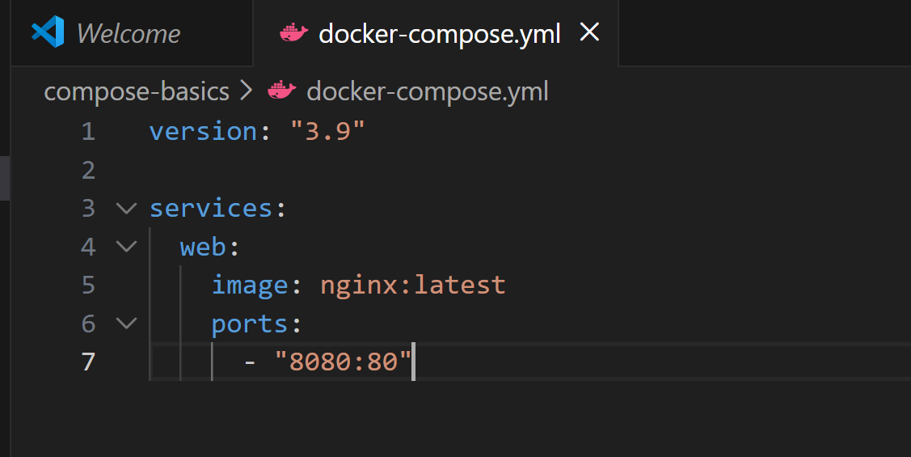
- Start it with docker compose up
docker compose up
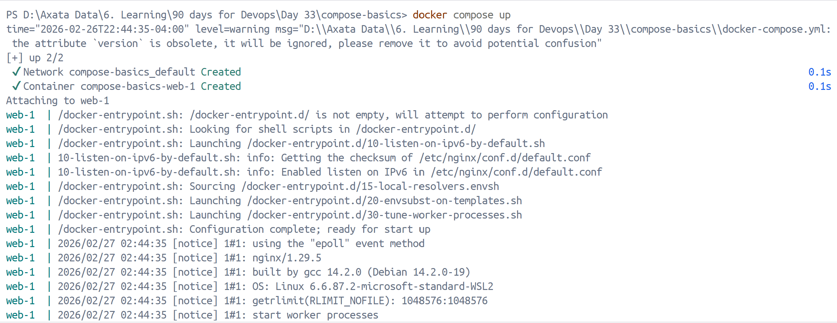
- Access it in your browser

- Stop it with docker compose down
docker compose down
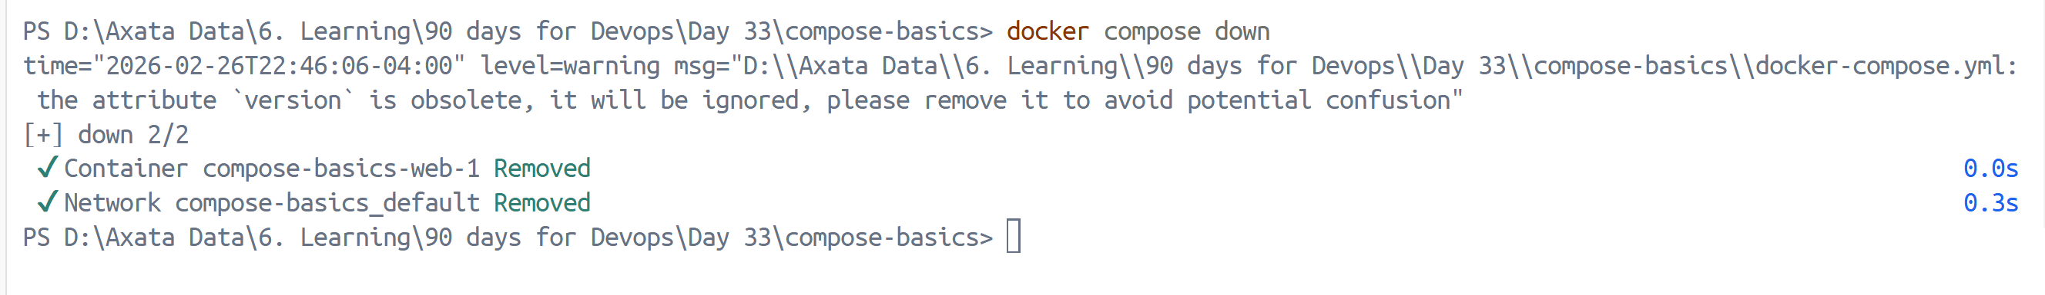

##Task 3: Two-Container Setup
Write a docker-compose.yml that runs:
- A WordPress container
- A MySQL container
They should:
- Be on the same network (Compose does this automatically)
- MySQL should have a named volume for data persistence
- WordPress should connect to MySQL using the service name
Start it, access WordPress in your browser, and set it up.
Verify: Stop and restart with docker compose down and docker compose up — is your WordPress data still there?
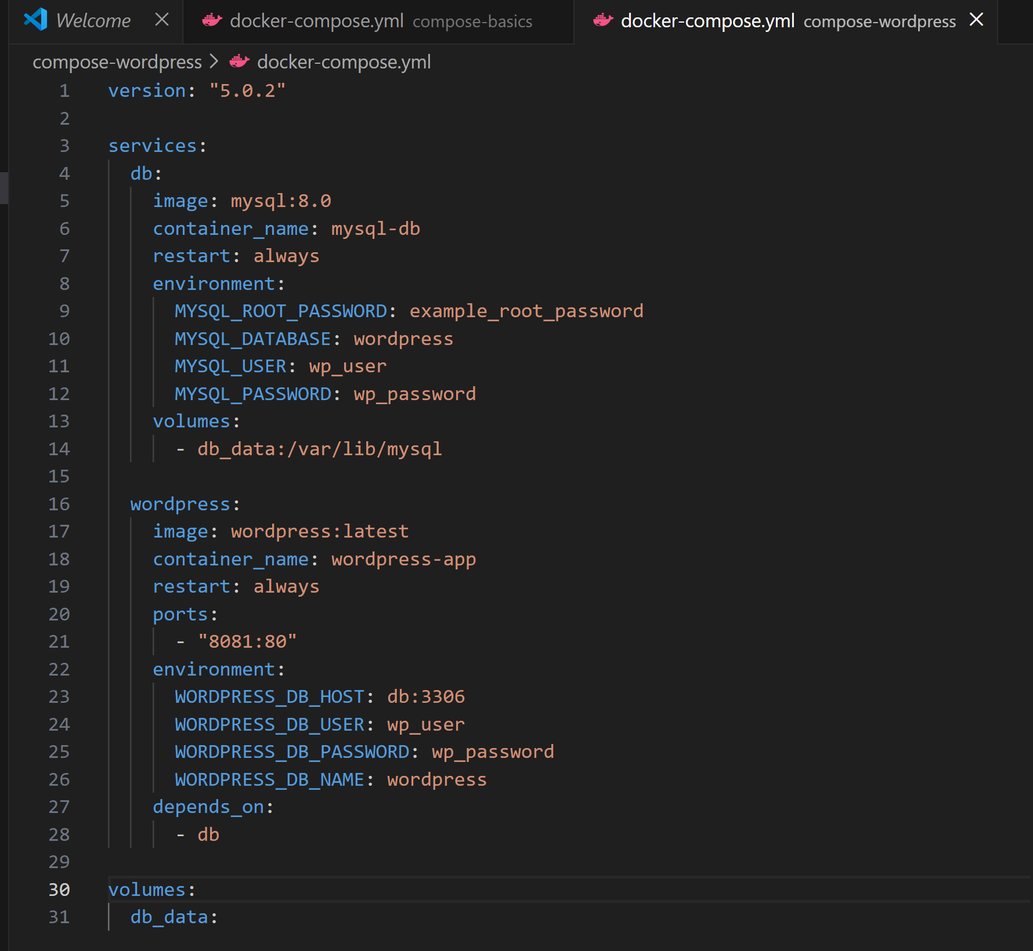
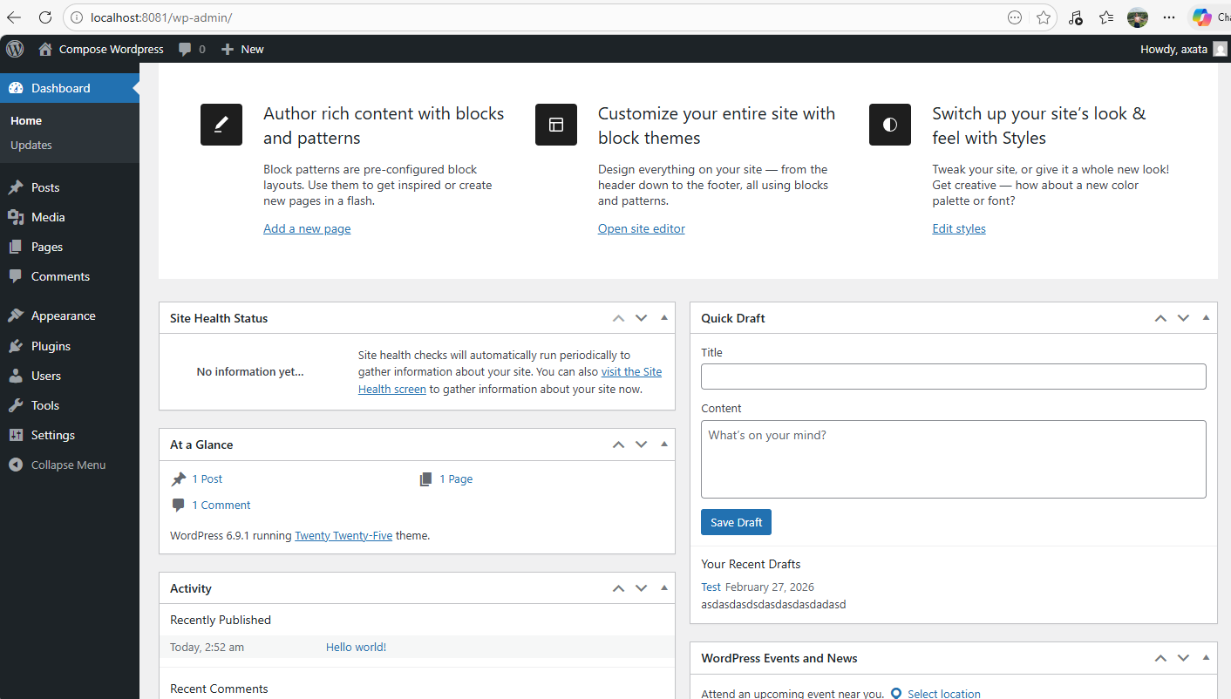
docker compose down
docker compose up –d
After stopping and restarting docker, data is still there.

## Task 4: Compose Commands
Practice and document these:
- Start services in detached mode
docker compose up -d
- View running services
docker compose ps
- View logs of all services
docker compose logs -f
- View logs of a specific service
docker compose logs -f wordpress
- Stop services without removing
docker compose down
- Remove everything (containers, networks)
docker compose down -v
- Rebuild images if you make a change
docker compose up --build

