### Day 33 – Docker Compose: Real-World Multi-Container Apps

## Task 1: Build Your Own App Stack
Created a folder structure:
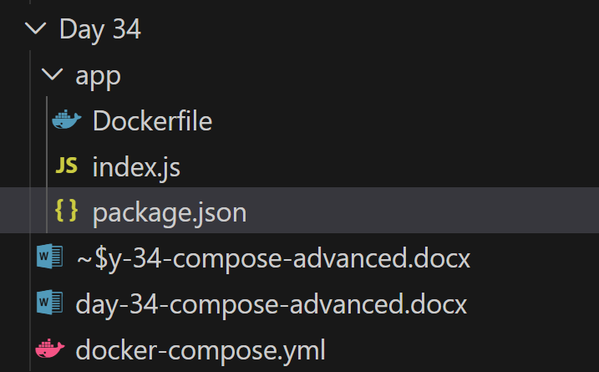
Docker-compose file:
version: "5.0.2"
services:
web:
build: ./app
container_name: web_app
ports:
- "3000:3000"
depends_on:
db:
condition: service_healthy
environment:
- DB_HOST=db
- DB_USER=root
- DB_PASSWORD=root
- DB_NAME=testdb
- REDIS_HOST=redis
networks:
- app-network
labels:
- "project=day34"
- "tier=frontend"
db:
image: mysql:8
container_name: mysql_db
restart: always
environment:
MYSQL_ROOT_PASSWORD: root
MYSQL_DATABASE: testdb
volumes:
- db-data:/var/lib/mysql
healthcheck:
test: ["CMD", "mysqladmin", "ping", "-h", "localhost", "-proot"]
interval: 5s
timeout: 5s
retries: 5
networks:
- app-network
labels:
- "project=day34"
- "tier=database"

redis:
image: redis:7
container_name: redis_cache
networks:
- app-network
labels:
- "project=day34"
- "tier=cache"

volumes:
db-data:

networks:
app-network:
driver: bridge
Dockerfile:
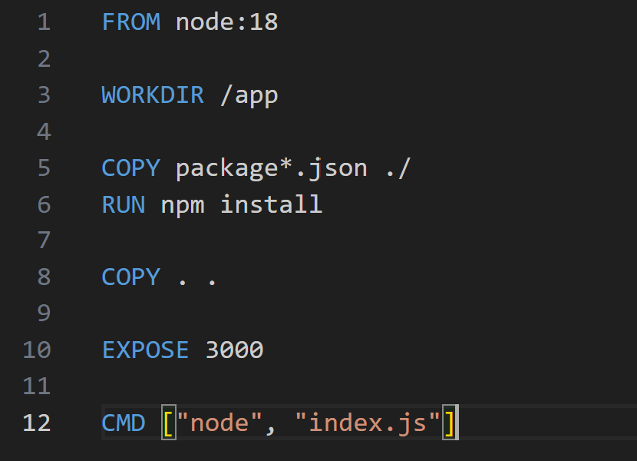
Package.json:
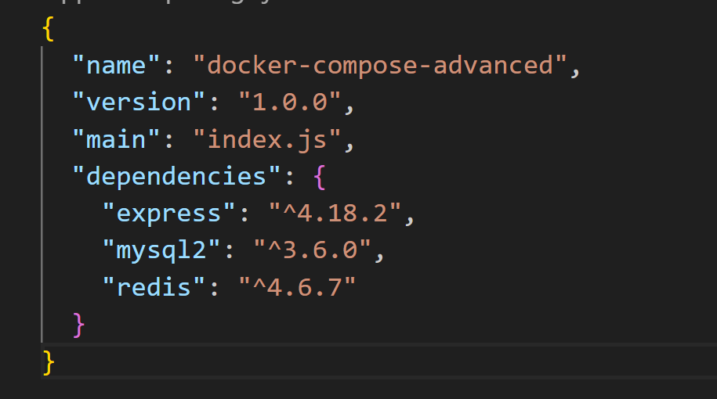

Output:
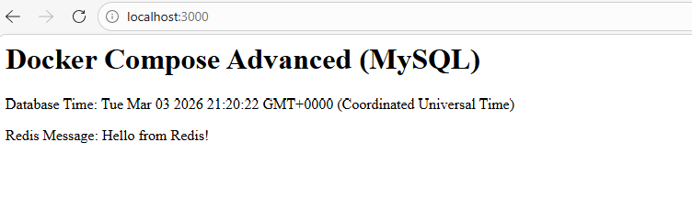
##Task 2: depends_on & Healthchecks
- Add depends_on to your compose file so the app starts after the database
- Add a healthcheck on the database service
- Use depends_on with condition: service_healthy so the app waits for the database to be truly ready, not just started
Test: Bring everything down and up — does the app wait for the DB?
The app waits until Postgres is truly ready
No more connection refused errors
##Task 3: Restart Policies
- Add restart: always to your database service
- Manually kill the database container — does it come back?
Container automatically restarts.
- Try restart: on-failure — how is it different?
Restarts only if container exits with non-zero status.
- Write in your notes: When would you use each restart policy?
- Batch jobs
- Workers
- Production databases
- Critical services that must always stay up
- Services that should not restart if manually stopped
## Task 4: Custom Dockerfiles in Compose
- Instead of using a pre-built image for your app, use build: in your compose file to build from a Dockerfile
- Make a code change in your app
- Rebuild and restart with one command
docker compose up –build
## Task 5: Named Networks & Volumes
- Define explicit networks in your compose file instead of relying on the default
networks:
app-network:
driver: bridge
- Define named volumes for database data
volumes:
db-data:
- Add labels to your services for better organization
All services communicate via service names:
- db
- redis
- web
## Task:6 Scaling
Try scaling your web app to 3 replicas using docker compose up –scale
docker compose up --scale web=3
What happens? What breaks?
Docker creates:
- web_
- web_2
- web_3
Write in your notes: Why doesn't simple scaling work with port mapping?
Because of port mapping. Only one container can bind to host port 3000.
Why Simple Scaling Fails?
Because:
- All replicas try to bind to the same host port.
- Docker Compose is not a load balancer.

