### Day 35 – Multi-Stage Builds & Docker Hub

## Task 1: Build Your Own App Stack
- Write a simple Go, Java, or Node.js app (even a "Hello World" is fine)
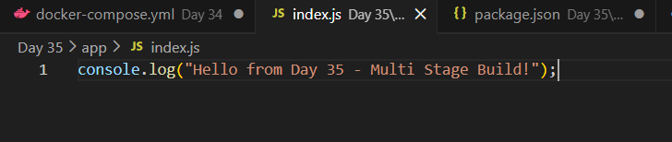

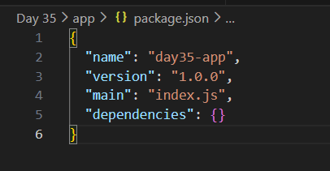
- Create a Dockerfile that builds and runs it in a single stage
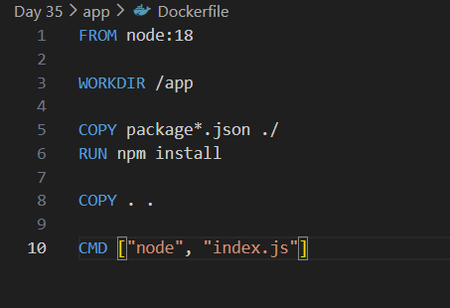
- Build the image and check its size
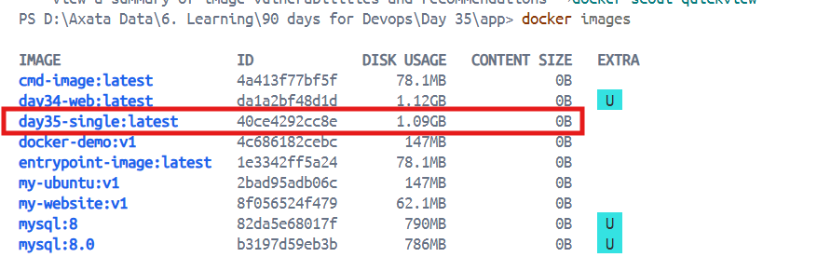
Note down the size — you'll compare it later. (Size is 1.09 GB)

##Task 2: Multi-Stage Build
- Rewrite the Dockerfile using multi-stage build:
Stage 1: Build the app (install dependencies, compile)
Stage 2: Copy only the built artifact into a minimal base image (alpine, distroless, or scratch)
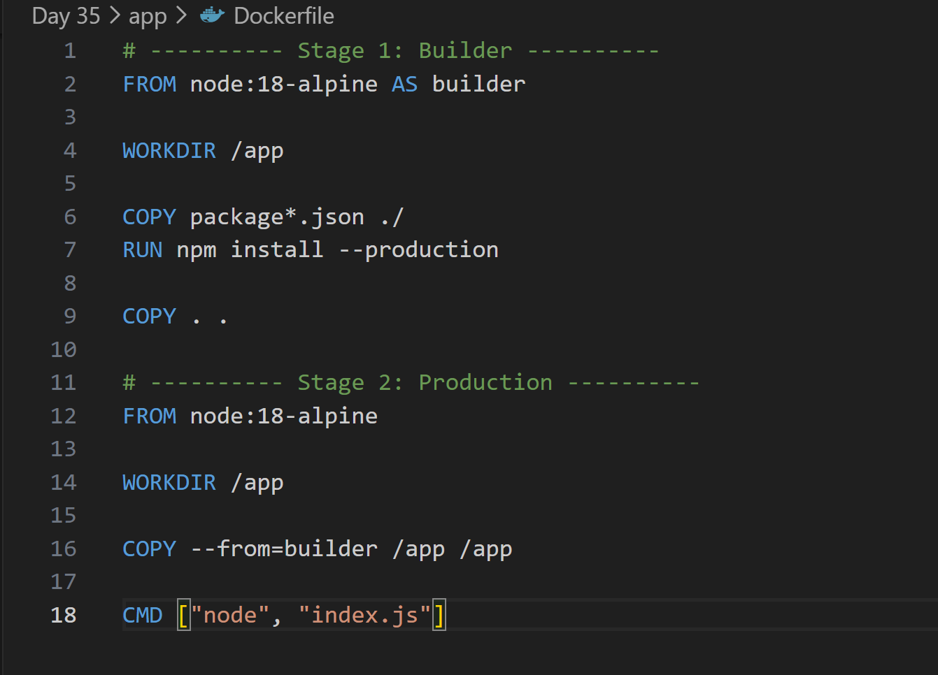
- Build the image and check its size again
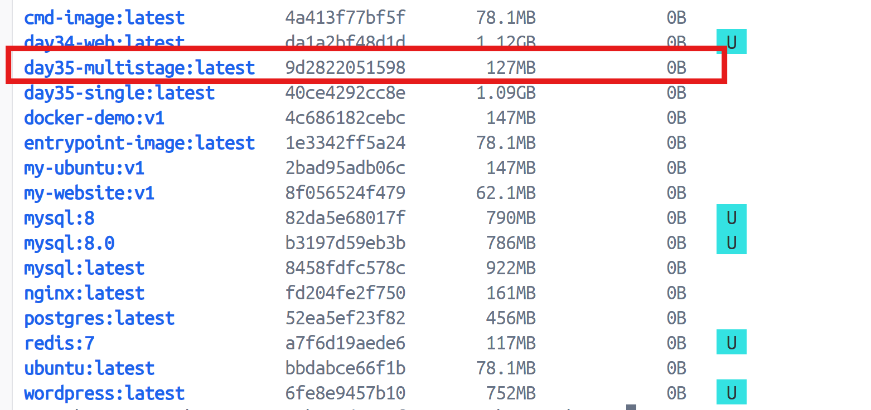
- Compare the two sizes
Single stage it is 1.09 GB
Multistage it is 127 MB
Write in your notes: Why is the multi-stage image so much smaller?
- Builder tools don’t go to final image
- No extra compilers
- Minimal base image (alpine)
- Fewer layers
- Only required runtime files copied

##Task 3: Push to Docker Hub
- Create a free account on Docker Hub (if you don't have one)
- Log in from your terminal
docker login
- Tag your image properly: yourusername/image-name:tag
docker tag day35-multistage axata/day35-app:v1
- Push it to Docker Hub
docker push axata/day35-app:v1
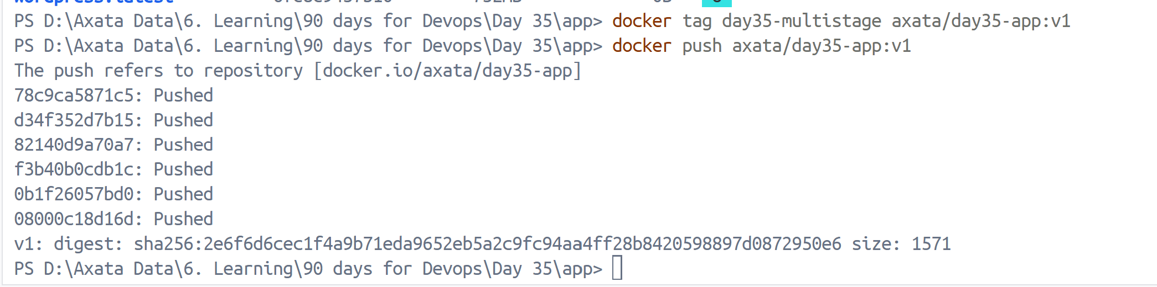
- Pull it on a different machine (or after removing locally) to verify
docker rmi axata/day35-app:v1
docker pull axata/day35-app:v1
docker run axata/day35-app:v1
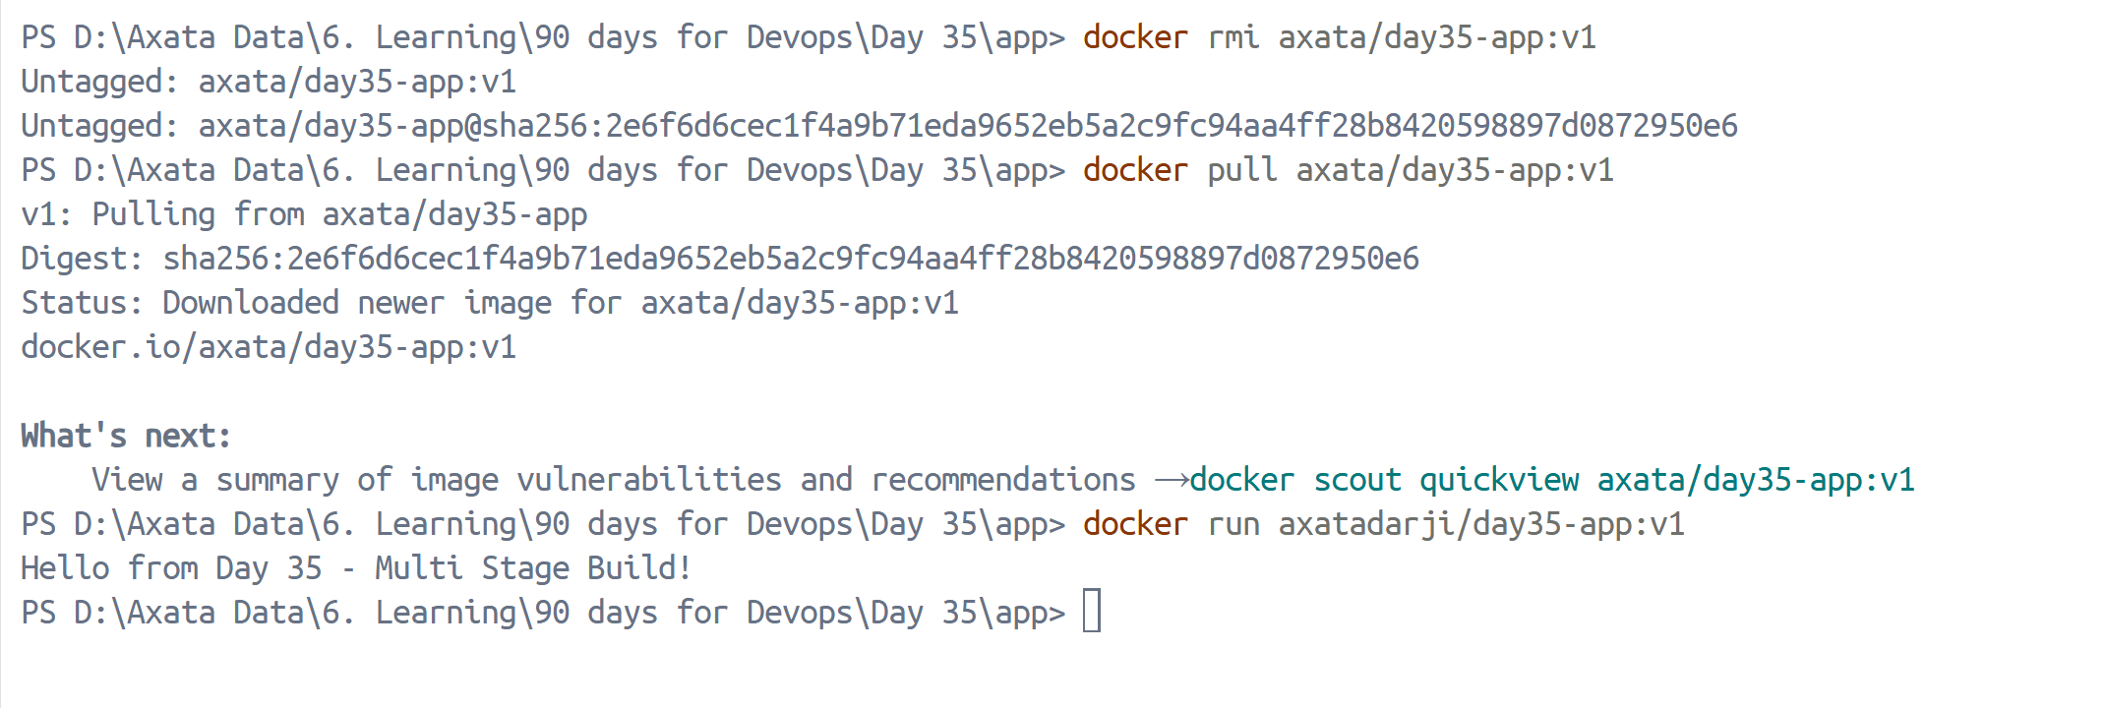
## Task 4: Docker Hub Repository
- Go to Docker Hub and check your pushed image
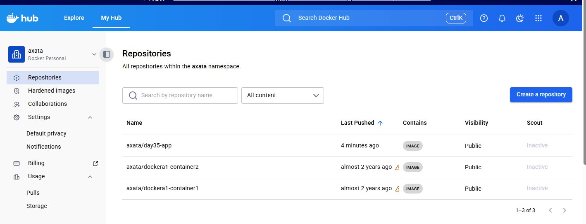
- Add a description to the repository
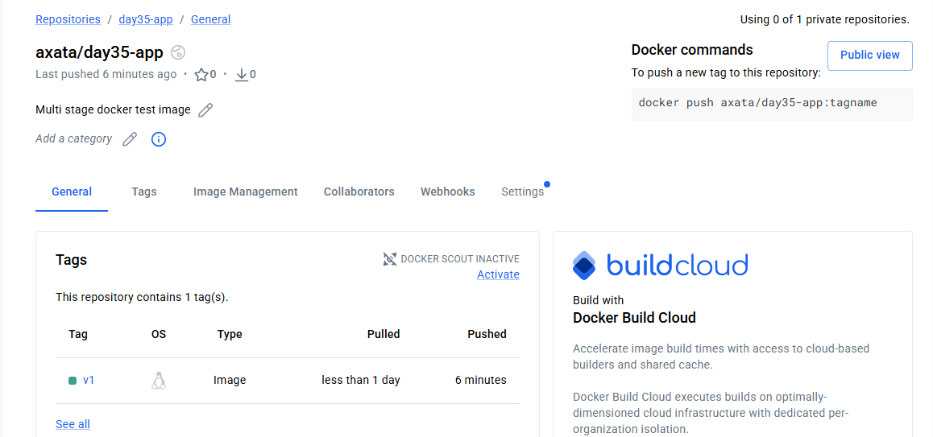
- Explore the tags tab — understand how versioning works
| Tag | Meaning |
| ------ | --------------------------- |
| v1 | Stable release |
| v2 | New version |
| latest | Default if no tag specified |
- Pull a specific tag vs latest — what happens?
docker pull axata/day35-app:v1
docker pull axatadarji/day35-app
If no tag specified → Docker pulls latest.
## Task 5: Image Best Practices
- Use a minimal base image (alpine vs ubuntu — compare sizes)
- Don't run as root — add a non-root USER in your Dockerfile
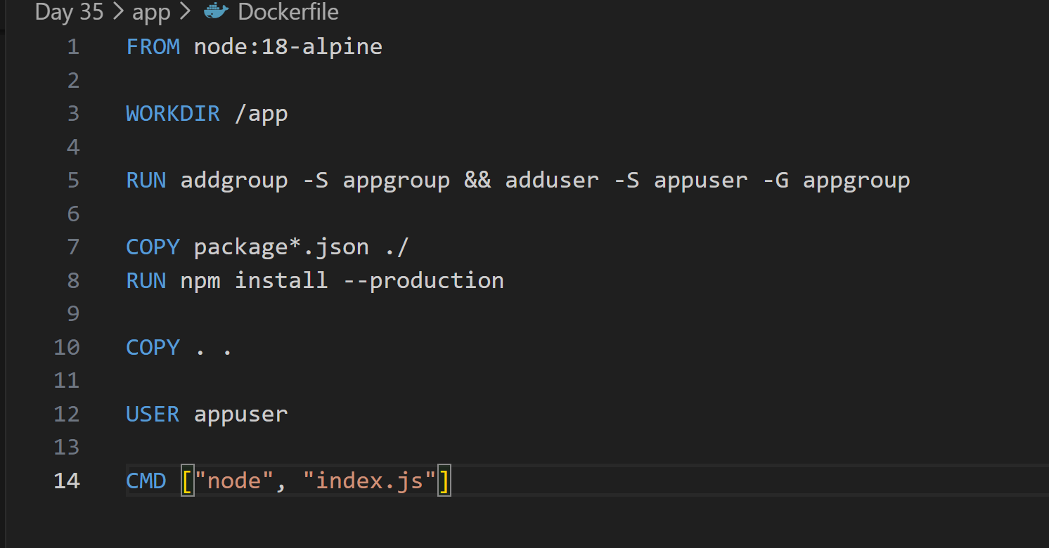
- Combine RUN commands to reduce layers
RUN apt update && apt install -y curl
- Use specific tags for base images (not latest)
FROM node:18.18-alpine3.18
