recipe ai

smart ingredient based recipe finder

NITHUVARSHINI K

2403717674422033

MSc AIML

table of contents | introduction...........................3
 | system design.........................4
 | methodology..........................5
 | existing systems.....................6

results....................................7

conclusion..............................8

introduction

problem definition
Cooking has become an essential daily activity, yet many people struggle with deciding what to cook based on the ingredients they already have at home. Existing recipe resources such as cookbooks or generic websites often require users to search manually, which can be time-consuming and inefficient.
The problem is the lack of a simple and intelligent system that allows users to quickly discover recipes based on available ingredients, dietary preferences, and time constraints. Without such a system, users either waste time browsing irrelevant recipes or end up not utilizing the ingredients they already have, leading to food wastage.

objectives of the project
1.To suggest accurate recipes instantly based on ingredients provided by the user.
2.To minimize food wastage by maximizing the use of available household items.
3.To provide recipe recommendations tailored to dietary preferences and nutritional needs.
4.To design a system that is both simple for users and scalable for larger recipe datasets.

SYSTEM DESIGN
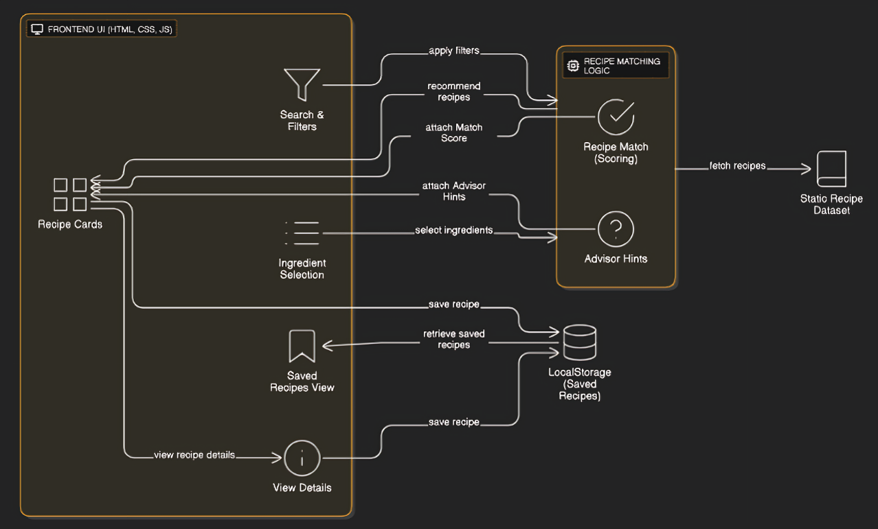
The system is designed with three main layers: Frontend UI, Recipe Matching Logic, and Data Storage.
- The Frontend UI (HTML, CSS, JS) allows users to search, filter, and view recipe cards. Users can also select ingredients, view detailed instructions, and save recipes.
- The Recipe Matching Logic processes filters and ingredient choices. It assigns a match score to rank recipes and provides advisor hints for substitutions or improvements. This logic fetches data from the static recipe dataset.
- The Data Storage layer uses local storage to save user-selected recipes for later retrieval, ensuring quick access without a backend server.
This design ensures personalized recommendations, lightweight storage, and a user-friendly browsing experience.

TOOLS AND TECHNOLOGIES
- Front End – HTML , CSS , JavaScript
- Data handling and Storage – Local storage , JSON

STEP BY STEP APPROACH
1.User Input: Collect available ingredients, optional filters (cuisine, diet, cooking time).
2.Normalize Data: Convert ingredients and filter values to lowercase for consistency.
3.Filter Recipes: Apply cuisine, diet, and time filters to the recipe dataset.
4.Match Ingredients: Compare user ingredients with recipe ingredients using sets.
5.Score Recipes: Calculate match percentage and generate reasoning/hints.
6.Sort & Select Top Recipes: Pick the top 3 recipes based on match score.
7.Display Results: Render recipe cards with save/view functionality and reasoning.
8.User Actions: Save recipes to localStorage, view full recipe modal.
9.Dynamic Updates: Update saved recipes sidebar and advisor hints
METHODOLOGY

EXISTING SYSTEMS
- Cookbooks & printed guides – physical recipe books organized by cuisine, diet, or occasion.
- Youtube & video tutorials – people watch cooking videos and pick recipes manually.
- Popular recipe apps (Allrecipes, Yummly, Tasty) - suggest recipes based on keyword search or pre-set filters.

THEIR LIMITATIONS:
- Limited ingredient reasoning – most apps just match keywords, not combinations.
- No personalized AI suggestions – minimal adaptation to user preferences.
- Overwhelming choices – many recipes, but no smart ranking or match score.
- Lack of reasoning/explanation – users don’t know why a recipe is recommended.

IMPROVEMENT AREAS:
- Dynamic AI scoring – rank recipes based on ingredient match, cooking time, and diet preferences, not just keyword search.
- Reasoning transparency – show why a recipe fits, helping users make smarter choices.
Creative substitutions – suggest viable ingredient alternatives to maximize pantry utilization

RESULTS

BENEFITS
- Reduces Food Waste: Suggests recipes based on what users already have, minimizing unused ingredients.
- Saves Time & Effort: Quickly narrows down recipe options instead of browsing multiple cookbooks or websites.
- Promotes Culinary Exploration: Introduces users to new cuisines, cooking techniques, and flavor combinations.
- Supports Sustainable Living: By using locally available or leftover ingredients, it encourages smarter consumption habits.

POSSIBLE IMPROVEMENTS
- Adaptive Personalization: Incorporate user history and preferences to suggest recipes based on previously selected or saved recipes.
- Advanced Ingredient Matching: Support partial matches, ingredient synonyms, and common substitutes (e.g., “bell pepper” = “capsicum”) to increase recipe relevance.
- Enhanced Scoring Algorithm: Include additional factors like seasonal availability, nutritional content, and user-defined priorities (e.g., low-calorie, high-protein).

- Developed an AI-powered recipe recommendation system that matches user-provided ingredients with available recipes.
- Dynamic scoring and reasoning: Recipes scored based on ingredient match %, filters (cuisine, diet, time), and AI-generated reasoning.
- Personalized hints: AI suggests best recipes based on user’s input to reduce waste and optimize cooking choices.

FUTURE VISION
- Full AI-Powered Kitchen Assistant: Beyond recommending recipes, the system can suggest weekly meal plans, generate shopping lists, and optimize ingredient usage to minimize wastage.
- Gamified Cooking Experience: Reward users for trying new recipes, matching ingredients efficiently, or reducing waste.
- Ingredient Inventory Tracking: Keep a virtual pantry that updates as recipes are cooked to suggest what’s left or needs replenishing.
- AI-Powered Cooking Assistant: Provide step-by-step voice guidance, timers, and tips for a hands-free cooking experience.

CONCLUSION

