NITHYA BALASUNDAR

1001763661

//SCREENSHOT FOR SENDING EMAIL

SCREENSHOT 1: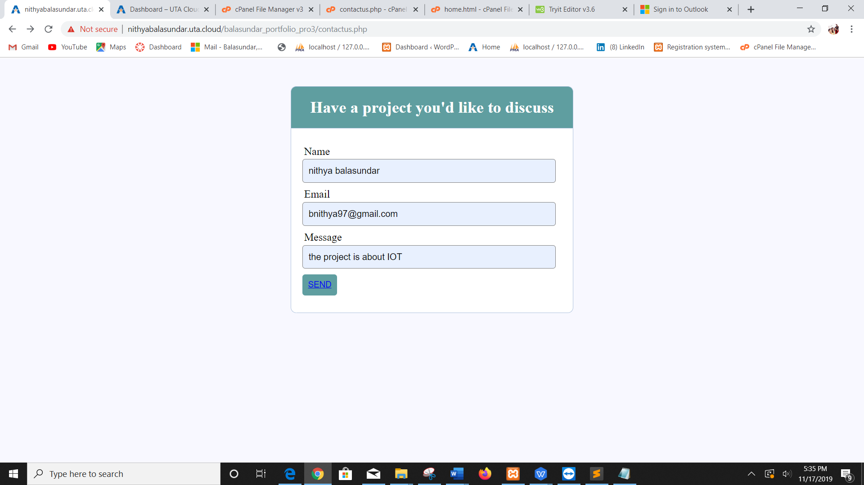

SCREENSHOT2:

