**GE-3 Computer Networks Lab**

Name : Nithya Priya

Roll no : 2007027

Department : Physics

**Q1.**Create HTML document with following formatting – Bold, Italics, Underline, Colors, Headings, Title, Font and Font Width, Background, Paragraph, Line Brakes, Horizontal Line, Blinking text as well as marquee text.

**Input:**

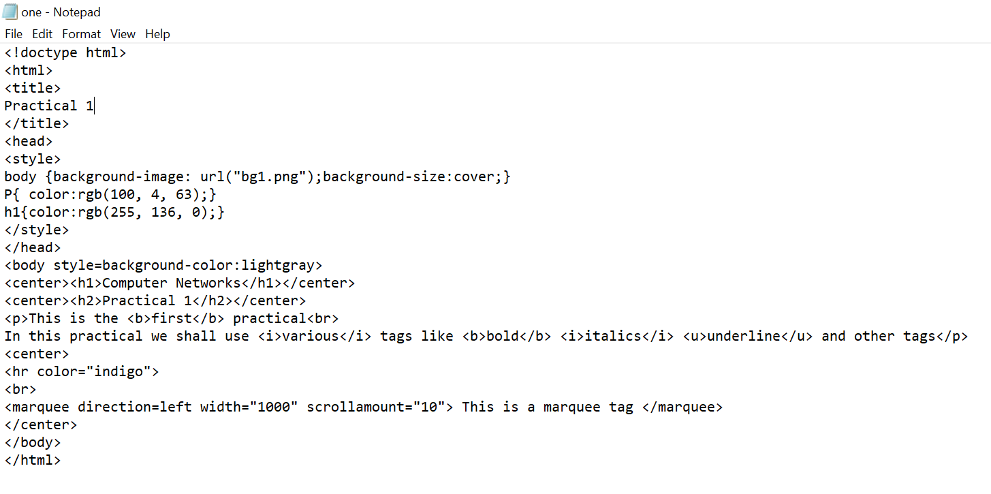

**Output:**

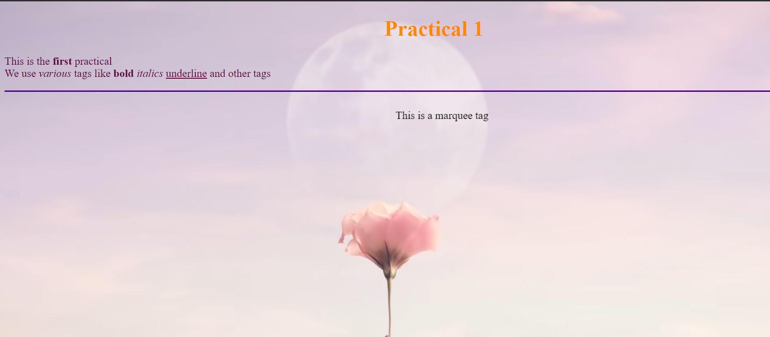

**Q2.**

Create HTML document with Ordered and Unordered lists, Inserting Images, Internal and External linking

**Input:**

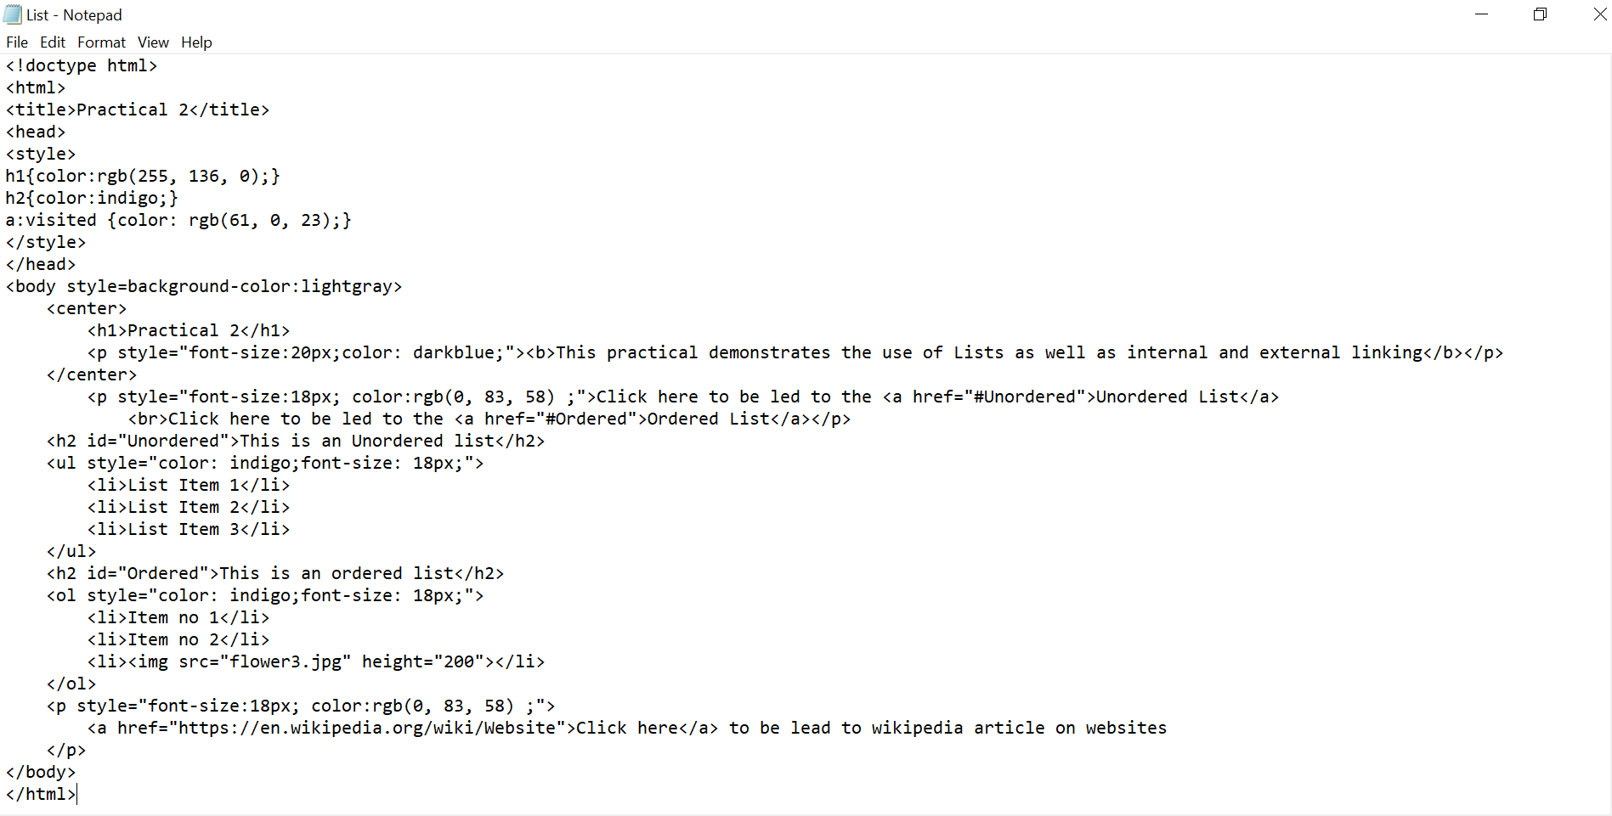

**Output:**

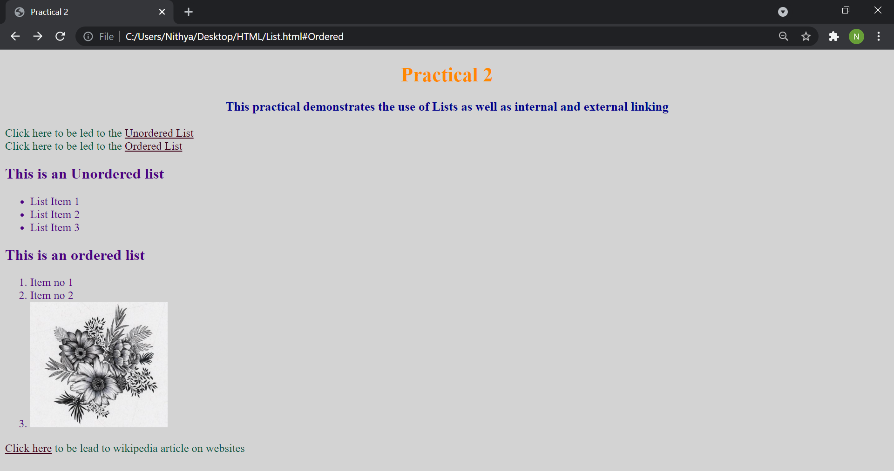

**Q3.**Create HTML document with Table

**Input:**

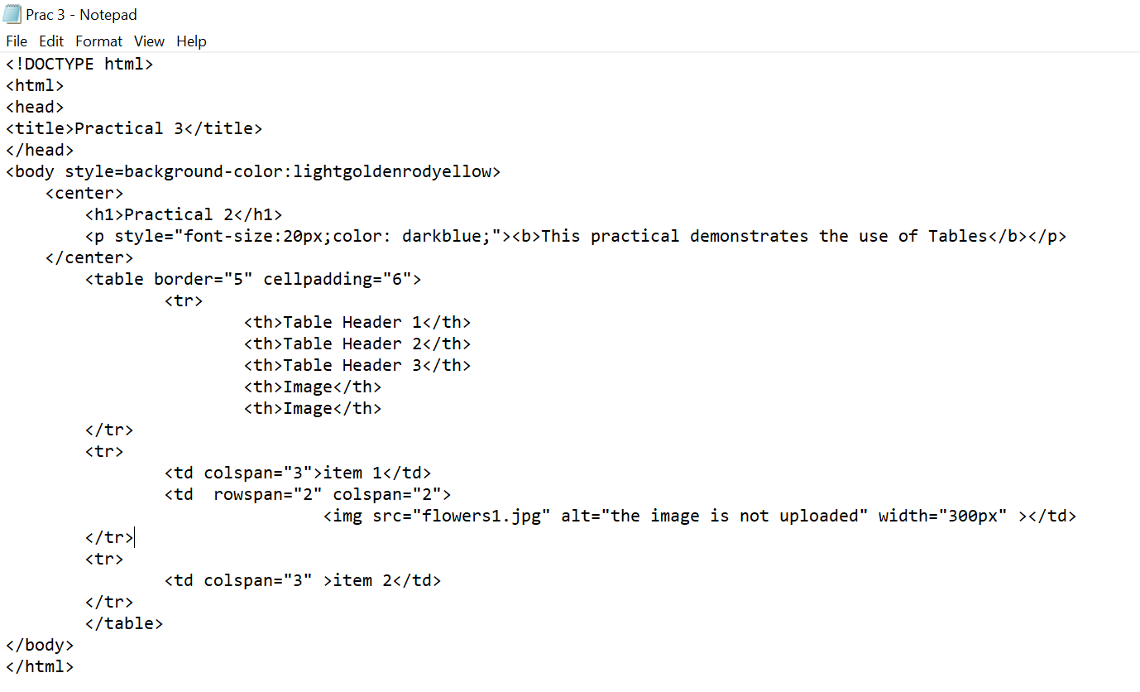

**Output:**

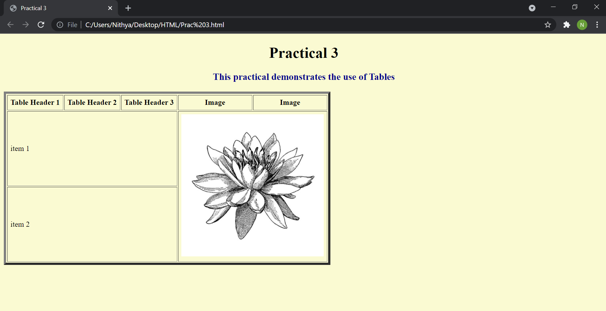

**Q4.** Create Form with Input Type, Select and Text Area in HTML.

Input:

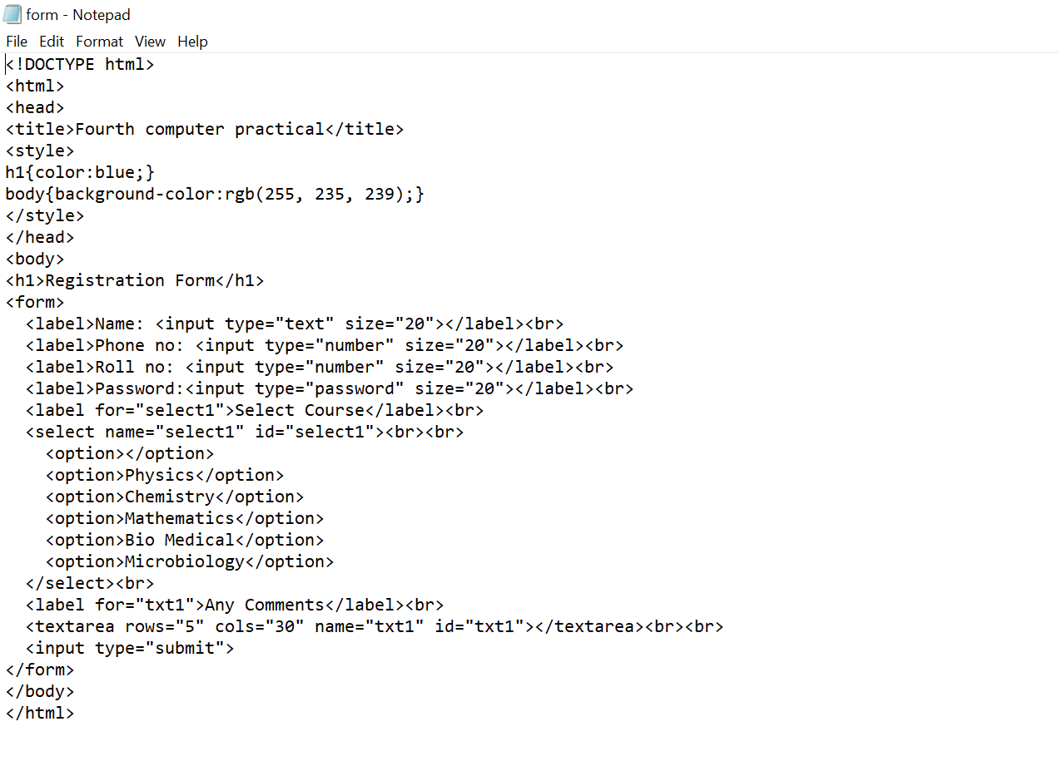

Output:

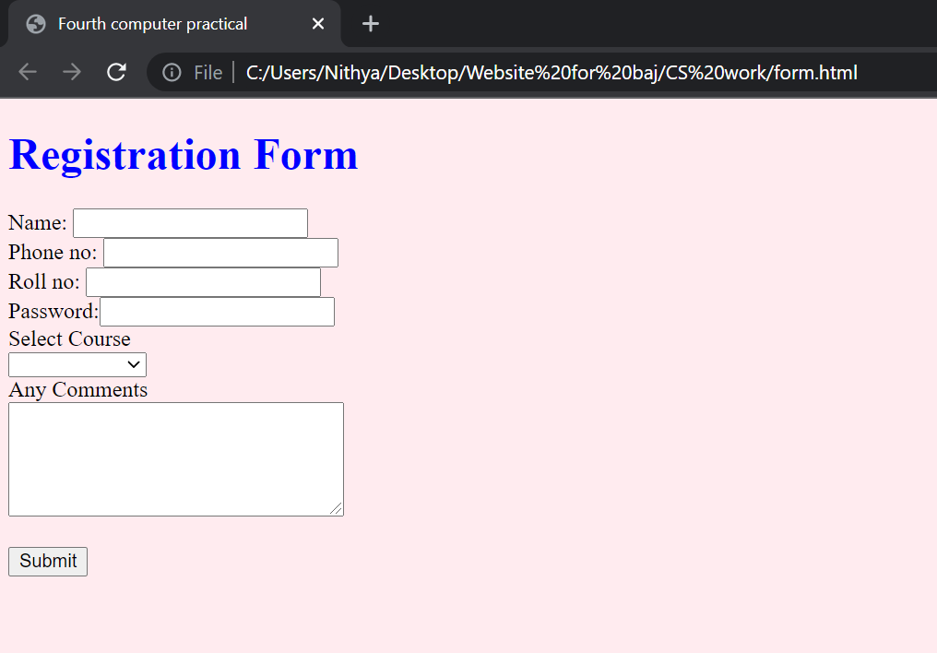

**Q2.** Create an HTML containing Roll No., student’s name and Grades in a tabular form.

Input:

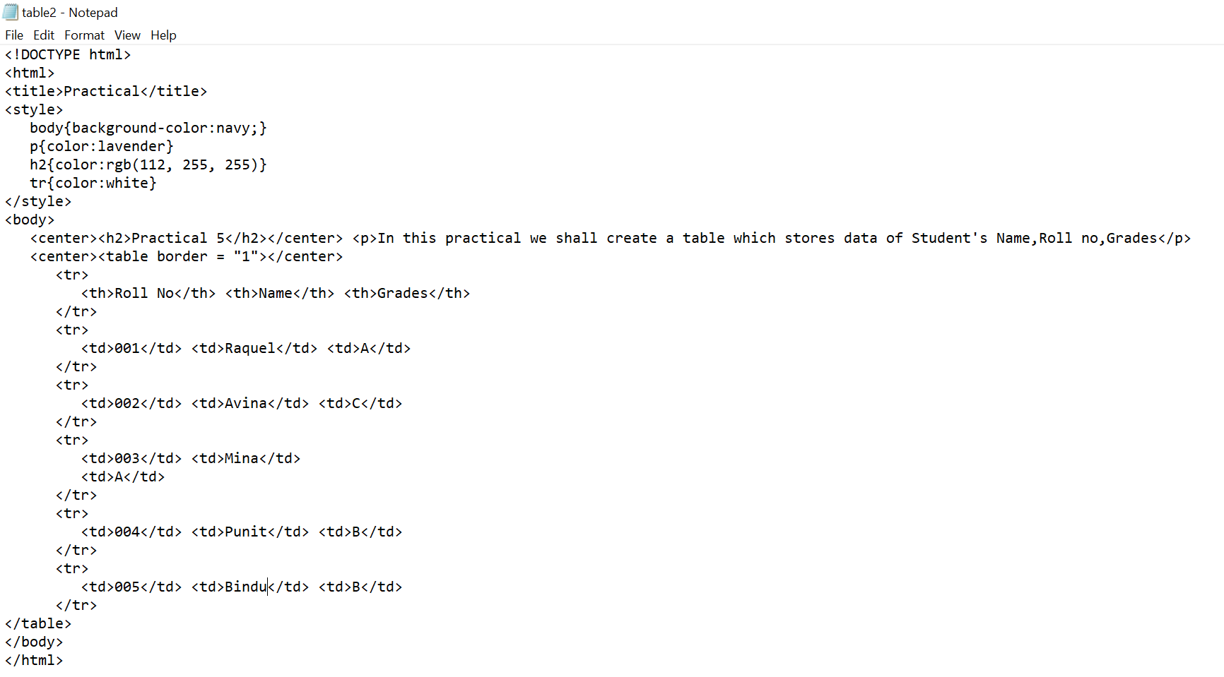

Output:

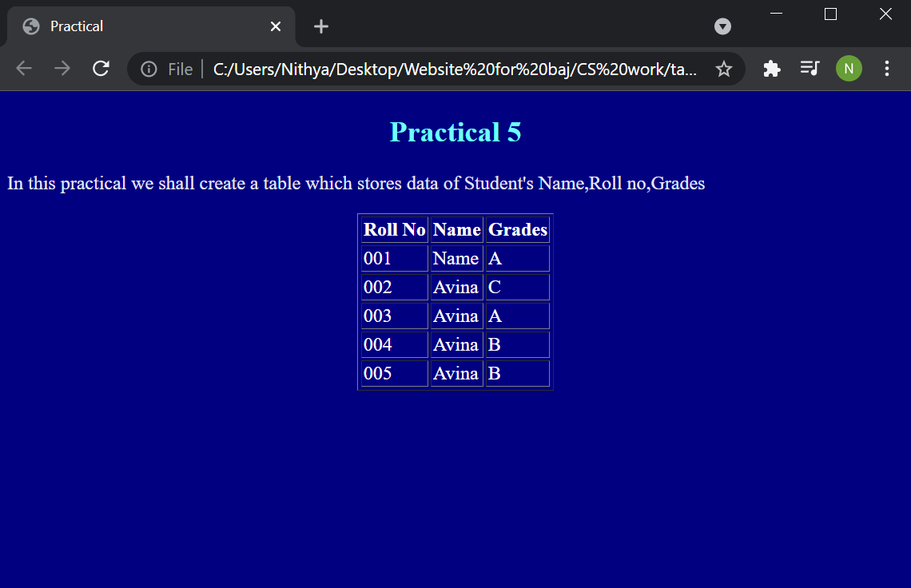

**Q6.**Create an HTML document having two frames

Input:

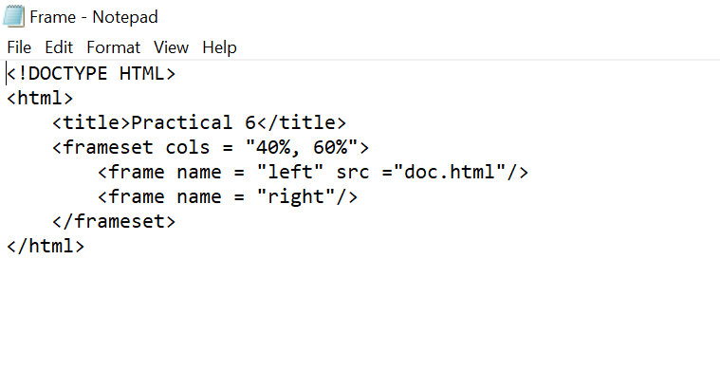

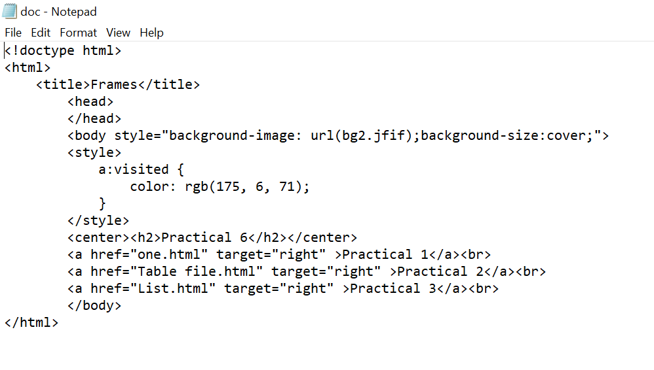

Output:

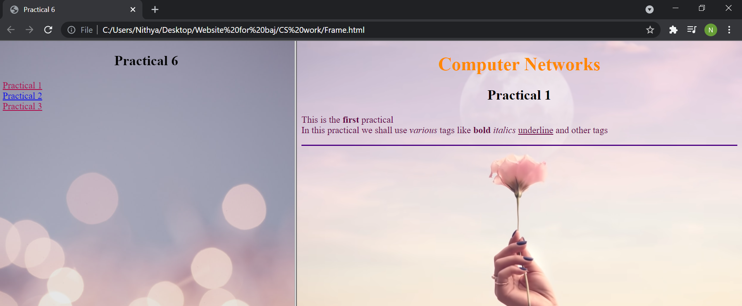

**Q7.**Create an HTML document containing horizontal frames

Input:

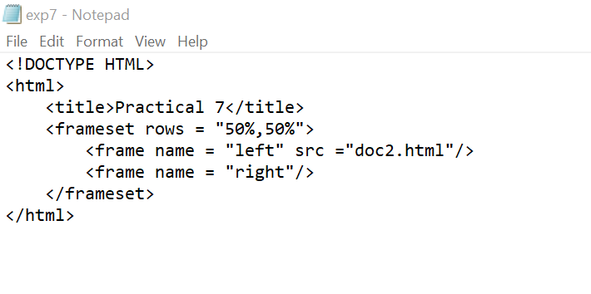

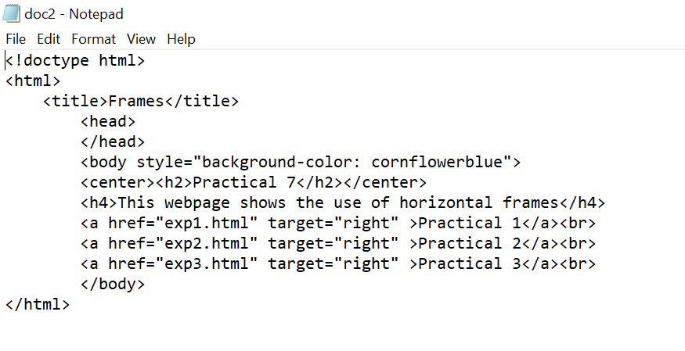

Output:

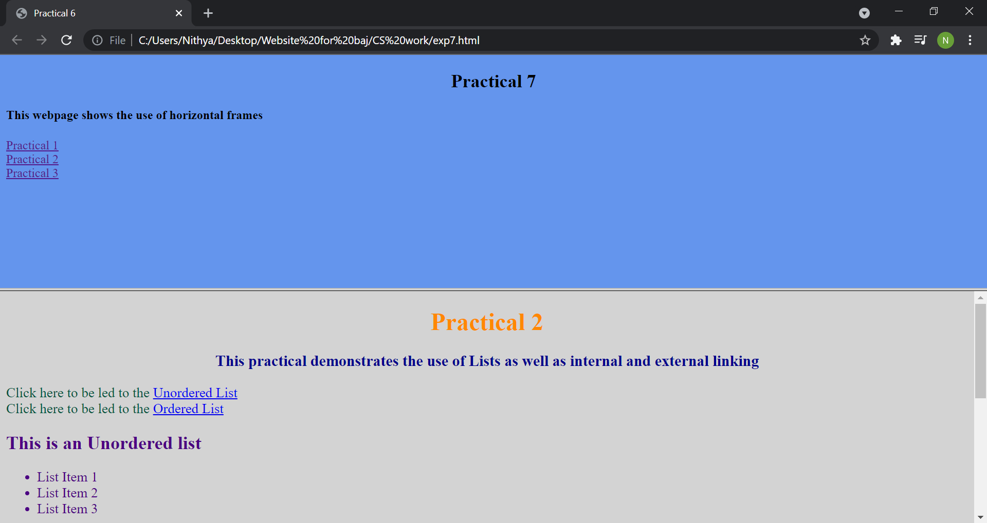

**Q9.** Create HTML documents having multiple frames

Input:

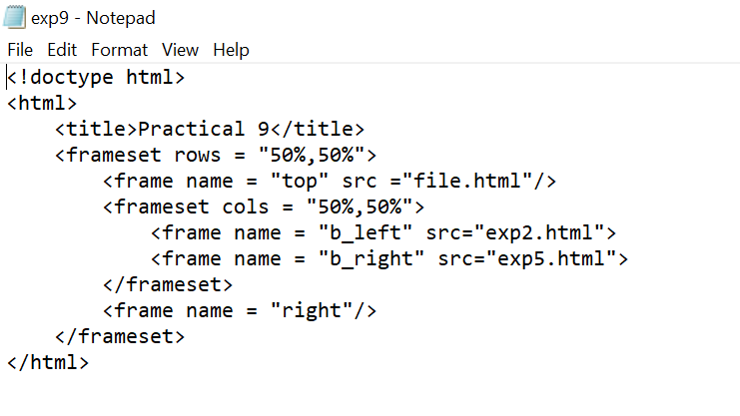

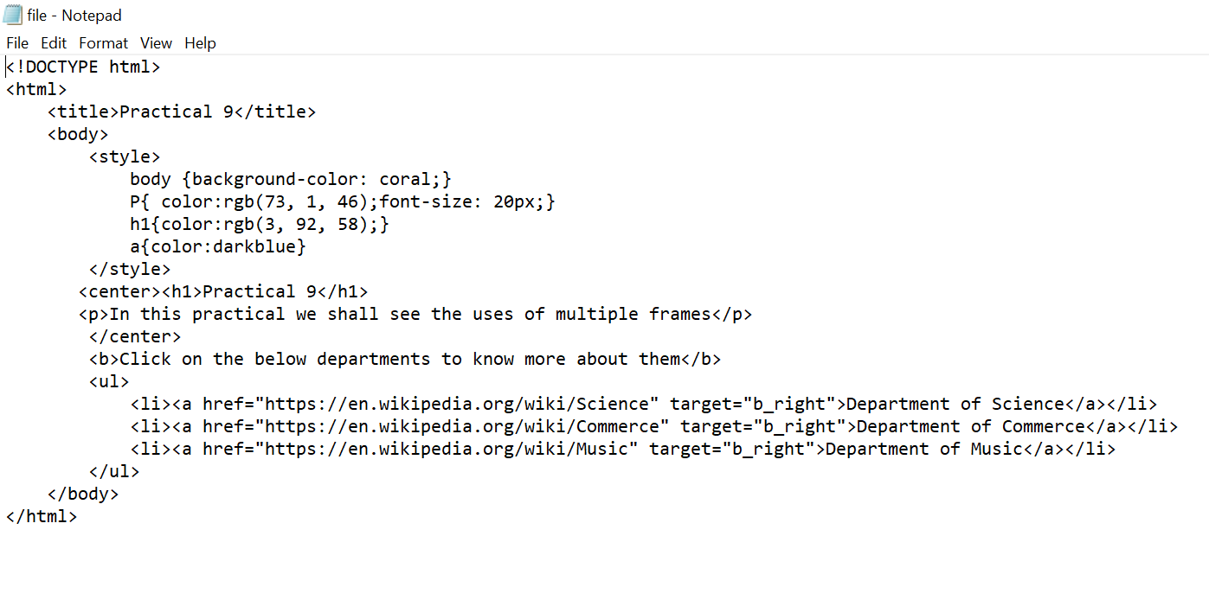

Output:

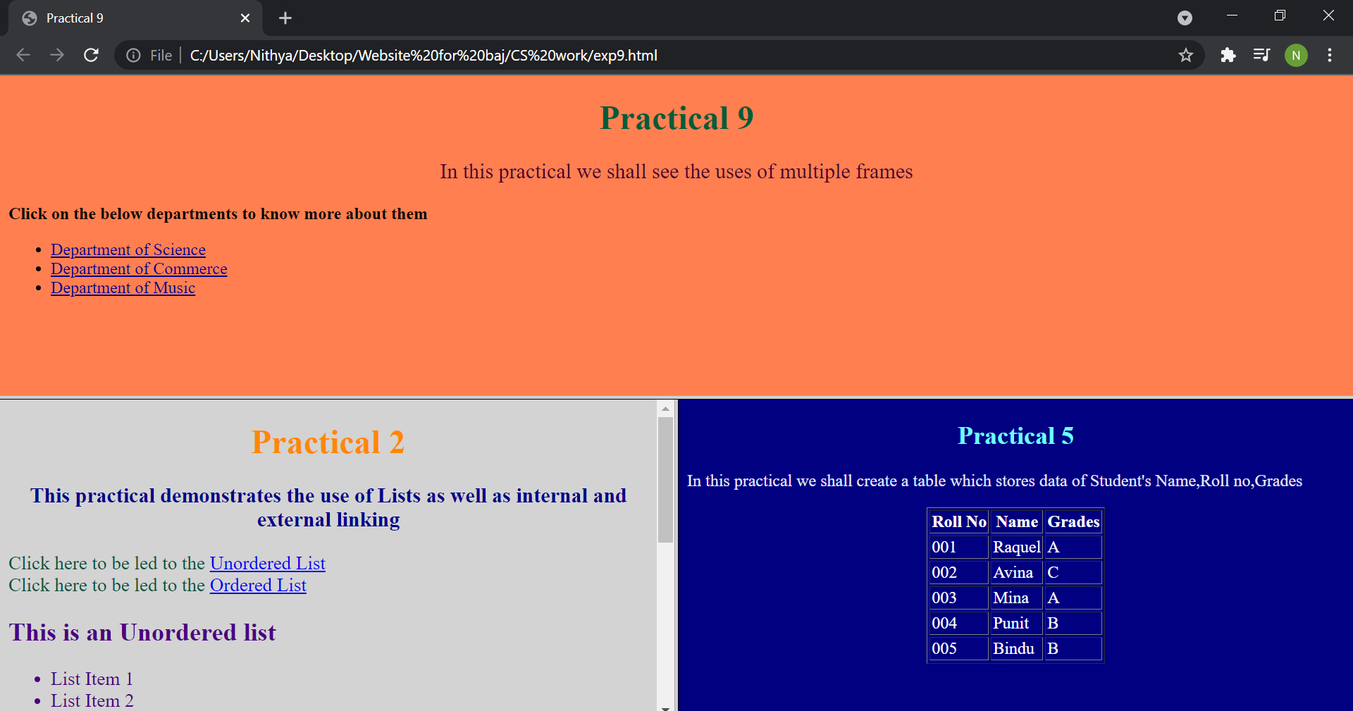

**Q10.**Create a form using HTML which has the following types of controls:

I. Text Box

II. Option/radio buttons

III. Check boxes

IV. Reset and Submit buttons

Input:

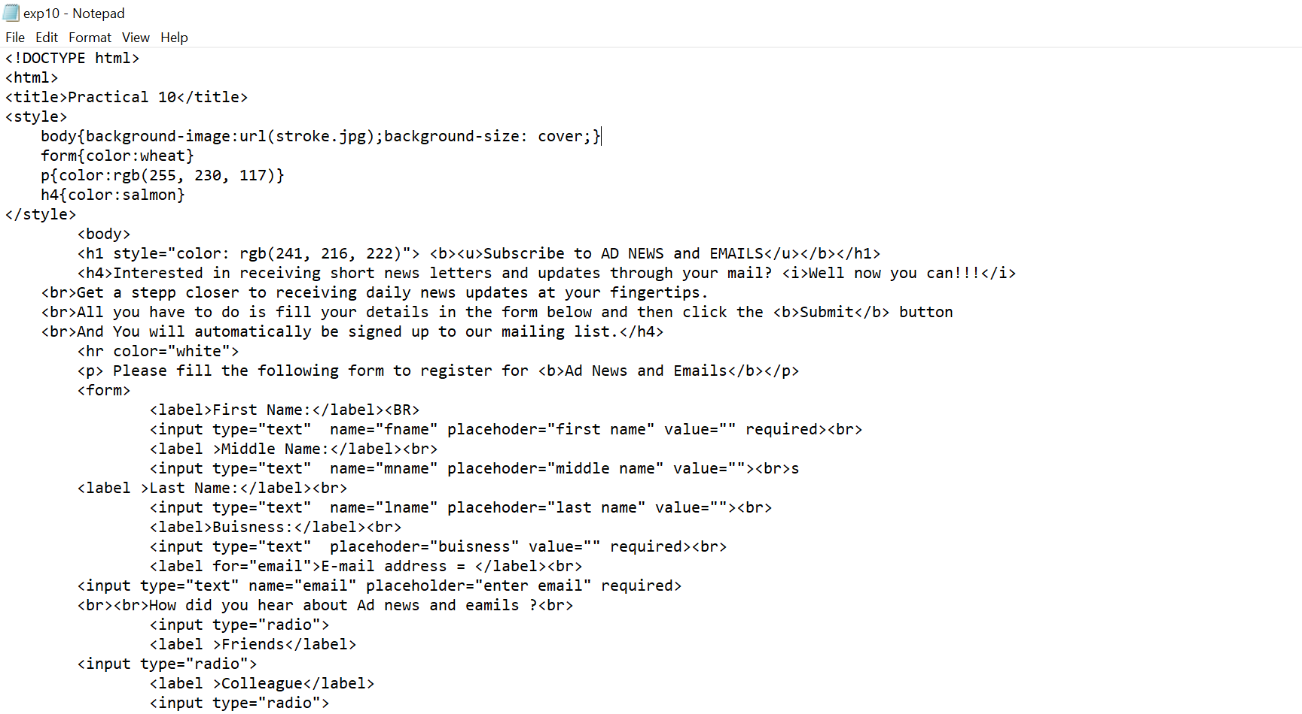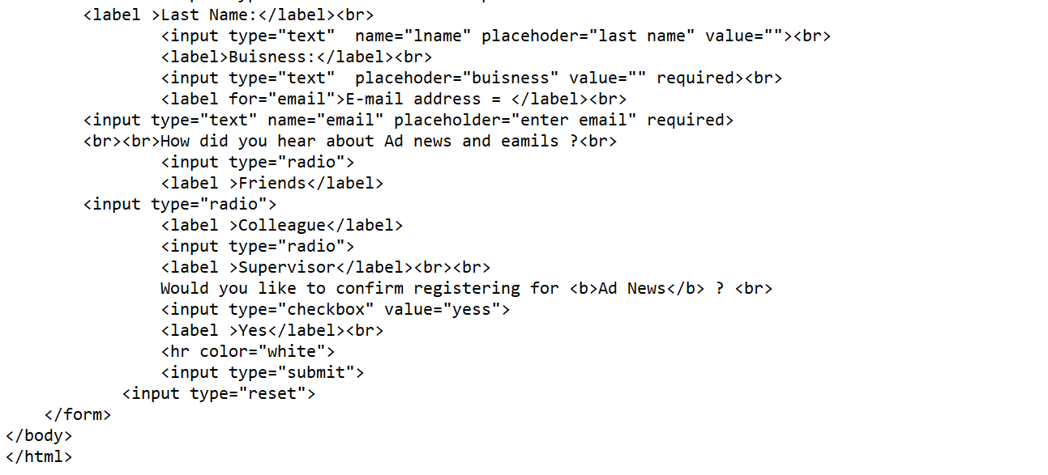

Output:

