QUESTION 9:

ListOfPlayers.jsx

import React from 'react';

const ListOfPlayers = () => {

  const players = [

    { name: 'Virat', score: 95 },

    { name: 'Rohit', score: 88 },

    { name: 'Dhoni', score: 68 },

    { name: 'Jadeja', score: 92 },

    { name: 'Rahul', score: 64 },

    { name: 'Shami', score: 71 },

    { name: 'Ashwin', score: 55 },

    { name: 'Bumrah', score: 80 },

    { name: 'Gill', score: 45 },

    { name: 'Iyer', score: 76 },

    { name: 'Surya', score: 66 },

  ];

  const filteredPlayers = players.filter(player => player.score < 70);

  return (

    <div>

      <h2>All Players with Scores</h2>

      <ul>

        {players.map((player, index) => (

          <li key={index}>{player.name}: {player.score}</li>

        ))}

      </ul>

      <h2>Players with Score below 70</h2>

      <ul>

        {filteredPlayers.map((player, index) => (

          <li key={index}>{player.name}: {player.score}</li>

        ))}

      </ul>

    </div>

  );

};

export default ListOfPlayers;

IndianPlayers.jsx

import React from 'react';

const IndianPlayers = () => {

  const oddTeam = ['Kohli', 'Dhoni', 'Rohit', 'Jadeja', 'Shami'];

  const evenTeam = ['Gill', 'Iyer', 'Pant', 'Surya', 'Ashwin'];

  // Destructuring example

  const [firstOdd, secondOdd, ...restOdd] = oddTeam;

  const [firstEven, secondEven, ...restEven] = evenTeam;

  // Merge example

  const T20players = ['Rohit', 'Hardik', 'Surya'];

  const RanjiTrophyPlayers = ['Jaiswal', 'Rahane', 'Pujara'];

  const mergedPlayers = [...T20players, ...RanjiTrophyPlayers];

  return (

    <div>

      <h2>Odd Team Players (Destructured)</h2>

      <p>{firstOdd}, {secondOdd}, {restOdd.join(', ')}</p>

      <h2>Even Team Players (Destructured)</h2>

      <p>{firstEven}, {secondEven}, {restEven.join(', ')}</p>

      <h2>Merged T20 and Ranji Trophy Players</h2>

      <ul>

        {mergedPlayers.map((player, index) => (

          <li key={index}>{player}</li>

        ))}

      </ul>

    </div>

  );

};

export default IndianPlayers;Output: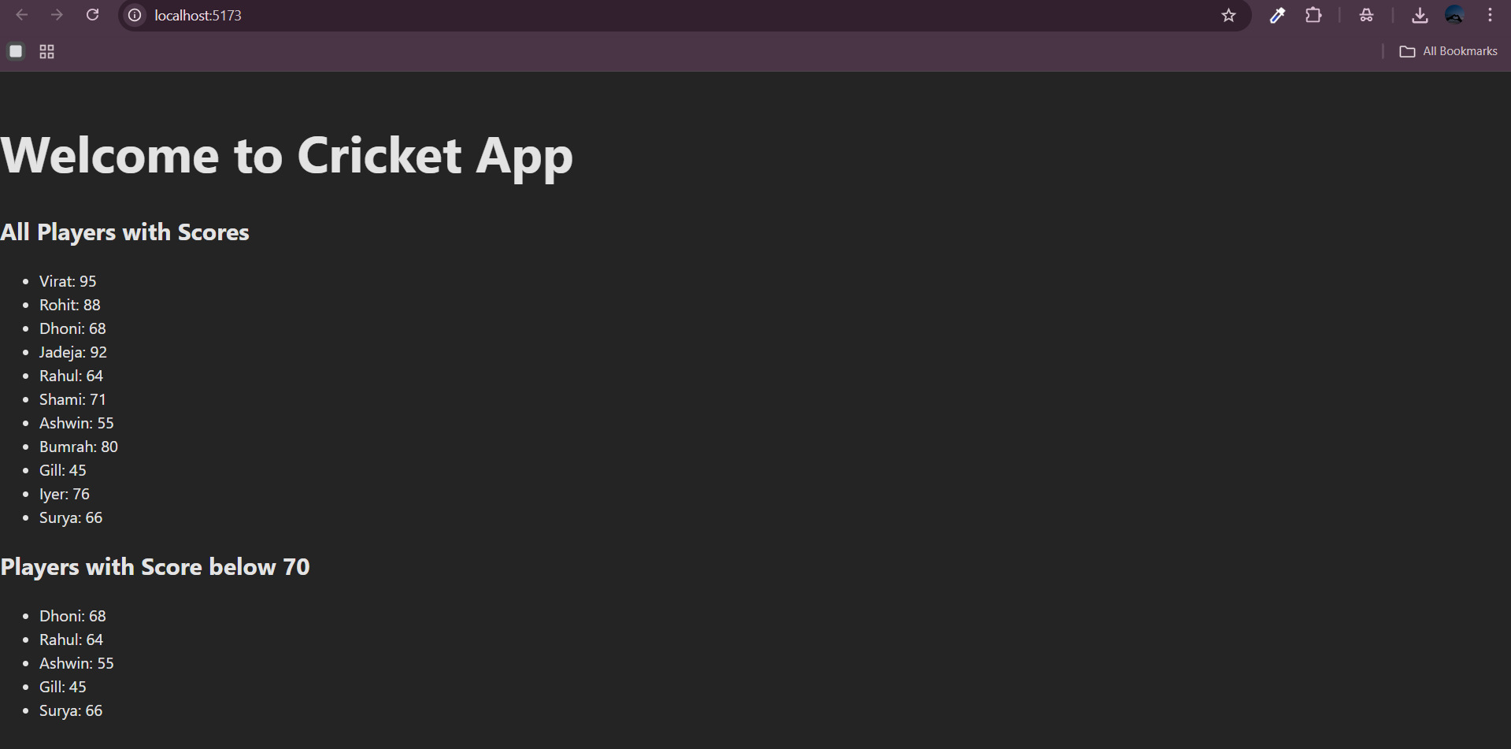

Question 10:

// src/App.jsx

import React from 'react';

function App() {

// Heading using JSX

const heading = <h1 style={{ textAlign: 'center' }}>Office Space Rental App</h1>;

// Office image URL

const imageURL = "https://images.unsplash.com/photo-1591696205602-2f950c417cb9";

// Single office object

const office = {

name: 'WeWork Space',

rent: 50000,

address: 'Bangalore, Karnataka'

};

// List of office spaces

const offices = [

{ id: 1, name: 'WeWork', rent: 50000, address: 'Mumbai' },

{ id: 2, name: 'Regus', rent: 75000, address: 'Bangalore' },

{ id: 3, name: '91Springboard', rent: 60000, address: 'Hyderabad' },

{ id: 4, name: 'Awfis', rent: 45000, address: 'Chennai' },

{ id: 5, name: 'SmartWorks', rent: 80000, address: 'Delhi' },

];

// JSX for rendering office list with inline styles

const officeList = offices.map((space) => {

const rentStyle = {

color: space.rent > 60000 ? 'green' : 'red',

fontWeight: 'bold'

};

return (

<div key={space.id} style={{ border: '1px solid #ccc', margin: '10px', padding: '10px' }}>

<h3>{space.name}</h3>

<p>Address: {space.address}</p>

<p style={rentStyle}>Rent: ₹{space.rent}</p>

</div>

);

});

return (

<div style={{ padding: '20px' }}>

{heading}

{/\* Image using JSX attribute \*/}

<img

src={imageURL}

alt="Office Space"

width="100%"

height="300px"

style={{ objectFit: 'cover', borderRadius: '10px', marginBottom: '20px' }}

/>

{/\* Display a single office details \*/}

<h2>Single Office Detail</h2>

<p><strong>Name:</strong> {office.name}</p>

<p><strong>Rent:</strong> ₹{office.rent}</p>

<p><strong>Address:</strong> {office.address}</p>

{/\* Display all office spaces \*/}

<h2>Available Office Spaces</h2>

{officeList}

</div>

);

}

export default App;

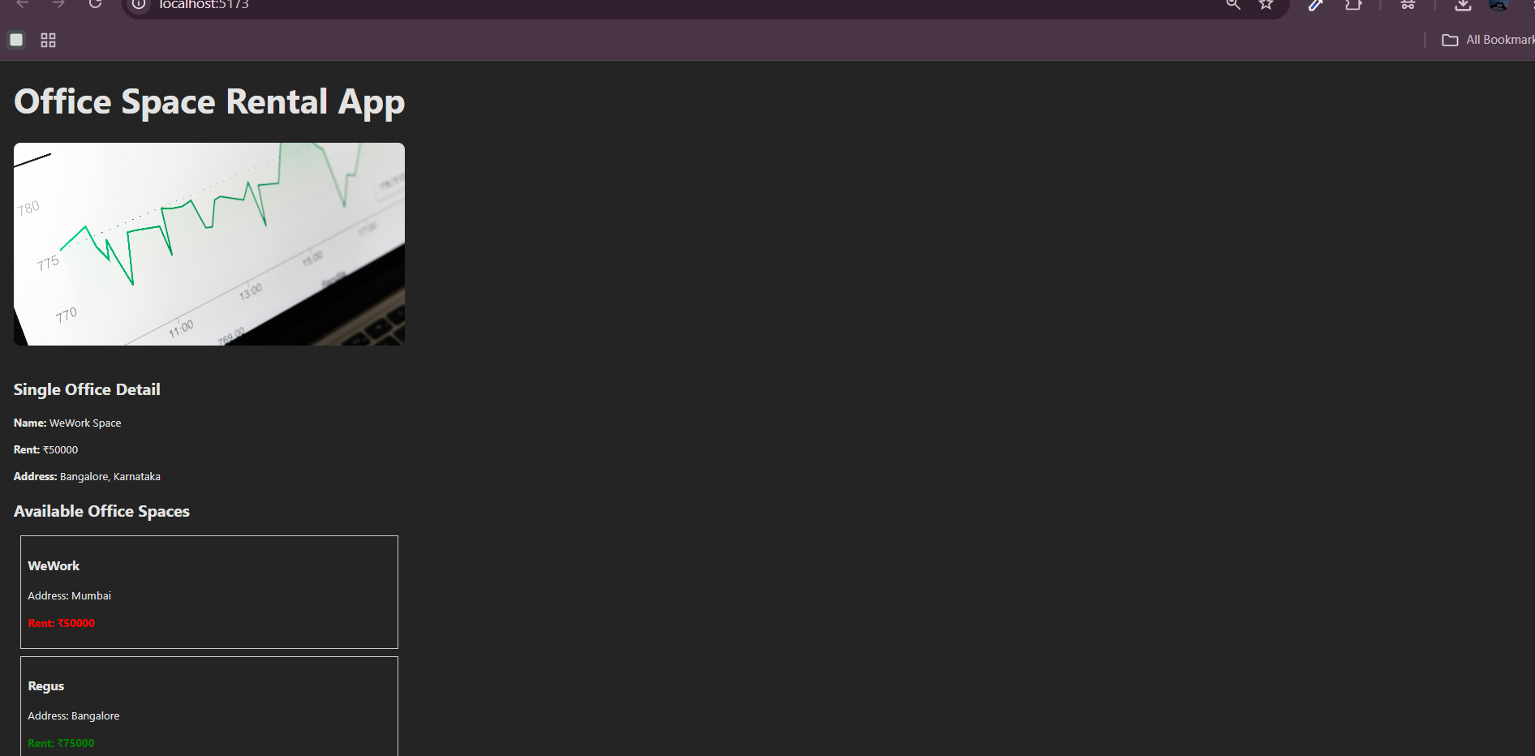

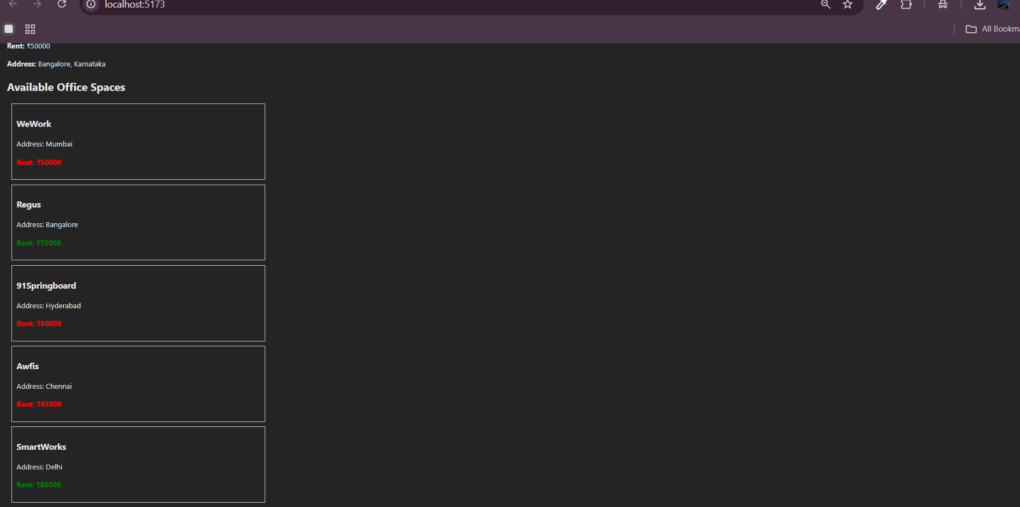

QUESTION 11:

import React, { useState } from 'react';

import CurrencyConvertor from './CurrencyConvertor';

function App() {

  const [count, setCount] = useState(0);

  // 1a: Increment function

  const increment = () => {

    setCount(prev => prev + 1);

    sayHello(); // invoke second method

  };

  // 1b: Say Hello

  const sayHello = () => {

    console.log("Hello! This is a static message.");

  };

  // Decrement handler

  const decrement = () => {

    setCount(prev => prev - 1);

  };

  // 2. Say Welcome with argument

  const sayWelcome = (message) => {

    alert(`Message: ${message}`);

  };

  // 3. Synthetic event example

  const handleClick = (event) => {

    alert('I was clicked (Synthetic Event)');

    console.log(event); // Synthetic event object

  };

  return (

    <div style={{ padding: '30px', fontFamily: 'Arial' }}>

      <h1>React Event Examples App</h1>

      <h2>Counter: {count}</h2>

      <button onClick={increment}>Increment</button>

      <button onClick={decrement} style={{ marginLeft: '10px' }}>Decrement</button>

      <h2>Welcome Button</h2>

      <button onClick={() => sayWelcome("Welcome to React Events!")}>Say Welcome</button>

      <h2>Synthetic Event</h2>

      <button onClick={handleClick}>OnPress</button>

      <h2>Currency Converter</h2>

      <CurrencyConvertor />

    </div>

  );

}

export default App;

currencyConvertor.jsx

import React, { useState } from 'react';

const CurrencyConvertor = () => {

  const [rupees, setRupees] = useState('');

  const [euro, setEuro] = useState(null);

  const handleSubmit = (event) => {

    event.preventDefault(); // prevent default form submission

    const rupeeValue = parseFloat(rupees);

    const conversionRate = 0.011; // 1 INR = 0.011 EUR

    if (!isNaN(rupeeValue)) {

      setEuro((rupeeValue \* conversionRate).toFixed(2));

    } else {

      setEuro('Invalid input');

    }

  };

  return (

    <form onSubmit={handleSubmit}>

      <label>Enter Amount in Rupees:</label><br />

      <input

        type="text"

        value={rupees}

        onChange={(e) => setRupees(e.target.value)}

      />

      <button type="submit" style={{ marginLeft: '10px' }}>Convert</button>

      {euro !== null && (

        <div style={{ marginTop: '10px' }}>

          <strong>Converted Euro:</strong> {euro}

        </div>

      )}

    </form>

  );

};

export default CurrencyConvertor;

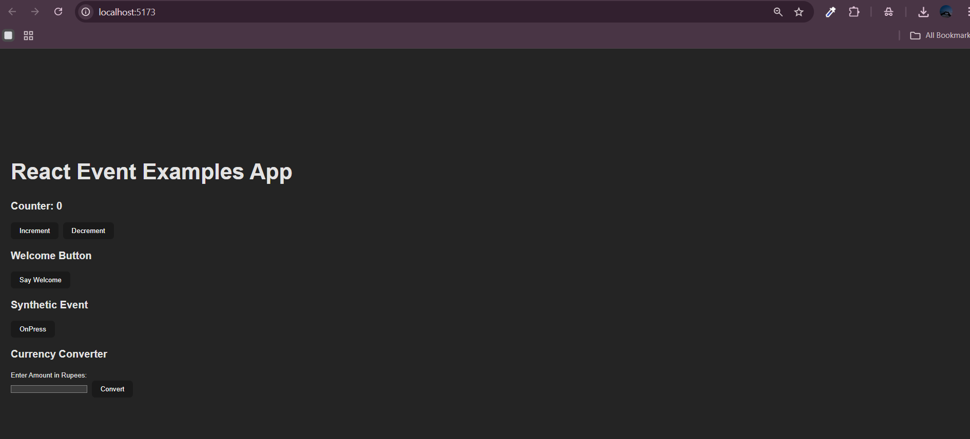

QUESTION 12:

import React, { useState } from 'react';

import GuestPage from './GuestPage';

import UserPage from './UserPage';

function App() {

  const [isLoggedIn, setIsLoggedIn] = useState(false);

  // Element variable to store the current view

  let content;

  if (isLoggedIn) {

    content = <UserPage />;

  } else {

    content = <GuestPage />;

  }

  return (

    <div style={{ padding: '20px', fontFamily: 'Arial' }}>

      <h1>Ticket Booking App</h1>

      {/\* Conditional button label \*/}

      {isLoggedIn ? (

        <button onClick={() => setIsLoggedIn(false)}>Logout</button>

      ) : (

        <button onClick={() => setIsLoggedIn(true)}>Login</button>

      )}

      <hr />

      {/\* Render based on login status \*/}

      {content}

    </div>

  );

}

export default App;

import React from 'react';

const GuestPage = () => {

  return (

    <div>

      <h2>Welcome, Guest!</h2>

      <p>Please log in to book your flight tickets.</p>

      <h3>Available Flights</h3>

      <ul>

        <li>Flight: AI-202 | From: Delhi | To: Mumbai | Time: 10:00 AM</li>

        <li>Flight: AI-305 | From: Chennai | To: Bangalore | Time: 2:30 PM</li>

        <li>Flight: AI-412 | From: Kolkata | To: Hyderabad | Time: 6:45 PM</li>

      </ul>

    </div>

  );

};

export default GuestPage;

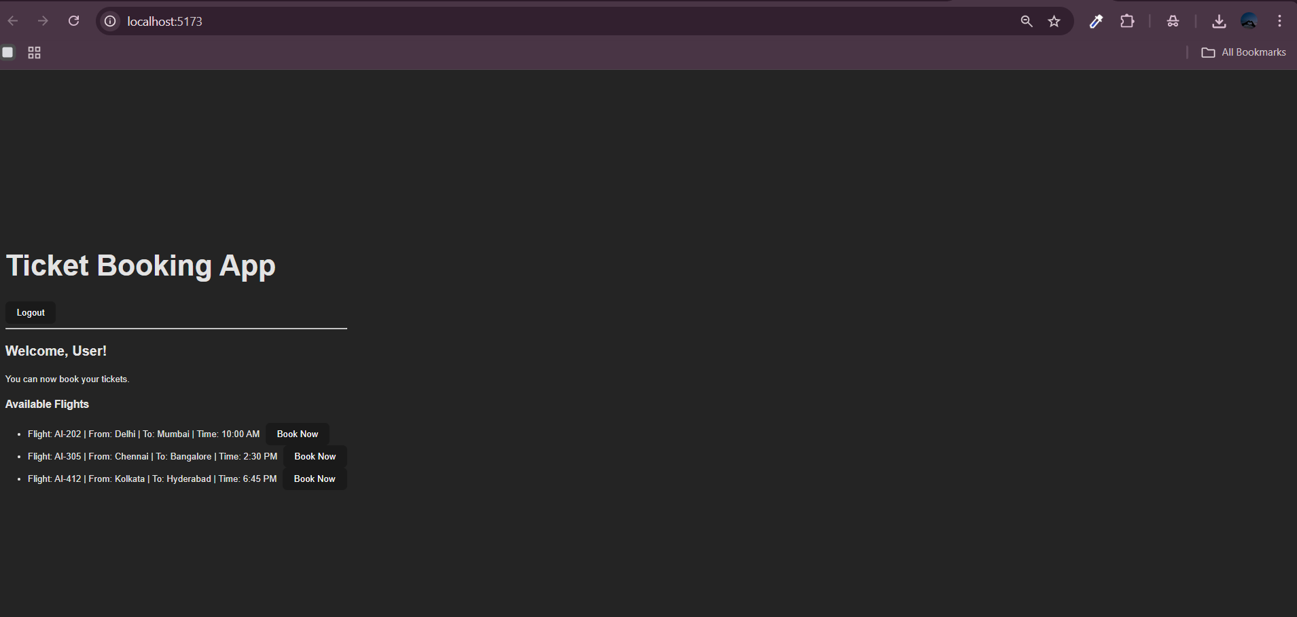

QUESTION 13:

import React from 'react';

const blogs = [

  { id: 1, title: 'Understanding JSX', author: 'Amit' },

  { id: 2, title: 'State vs Props', author: 'Priya' },

  { id: 3, title: 'React Hooks Simplified', author: 'Rahul' },

];

const BlogDetails = () => {

  return (

    <div>

      <h2>📝 Blog Details</h2>

      <ul>

        {blogs.map((blog) => (

          <li key={blog.id}>

            <strong>{blog.title}</strong> - by {blog.author}

          </li>

        ))}

      </ul>

    </div>

  );

};

export default BlogDetails;

import React from 'react';

const books = [

  { id: 1, title: 'React for Beginners', author: 'John Doe' },

  { id: 2, title: 'Learning JavaScript', author: 'Jane Smith' },

  { id: 3, title: 'Advanced React', author: 'Bob Marley' },

];

const BookDetails = () => {

  return (

    <div>

      <h2>📚 Book Details</h2>

      <ul>

        {books.map((book) => (

          <li key={book.id}>

            <strong>{book.title}</strong> by {book.author}

          </li>

        ))}

      </ul>

    </div>

  );

};

export default BookDetails;

