EXERCISE 1:

import { useState } from 'react'

import reactLogo from './assets/react.svg'

import viteLogo from '/vite.svg'

import './App.css'

import Home from'./Home';

import About from'./About';

import Contact from'./Contact';

function App() {

  return(

    <div>

      <h1> Welcome To The First Session Of React</h1>

    </div>

  );

}

export default App;

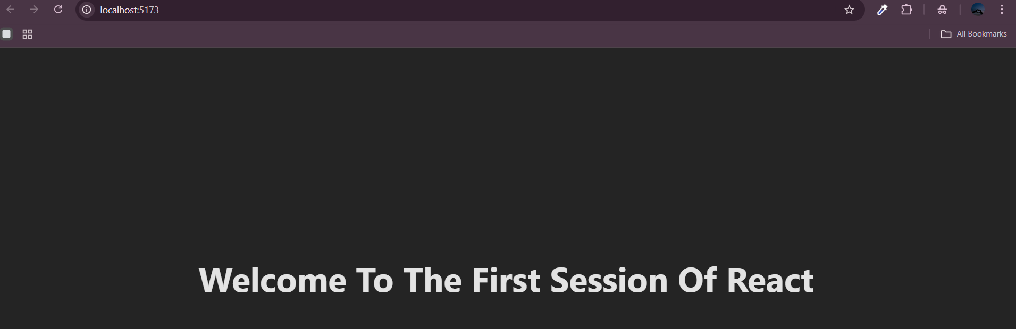

Exercise 2:

Home.jsx

import React from 'react';

  function Home(){

    return(

    <div>

    <h3> Welcome to the Home Page of Student Management Portal</h3></div>

    );

export default Home;

About.jsx

import React from 'react';

  function About(){

    return(

    <div>

    <h3> Welcome to the About Page of Student Management Portal</h3></div>

    );

  }

export default About;

Contact.jsx

import React from 'react';

  function Contact(){

    return(

    <div>

    <h3> Welcome to the Contact Page of Student Management Portal</h3></div>

    );

  }

export default Contact;

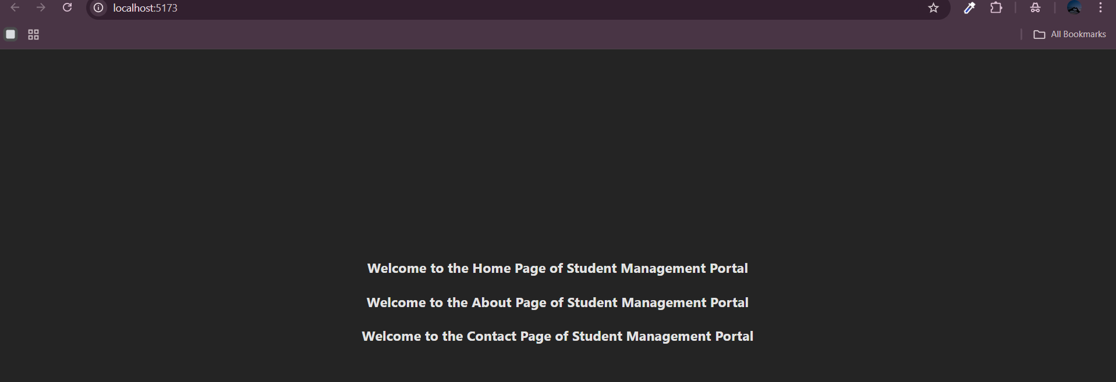

EXERCISE 3:

import './myStyle.css';

const percentToDecimal=(decimal)=>{

  return(decimal.toFixed(2)+'%')

}

const calcScore=(total,goal)=>{

  return percentToDecimal(total/goal)

}

export const CalculateScore=({Name,School,total,goal})=>(

  <div className="formStyle">

    <h1><font color="Brown">Student Details</font></h1>

    <div className="Name">

      <b> <span>Name: </span></b>

      <span>{Name}</span>

    </div>

  <div className="School">

    <b><span> School:</span></b>

    <span>{School}</span>

  </div>

  <div className="Total">

    <b><span> Total:</span></b>

    <span>{total}</span>

    <span>Marks</span>

  </div>

  <div className="Score">

    <b>Score:</b>

    <span>{calcScore(

      total,goal)}

      </span>

  </div>

  </div>)

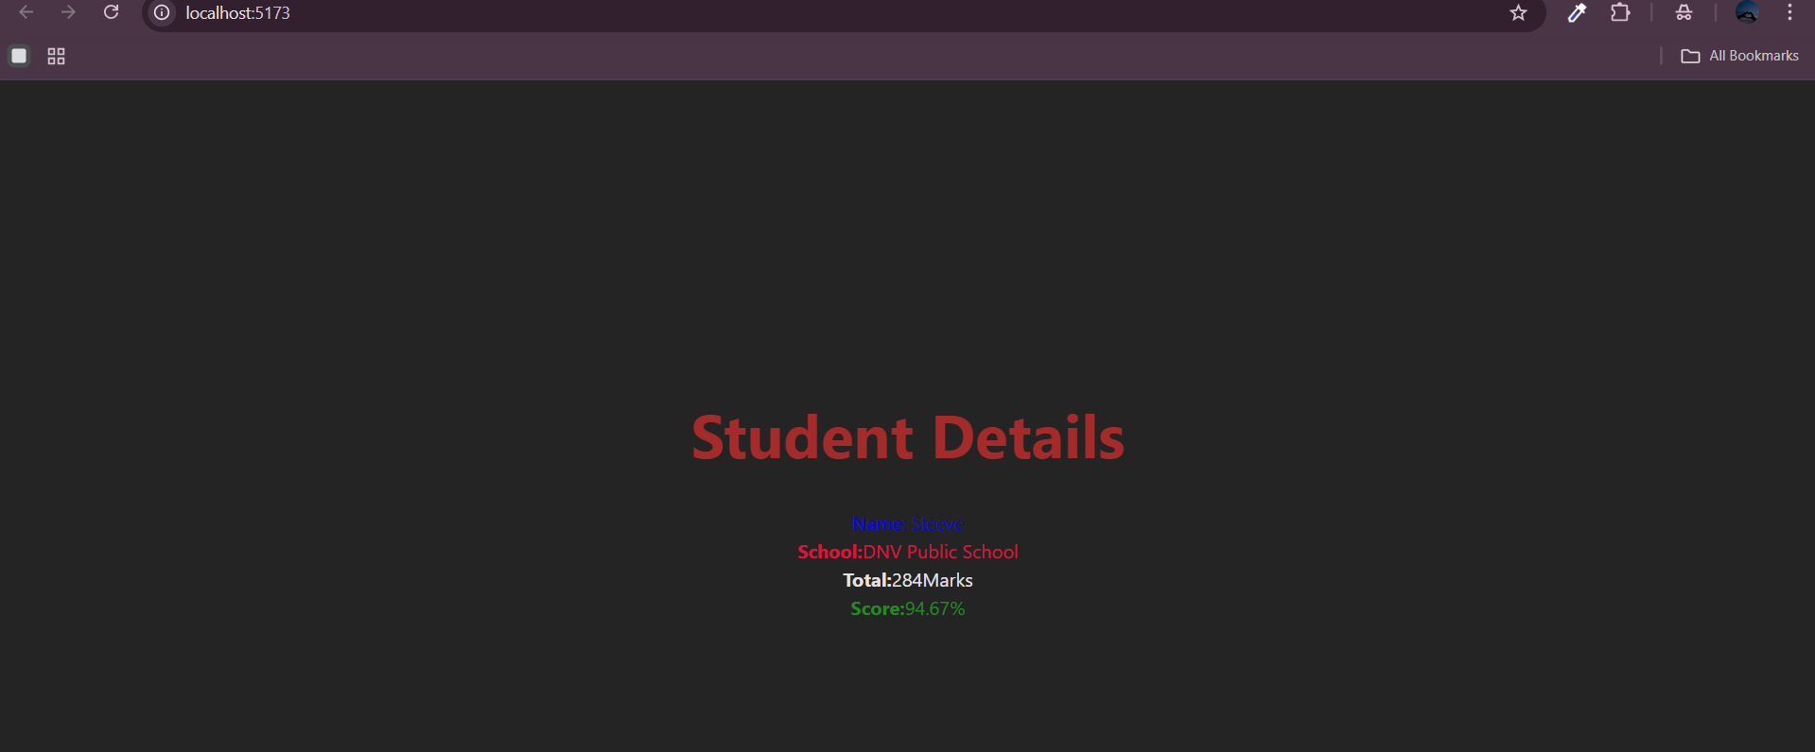

EXERCISE 4:

Post.jsx

import React from "react";

class Post extends React.Component {

  render() {

    const { title, body } = this.props;

    return (

      <div style={{ marginBottom: "20px", border: "1px solid #ccc", padding: "10px" }}>

        <h2>{title}</h2>

        <p>{body}</p>

      </div>

    );

  }

}

export default Post;

Posts.jsx

import React from "react";

import Post from "./Post";

class Posts extends React.Component {

  constructor(props) {

    super(props);

    this.state = {

      posts: [],

      hasError: false,

    };

  }

  loadPosts() {

    fetch("https://jsonplaceholder.typicode.com/posts")

      .then((response) => response.json())

      .then((data) => this.setState({ posts: data }))

      .catch((error) => {

        console.error("Error fetching posts:", error);

        this.setState({ hasError: true });

      });

  }

  componentDidMount() {

    this.loadPosts();

  }

  componentDidCatch(error, info) {

    alert("An error occurred: " + error);

    this.setState({ hasError: true });

  }

  render() {

    const { posts } = this.state;

    return (

      <div style={{ padding: "20px" }}>

        <h1>Blog Posts</h1>

        {posts.map((post) => (

          <Post key={post.id} title={post.title} body={post.body} />

        ))}

      </div>

    );

  }

}

export default Posts;

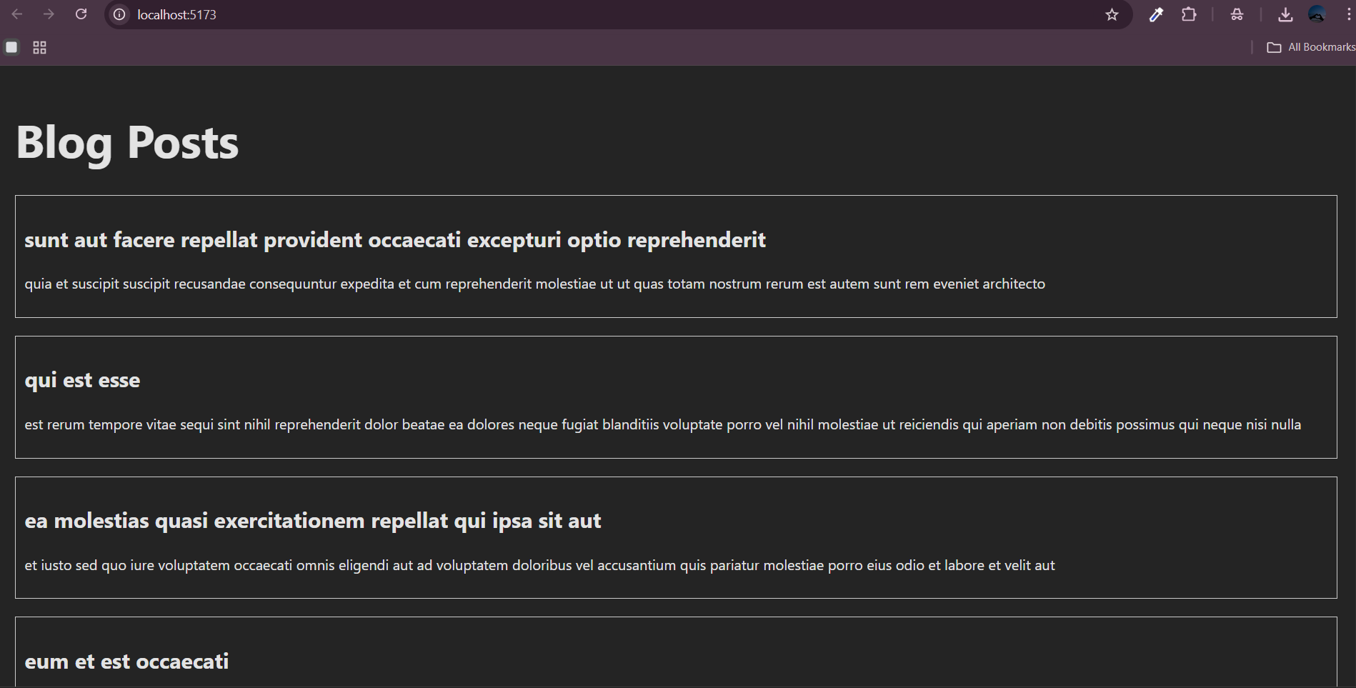

EXERCISE 5:

cohortDetails.jsx

import React from "react";

import styles from "./CohortDetails.module.css";

const CohortDetails = ({ cohort }) => {

  const headingColor =

    cohort.status.toLowerCase() === "ongoing" ? "green" : "blue";

  return (

    <div className={styles.box}>

      <h3 style={{ color: headingColor }}>{cohort.name}</h3>

      <dl>

        <dt>Status:</dt>

        <dd>{cohort.status}</dd>

        <dt>Start Date:</dt>

        <dd>{cohort.startDate}</dd>

        <dt>End Date:</dt>

        <dd>{cohort.endDate}</dd>

      </dl>

    </div>

  );

};

export default CohortDetails;

