Principal Component Analysis (PCA): A Complete Tutorial Using the Iris Dataset
1. Introduction
The Principal Component Analysis (PCA) is a machine-learning methodology that is grounded on dimensionality reduction, visualization, features and noise extraction. With larger and more complex datasets, it becomes more challenging to comprehend them or visualize them in their uncooked form. PCA can overcome this issue by converting high-dimensional datasets into the lower-dimensional form, but it has to maximize the amount of variance. In the current report, there is a full and clear tutorial of PCA based on the popular Iris data. The tutorial also includes a Jupyter/Colab notebook to load the dataset online, stepwise perform PCA on it and visualize the findings in a form of interpretable figures.
2. Overview of PCA
PCA is a linear transformation which establishes those directions in the data which represent the greatest variance. These directions are termed to be the principal components and they are new axes in which the data is projected. All major components are linear combinations of the original features and the components are orthogonal to each other, therefore, the same information is not repeated.
The maximum variance found in the dataset is represented in the first principal component. The second has the next-largest amount of variance, yet is by definition orthogonal to the first, and so on. PCA leaves behind only the best principal components so that the resulting representation has the majority of the meaningful information. This does not only simplify the dataset but improves the interpretability as well as efficiency in computation.
3. Why PCA Matters in Machine Learning
The main reason why PCA is applicable is because of the necessity to deal with high dimensionality. Datasets that are high-dimensional usually have redundant or correlated features, which is challenging to learn using many algorithms. PCA is used to decrease the number of dimensions by converting the data into fewer variables, uncorrelated, which is useful in various aspects. One, PCA will enable one to reduce a dataset to two or three components, and thus, be easier to visualize data. Second, PCA-transformed data tends to be more generalizable, and the models using the PCA-transformed data take less time, as noise and irrelevant data are reduced to minimum. Lastly, PCA enables more knowledge of the underlying structure of the data since it demonstrates the directions in which data changes most.
4. The Iris Dataset
Iris dataset is a popular dataset that is used to illustrate machine-learning techniques. It was collected by a statistician, Ronald Fisher and has 150 samples of 3 species of iris flowers, Setosa, Versicolor, and Virginica. There are four numerical characteristics measured on each sample, i.e. sepal length, sepal width, petal length and petal width. These values render the data suitable to PCA since the attributes are continuous, connected with each other to different extents, and meaningfully biological.
The benefits of the Iris dataset are that it offers a simple, concise and easy to use environment to learn about PCA since the data initially has four dimensions, but should be reduced to two main components to make it visually discernible. The trends that occur in the space of PCA usually display a natural formation of clusters which relate to the three species.
5. Preparing the Data for PCA
To use PCA, the data should be pre-processed to achieve relevant and precise results. The Iris data is read in the data notebook that comes along with it via a direct CSV connection. The target column of species labels is separated out, then the numerical features are separated out.
Before PCA can be done, it is necessary to first do standardization. The PCA is also sensitive to the magnitude of the features since PCA is founded on the variance, and features with greater numerical dispersion would overpower the principal components in the absence of scaling. Each feature is changed with the help of StandardScaler with the mean of zero and the standard deviation of one. This is to make sure that features play an equal role in the calculation of principal components.
6. Applying PCA to the Iris Dataset
After the standardization of the features, PCA is performed with the implementation of scikit-learn with PCA. The first PCA is set in such a way that there is no restriction to the number of components so that the algorithm can calculate all four principal components. The ratio of explained variation of each component is then analysed. This ratio shows the contribution made by each principal component towards the total variance.
A cumulative explained variance plot is drawn to show the number of components required to retain various amounts of information. In the case of the Iris data, the top two principal components will normally incorporate more than 95 percent of the overall variance. This implies that almost all the information that is relevant in the four-dimensional dataset can be modeled only on two dimensions.
7. Visualizing the Results of PCA
The visualization of data after PCA-transformation gives a better understanding of the structure of the data. The first two major components are used to create a 2-D scatter plot. The points of data are coloured by species, making it possible to notice natural groupings.
The Iris data has strong and significant trends. Iris Setosa is a small group with a full separation with the other two species. Versicolor and Virginica are most of the times overlapping each other being biologically related. These cluster patterns prove that PCA does not only effectively reduce dimensionality, but also finds a latent structure in the data.
The other significant section of PCA interpretation is the analysis of the loading matrix. This matrix demonstrates the contributions of every original feature to every principal component. To illustrate, the length of petals and the width of petals tend to be a strong contributor to the first principal component, meaning that the two measurements account for a large portion of the variation of iris flowers. Sepal measurements can be playing a larger part in the second component. These insights can be used to learn about the biological meaning of the dataset.
8. Strengths of PCA
PCA has a number of strengths that render it to be an inescapable tool in data analysis and machine learning. It is computationally cheap and simple to execute even with large datasets. PCA can be used to enhance the performance of downstream machine-learning models by removing redundancy and noise. The feature that is reduced and uncorrelated also helps in avoiding other problems that arise, including multicollinearity. The fact that PCA can visualize high-dimensional data using two or three dimensions offers the best visualization tools that can identify concealed patterns and clusters.
9. Limitations of PCA
PCA, though useful, has some drawbacks which should be known. It is a linear approach, and it has no ability to represent nonlinear relationships in the data. The main features are combinations of the initial features that might be hard to interpret in certain applications. PCA too is susceptible to outliers; extreme values can skew the principal components in a big way. The other weakness is that PCA does not take class labels into consideration during computing of components, its sole aim is to achieve maximum variance which may not necessarily be in agreement with other aims such as classification accuracy.

10. Conclusion
PCA is a strong and popular method of reducing the high-dimensional data sets still preserving their principal structure. Working with the Iris dataset is a simple and easy-to-understand illustration of how PCA can be applied, including data preparation and normalization, as well as working out components and visualizing the low-dimensional space. The supplementary Google Colab notebook shows every procedure in PCA in an understandable and repeatable way. Having excellent knowledge of the strengths, weaknesses, and real-world uses of PCA, students and practitioners can successfully use the technique in a broad assortment of real-life machine-learning challenges.

Python Results

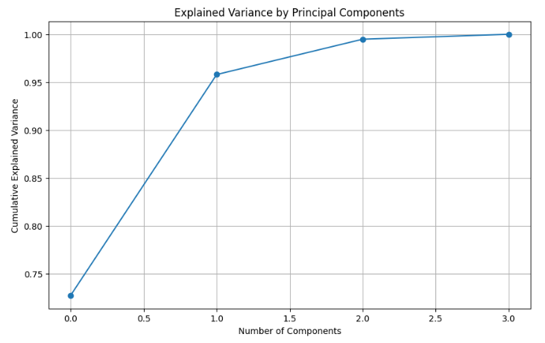
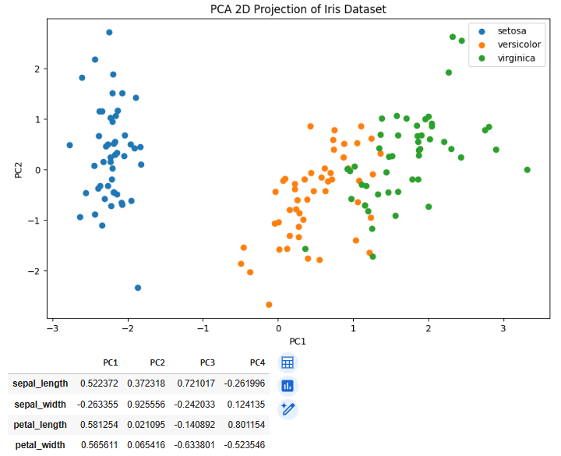

Critical Evaluation of PCA Model Results
The Principal Component Analysis (PCA) of the data of Iris indicated that there are significant patterns in the data and it provides a great idea of the way the four initial variables are playing a role behind the underlying patterns in the three iris species. One of the most important items in the interpretation of the transformation is the loading matrix that is derived by PCA; it measures the strength with which each feature impacts each principal component. The findings indicate that the two key components are used to explain a vast majority of the variance in the dataset, and the loadings of the key components give an idea of why dimensionality reduction is useful in this instance.
The values of loading indicate that the petal measurements have a great impact on PC1. The contribution of both the petal length (0.581) and the petal width (0.565) to this component is strong and positive besides sepal length (0.522) also makes a significant contribution. This implies that PC1 mainly embodies the variation relating to flower size the size of petals in particular which differs greatly between the three species. As a matter of fact, Iris Setosa has very small petals relative to Versicolor and Virginica, hence the reason why the PCA scatter plot displays Setosa occupying a distinct cluster on PC1. PC1 is therefore a powerful species separator with regard to morphology of flowers. The large scale of such loadings proves that petal features are the most significant factor of discrimination in the dataset.
However, PC2 has sepal width as the dominant factor, and remarkably high loading of 0.925. It means that PC2 records the difference which is mainly caused by the structure of the sepal and not the morphology of petals. Sepal width differs a lot among species, particularly between Setosa and other two species that the choice and the depth of the separation that has been observed in the PCA scatter plot. The fact that the sepal length is negatively loaded in PC2 further stresses on the fact that PC2 is a contrasting dimension which is associated with the overall sepal geometry as opposed to size.
The PC3 and PC4 loadings are used to show components that are not absorbed by PC1 and PC2. As an illustration, PC3 loads sepal length (0.721) affirmatively, and petal width ( -0.633) negatively. It would imply a comparison between sepal and petal traits, but the amount of variance expounded by PC3 is considerably lower. Equally, PC4 is highly affected by petal length (0.801) and petal width (-0.523), once more, it must be some of the finer tendencies once the big structural variations have been already reflected in the previous components. These subsequent parts are not as helpful visually or classifiable but are still significant in multidimensional structure.
In general, the results of the PCA model have a high correspondence with biological knowledge of the Iris data. The distinct separation of Setosa in PCA space is entirely attributed to high loadings of petals in PC1 and the fine-tuning of connections between Versicolor and Virginica in PC2 and so on. The obtained results confirm the use of PCA as a suitable data dimensionality-reduction method in this dataset. Its advantages are the straightforwardness in visualization, the lessening of redundancy, and elucidation of the structure of variance. Nevertheless, PCA is restricted by the fact that it is linear and fails to use class labels directly. Nevertheless, these shortcomings do not mean that the model is not successful in showing natural clustering patterns in the Iris dataset and it offers a potent base to the further analysis.

