Assignment:
Similar to test case ingestion, please ingest the following into MongoDB:
1️⃣ User Stories
2️⃣ 6000+ Test Cases
Ingested the 6354 test cases available in the Excel sheet into Mongo DB via the RAG pipeline:
- Converted the given test cases Excel file into JSON via the “Convert to JSON” option in the RAG pipeline (RAG Pipeline - Testleaf).
- Using the “Embeddings and Store” option, ingested the converted JSON files into Mongo DB in the Documents section.
Ingested the stories.json (user stories that were already converted to JSON) into Mongo DB via the RAG pipeline:
- Using the “Embeddings and Store” option, ingested the stories.json JSON files into Mongo DB in the Documents section.

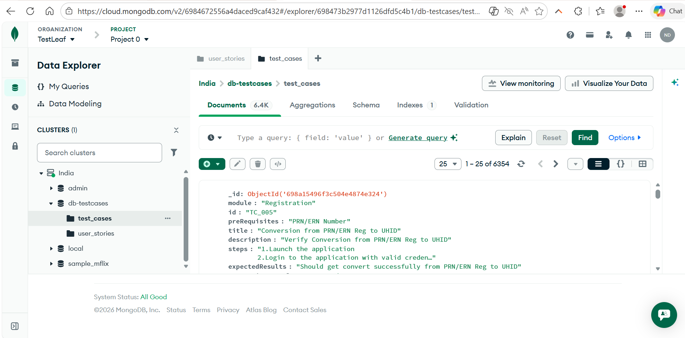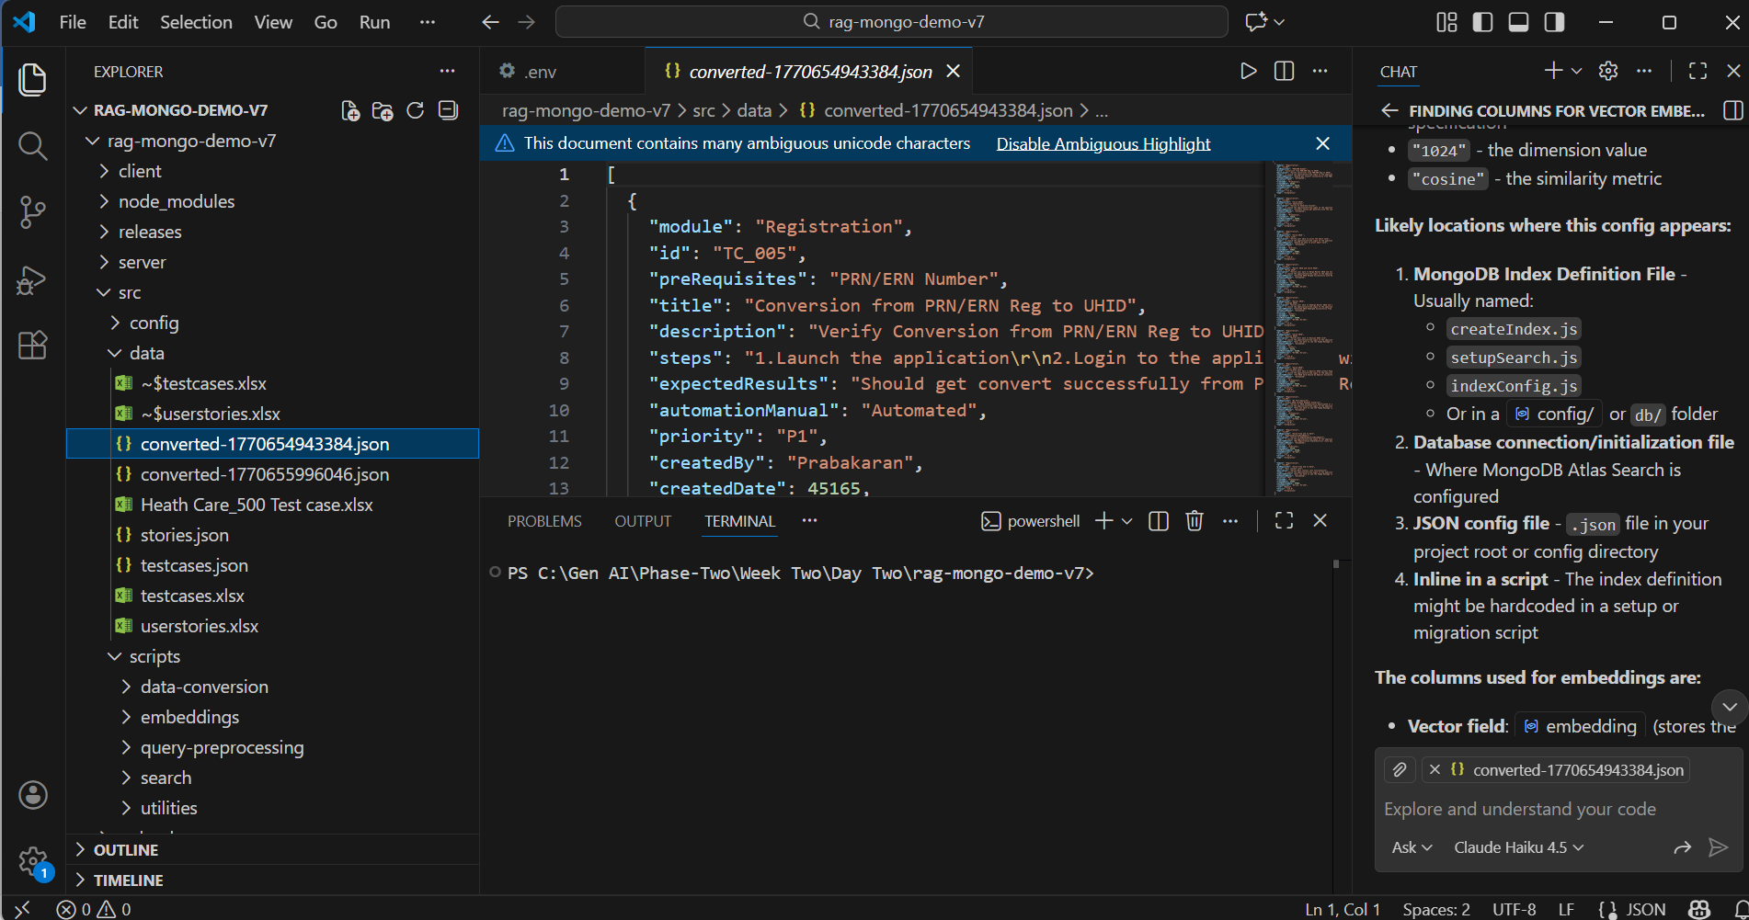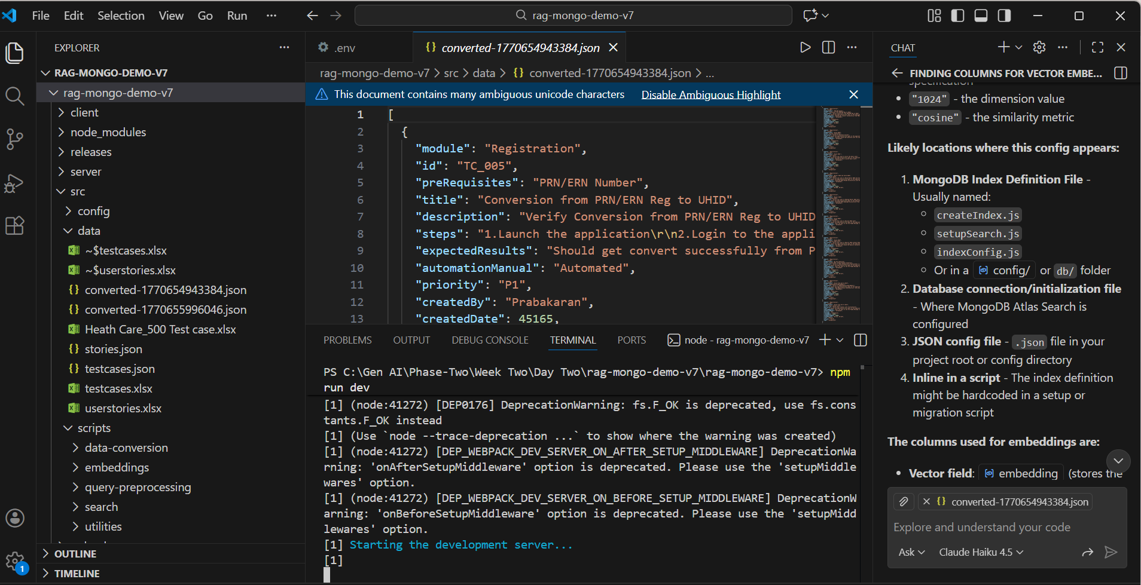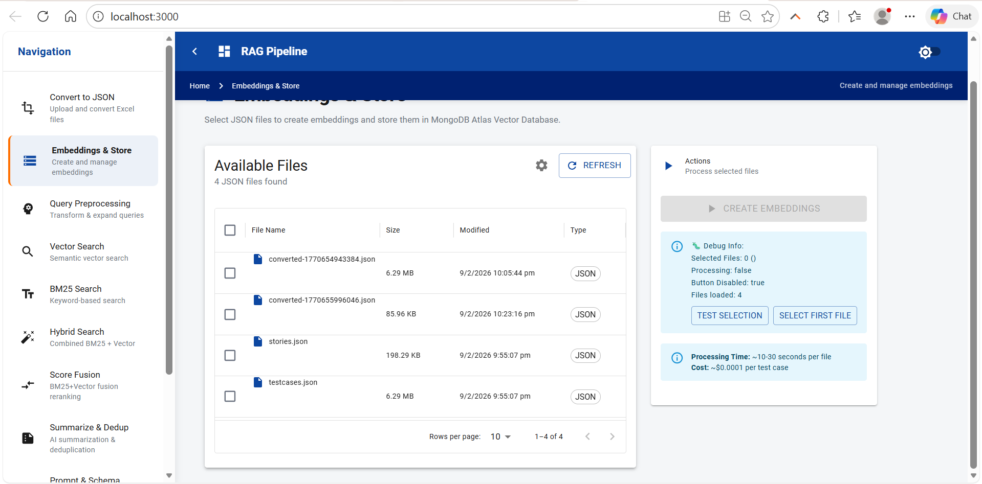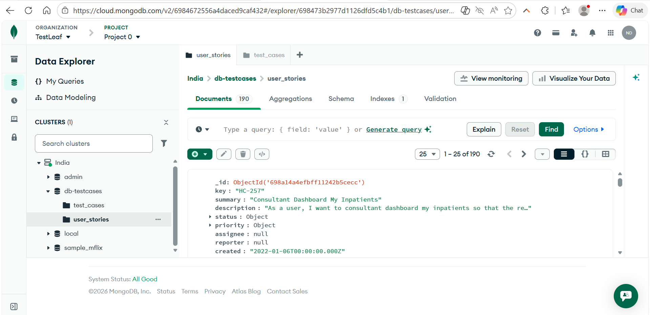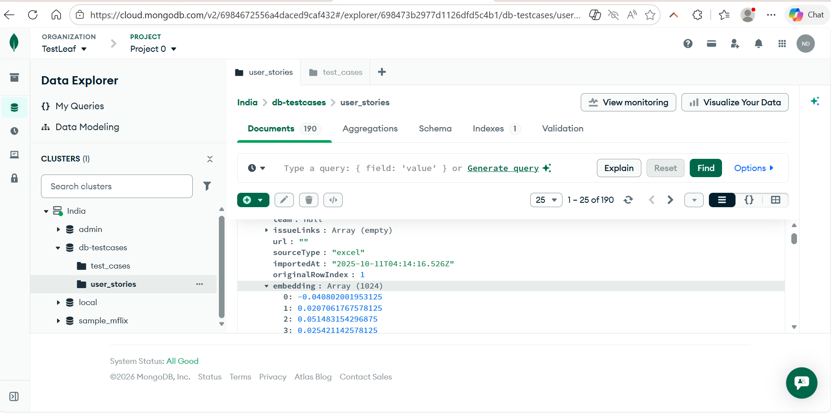
Note: For User Stories, there is no option to upload Excel files in the RAG pipeline. The only available option is to convert test cases to JSON format. Therefore, used the already available stories.json file directly for ingestion into Mongo BDBD for User Stories.