4)S09 - TextFromImage-Url
Use the vision model to extract the text from multilingual
Model Used: Llama 4 Scout 17B 16E
Picture URL: https://drive.usercontent.google.com/download?id=1AHRXaWeMqrMcxEQwFoCoy3o3D7yaWooe&export=view&authuser=0
When the first pasted the output from Postman to beautify in ChatGPT, got he below Text from the image with explanation:
AI vs ML vs DL — Fundamentals
Artificial Intelligence (AI)
- The broad concept of machines simulating human intelligence
- Encompasses reasoning, problem-solving, perception, and language understanding
Examples:
ChatGPT, LLaMA, Gemini, expert systems

Machine Learning (ML)
- A subset of AI
- Systems learn patterns from data without being explicitly programmed
Key Characteristics:
- Data-driven
- Predictive and decision-oriented
- Includes supervised, unsupervised, and reinforcement learning
Model Types:
- Discriminative models (e.g., Logistic Regression, SVM)

Deep Learning (DL)
- A subset of Machine Learning
- Uses multi-layered neural networks to model complex patterns
Key Characteristics:
- Handles large-scale data
- Excels in vision, speech, and NLP tasks
- Requires high computational power

Large Language Models (LLMs) & Generative AI
- Built primarily using Deep Learning
- Capable of generating text, images, code, and more
Examples:
- LLMs: GPT, LLaMA, Gemini
- Generative AI: Text generation, image synthesis, code completion

Hierarchy Overview
Artificial Intelligence
└── Machine Learning
└── Deep Learning
└── LLMs / Generative AI

Then I provide the below prompt: provide only the text present in the image and then got only the text
AI vs ML vs DL
Fundamentals
ChatGPT, Llama, Gemini, etc.,
ARTIFICIAL
INTELLIGENCE
Machine Learning
Deep Learning
Discriminative
LLMs
Gen AI
DeepSeek Output: DeepSeek provided the below diagram and also full explanation of each text present in the image.
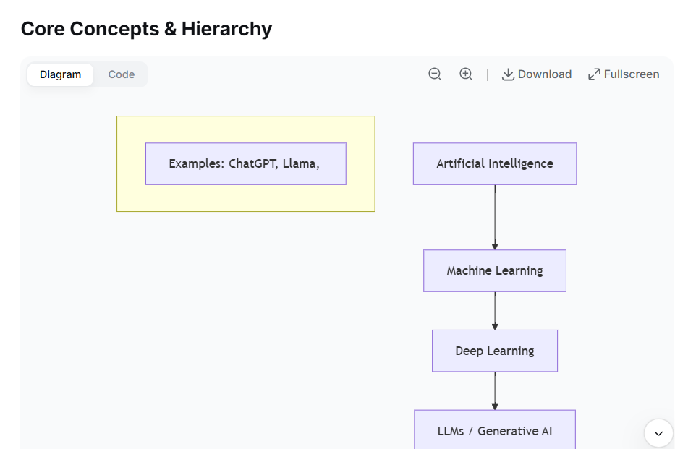
When I specifically asked only for the text then, below is the output:
text
AI vs ML vs DL
Fundamentals
ChatGPT, Llama, Gemini, etc.,
ARTIFICIAL
INTELLIGENCE
Machine Learning
Deep Learning
Discriminative
LLMs Gen AI
Model Used: Llama 4 Maverick 17B 128E
Picture URL: https://drive.usercontent.google.com/download?id=1AHRXaWeMqrMcxEQwFoCoy3o3D7yaWooe&export=view&authuser=0
ChatGPT providing only the text present in the image:
The text in the image is:
AI vs ML vs DL
Fundamentals
ChatGPT, Llama, Gemini, etc.,
ARTIFICIAL INTELLIGENCE
Machine Learning
Deep Learning
Discriminative
LLMs
Gen AI
Qwen output:
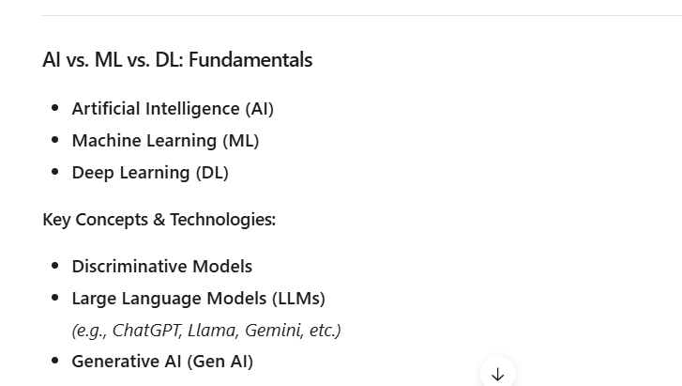
DeepSeek Output:
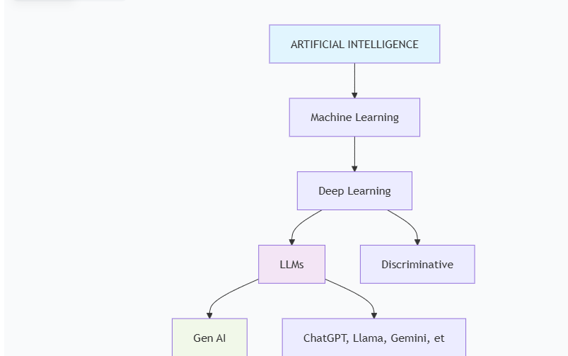
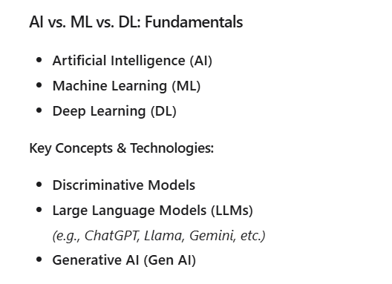
Analysis: When we used the model Llama 4 Scout 17B 16E not providing only the text even though insisted, but the model Llama 4 Maverick 17B 128E provided only the text present in the image.

