Hands-on Lab 2 Output - Git Ignore Implementation

Objectives
• Explain git ignore
• Explain how to ignore unwanted files using git ignore

Lab Description
In this hands-on lab, the objective was to demonstrate the use of the `.gitignore` file to exclude specific files and folders from being tracked by Git. Specifically, `.log` files and a log folder inside the working directory were targeted for ignoring.

Steps Performed
1. Navigated to the working directory of the Git repository.
2. Created a folder `GIT_HOL_2` under `Solutions/WEEK8/`.
3. Added a sample `.log` file named `debug.log`.
4. Created a folder named `log` inside `GIT_HOL_2` and added a sample file `test.txt` inside it.
5. Updated the `.gitignore` file with the following patterns:
*.log
week8/GIT_HOL_2/log/
6. Verified the `.gitignore` file contents using the `type` command (Windows alternative to `cat`).
7. Checked the `git status` to ensure `.log` files and the `log` folder were ignored.
8. Committed the `.gitignore` changes and pushed to the remote repository on GitHub.

Verification
After updating the `.gitignore` file, the `git status` output confirmed that `.log` files and the `log` folder were not tracked by Git. Only the `.gitignore` file and other relevant files were staged and committed.

Contd…

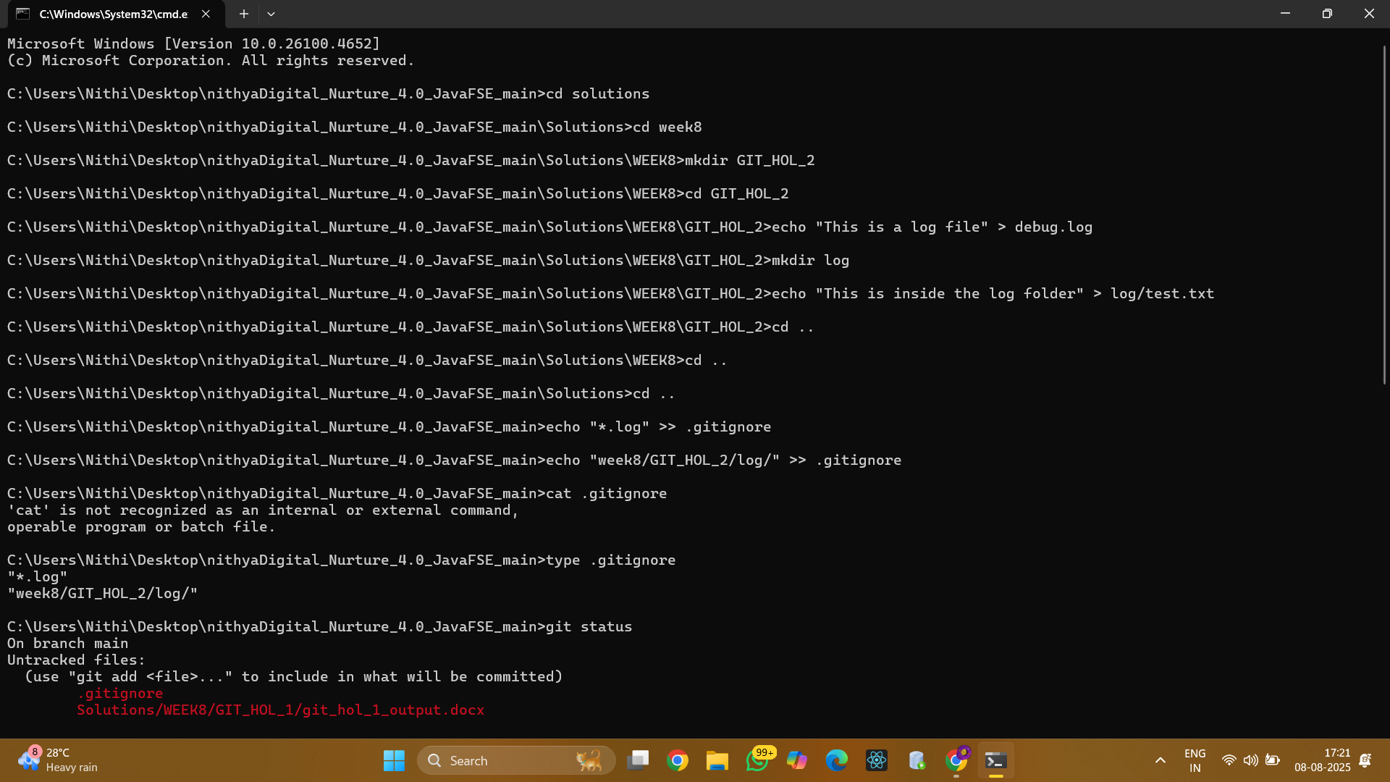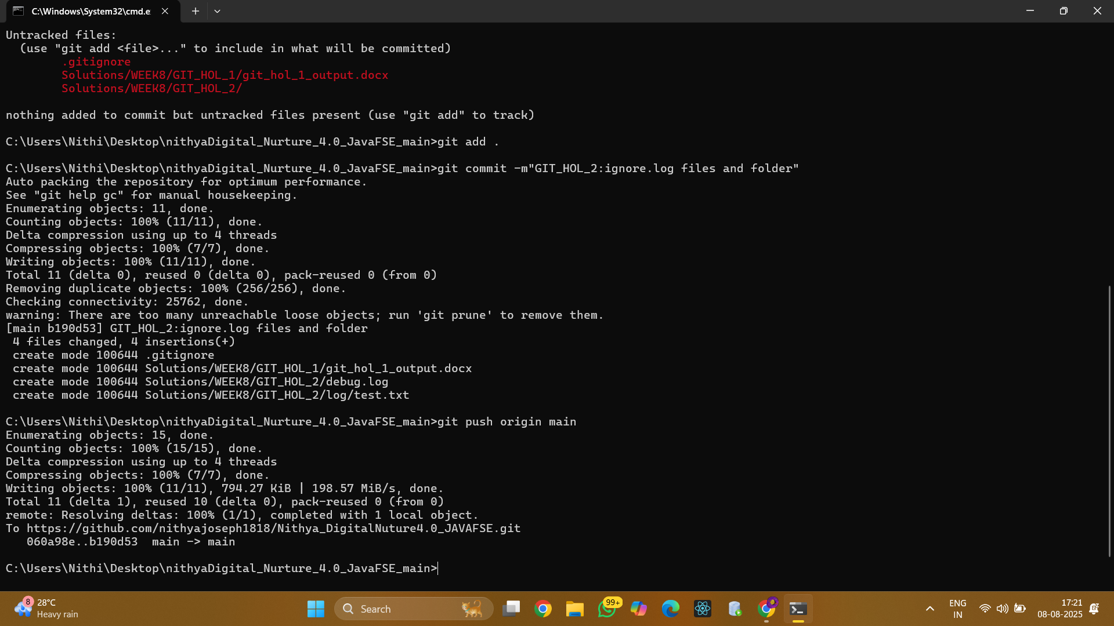

Result
The `.gitignore` configuration successfully ignored all `.log` files and the `log` folder, demonstrating effective use of Git's ignore functionality.

