Hands-on 3: Branching and Merging in Git
This document contains the complete execution of Hands-on 3, covering creation of a new GitHub repository, linking it to a local Git repository, creating a branch, committing changes, and merging it back to the master branch.

Step 1: Create and Link Repository
A new GitHub repository named 'branch-merge-lab' was created. A local folder with the same name was initialized as a Git repository. The README.md file was created and committed. The remote GitHub repository was linked using 'git remote add origin', and the initial commit was pushed to master.
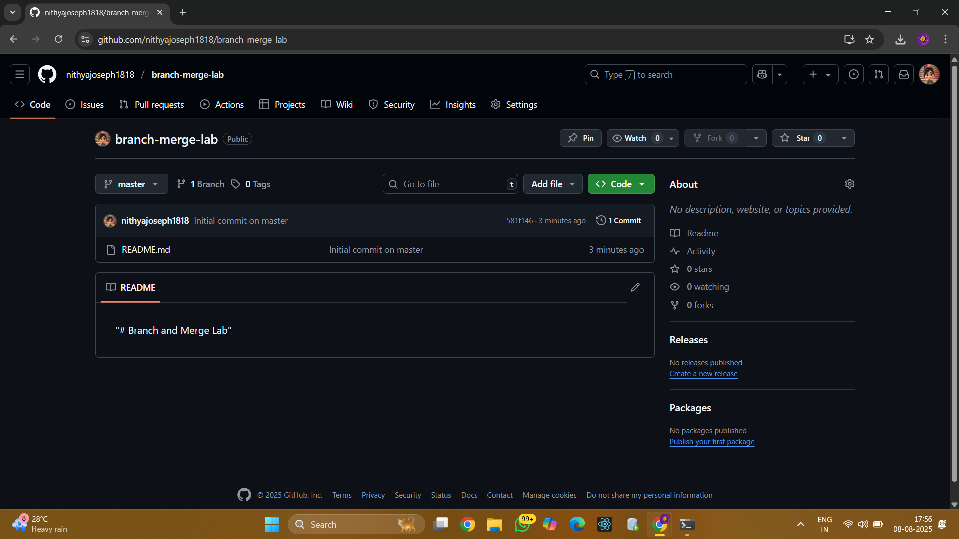
Commands executed:
cd ~/Desktop
mkdir branch-merge-lab
cd branch-merge-lab
git init
echo "# Branch and Merge Lab" > README.md
git add README.md
git commit -m "Initial commit on master"
git remote add origin https://github.com/<your-username>/branch-merge-lab.git
git branch -M master
git push -u origin master

Step 2: Branching
A new branch 'GitNewBranch' was created and switched to. A file 'branchfile.txt' was added and committed in this branch, then pushed to GitHub.
Commands executed:
git branch GitNewBranch
git branch -a
git checkout GitNewBranch
echo "This is content in GitNewBranch" > branchfile.txt
git add branchfile.txt
git commit -m "Added branchfile.txt in GitNewBranch"
git status
git push -u origin GitNewBranch
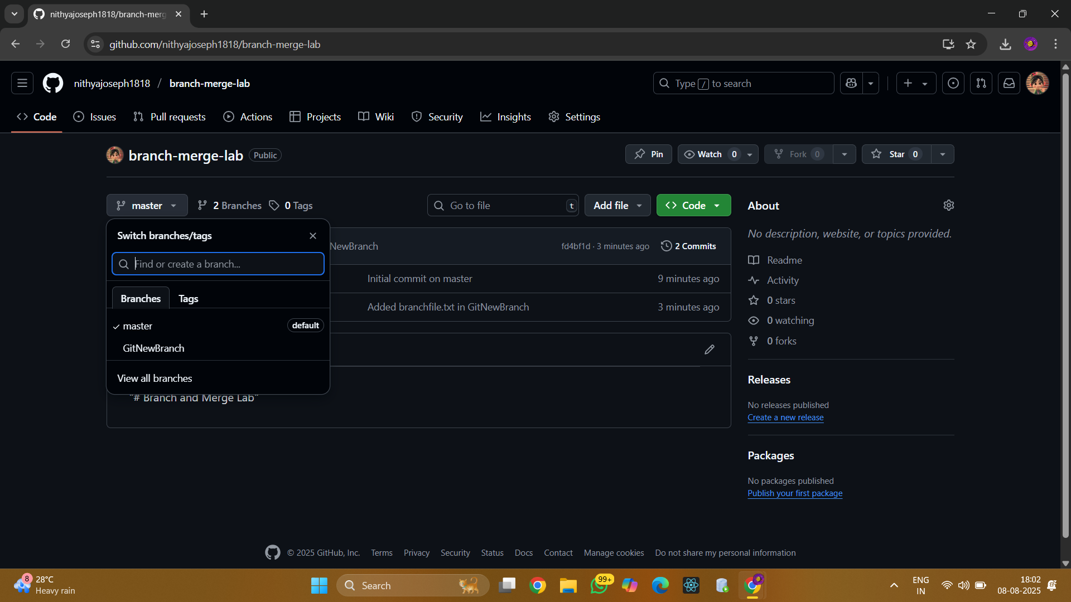
Figure 1: Repository on GitHub showing both master and GitNewBranch.
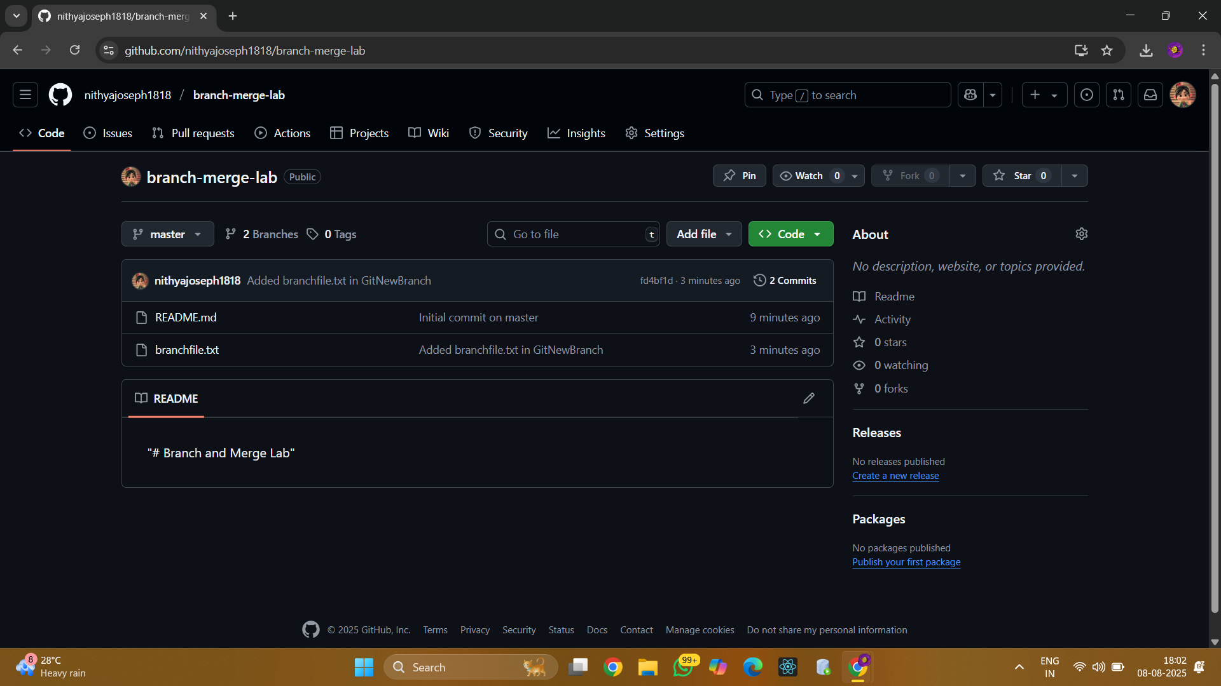
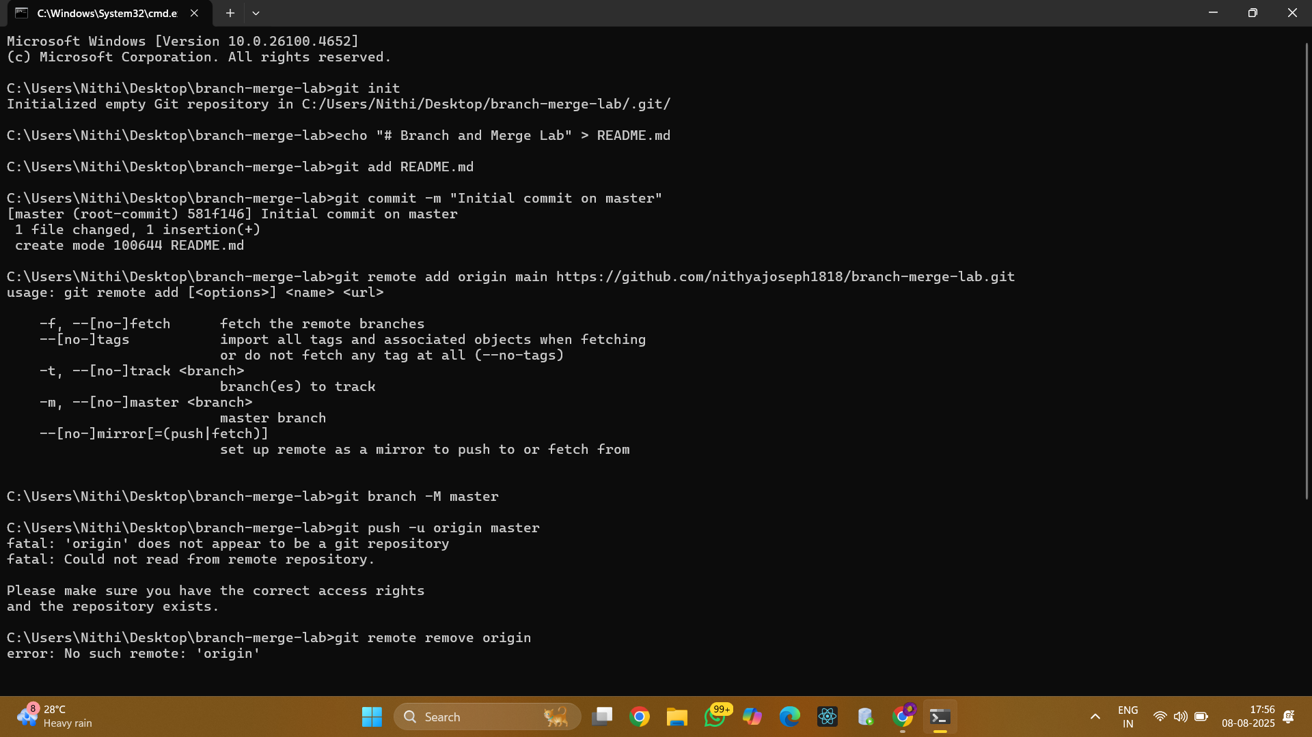

Step 3: Merging
The branch 'GitNewBranch' was merged back into 'master'. Differences between master and branch were checked using 'git diff'. The branch was deleted locally after the merge, and changes were pushed to GitHub.
Commands executed:
git checkout master
git diff master GitNewBranch
git merge GitNewBranch
git log --oneline --graph --decorate
git branch -d GitNewBranch
git push origin master
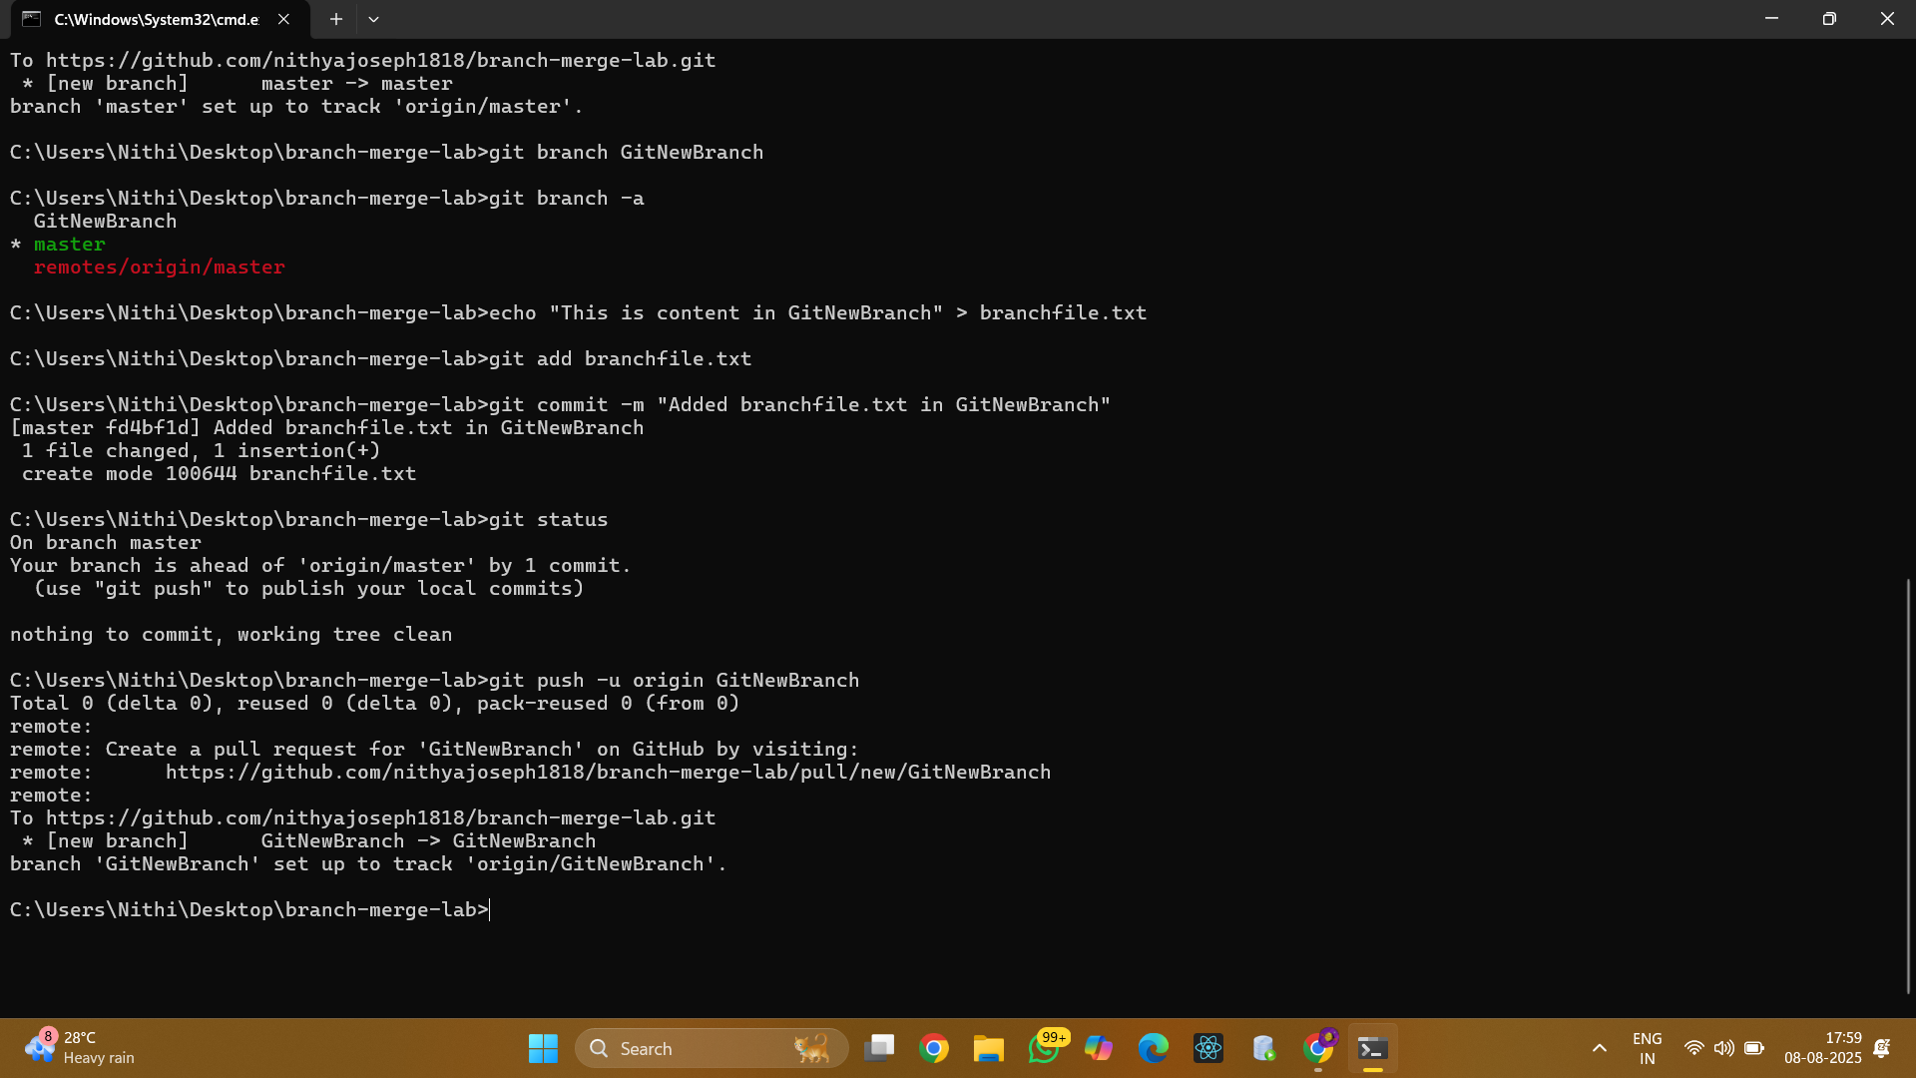

Conclusion
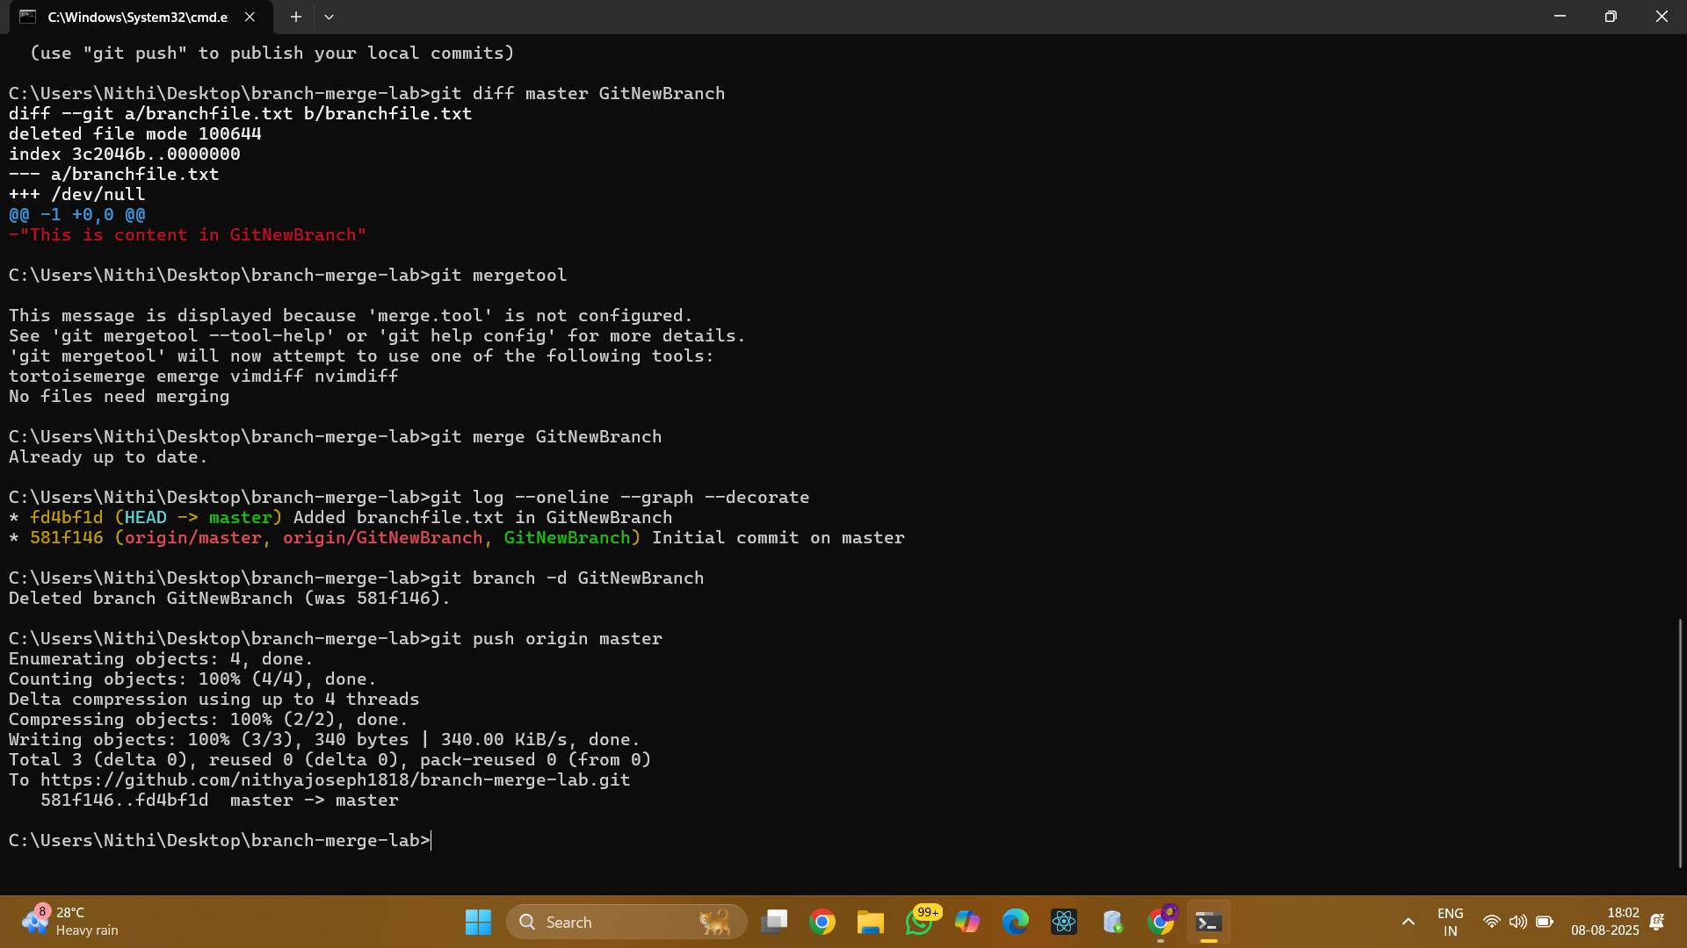


The branching and merging process was successfully demonstrated using both local Git operations and remote synchronization with GitHub.

