Git Hands-on Lab 4 – Conflict Resolution During Merge

Objectives
• Explain how to resolve the conflict during merge.
• Implement conflict resolution when multiple users are updating the trunk (or master) in such a way that it results in a conflict with the branch’s modification.

Prerequisites
• Hands-on ID: “Git-T03-HOL_001”
• A Git repository initialized and ready for branching and merging operations.
• Git Bash installed.
• P4Merge tool installed for visual merge conflict resolution.
• Do not use Cognizant credentials to log in to GitHub.
Estimated time to complete this lab: 30 minutes.

Step-by-Step Instructions
- 1. Verify if master is in a clean state:
git status
- 2. Create a branch 'GitWork' and switch to it:
git checkout -b GitWork
- 3. Add a file 'hello.xml' and add initial content:
echo '<message>Hello from branch</message>' > hello.xml
- 4. Observe the status:
git status
- 5. Commit the changes to the branch:
git add hello.xml
git commit -m 'Added hello.xml in GitWork branch'
- 6. Switch to master:
git checkout master
- 7. Add a file 'hello.xml' with different content:
echo '<message>Hello from master</message>' > hello.xml
- 8. Commit the changes to master:
git add hello.xml
git commit -m 'Added hello.xml in master branch'
- 9. Observe the log:
git log --oneline --graph --decorate --all
- 10. Check differences:
git diff master GitWork
- 11. Use P4Merge for better visualization:
git mergetool
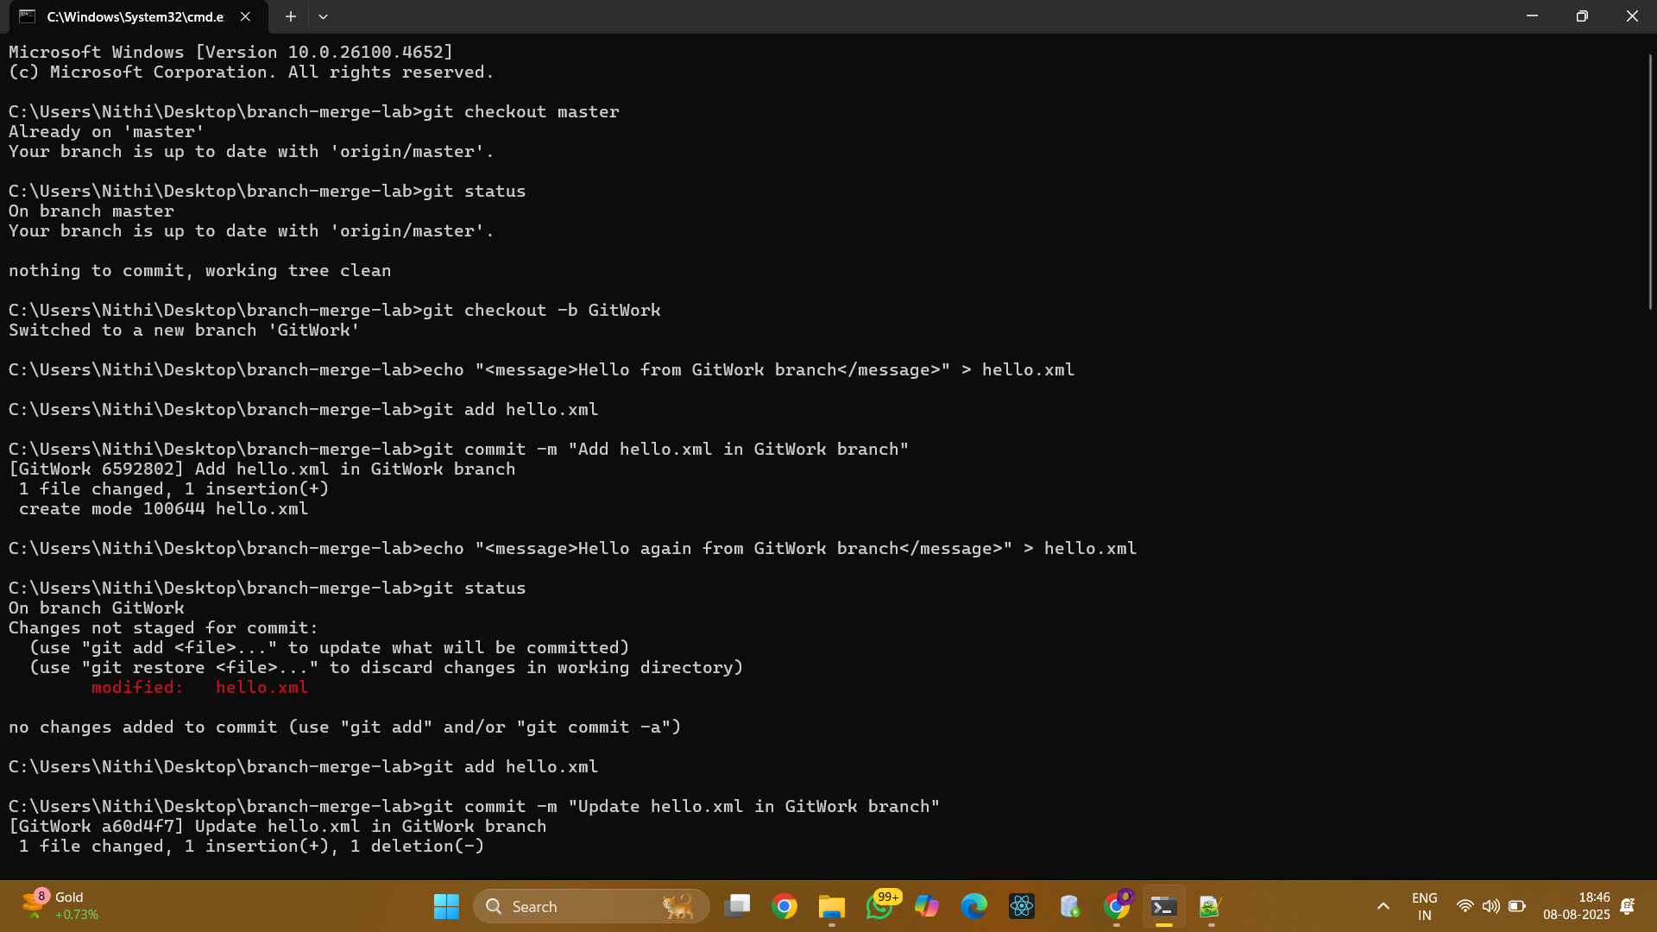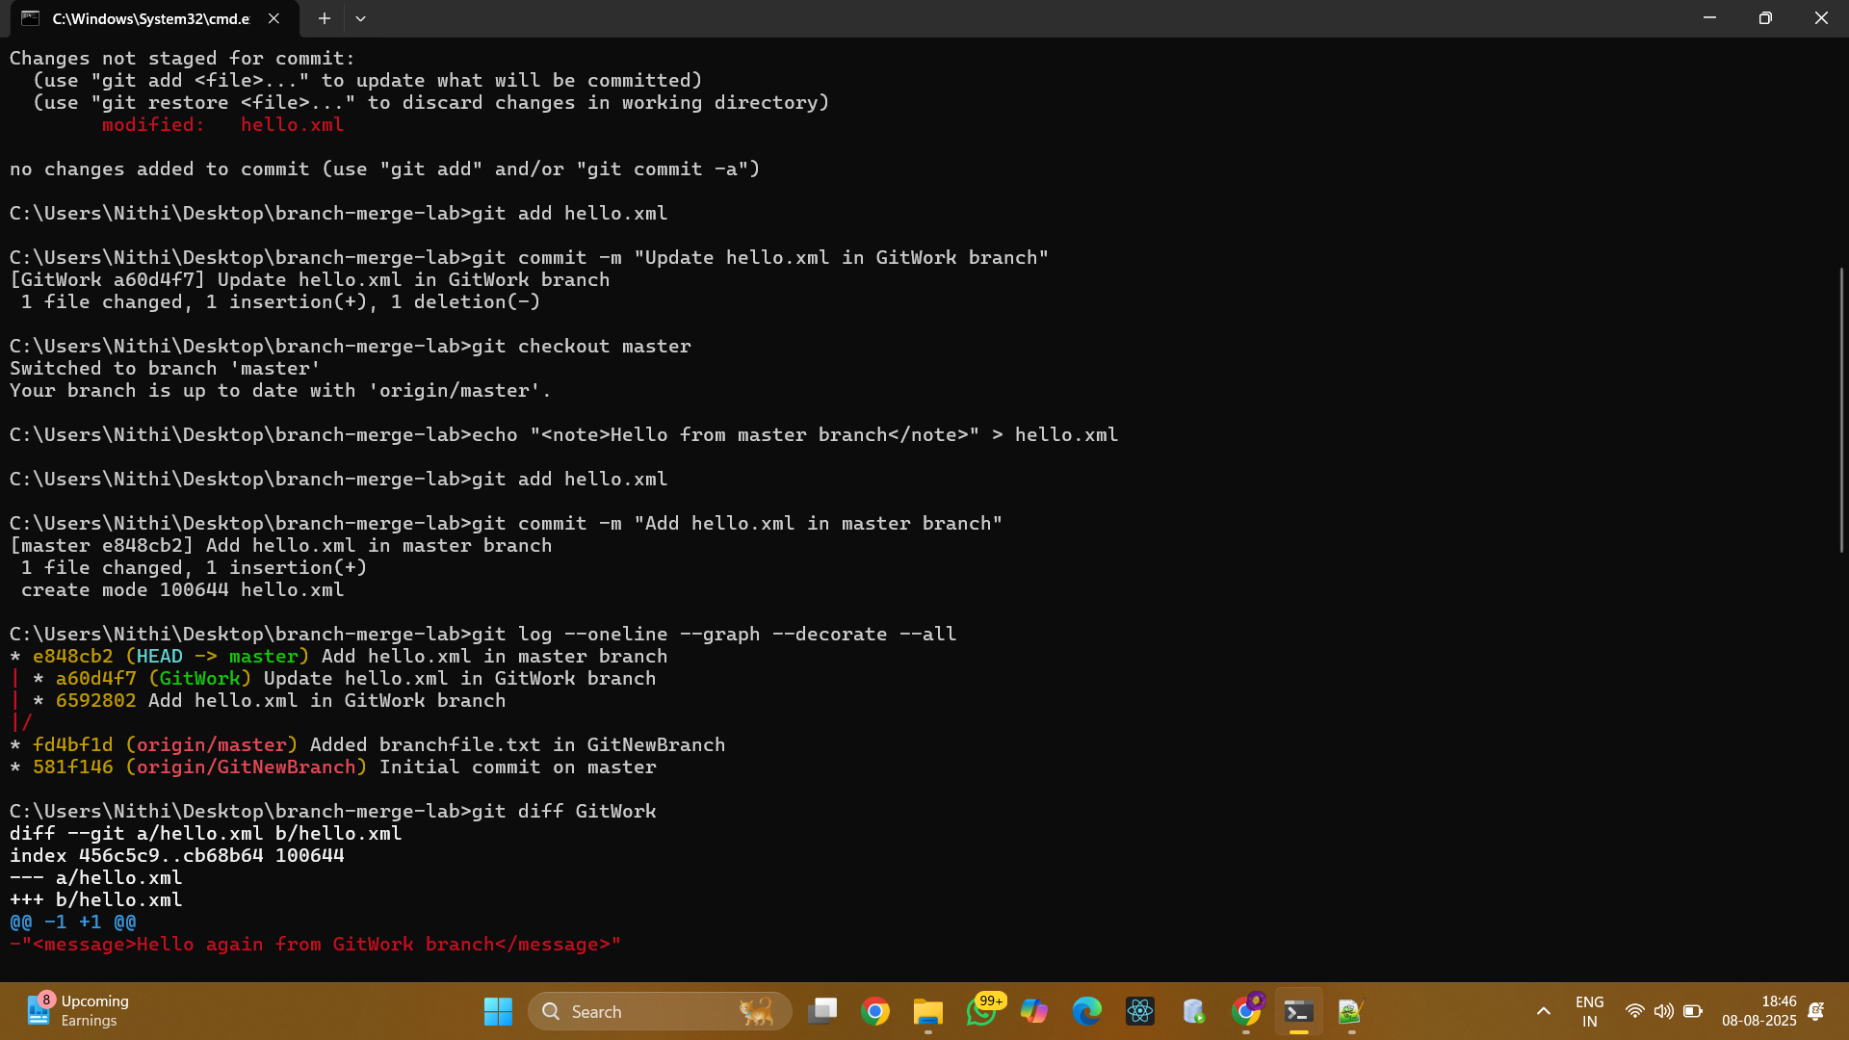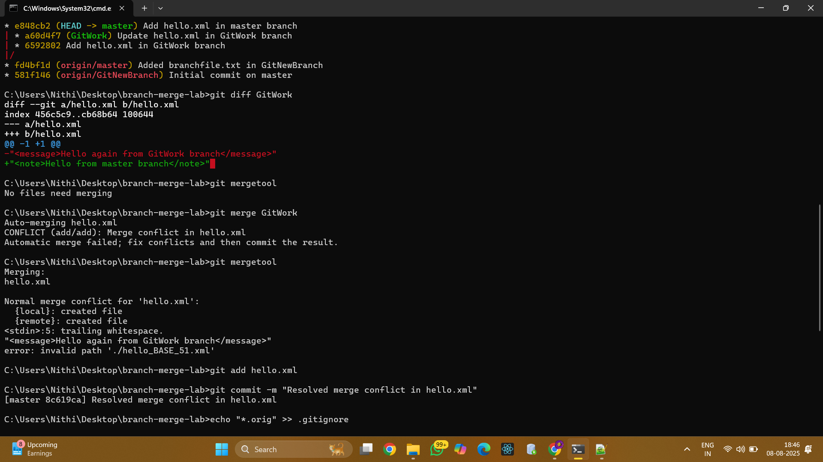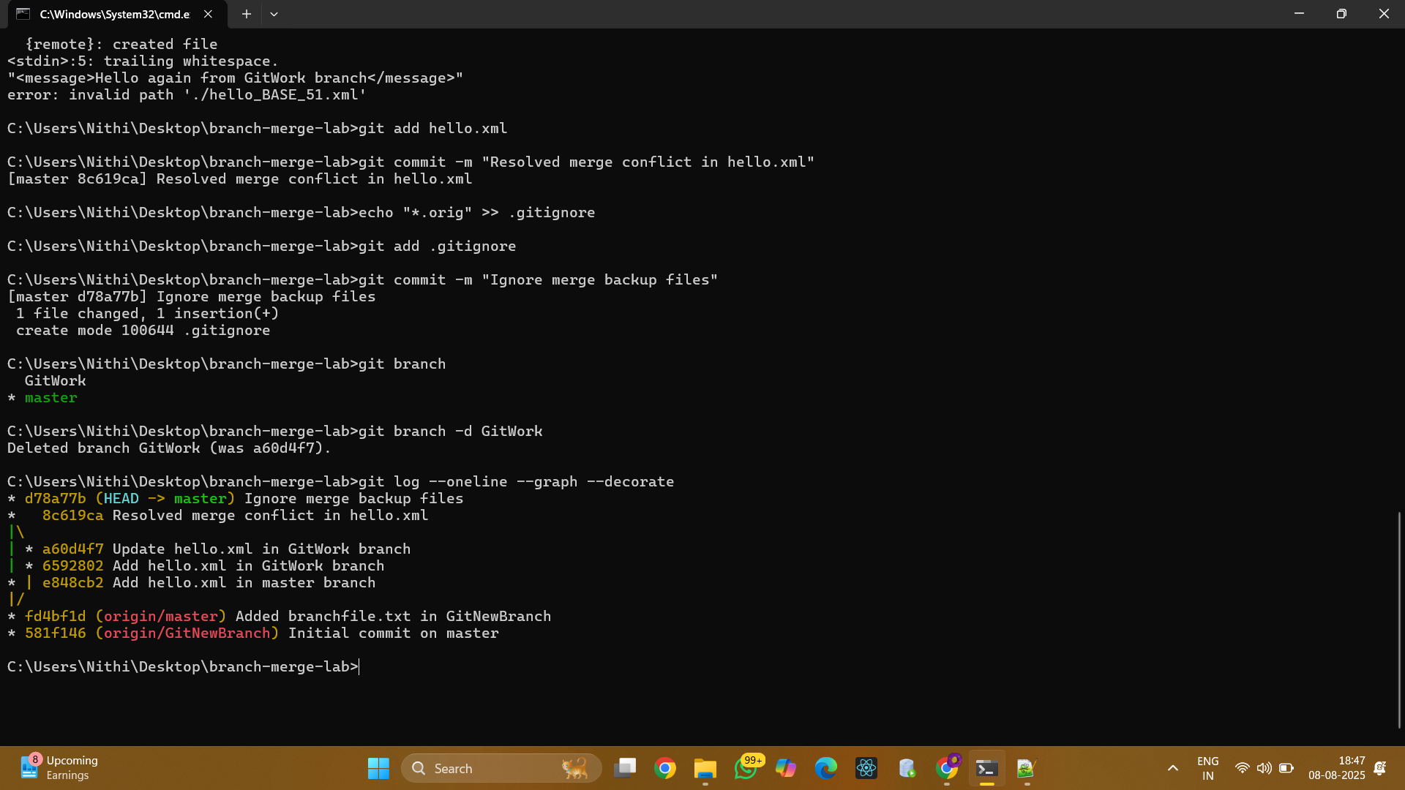
- 12. Merge the branch into master:
git merge GitWork
- 13. Observe the Git conflict markup in 'hello.xml'.
- 14. Use 3-way merge tool to resolve the conflict (P4Merge will open).
- 15. Commit the resolved changes:
git add hello.xml
git commit -m 'Resolved merge conflict in hello.xml'
- 16. Observe git status:
git status
- 17. Add backup file (e.g., hello.xml.orig) to .gitignore:
echo '*.orig' >> .gitignore
- 18. Commit the changes to .gitignore:
git add .gitignore
git commit -m 'Added .orig to .gitignore'
- 19. List all available branches:
git branch -a
- 20. Delete the merged branch:
git branch -d GitWork
- 21. Observe the log:
git log --oneline --graph –decorate
