Hands-on 5 – Clean Up and Push to Remote Git

1. Objective
Explain how to clean up and push back to remote Git.
Execute steps to sync local changes with the remote repository.

2. Prerequisites
• Hands-on ID: Git-T03-HOL_002 must already be completed.
• You should have a GitHub account (free).
• Do not use Cognizant credentials to log in to GitHub.

3. Estimated Time
10 minutes.

4. Steps

Step 1: Verify if master is in a clean state
Run the following command to check if there are uncommitted changes in the master branch:
git status
Expected Output: "nothing to commit, working tree clean"
Screenshot: [Insert Screenshot Here]

Step 2: List all available branches
To see all the local and remote branches:
git branch -a

Step 3: Checkout to master and Pull from remote Git repository
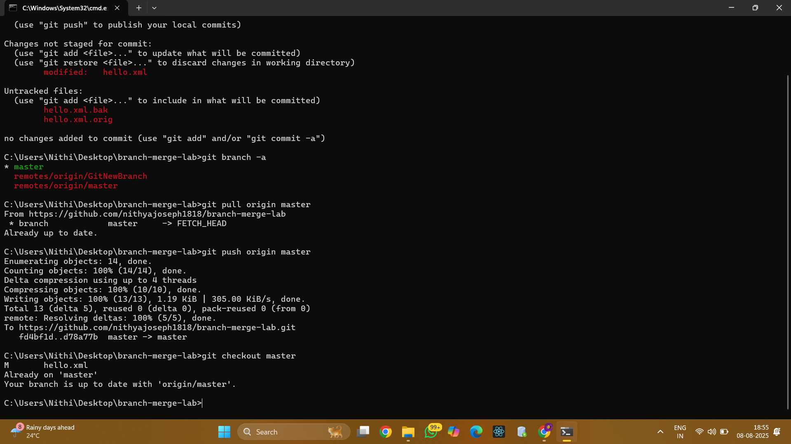
Ensure you are on the master branch and update local with remote:
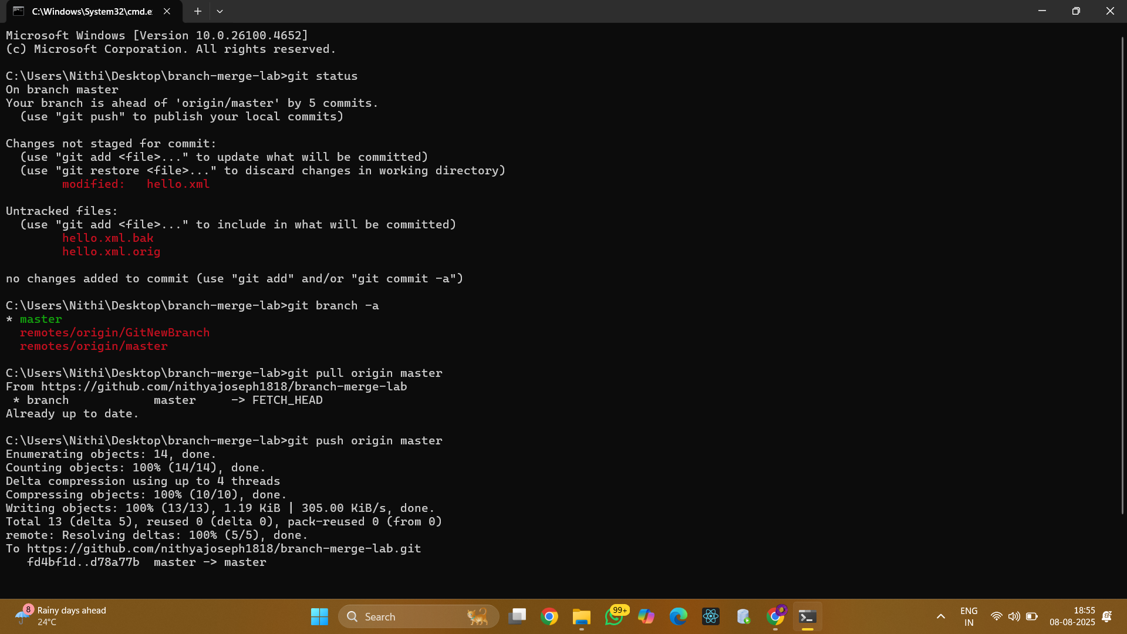
git checkout master
git pull origin master

Step 4: Push pending changes from “Git-T03-HOL_002”
If you made changes in Hands-on 2 and they’re committed locally, push them:
git push origin master

Step 5: Verify changes on GitHub
Go to your repository on GitHub in the browser.
Check if the files/commits from “Git-T03-HOL_002” are now visible.

5. Expected Result
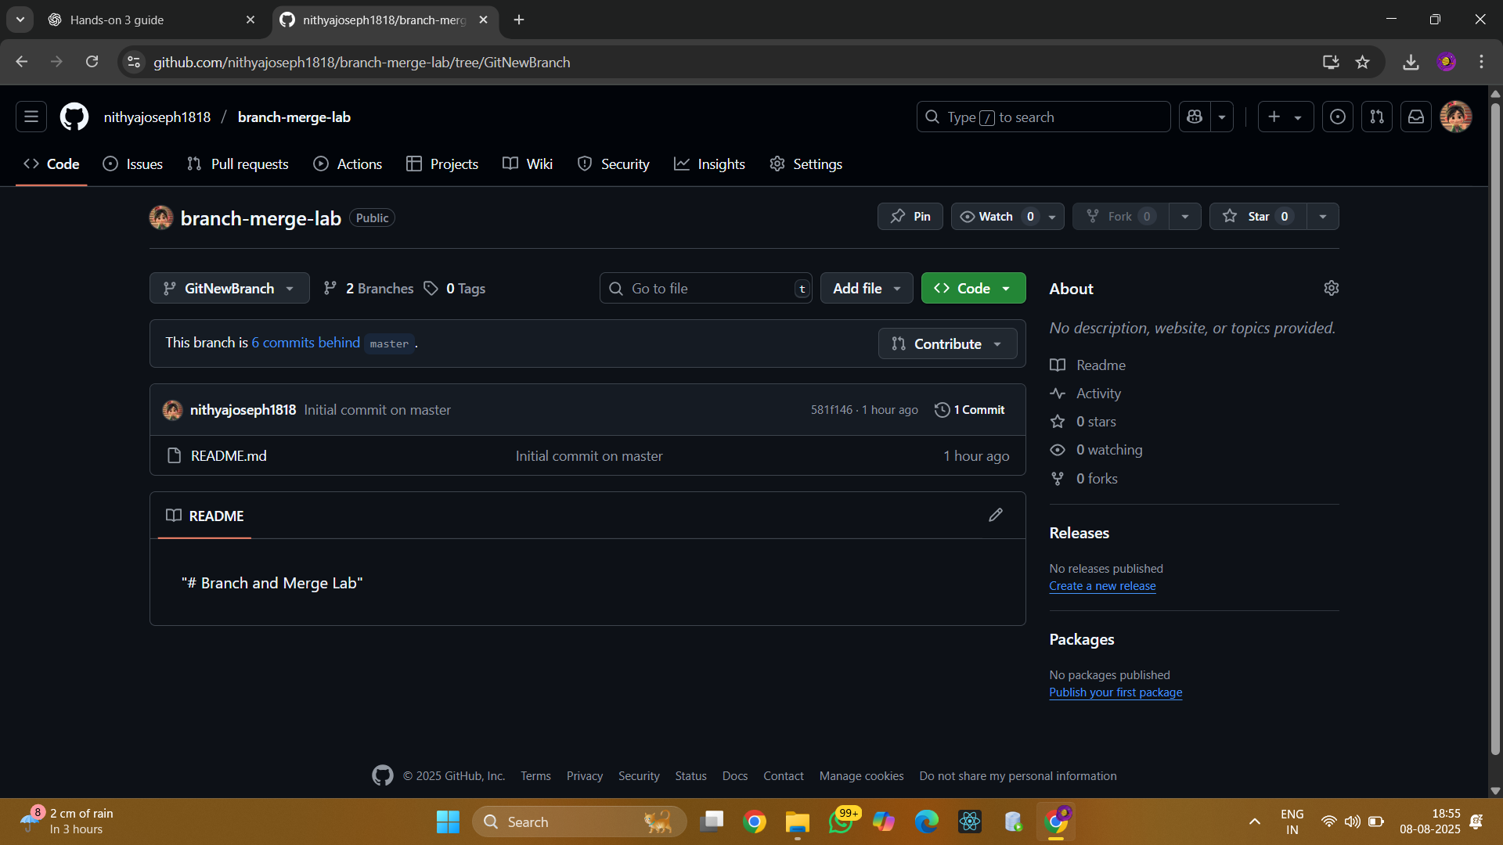
Your local master branch should now be in sync with the remote master, and any pending changes should be reflected in the GitHub repository.

