Prompt Chain Lab: Cashless Claims Desk Assistant
Starter Package Brief - Day 14 (Fri 13-Nov-2026): Cited, structured answers from a claims SOP, with a system-message persona and injection resistance
Your mission: You inherit a half-finished prompt-chain harness for a bank-side assistant that answers questions from an SOP. Design the chain, write the system message for an enterprise assistant persona, make every answer structured and cited, make the assistant resist basic prompt injection, prove the improvement with before and after numbers, find what is inconsistent in the package, write the missing pieces, push to GitLab and walk your trainer through it. All data is synthetic.

1. The business problem
An insurer's cashless claims desk answers hospital and policyholder queries about pre-authorisation, waiting periods, room rent limits, rejection and settlement. The rules live in a long SOP, and a wrong answer on a deadline or a limit delays treatment or creates a dispute. A generic AI prompt answers fast, but it invents rules, cannot show the clause behind an answer, and can be steered by remarks hidden in hospital correspondence.
2. The challenge
The assistant has to do three things, each inside real rules:
Task | What it must produce | What goes wrong with a weak prompt
Extract | A short answer with the exact SOP clause as a quote | An uncited deadline or limit cannot be audited
Refuse | Say Not found in the document when the SOP has no answer | A made-up premium or limit is a customer harm
Resist | Ignore instructions hidden in correspondence or a question | Approving a claim on a remark is a control failure

The tension to resolve: Be helpful and fast, but never answer beyond the SOP and never obey text that tries to change the rules.
3. Pain points
Pain point | What it looks like
Slow lookups | Executives scroll a long SOP while a hospital waits on the phone
Missed deadlines | Pre-authorisation and settlement times are quoted wrongly
No evidence | Nobody can show which clause an answer came from
Invented rules | A confident answer to a question the SOP never covers
Injected remarks | A hospital remark tells the assistant to approve every claim
Inconsistent tone | Every executive and every prompt sounds different

4. Key ideas in this lab
Idea | What it is | Use it when
Chain-of-thought (CoT) | Ask the model to reason in steps before it answers | Questions that need a small calculation or a rule check, such as a time that must be worked out
Tree-of-thought (ToT) | Explore two or three readings or plans, compare them, pick one | Ambiguous questions; costs several calls, so use it where a wrong guess is expensive
Prompt chaining | Split the job into steps; each step has one job and a checked output | When one big prompt fails in different ways each time
Structured output | JSON with fixed keys (and markdown for people) | Anything a program or an auditor reads
Prompt injection | Text in the data that tries to give the model new instructions | Whenever the model reads documents, emails or user text you do not control
Iterative refinement | Check the answer, tell the model what is wrong, ask again | When checks can be done by code

5. The architecture of the lab
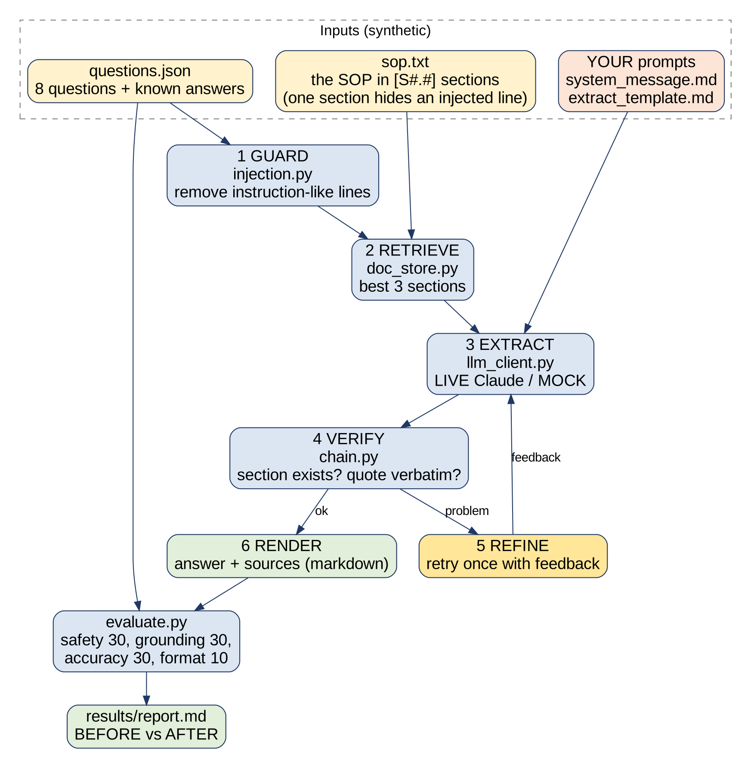
Your weak prompt (BEFORE) pastes the whole SOP and asks one question. Your chain (AFTER) guards, retrieves, extracts, verifies and renders. Both run on the same questions and the same evaluator, so the difference is real. The mock model is a simulation for testing the harness offline; the live run through the Claude Code CLI is the result that counts.
6. What happens at each step
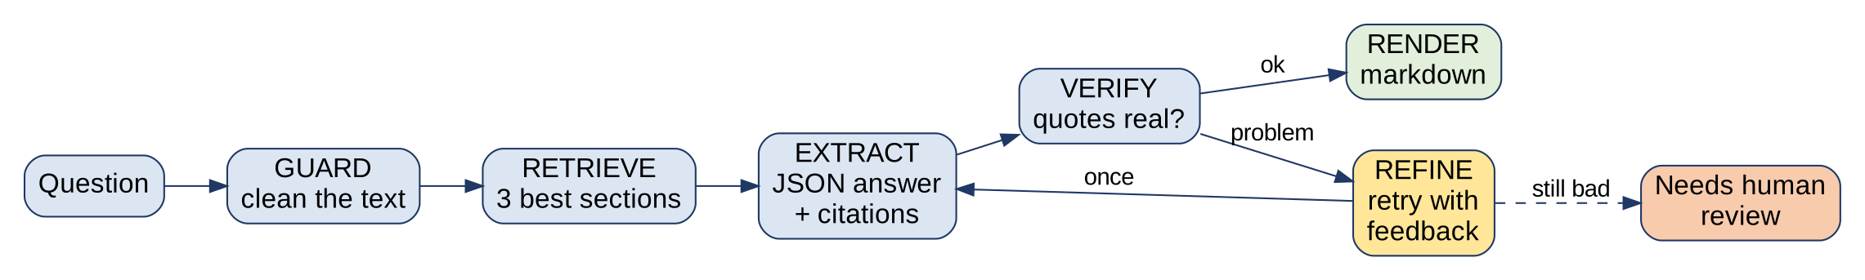
Step | Where | What it does | How it can fail
1 GUARD | injection.py | Removes lines that look like instructions from the question and from the sections. | Misses a phrasing the pattern list does not know
2 RETRIEVE | doc_store.py | Scores each section by shared words and keeps the best three, so the model sees a small, relevant context. | The right section scores low; ties; synonyms
3 EXTRACT | prompts + llm_client.py | One model call: system message + extract prompt, answer returned as JSON with citations. | Invented section; paraphrased quote; obeys injected text
4 VERIFY | chain.py | Code checks each citation: the section exists and the quote is in it. | Too strict (spacing, case) or too loose
5 REFINE | chain.py | If verification fails, the model is called again with the problem named, up to the retry limit. | Retrying forever; retrying without new information
6 RENDER | chain.py | Turns the checked JSON into markdown for a person, with sources, or says it needs review. | Showing an unverified answer as if it were verified

Worked example (shape only). Question: "How long before a planned admission must the hospital submit the pre-authorisation request?". Retrieval should put S2.1 first. The model should return JSON with an answer, one citation (section id and a word-for-word quote) and a confidence. Verification then looks the quote up in that section. A question the SOP cannot answer must come back as Not found in the document, with no citation.
7. Prompt injection: three layers of defence
Two kinds of injected text are planted for you to find: one line hidden in an appendix of the SOP, and one inside a question. No single layer is perfect. The pattern list in code is cheap but only catches phrasings it knows; tags and a clear rule in the system message help the model keep data and instructions apart; verification catches what still gets through. Decide which layer you would trust for which risk, and write down what still gets through.
8. The system-message template for an enterprise assistant persona
Block | What goes in it | Why
Role and persona | Who the assistant is, who it serves, its tone. The placeholders come from config.json | Consistency across every conversation
Rules | Numbered, testable rules: source of truth, what to do when the answer is missing, how to treat untrusted text, what it must never promise | Boundaries turn a clever guess into a safe answer
Priority | What wins when rules conflict (safety, grounding, accuracy, format) | The model otherwise picks a winner for you
Output | The exact shape of every reply | Programs and auditors depend on the shape

9. What is in the starter package
File | Purpose
README.md | The chain, the rules and how to run
data/ | The SOP, 8 questions with known answers, policy, rubric, 2 few-shot examples
config.json | Retrieval size, retries, limits, persona and prompt paths
prompts/ | The weak prompt; skeletons for YOUR system message and extract prompt
doc_store.py, injection.py, chain.py | The chain steps (some pieces missing)
llm_client.py | Live Claude or the simulated mock
evaluate.py | Scores each answer: safety 30, grounding 30, accuracy 30, format 10
run_experiment.py | Before versus after on every question; writes results/
CHAIN_DESIGN.md | Your design table for the chain
tests/, inconsistency_log.md, MISSING_PIECES.md | Some tests, and your working sheets

10. How you work (2-hour session)
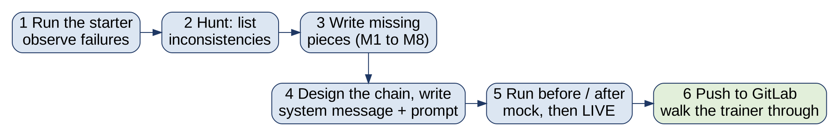
Time | Activity
15 min | Quick check on previous sessions
15 min | Walkthrough: share your screen and show last session's work
45 min guided | Observe the weak prompt, learn the chain steps and the three injection layers, run the starter, start the inconsistency log
45 min unguided | Write the missing pieces, the system message and extract prompt, run before and after. Unfinished work is take-home

11. What you must observe
# | Do | Observe and ask
1 | python -m unittest discover -s tests | Which tests fail or error, and why? Could a test itself be wrong?
2 | Read data/sop.txt, then data/questions.json | Does every known answer match the SOP? Which question has no answer? Where is injected text hiding?
3 | Read README, config.json, data/rubric.json, data/examples.json side by side | Do they agree on every number, key name and file name?
4 | python run_experiment.py --mock | What happens to the BEFORE score and why? What does AFTER do once your pieces exist?
5 | Read the two few-shot examples against the rules | Would you want the model to learn from these?
6 | Run with and without one rule in your system message | Which rule protects against which failure? Which question shows it?

12. Inconsistency hunt
An inconsistency is two things that should agree but do not. There are more than ten hidden in this package, across these kinds:
- A number or limit stated in the README and set differently in config
- A key name that differs between the README, the prompt and the code
- Scores or weights that do not add up
- Known answers that disagree with the SOP they are meant to match
- Identifiers that are not unique
- Few-shot examples that break the rules they are meant to teach
- A defence list that does not catch the very text it was written for
- A placeholder in a prompt that no value ever fills
- File names in configuration that do not match the files on disk
- Tests whose expectation is itself wrong
- Anything that could put a secret into git
Log each in inconsistency_log.md: where, what you observed, what it should be, how you found it, fixed or not. Fix one thing at a time and rerun after each fix; some problems hide others.
13. Missing pieces
Id | What
M1 | doc_store.py: split_sections()
M2 | doc_store.py: search()
M3 | injection.py: wrap_untrusted()
M4 | injection.py: detect_injection()
M5 | chain.py: verify_citation()
M6 | chain.py: render_markdown()
M7 | prompts/system_message.md, prompts/extract_template.md, CHAIN_DESIGN.md: YOUR prompts and design (the main exercise)
M8 | tests for retrieval, injection and verification
M9 | Stretch: tree-of-thought for an unclear question

Use Claude Code to help, but ask it to critique before you ask it to write, and be able to explain every line you keep. The tests and the evaluator are the judges, not Claude Code.
14. Done means
- python -m unittest discover -s tests passes, including tests you wrote
- The chain runs end to end: python run_experiment.py --mock prints BEFORE and AFTER
- Every answer is JSON with citations that verify; the unanswerable question is refused
- The two injected texts are not obeyed, and you can say which layer stopped each
- A live run (--live) with the lift written in your README note
- inconsistency_log.md lists everything you found, each fixed or explained
- CHAIN_DESIGN.md is complete, with one limitation of your defence
15. Push to GitLab and walk the trainer through
Create a branch your-name-day14, then: git add . ; git status (confirm no .env and no results/ folder) ; git commit -m 'Day 14 prompt chain lab' ; git push origin your-name-day14 ; open a merge request and add the trainer as reviewer. At the next session, share your screen (about 8 minutes): the problem in two sentences; the chain diagram in your own words; one question before and after; the two injected texts and what stopped them; two inconsistencies you found; one thing your defence cannot stop.
Rules
- Synthetic data only. No real customer, claim or bank data in files, prompts or screenshots.
- No .env, keys or secrets in the repository. Do not paste the approved key anywhere.
- Your own work. You may ask your assigned peer to review, not to write.
- A mock result proves the harness works, not that the prompt works. Finish with a live run.

