Tools, Libraries and Concepts
Module 1: The AI Ecosystem - lab reference guide
Read this once before Day 1 and keep it open during the labs. It explains what each tool and library is for, the concepts behind the exercises, and where each concept appears in the code.

1. Architecture at a glance
Every script runs on your lab VM. Python scripts reach the Anthropic API through a thin wrapper (common/llm.py). The Claude Code CLI is a second route to the same models. The key lives only in .env.
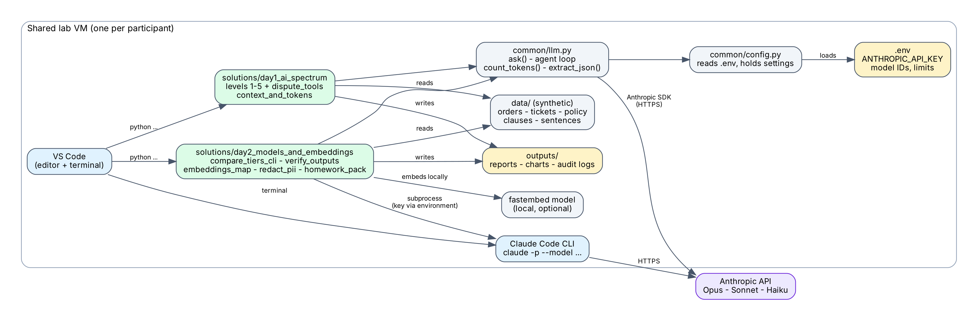
Figure 1. Lab architecture: who talks to whom.
How to read it: the green boxes are the exercises you run. They call common/llm.py, which reads the key through common/config.py from .env, and talks to the Anthropic API. The tier comparison starts the Claude Code CLI as a separate process and passes the key through that process's environment. Synthetic data is read from data/ folders; reports, charts and audit logs are written to outputs/.

The five levels of the spectrum
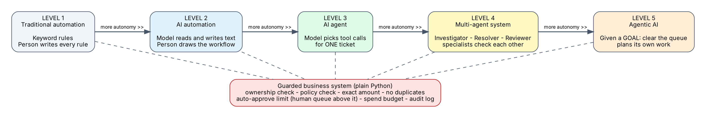
Figure 2. One scenario, five levels of autonomy, one guarded business system underneath.

The agent loop
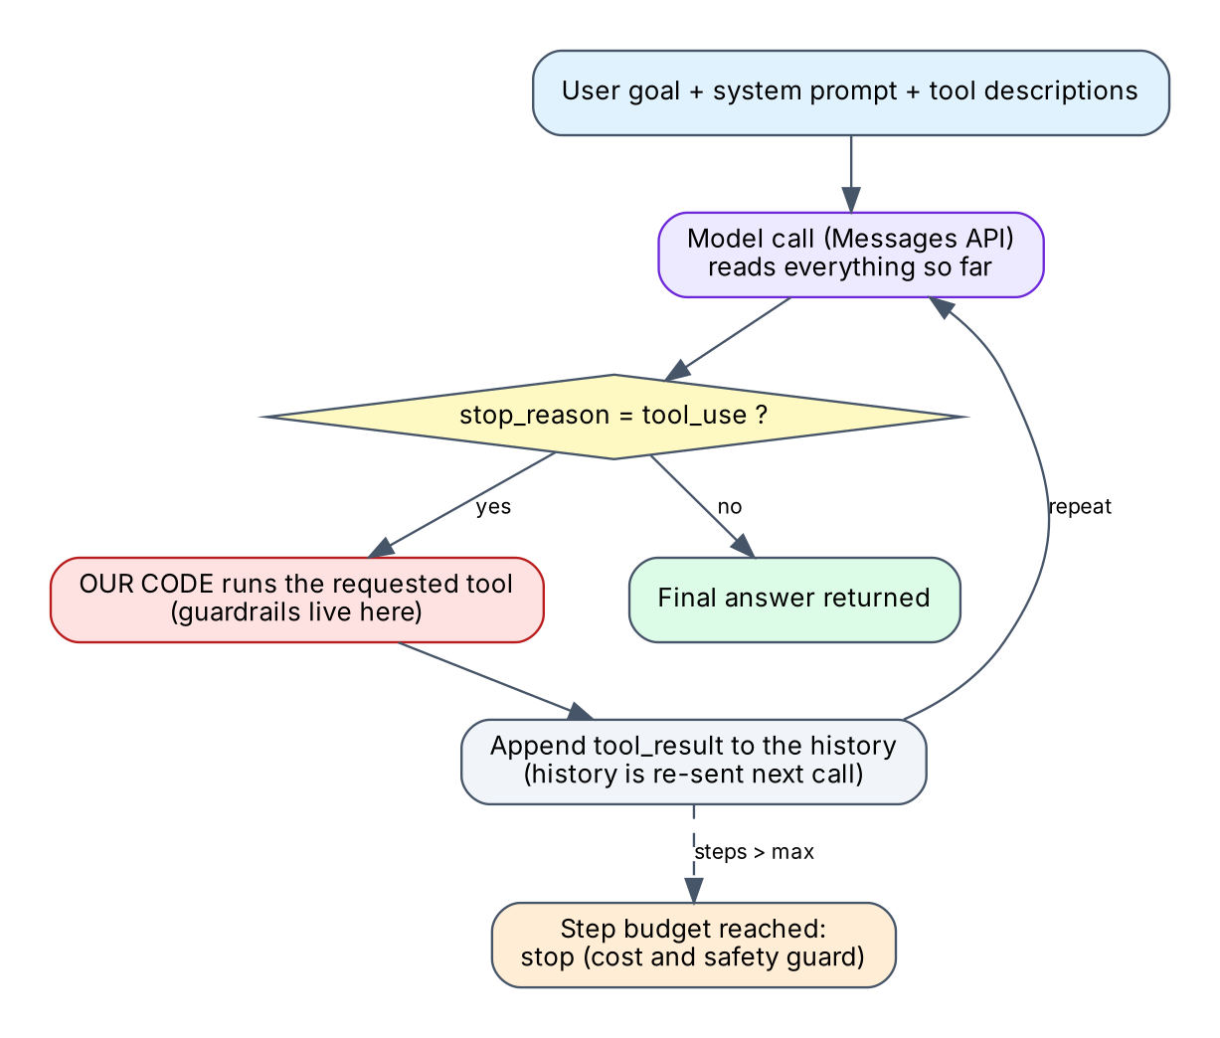
Figure 3. How common/llm.py run_tool_loop() works.
The model never runs anything. It asks for a tool in structured text; our code decides whether and how to run it, and returns the result. The loop stops when the model answers without asking for a tool, or when the step budget is used up.

Propose - verify - decide - log
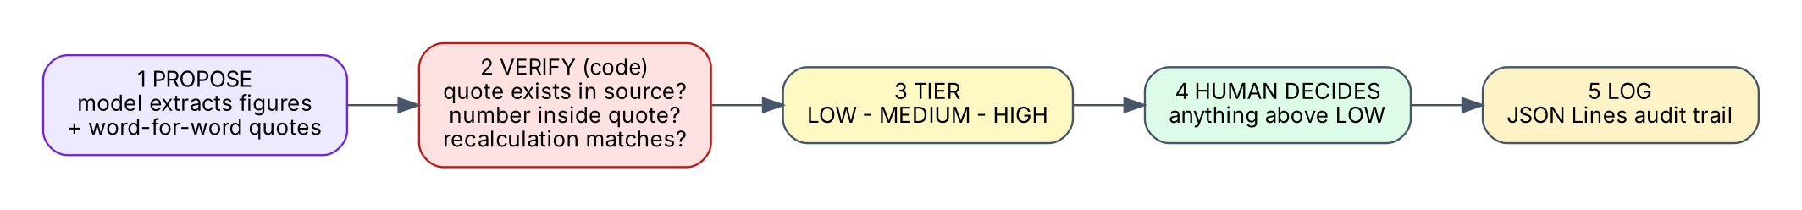
Figure 4. The verification pattern from Day 2.

2. Tools
Tool | What it is | Used for in this lab | Watch out for
VS Code | Code editor with an integrated terminal | Open the repo, edit .env, run scripts | Install the Python extension; open a NEW terminal after installing anything
Git | Version control | Get the repository; track your changes | Never commit .env (it is git-ignored)
Python 3.11+ and venv | Language runtime and an isolated package folder (.venv) | Runs every exercise | Activate .venv in each new terminal: the prompt shows (.venv)
Claude Code CLI (claude) | Command-line assistant from Anthropic | Day 2 tier comparison in non-interactive mode (claude -p) | Does not read .env; PATH needs a new terminal; first run asks to approve the API key
Anthropic API key | Credential that identifies and bills your calls | Powers the SDK scripts and the CLI | Treat as a password. Do not paste into chats, screenshots or Git
Anthropic Console / docs | Where keys, usage, model names and limits are managed | Confirm the model IDs your organisation approved | Model names and prices change; check the current docs
ChatGPT, Claude.ai, Gemini (web/mobile) | Consumer chat interfaces from three vendors | Day 2 homework: same prompt in all three | Personal accounts: synthetic or public text only; check the data-controls setting

3. Python libraries
Library | Purpose | Where used
anthropic | Official SDK for the Messages API: send messages, tool definitions, count tokens | common/llm.py (all model calls from Python)
python-dotenv | Loads KEY=value lines from .env into environment variables | common/config.py
numpy | Fast arrays and maths on vectors | embeddings_map.py
scikit-learn | Machine-learning toolkit; here only PCA to squash vectors to 2-D | embeddings_map.py (map of meaning)
matplotlib | Draws charts to PNG files | embeddings_map.py
fastembed (optional) | Runs a small open-source embedding model locally (ONNX); no API key, no data leaves the machine | embeddings_map.py (real embeddings)
Standard library | json, re, argparse, subprocess, dataclasses, pathlib, datetime, unittest - nothing to install | Throughout

4. Concepts

4.1 The automation-to-agentic spectrum
Level | Who decides what happens next? | Language understanding | Example in the lab | Main risk
1 Traditional automation | A person wrote every rule | None (keywords) | level1: keyword rules | Brittle: new wording breaks it
2 AI automation | A person drew the workflow; model fills language steps | Model reads and writes text | level2: understand -> policy -> reply | Wrong extraction; injection in text
3 AI agent | The model chooses tool calls for one task | Yes + tool use | level3: single-ticket agent | Wrong tool use; hard to check one big agent
4 Multi-agent system | Specialist agents hand work to each other | Yes, per role | level4: Investigator, Resolver, Reviewer | More cost and latency; agents can agree on a mistake
5 Agentic AI | The system is given a goal and plans its own multi-step work | Yes + planning | level5: clear the queue | Largest blast radius: needs hard limits and audit

4.2 Glossary
Term | Meaning
Prompt | Everything you send in one request: instructions, data and the question.
System prompt | Standing instructions that set the model's role and rules for the whole call.
Token | The unit a model reads and bills in; a piece of text, roughly 4 characters or 3/4 of an English word. Code, numbers and non-English text usually cost more tokens per word.
Context window | The maximum tokens the model can consider at once, covering input plus its reply. Anything outside it does not exist for the model.
Chunk | A slice of a large document sized to fit and to be searched; the starting point of retrieval.
Tool use | The model asks for a named function with arguments; your code runs it and returns the result.
Agent loop | Repeat: model call, tool request, tool result, until the model answers or a step budget ends. The whole history is re-sent each time, so cost grows.
Guardrail | A control enforced in code (limit, ownership check, approval queue, budget). Prompts can be talked around; code cannot.
Prompt injection | Text inside the data (an email, a ticket, a web page) that tries to instruct the model. Treat all such text as data, and keep dangerous actions behind code-level checks.
Human in the loop | A person reviews or approves before an action takes effect. Put it where it buys the most safety per minute of human time.
Audit log | An append-only record of what happened, including blocked attempts. Here: JSON Lines, one JSON object per line.
Model tier | Larger models are generally stronger and slower and cost more; smaller ones are faster and cheaper. Choose by evidence on your task.
Embedding | A list of numbers representing the meaning of text. Similar meanings point in similar directions, even with different words.
Cosine similarity | A score for how closely two vectors point the same way: 1 = same direction, 0 = unrelated.
Vector database | A store that finds the nearest embeddings quickly. Day 2 does the same with a plain list so nothing is hidden.
PII | Personally identifiable information: names, emails, phone numbers, card numbers and so on. Pattern-based redaction finds shapes (emails, cards) but not names.
Approved-tools policy | Your organisation's rule for which AI tools may receive which class of data. Consumer (personal) and enterprise accounts usually have different data terms.
Non-determinism | Models can answer differently each run. Judge decisions and reasons, not exact wording; test with checks, not exact matches.

5. Where each concept appears in the code
Concept | File | What to look for
Configuration and secrets | common/config.py, .env.example | Explicit .env path; placeholder key detection
Plain model call, retries, timeout | common/llm.py ask() | max_retries and timeout on the client
Agent loop and step budget | common/llm.py run_tool_loop() | stop_reason == 'tool_use'; max_steps
Guardrails in code | day1 dispute_tools.py issue_refund() | Six numbered guardrails
Policy as code | day1 dispute_tools.py evaluate() | Same function is the scoring ground truth
Prompt-injection handling | level2 prompt, level3-5 prompts, ticket T-07 | Ticket text wrapped as untrusted data; refund still blocked in code
Separation of duties and tier per role | level4_multi_agent.py | INVESTIGATOR_MODEL / RESOLVER_MODEL / REVIEWER_MODEL
Goal, budget, approval queue, audit | level5_agentic_ai.py | Budget flag, pending_approval list, JSONL audit
Tokens, window, chunking | context_and_tokens.py | Four parts A-D
CLI as a subprocess | day2 compare_tiers_cli.py | Prompt on stdin; key in env; JSON output parsed
Embeddings and similarity | day2 embeddings_map.py | toy_embed(), real_embed(), cosine_top_k()
Verification and risk tiers | day2 verify_outputs.py | verify(), risk_tier(), write_audit()
Redaction | day2 redact_pii.py | Ordered regular expressions; the name limitation
Testing without a model | tests/fakes.py, tests/test_*.py | A scripted fake client; the 'gullible model' test

6. Common pitfalls
- Tool 'not found' after install. Open a new terminal; PATH is read when a terminal starts.
- Key ignored. .env must be in the repo root with no quotes and no spaces; Claude Code does not read it.
- Believing a fluent answer. Fluency is not accuracy. Verify numbers and quotes with code or a person.
- Putting rules only in the prompt. A clever input can override a prompt. Enforce limits in code.
- Pasting real data into personal accounts. Use synthetic data in this lab and follow your approved-tools policy at work.
- Expecting identical output every run. Compare decisions and reasons.

