Vector Mathematics: The Internals
Day 3 participant guide - Module 2: Vector Mathematics & Applied Retrieval Math
At a glance
Session | Day 3 of the programme table of contents: Part 1 guided learning (2 hours) + Part 2 unguided practice (2 hours)
Learning outcome | Manually compute and correctly interpret cosine similarity and Euclidean distance between two vectors - not just how to use embeddings, but why they work
Hands-on | Compute cosine similarity and Euclidean distance between sample word and sentence vectors by hand, then in Python via Claude Code
Tools | VS Code, Python, Claude Code CLI (numpy optional). No API key is used by the lab code
Repository | vector-math-lab (small: 5 Python files + data + tests)
Data | Synthetic only. Four-number toy vectors that you can calculate with a pencil

1. What you will be able to do
- Explain what a vector is and what the numbers inside it mean, using a banking example.
- Calculate the dot product, the length, the cosine similarity and the Euclidean distance of two vectors by hand.
- Say which of cosine and distance to use, and what the answer means for a business decision.
- Ask Claude Code to write the same maths in Python - then prove the code is right instead of trusting it.
- Explain why embeddings with close vectors tend to have similar meaning, and where that idea can fail.

2. The big picture (architecture in simple words)
Computers cannot compare the meaning of two sentences directly. So an embedding model first turns each text into a vector: a list of numbers that works like an address on a map of meaning. After that, comparing two texts becomes simple arithmetic on their addresses. This session is about that arithmetic - the part in yellow in the picture.
Figure 1. From text to decision. This session explains the yellow box.
- Text. A sentence, a clause, a customer record, a ticket.
- Embedding model. A trained model (you met embeddings on Day 2). You do not build it here; you only use its output.
- Vector. The list of numbers the model produces. Similar texts get similar numbers.
- The mathematics. Dot product, length, cosine similarity, Euclidean distance. Four small formulas.
- Score. A single number, such as 0.97, saying how close the two texts are.
- Decision. Your system ranks results, applies a threshold, says "I don't know", or sends the case to a human. Humans own this part.

Where it fits with Day 1 and Day 2
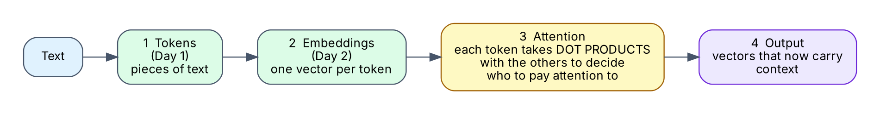
Figure 2. Tokens (Day 1), embeddings (Day 2) and attention. Attention also runs on dot products, the same tool you learn today.
A language model first cuts text into tokens, turns each token into a vector, then lets every token look at the others to decide which ones matter. That 'looking' is done by multiplying vectors together - the dot product. So the same small piece of maths sits inside both search and the language model itself.

3. The concepts, one at a time
Each concept has the same three parts: a one-line meaning, a real-world example, and where you will touch it in the lab.

3.1 Vector
In one line: An ordered list of numbers. Think of it as an arrow from the starting point to a spot on a map.
Real-world example: A GPS location is two numbers (latitude, longitude). A customer on a CRM screen is a row of numbers: age, products held, complaints this year, months since last login.
In the lab: Every word and sentence in data/vectors.json is a list of four numbers.

3.2 Dimension
In one line: One position in the list. Each dimension answers one question.
Real-world example: In our toy bank data the four dimensions are lending, fraud risk, KYC/compliance and customer service. The word 'mortgage' scores [5, 1, 3, 1]: very lending-related, a bit KYC-related, hardly service-related.
In the lab: Real embeddings use hundreds or thousands of dimensions that a model learned itself; nobody can name them. We use four, named, so you can calculate by hand.

3.3 Vector space intuition
In one line: If every item is a point on a map, nearby points mean similar things.
Real-world example: On a city map, shops of the same type cluster in the same bazaar. On a 'map of meaning', 'loan', 'mortgage' and 'overdraft' end up in the same neighbourhood and 'complaint' lives somewhere else.
In the lab: Figure 3 shows three arrows in two dimensions. Everything else in the lab is this same picture with more dimensions.
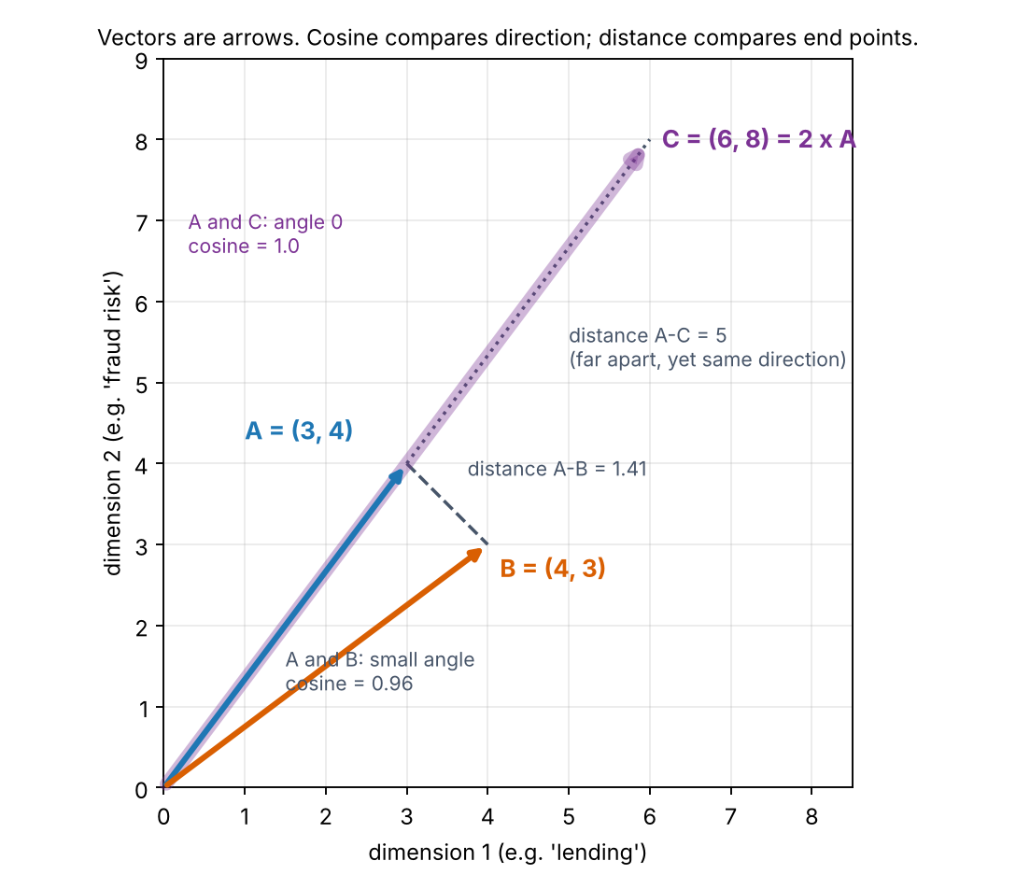
Figure 3. A = (3, 4), B = (4, 3), C = (6, 8). C is A doubled: same direction, twice as long.

3.4 Dot product
In one line: Multiply the matching numbers, then add the results. It is large when the two vectors are strong in the same places.
Real-world example: A shop bill: quantity x price for each item, then the total. Here the 'quantities' are one vector and the 'prices' the other. Another way to see it: two reviewers score the same five features; where both scored high, the sum is large.
In the lab: dot([3, 4], [4, 3]) = 3x4 + 4x3 = 12 + 12 = 24.

3.5 Length (norm)
In one line: How long the arrow is: the square root of the sum of the squares. This is Pythagoras extended to many dimensions.
Real-world example: A ladder leaning on a wall: 3 metres up and 4 metres out gives a 5-metre ladder, because 3 x 3 + 4 x 4 = 25 and the square root of 25 is 5.
In the lab: norm([3, 4]) = sqrt(9 + 16) = 5.

3.6 Cosine similarity
In one line: Do the two arrows point the same way? Cosine similarity = dot product divided by (length of A x length of B). It runs from -1 (opposite) through 0 (unrelated) to 1 (same direction).
Real-world example: Two people at different distances from a fort both point at it: their arms point the same way even though they stand far apart. The 'direction' is the topic; the 'distance from the origin' is mostly how much text there was.
In the lab: cosine([3, 4], [4, 3]) = 24 / (5 x 5) = 0.96. Very similar.

3.7 Euclidean distance
In one line: The straight-line distance between the two end points: subtract matching numbers, square, add, square-root.
Real-world example: As-the-crow-flies distance between two branch offices on a map.
In the lab: distance([3, 4], [4, 3]) = sqrt(1 + 1) = 1.414. Small distance also means 'similar'.

3.8 When cosine and distance disagree
In one line: Cosine ignores length; distance does not. A long document and a short note on the same topic have the same direction but are far apart.
Real-world example: A one-page product leaflet and a 60-page product manual about the same mortgage: same topic, so cosine says 'very similar'; distance says 'far apart' because the manual's vector is much bigger. For text, cosine is the usual default for this reason.
In the lab: step4_why_cosine.py, experiments 1 and 2 show this with numbers. Neither measure is always right - which is why retrieval systems cut documents into chunks of similar size (Day 4).

3.9 Why close vectors tend to mean similar meaning
In one line: Models are trained on huge amounts of text so that words used in similar situations get similar vectors: a word is known by the company it keeps.
Real-world example: In a bank, 'loan' and 'mortgage' appear near the same words (rate, tenure, EMI, collateral). 'Fraud' appears near different words (suspicious, alert, chargeback). So the model places loan and mortgage close together, and fraud far from both.
In the lab: In your toy data, loan vs mortgage gives cosine 0.97 and loan vs fraud gives 0.34.
Limit to remember. Close means 'used in similar contexts', not 'same meaning' and not 'true'. 'Approve the loan' and 'decline the loan' appear in nearly identical contexts, so their vectors can be very close even though the meaning is opposite. That is why a similarity score is evidence for a person or a rule to weigh, not a verdict.

4. One example worked completely by hand
Compare 'loan' = [5, 1, 2, 2] and 'mortgage' = [5, 1, 3, 1].
Step | Working | Result
1. Dot product | 5x5 + 1x1 + 2x3 + 2x1 = 25 + 1 + 6 + 2 | 34
2. Length of loan | sqrt(5x5 + 1x1 + 2x2 + 2x2) = sqrt(25 + 1 + 4 + 4) = sqrt(34) | 5.831
3. Length of mortgage | sqrt(25 + 1 + 9 + 1) = sqrt(36) | 6.000
4. Cosine similarity | 34 / (5.831 x 6.000) = 34 / 34.986 | 0.972
5. Euclidean distance | sqrt((5-5)^2 + (1-1)^2 + (2-3)^2 + (2-1)^2) = sqrt(0 + 0 + 1 + 1) | 1.414

How to read a cosine score (rule of thumb for these toy vectors)
Cosine | Reading | Example from the lab
0.9 to 1.0 | Very similar direction | loan vs mortgage 0.97
0.6 to 0.9 | Related | KYC vs AML 0.80; overdraft vs chargeback 0.77
0.2 to 0.6 | Weakly related | loan vs fraud 0.34; complaint vs fraud 0.36
about 0 | Unrelated | [1, 0] vs [0, 1]
below 0 | Pointing in opposite directions | [1, 2] vs [-1, -2] = -1

These bands only describe the toy data. With real embeddings the useful ranges differ by model and by task, so a real threshold must be measured on your own examples (more on this in section 7).

Common mistakes
Mistake | How to avoid it
Forgetting a square root, or taking the square root of each term separately | Square and add first; take ONE square root at the end
Treating cosine as a distance | Cosine is a SIMILARITY: higher is closer. Distance: lower is closer
Comparing vectors of different lengths (number of dimensions) | They must have the same number of dimensions - the code raises an error
Dividing by zero for an all-zero vector | A zero vector has no direction; cosine is undefined. Treat as 'no information'
Trusting code because it looks right | Compare with your hand answer and run the checker

5. Tools and libraries used
Tool / library | What it is | Why we use it today
VS Code | Code editor with a built-in terminal | One place to read files, run commands and talk to Claude Code
Python 3.11+ | The programming language | Our functions are plain Python so you can read every line
math (standard library) | Built-in square root and friends | The only 'library' the lab code needs
Claude Code CLI | Assistant that reads and edits files in your folder from the terminal | Writes your my_vector_math.py; you check it. Uses the programme key you set up on Day 1
unittest (standard library) | Built-in test runner | Repository tests, and the pattern behind the checker
numpy (optional) | The standard library for fast array maths | Experiment 4 proves your numbers match a professional tool. Real systems use it, or a vector database, for millions of vectors
JSON files | Plain-text data format | data/vectors.json holds the toy vectors

Why plain Python first? If you can write these four functions yourself, you understand what a vector database does for you. Tools hide the maths; today we want to see it.

6. The lab, step by step (Part 1: guided, 2 hours)
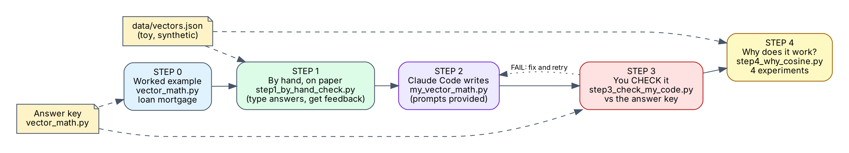
Figure 4. The five steps. Step 3 is the gatekeeper: nothing is 'done' until the checker says PASS.
Time | Step | What happens
0:00 - 0:10 | Set-up | Open vector-math-lab in VS Code; open a terminal; confirm python --version and claude --version
0:10 - 0:25 | Step 0 - worked example | Facilitator runs python vector_math.py loan mortgage and walks through the five lines of working
0:25 - 0:55 | Step 1 - by hand | Pairs calculate four exercises on paper, then type answers into python step1_by_hand_check.py
0:55 - 1:25 | Step 2 - Claude Code | Use CLAUDE_CODE_PROMPTS.md to have Claude Code write my_vector_math.py
1:25 - 1:40 | Step 3 - check | python step3_check_my_code.py. Fix failures; explain each function to your partner
1:40 - 1:55 | Step 4 - why it works | python step4_why_cosine.py; discuss the questions after each experiment
1:55 - 2:00 | Wrap-up | Each pair states one thing that surprised them. Hand-over to the unguided session

Commands (from the vector-math-lab folder)
Step | Command
0 | python vector_math.py --list then python vector_math.py loan mortgage
1 | python step1_by_hand_check.py (add --show only after you tried)
2 | claude then paste the prompts from CLAUDE_CODE_PROMPTS.md
3 | python step3_check_my_code.py
4 | python step4_why_cosine.py
Tests | python -m unittest discover -s tests

Human-in-the-loop habit. Claude Code is fast and usually right, but it can be confidently wrong. In this lab the checker, and the numbers you worked out by hand, are the judges - not the assistant. The same habit applies to anything it builds for your project work.

What good looks like at the end of Part 1
- Four hand-worked exercises, at least three correct on the first or second try.
- my_vector_math.py shows 4/4 PASS in the checker.
- You can explain, in one sentence each: dot product, length, cosine similarity, distance, and why cosine ignores length.
- You can name one case where cosine and distance gave different answers, and which you would trust there.

7. What this means for the CGI BFSI team
The goal of this programme is not general AI knowledge. It is to build people who can apply these ideas inside CGI's banking and financial-services work. So everything in the session is tied to the use cases listed in the programme table of contents (the Business Scenarios & Capstone sheet), which map to CGI's own GenAIOps initiatives.

7.1 Where today's maths shows up in each listed scenario
Scenario (initiative) | Where cosine / distance appears | What to watch in a BFSI setting
1. KYC document remediation assistant (Document Intelligence & Data Remediation) | Matching extracted text to the expected document type; finding near-duplicate or conflicting records; deciding which cases are 'uncertain' and go to a human | Similarity is not identity verification. Never auto-accept an identity or address on a score alone. Keep the source citation. Synthetic or redacted documents only
2. Policy & product knowledge search assistant (Knowledge Search) | Ranking policy clauses against an agent's question; a minimum score below which the assistant says 'I don't know' | Opposite clauses ('eligible' / 'not eligible') can score close. Always show the cited clause. Combine with keyword search (Day 4)
3. Agentic data-quality remediation (Agentic Data Engineering) | Spotting near-duplicate records and similar column names or schemas; ranking likely matches for a human to confirm | Propose, do not auto-merge. High-risk changes need human sign-off. Log the score behind each suggestion
4. Fraud-detection copilot drift watch (AI Observability) | Tracking whether the 'centre' of today's queries or retrieved passages moves away from last month's (distance and cosine between averages) | A threshold needs a baseline measured first. Too sensitive means alert fatigue; too loose means silent degradation
5. Legacy modernization copilot - Mainframe / Informatica (Code Modernization) | Finding the closest existing documentation or similar jobs for a legacy component | Similar text is not the same behaviour. A human reviews any proposed equivalent before anything is deployed

Note for the facilitator: the five scenarios are listed in the programme table of contents and are subject to review by the client's nominated reviewers before the capstone phase. Confirm their current validation status before presenting them as approved.

7.2 Ground rules: building only around client-listed use cases
- Traceable. Every example, exercise and demo in this session links to one of the five listed scenarios or to a foundation concept in the table of contents. No new use case is introduced in class without client sign-off.
- Synthetic or redacted data only. No real customer, account or employee data in files, prompts or screenshots.
- Thresholds are business decisions. A cut-off such as 'cosine below 0.8 goes to a human' is chosen with the process owner, measured on examples, written down, and revisited.
- Explainable. In an audit you must be able to show the two texts, the score and the rule that acted on it. This is why we calculate the score ourselves today.
- No accuracy claims without evidence. Say 'this ranked the right clause first in 8 of 10 test questions', not 'it is 95% accurate'.
- A human owns the decision. In regulated work the score ranks and flags; a person approves actions that affect customers or money.

7.3 How it supports a mixed-experience cohort
If you are... | Use Day 3 to...
New to AI, strong in Python / data engineering | Build intuition: do the by-hand work first, then read the code. The maths is school-level; the new idea is applying it to meaning
Experienced with GenAI and RAG | Go deeper: unit vectors and the identity distance^2 = 2 - 2 x cosine (experiment 3); why high dimensions behave differently; how thresholds are tuned; what can fail in similarity search
Pairing | Pair a stronger coder with a less experienced one. The one who knows more explains; the other types the answers

7.4 What comes next
- Day 4. Applied Math for Semantic Search & RAG: nearest-neighbour search without a vector database, metadata filtering, benchmark against keyword search.
- Day 5 Friday checkpoint. A quick quiz plus a short applied maths task on this week's content, and the next week's pre-read.
- Week 5 onwards. Hybrid search, semantic reranking and GraphRAG build directly on the ideas from today.
- Capstone. Scenarios 1 and 2 especially depend on getting similarity, thresholds and human review right.

8. Cheat sheet and glossary
Name | Formula (a and b are vectors) | Range | Higher means
Dot product | a1 x b1 + a2 x b2 + ... | any number | stronger agreement (but depends on length)
Length (norm) | sqrt(a1^2 + a2^2 + ...) | 0 or more | longer arrow
Cosine similarity | dot(a, b) / (length(a) x length(b)) | -1 to 1 | more similar
Euclidean distance | sqrt((a1-b1)^2 + (a2-b2)^2 + ...) | 0 or more | MORE DIFFERENT (lower is more similar)

Term | Meaning
Embedding | The vector a model produces for a piece of text
Unit vector | A vector of length 1. For unit vectors the dot product equals cosine similarity
Orthogonal | At right angles: cosine 0, nothing in common
Nearest neighbour | The item whose vector is closest to the query (Day 4)
Threshold | A cut-off score that decides what happens next: accept, review, or reject
Zero vector | All zeros; has no direction; cosine is undefined

Appendix A - Answer key (look only after you have tried)
Exercise | Vectors | Dot product | Cosine | Euclidean distance
E1 | [3, 4] and [4, 3] | 24 | 0.96 | 1.414
E2 | [3, 4] and [6, 8] | 50 | 1.00 | 5.000
E3 | loan and mortgage | 34 | 0.972 | 1.414
E4 | loan and fraud | 11 | 0.344 | 6.481

Appendix B - Troubleshooting
Symptom | Fix
ModuleNotFoundError: vector_math | Run commands from inside the vector-math-lab folder
python / claude not found | Open a NEW terminal after installing; on Windows try py
Checker says TODO | my_vector_math.py still has the placeholder functions: do Step 2
Claude Code asks permission to edit a file | Allow it for my_vector_math.py only; read the change before moving on
Your cosine is greater than 1 | A calculation slip (usually a missing square root). Recheck the lengths

