# Tableau L1 Training Assignment

# Connecting to Data and Bar graph Visualization

1. Connect to Sample Superstore excel file through excel. Once Connected
   1. Create a Data source level filter to show data after year 2013.

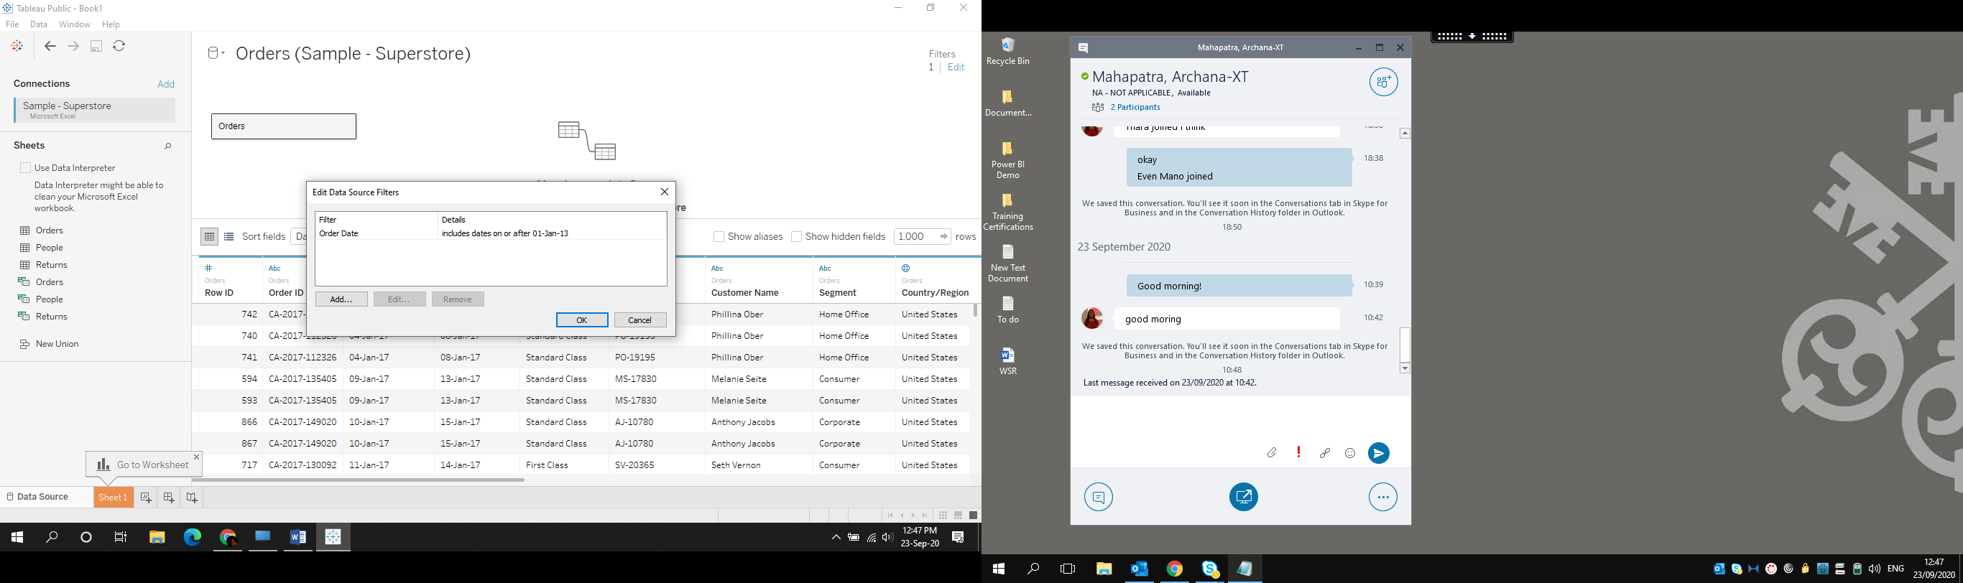

* 1. Fetch Orders table in “Drag Sheet Here “area.

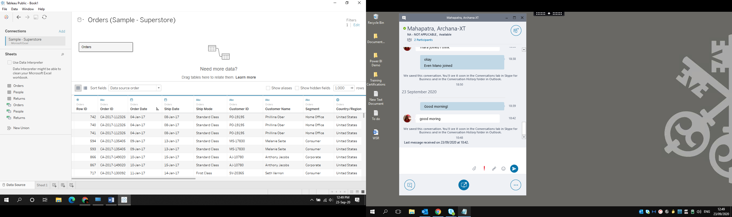

* 1. Show Top 300 rows only

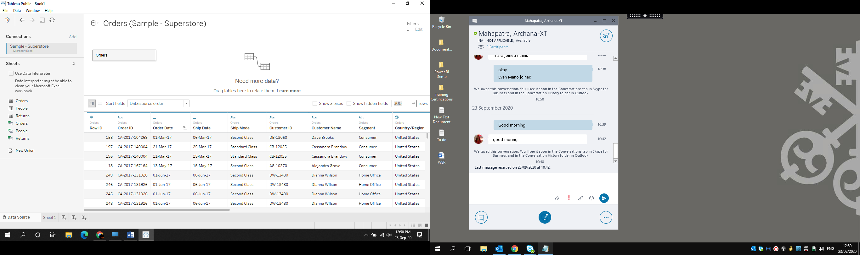

* 1. Create few basic charts using Dimensions & Measures.

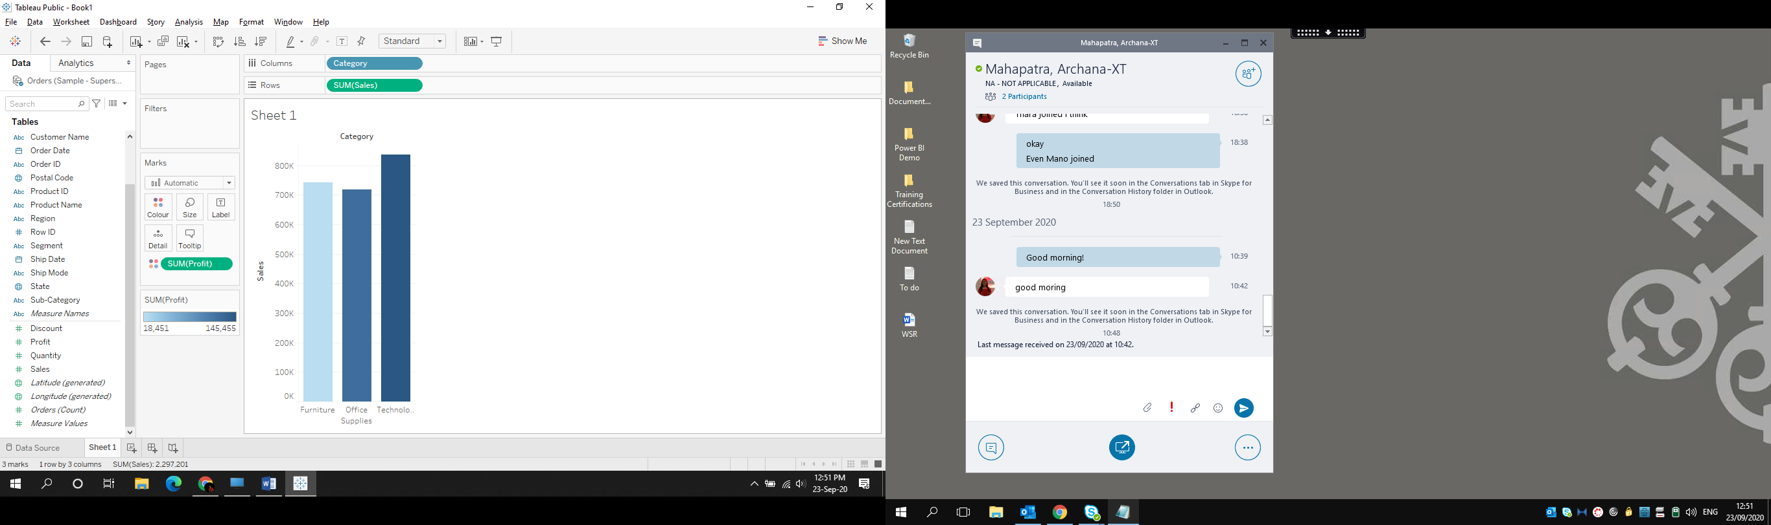

* 1. Change the Data source from Sample superstore to Global Superstore.

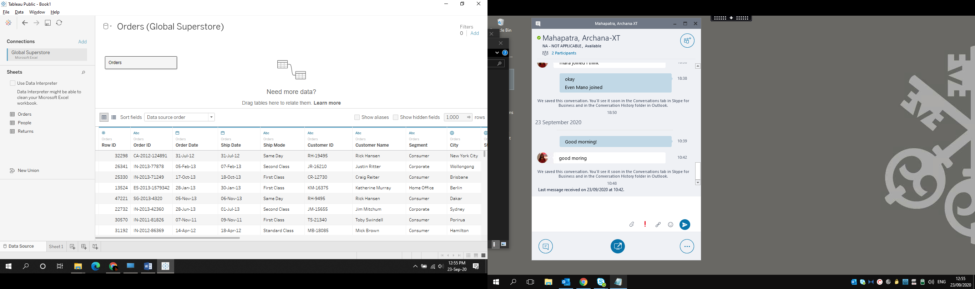

1. Create extract of the connected data source on your desktop.

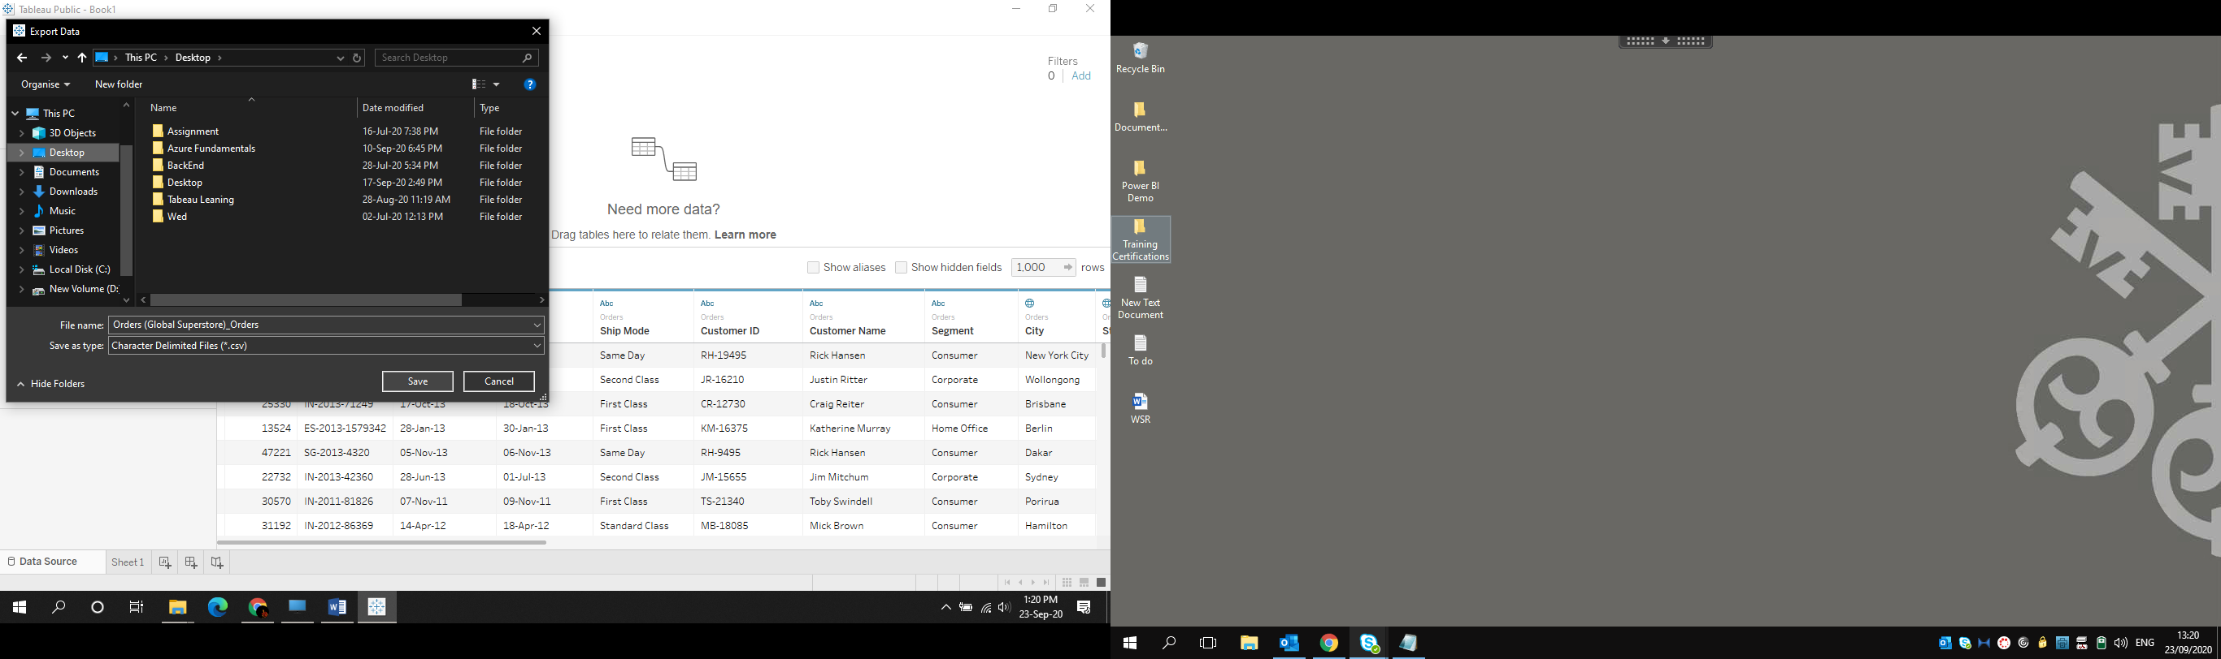

1. Connect to Data source & Create Incremental refresh on Order Date.

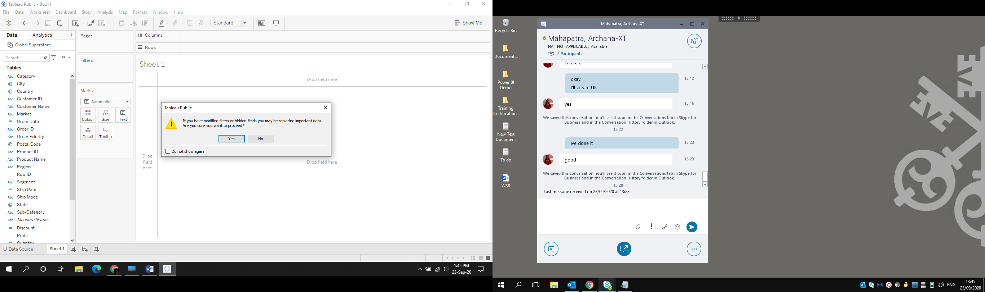

1. Create a Left Join between Orders and Returns Table based on Common column name.

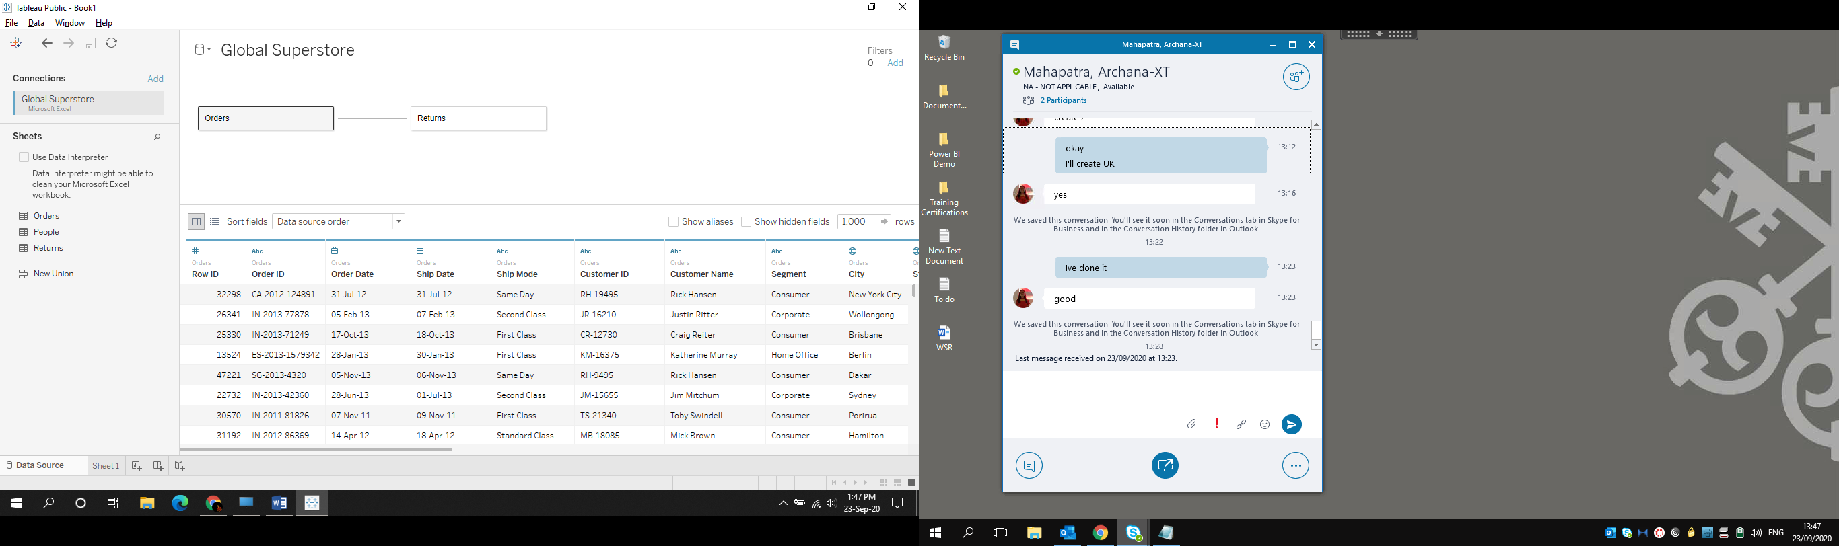

1. Create Bar chart for top 5 Products by Sales amount.

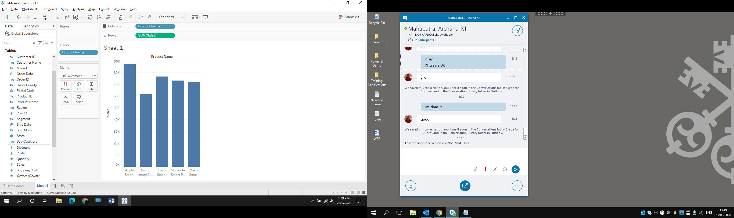

1. Create a heat map to Identify the top customer by region ,
   1. Dimension: Customer Name, Region
   2. Measures: Profit and Sales

