ROLLNO:19UITE021

NAME:J.NITHYA SHRI

SUBJECT:IT8711-FOSS and cloud computing laboratory

Ex 8: Virtual Machine Creation in OpenStack Cloud Platform (Online)

# Step 1: Switch to “root” user

user@vmub-hadoop1:~$ sudo su - root@vmub-hadoop1:~# sudo apt-get update

**Step 2: Install “git” and logout from “root user”** root@vmub-hadoop1:~# sudo apt-get install git root@vmub-hadoop1:~# exit

logout

user@vmub-hadoop1:~$

# Step 3: Create/Add a user “stack” with “no password”

user@vmub-hadoop1:~$ sudo useradd -s /bin/bash -d /opt/stack -m stack user@vmub-hadoop1:~$ echo "stack ALL=(ALL) NOPASSWD: ALL" | sudo tee

/etc/sudoers.d/stack

stack ALL=(ALL) NOPASSWD: ALL

# Step 4: Move to “stack” user

user@vmub-hadoop1:~$ sudo su - stack

# Step 5: Clone the “devstack” from the specified link

stack@vmub-hadoop1:~$ git clone <https://github.com/openstack-dev/devstack>

Cloning into 'devstack'...

remote: Enumerating objects: 49330, done.

remote: Counting objects: 100% (2556/2556), done. remote: Compressing objects: 100% (836/836), done.

remote: Total 49330 (delta 1831), reused 2226 (delta 1709), pack-reused 46774 Receiving objects: 100% (49330/49330), 15.56 MiB | 2.33 MiB/s, done.

Resolving deltas: 100% (34462/34462), done. Checking connectivity... done.

**Step 6: Move to “/devstack/samples”** stack@vmub-hadoop1:~$ cd devstack stack@vmub-hadoop1:~/devstack$ ls

clean.sh doc functions gate lib openrc roles stackrc tools CONTRIBUTING.rst extras.d functions-common HACKING.rst LICENSE playbooks run_tests.sh stack.sh tox.ini

data files FUTURE.rst inc Makefile README.rst **samples** tests unstack.sh

stack@vmub-hadoop1:~/devstack$ cd samples stack@vmub-hadoop1:~/devstack/samples$ ls **local.conf** local.sh

# Step 7: Copy “local.conf” file to “devstack”

stack@vmub-hadoop1:~/devstack/samples$ cp local.conf ../ stack@vmub-hadoop1:~/devstack/samples$ cd .. stack@vmub-hadoop1:~/devstack$ ls

clean.sh doc functions gate lib Makefile README.rst samples tests unstack.sh

CONTRIBUTING.rst extras.d functions-common HACKING.rst LICENSE openrc roles stackrc tools

data files FUTURE.rst inc **local.conf** playbooks run_tests.sh stack.sh tox.ini

# Step 8: Open “local.conf” and edit the lines

stack@vmub-hadoop1:~/devstack$ nano local.conf

ADMIN_PASSWORD=**p1** DATABASE_PASSWORD=**p1** RABBIT_PASSWORD=**p1** SERVICE_PASSWORD=**p1**

HOST_IP=**10.0.2.4**

FLOATING_RANGE=**10.0.2.224/27**

**Step 9: Remove the following files to Lock the error** stack@vmub-hadoop1:~/devstack$ sudo rm /var/lib/dpkg/lock stack@vmub-hadoop1:~/devstack$ sudo rm /var/lib/apt/lists/lock

stack@vmub-hadoop1:~/devstack$ sudo rm /var/cache/apt/archives/lock stack@vmub-hadoop1:~/devstack$ sudo rm -rf /var/lib/apt/lists/*

# Step 10: To install stack

stack@vmub-hadoop1:~/devstack$ FORCE=yes ./stack.sh

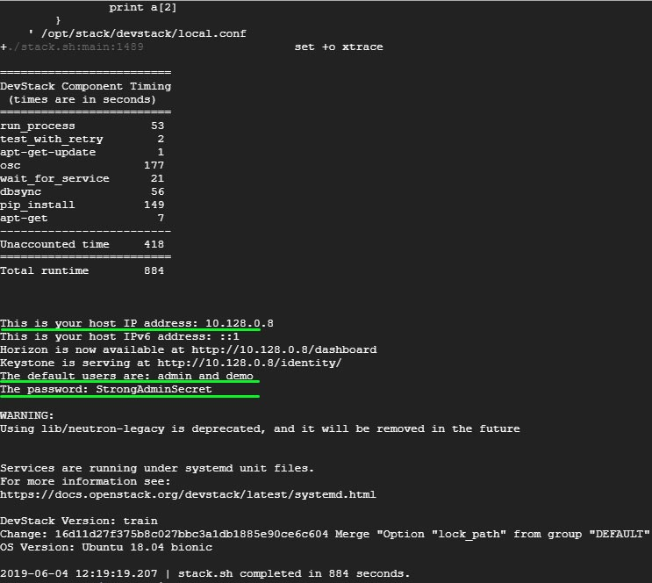

# Accessing OpenStack on a web browser

To access OpenStack via a web browser browse your Ubuntu’s IP address as shown. <https://server-ip/dashboard>

This directs you to a login page as shown.

