Student Companion

Project Plan and First Iteration Report

COMP-SCI 5551 Advanced Software Engineering

Group 7

Sri Harsha Chennavajjala (7)

Teja Garidepally (12)

Raj Kiran Reddy Munnangi (32)

Suhas Sai Raparthi (51)

# Introduction

This document is intended to provide an overall description of the project named “Student Companion” in detail. The project schedule and the plan of action is also discussed. The proposal document will give an insight on the project. The outcome of the first increment is the high and low level design of the application.

# Project Goal and Objectives

The goal of this project is to provide various functionalities that a student uses regularly such as updating the profile, checking for computer lab availability, library study room reservation etc. The student details will already present in the database. The student has to login before he uses these functionalities. Main objectives of this application are:

* To reduce the student’s stress and to save the student’s time by providing the latest availability of the computer labs.
* To develop an application that helps the students in taking the decision on to which laboratory the students have to go.
* To secure the information by providing a login form to the end user.
* To provide a tool with which the students will be able to reserve the library study rooms.
* To ensure that the student will never miss his schedules by setting reminders.
* To enable the Student Assistants to view their shifts, post and take substitutions.
* To provide the students with the option to update their address or mobile phone number etc.

# Project Background and Related Work

Some functionalities of this application are already exist. We are creating a new android application which integrates (mash up) all the available and new functionalities under one hood, thus making the application a viable one. Some functionalities will be developed by importing the existing APIs into our application like Google Calendar API, Google Maps API etc. We are inspired by the problems that the Students are currently facing in reserving the study rooms, problems related to their working shifts and we came up with a solution which can resolve the existing challenges.

**Significance:**

The major significance of the application lies in mashing up of all the useful services under one system. This will save the student’s time and increases the productivity. The application will prevent the fraudulent usage by restricting the resources access to only the students who successfully logged in to the system. As of now, the student assistants has to go through a lengthy process in order to post or take shifts. The proposed application will make it easier for the student to perform such tasks by providing on-the-go support.

# Project Plan

The proposed project plan is outlined the by the screenshot from the ZenHub tool. The project is divided into four milestones. Each iteration has several states namely future tasks, new issues, to do, development in progress, testing in progress, done and closed.

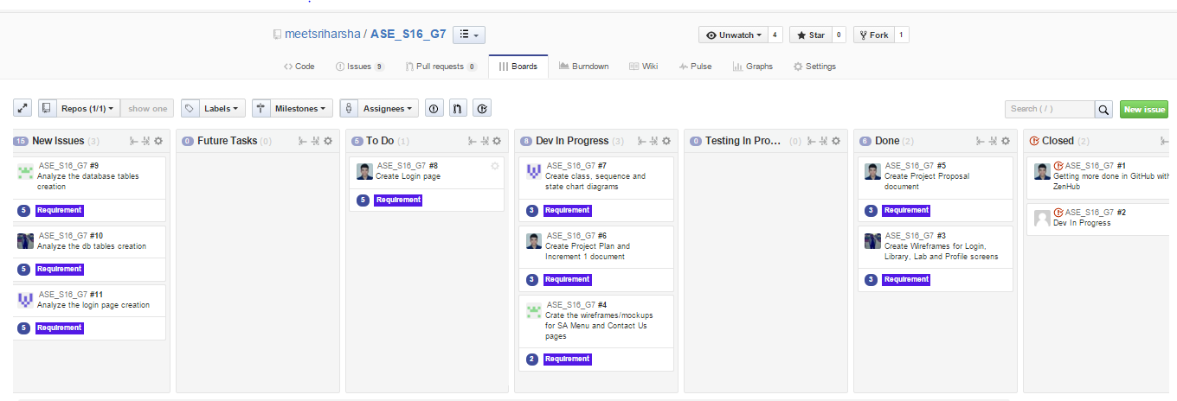

Fig. 1 ZenHub Board showing the project plan and current tasks.

**Milestone 1:**

This milestone mainly deals with the designing the system for the implementation phase. The tasks of this phase mainly focuses on the UML diagram and collecting the necessary requirements details for the realization and development of the application. The results of this milestone contains the mockup screens of the application and the related class, sequence and state chart diagrams.

# First Increment Report

This document contains the report of first increment of work done on the Student Companion application. This document emphasizes the pictorial representation of the application using different implementations to get an insight on the internal system. We’re using the HTML5, CSS and Angular JS for the front end user interface creation.

First increment mainly involves in designing the application. We’ve created the class diagrams and sequence diagrams which depicts the workflow and the module relationships of the application. We’ve generated the application blueprint using the wireframes.

**Class diagram for the high level design of the application:**

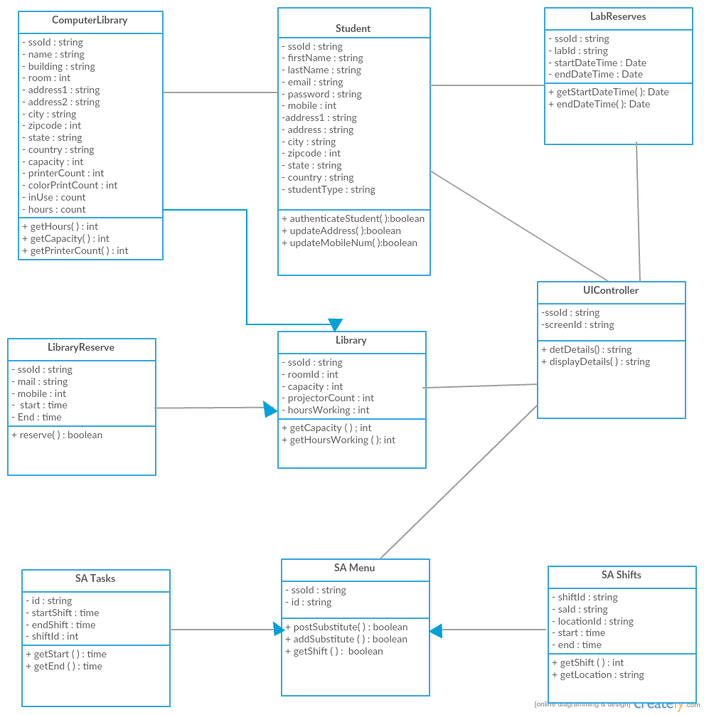

Fig. 2 demonstrates a class diagram of high level design of application

**Sequence diagrams for the high level design of the application:**

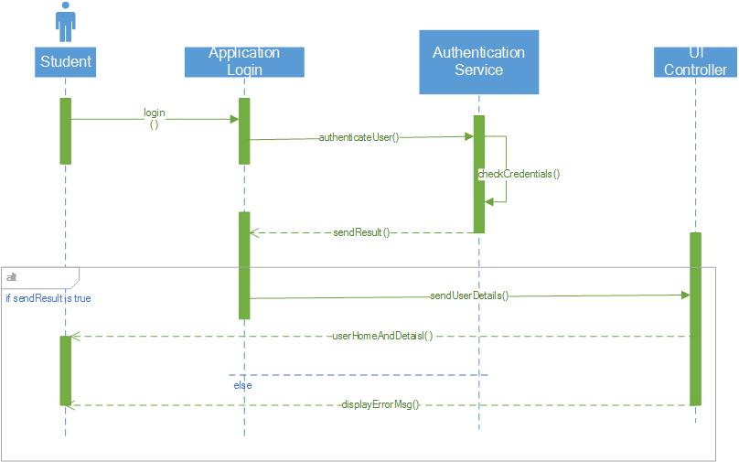

Fig. 3 Sequence diagram for student login activity

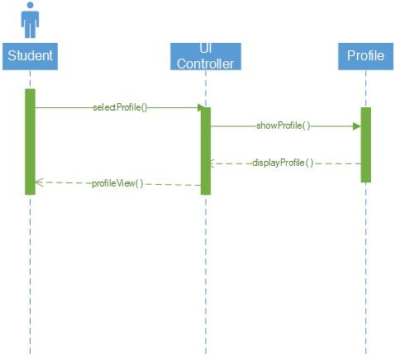

Fig. 4 Sequence diagram shows the control flow for “view user profile” task

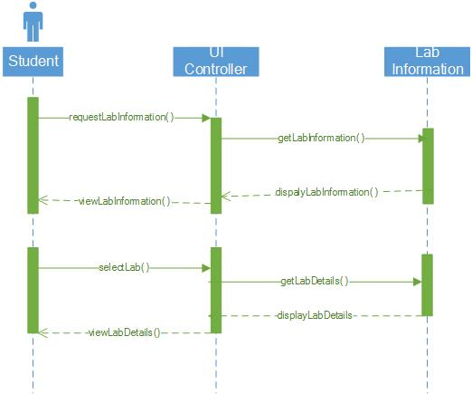

Fig. 5 Sequence diagram for “View lab information” activity

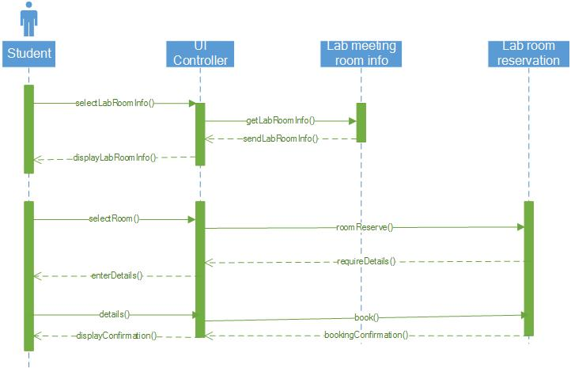

Fig. 6 Sequence diagram for reserving library study room activity

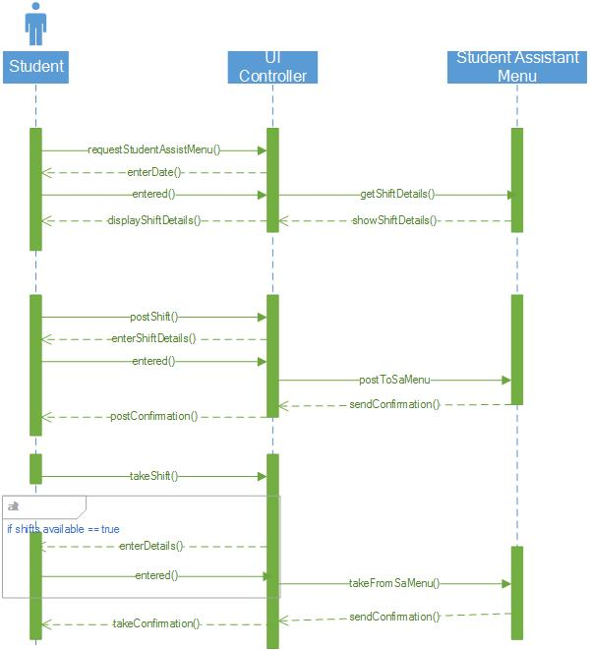

Fig. 7 Sequence diagram for student assistant activities like post or take shifts.

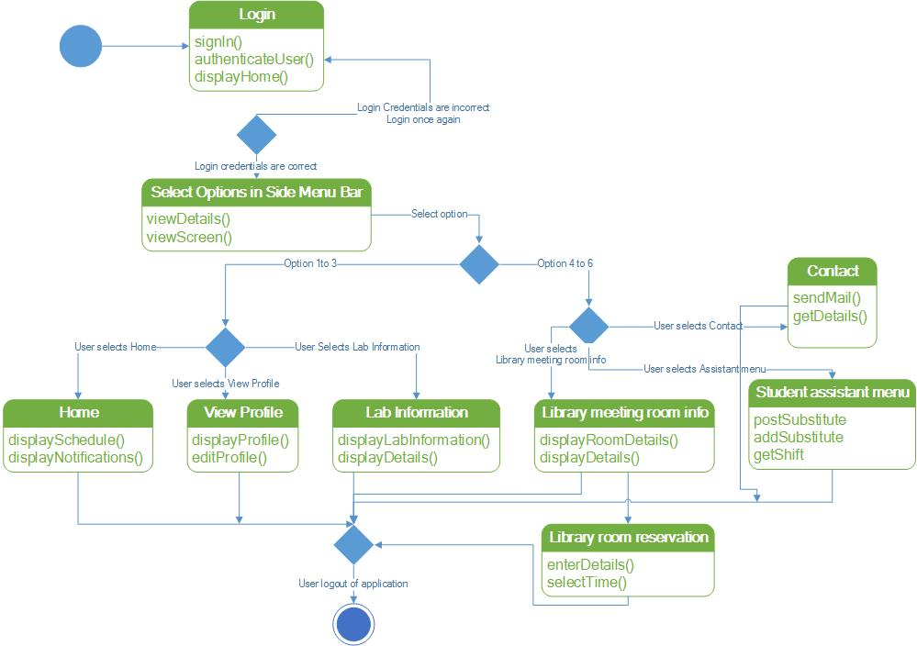

Fig. 8 State chart diagram for the application modules.

## Wireframes of the application

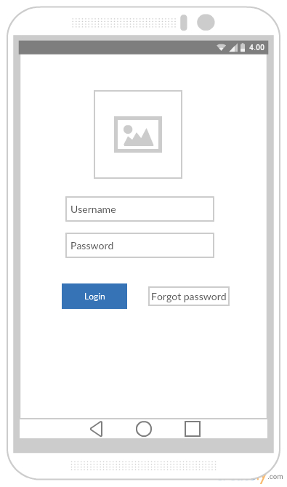

Fig. 9 Login screen

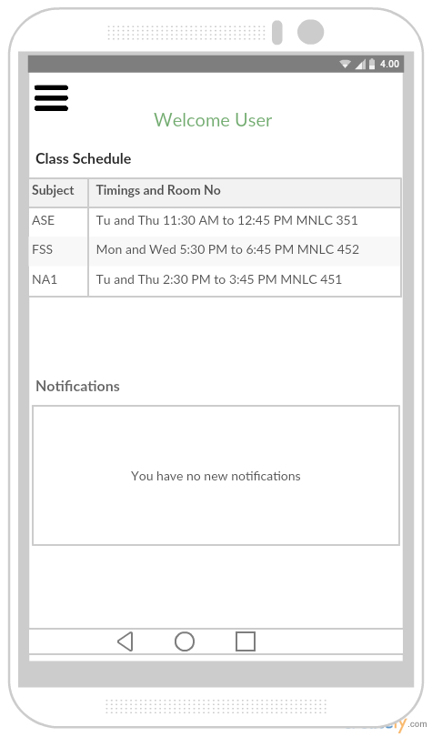

Fig. 10 Main Home page

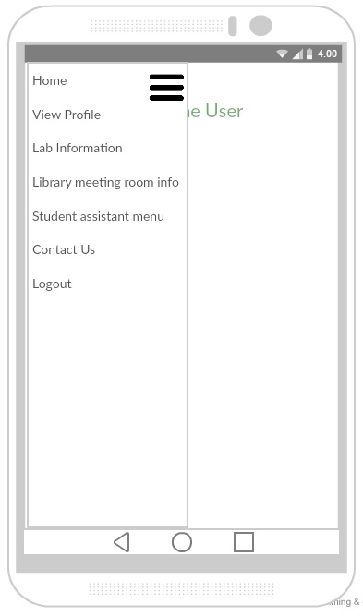

Fig. 11 Side menu bar

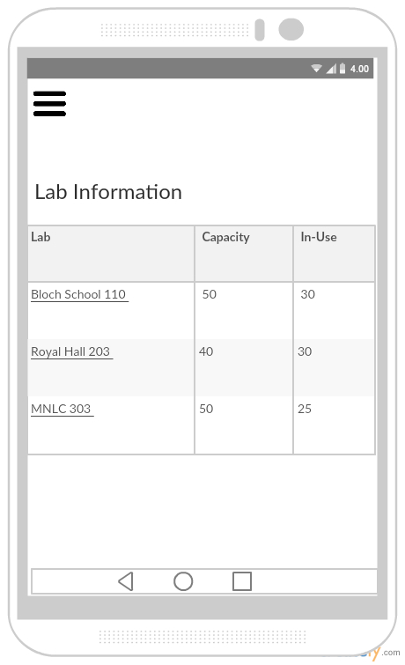

Fig. 12 Computer Labs information page

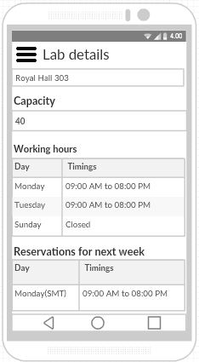

Fig. 13 Detailed information of a computer lab

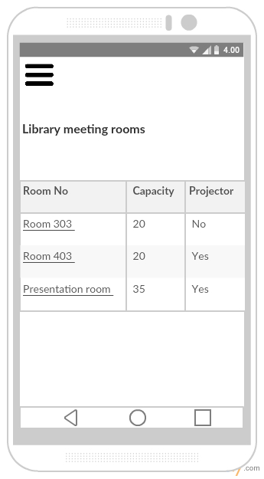

Fig. 14 Library study room information

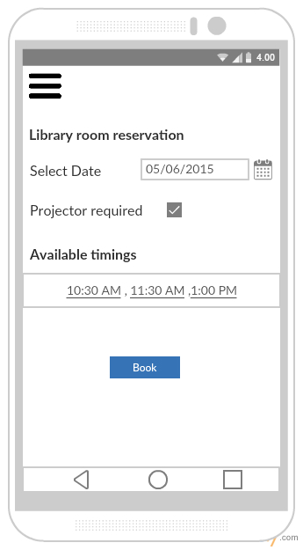

Fig. 15 Library room reservation page

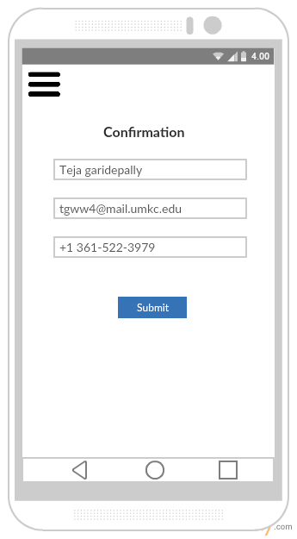

Fig. 16 Library room reservation form

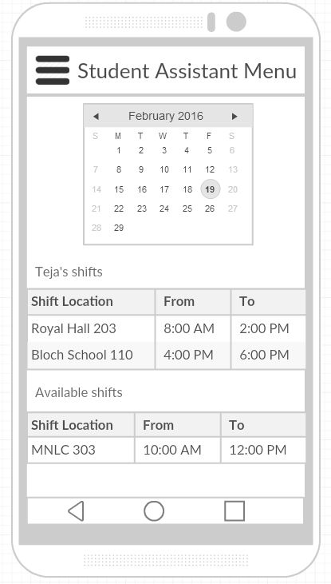

Fig. 17 Student Assistant menu page

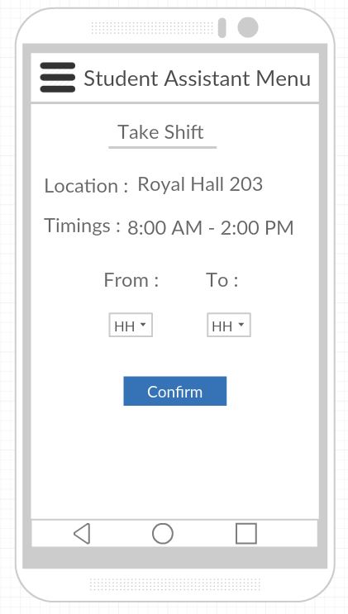

Fig. 18 Taking a Student Assistant shift

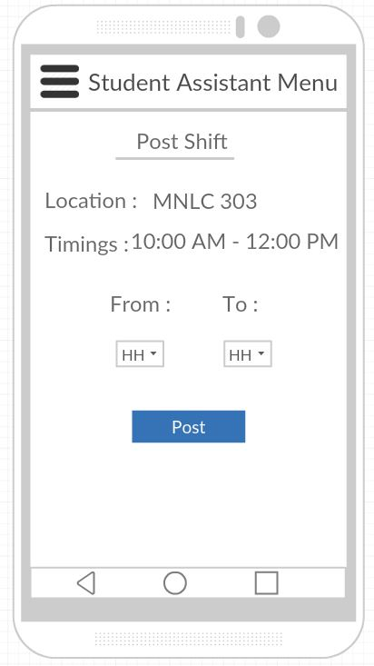

Fig. 19 Posting a Student Assistant shift

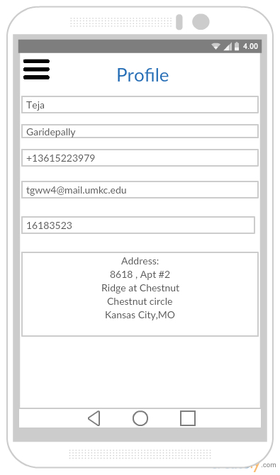

Fig. 20 Student profile page

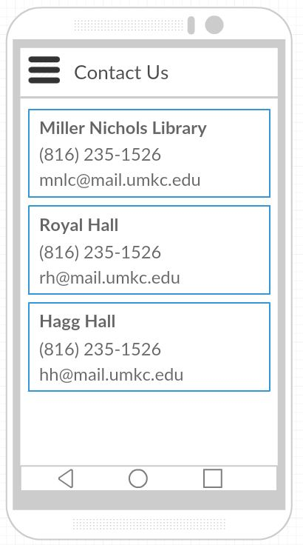

Fig. 21 Contact Us information page

# Project Management

## Work Completed

In detailed analysis of the system, environment and technical requirements for the application development. Project proposal documentation, Project tasks created in ZenHub and assigned the tasks to team members. Created the Project increment 1 document. All team members are involved in this task. Total time taken is 30 hours per person. Contributions: Harsha 30%, Teja 25%, Raj 25%, Suhas 20%.

## Work To Be Completed

We need to work on login page creation (both UI and logic) and the backend database tables creation. We would like to use mongo db as our database server. Raj Kiran and Harsha will work on login page creation. Teja and Suhas will work on creation of sample database tables. Projected person participation: Harsha 25%, Teja 25%, Raj 25%, Suhas 25%.

# Bibliography

* + University of Missouri Library -<http://library.umkc.edu/>
  + UMKC IS Labs - <http://www.umkc.edu/is/labs>
  + Top Library management android applications - [http://appcrawlr.com/androidapps/best-apps-library-manager](http://appcrawlr.com/android-apps/best-apps-library-manager)
  + SFU: Student Companion - <https://play.google.com/store/apps/details?id=com.teamzeta.sfu&hl=en>
  + ZenHub - Agile project management tool for GitHub - <https://www.zenhub.io>