Student Companion

Second Iteration Report

COMP-SCI 5551 Advanced Software Engineering

Group 7

Sri Harsha Chennavajjala (7)

Teja Garidepally (12)

Raj Kiran Reddy Munnangi (32)

Suhas Sai Raparthi (51)

# Introduction

This document is intended to provide an overall description of the project named “Student Companion” in detail. The project schedule and the plan of action is also discussed. The proposal document will give an insight on the project. The outcome of the second increment is the login page validation, database creation, home page creation and side menu creation.

# Project Goal and Objectives

The goal of this project is to provide various functionalities that a student uses regularly such as updating the profile, checking for computer lab availability, library study room reservation etc. The student details will already present in the database. The student has to login before he uses these functionalities. Main objectives of this application are:

* To reduce the student’s stress and to save the student’s time by providing the latest availability of the computer labs.
* To develop an application that helps the students in taking the decision on to which laboratory the students have to go.
* To secure the information by providing a login form to the end user.
* To provide a tool with which the students will be able to reserve the library study rooms.
* To ensure that the student will never miss his schedules by setting reminders.
* To enable the Student Assistants to view their shifts, post and take substitutions.
* To provide the students with the option to update their address or mobile phone number etc.

# Project Background and Related Work

Some functionalities of this application are already exist. We are creating a new android application which integrates (mash up) all the available and new functionalities under one hood, thus making the application a viable one. Some functionalities will be developed by importing the existing APIs into our application like Google Calendar API, Google Maps API etc. We are inspired by the problems that the Students are currently facing in reserving the study rooms, problems related to their working shifts and we came up with a solution which can resolve the existing challenges.

**Significance:**

The major significance of the application lies in mashing up of all the useful services under one system. This will save the student’s time and increases the productivity. The application will prevent the fraudulent usage by restricting the resources access to only the students who successfully logged in to the system. As of now, the student assistants has to go through a lengthy process in order to post or take shifts. The proposed application will make it easier for the student to perform such tasks by providing on-the-go support.

# Work flow

The first workflow of the application is that of the designing the User Interface for the system. Our application goal is to provide instant access to the user regarding lab availability and library room availability. So, for this we are developing an mobile application. We are using ionic framework so that we can develop hybrid application.

Second, we have created the login page and database using MongoLab and we have successfully authenticated the user based on his details which are stored in database in mongodb.

The third workflow deals with the creating a mongodb database to store and retrieve the user profile and information about IS labs, library study rooms etc. The work flow of the each and every feature of the application is explained through sequence diagrams and state chart diagram presented in the first increment report.

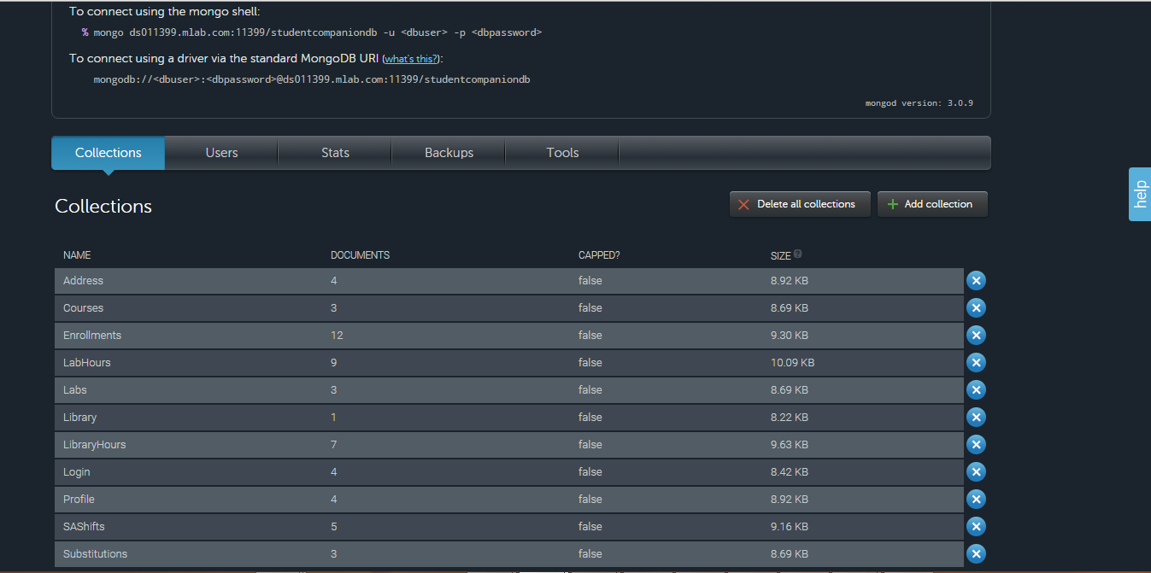

# Technological and architecture requirements

In the application system need to interact with the database for retrieving the data to do this interaction between the system and database is done through REST technology. We use CRUD API calls of the REST for accessing the database.

Ionic framework, it is a powerful SDK used to develop hybrid applications using web technologies like HTML, CSS and JavaScript. It is also a core in providing better UI to the user.

The architectural requirement aims at the development of flexible architecture for the better interaction between the system and the database.

# Existing Services/API

We have so far used the MongoDB in our application. MongoDB is a cross-platform document-oriented database and it is a NoSQL database, MongoDB avoids the traditional table-based relational database structure in favor of JSON-like documents with dynamic schemas making the integration of data in certain types of applications easier and faster.

We have used mongoDB to store the information of the users and data about the IS labs, library study rooms, student assistant information etc. Using REST API calls data is retrieved from the database and displayed to the user.

mLab is a fully managed cloud database service that hosts and provide featuring automated provisioning and scaling of MongoDB databases. Data can be accessed from mongoDB using two ways. Fist, by using the DATA APT URL in which it contains database name, collection name and API key.

Example URL:

**[https://api.mongolab.com/api/1/databases/studentcorner/collections//Ase\_project/'](https://api.mongolab.com/api/1/databases/studentcorner/collections//Ase_project/' + id + '?apiKey=Q_u73BV4oOdMGpnu3WFGmJ8YH_HDHO)** [+ id +](https://api.mongolab.com/api/1/databases/studentcorner/collections//Ase_project/' + id + '?apiKey=Q_u73BV4oOdMGpnu3WFGmJ8YH_HDHO) **['?apiKey=Q\_u73BV4oOdMGpnu3WFGmJ8YH\_HDHO](https://api.mongolab.com/api/1/databases/studentcorner/collections//Ase_project/' + id + '?apiKey=Q_u73BV4oOdMGpnu3WFGmJ8YH_HDHO)**

Second, accessing the mongoDB using a driver to connect the database. An example driver:

mongodb://<dbuser>:<dbpassword>@ds011399.mlab.com:11399/studentcompaniondb

# Architecture Diagram

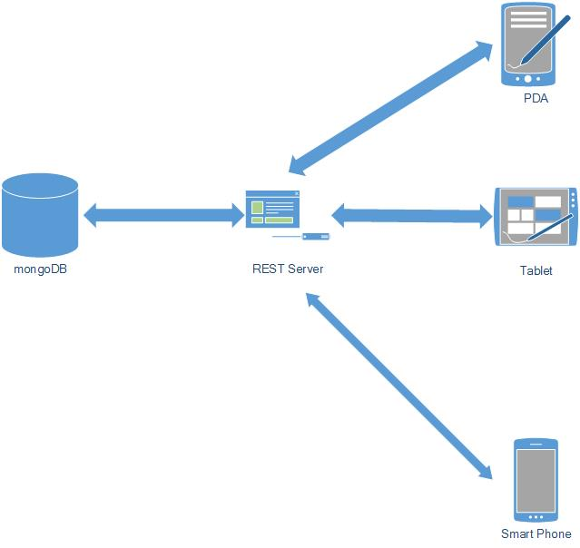

Fig 1: Architecture Diagram for StudentCompanion

The architecture diagram for our application shows that it is 3-tier architecture. Application which deployed in smart phones, PDA’s and Tablet uses the REST services for interacting with the database for storing and retrieval of required information from the mongoDB.

# Project plan

The proposed project plan is outlined the by the screenshot from the ZenHub tool. The project is divided into four milestones. Each iteration has several states namely future tasks, new issues, to do, development in progress, testing in progress, done and closed.

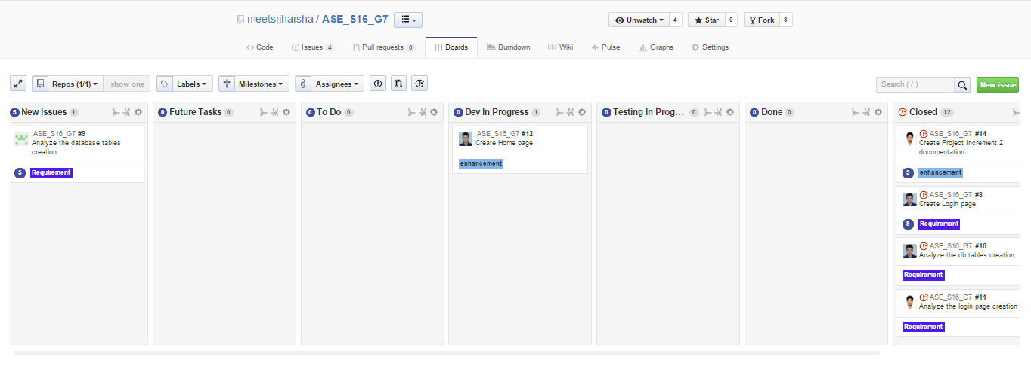

Fig. 2 ZenHub Board showing the project plan and current tasks.

**Milestone 2:**

This milestone mainly deals with the designing the system for the implementation phase. The tasks of this phase mainly focuses three tasks.

First, the development of basic skeleton which gives pleasant UI to the user.

Second, development of login page and authentication of user using his/her credentials which are stored in the mongoDB.

Third, creation of database using mongoDB , populating the database and accessing the database using monoDB API.

The results of this milestone contains the screenshots of the application and the related class, sequence and state chart diagrams.

# Second Increment Report

This document contains the report of second increment of work done on the Student Companion application. This document emphasizes the initial implementation of the application using different web technologies such as CSS,HTML5,JavaScript and mongoDB. We’re using the HTML5, CSS and Angular JS for the front end user interface creation.

We have created our database in mongoDB and the interaction between the system and database is through REST API calls. We have used mongoDB API for data accessing by using API key authentication.

We have created the login page and the user login is done by authenticating the user by checking the credentials with that are stored in database. We have also checked the work so far by deploying the application in the mobile and manual testing is done.

The detail development in second increment include the login page, database creation using mongoDB and accessing database using REST API calls. We are going to work on the other features in the side menu bar in upcoming increment.

**Class diagram for the high level design of the application:**

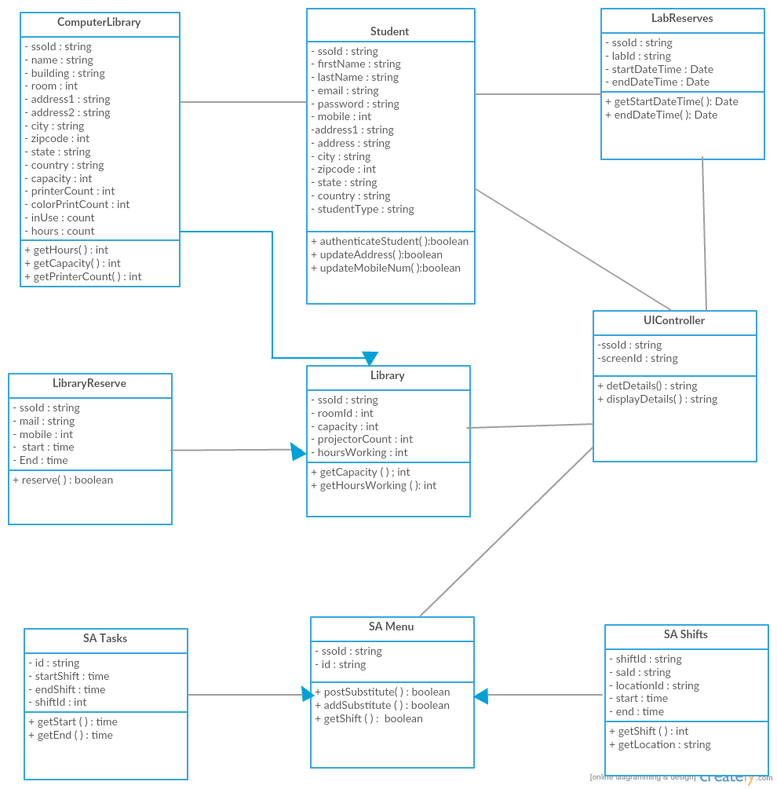

Fig. 2 demonstrates a class diagram of high level design of application

**Sequence diagrams for the high level design of the application:**

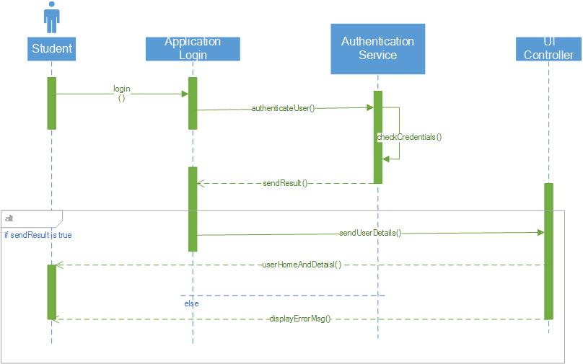

Fig. 3 Sequence diagram for student login activity

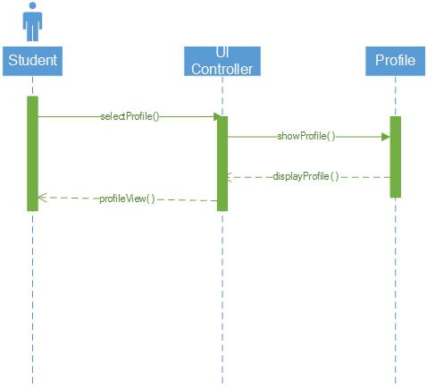

Fig. 4 Sequence diagram shows the control flow for “view user profile” task

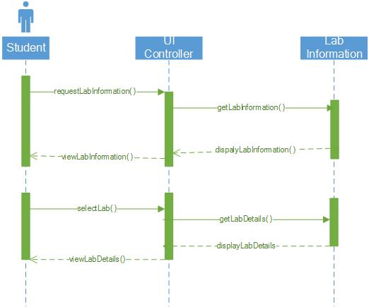

Fig. 5 Sequence diagram for “View lab information” activity

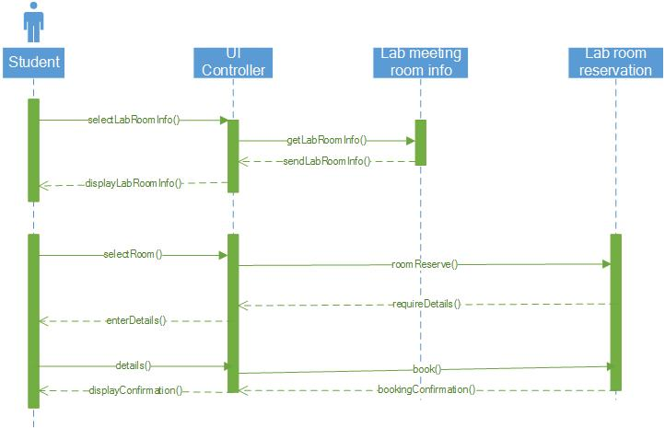

Fig. 6 Sequence diagram for reserving library study room activity

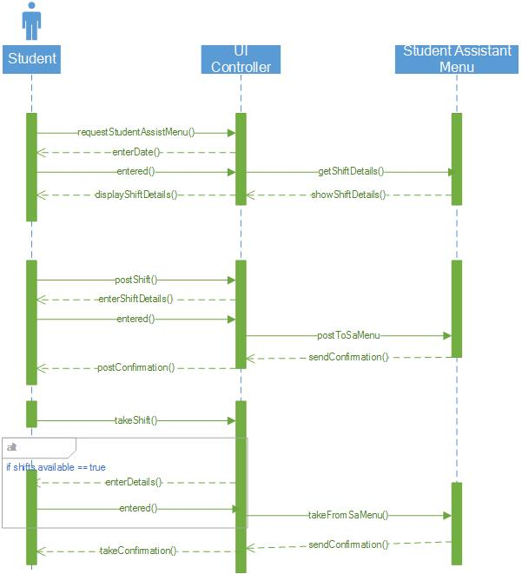

Fig. 7 Sequence diagram for student assistant activities like post or take shifts.

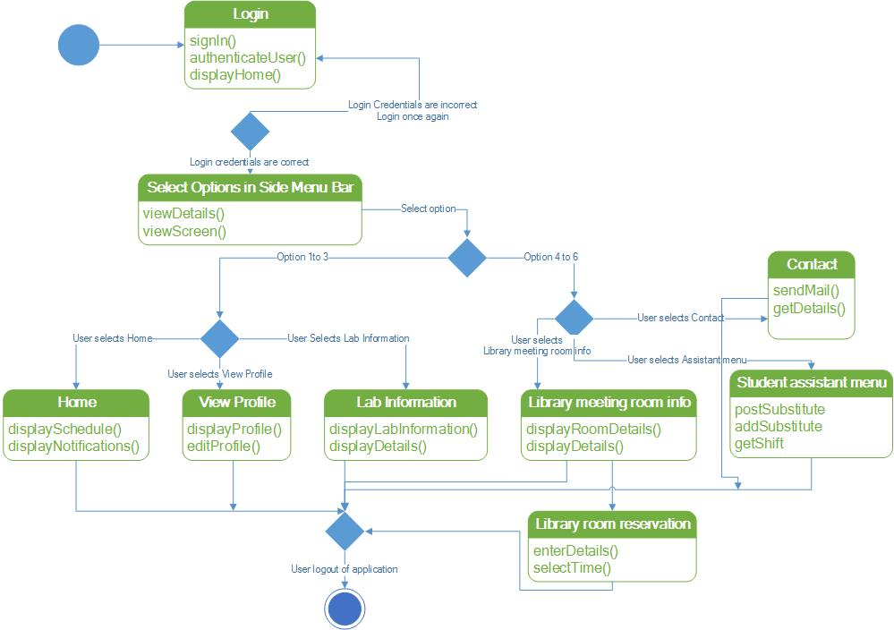

Fig. 8 State chart diagram for the application modules.

## Wireframes of the application

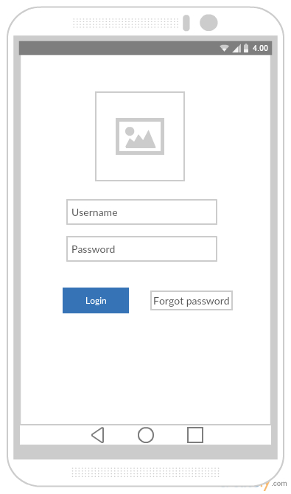

Fig. 9 Login screen

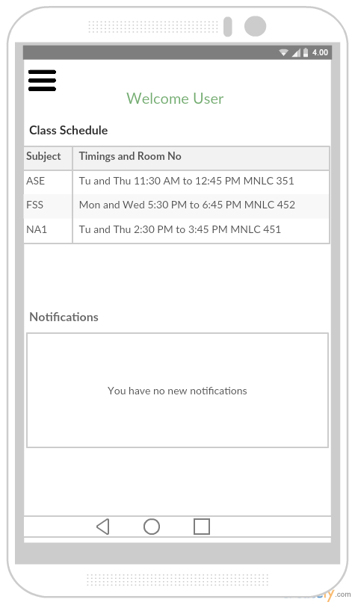

Fig. 10 Main Home page

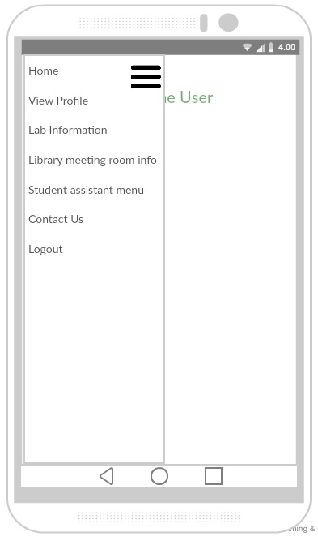

Fig. 11 Side menu bar

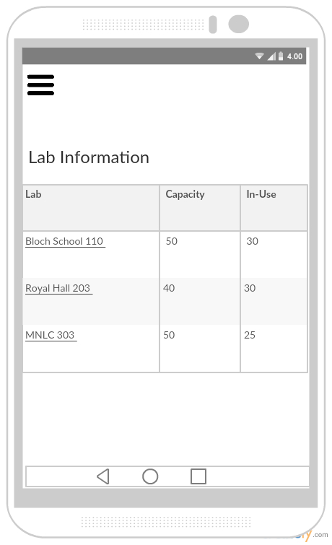

Fig. 12 Computer Labs information page

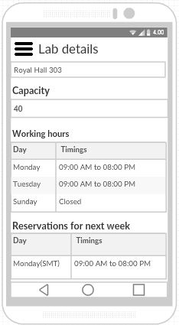

Fig. 13 Detailed information of a computer lab

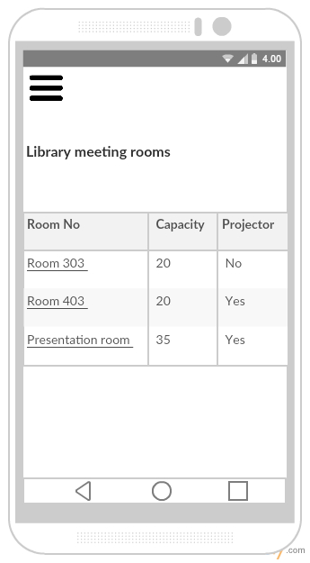

Fig. 14 Library study room information

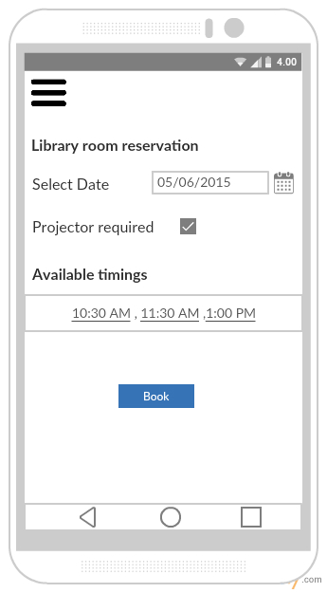

Fig. 15 Library room reservation page

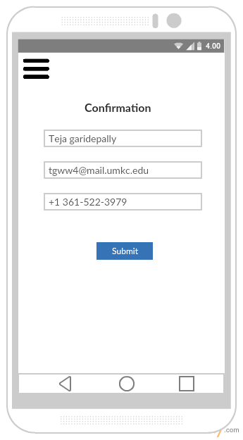

Fig. 16 Library room reservation form

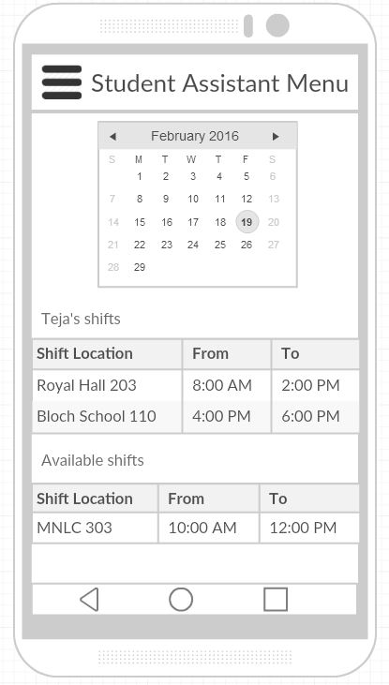

Fig. 17 Student Assistant menu page

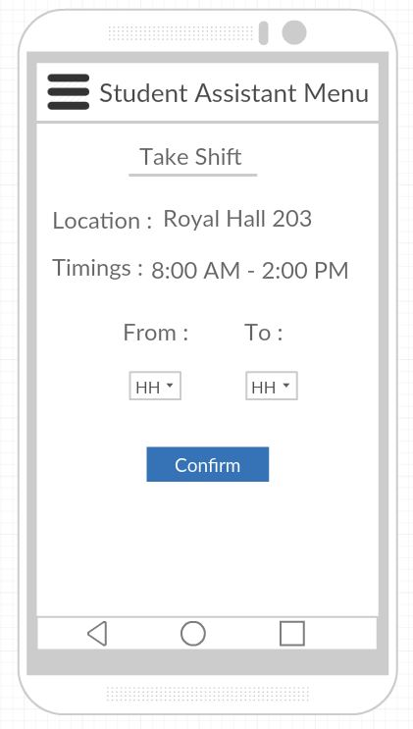

Fig. 18 Taking a Student Assistant shift

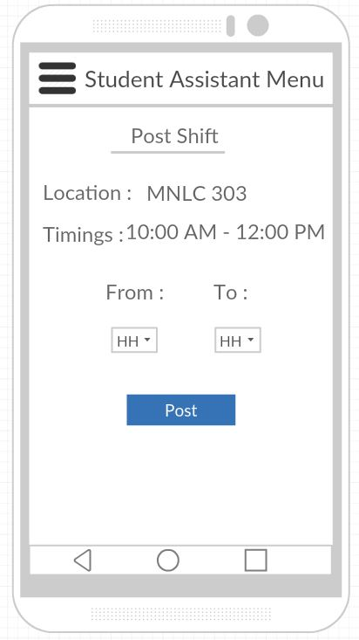

Fig. 19 Posting a Student Assistant shift

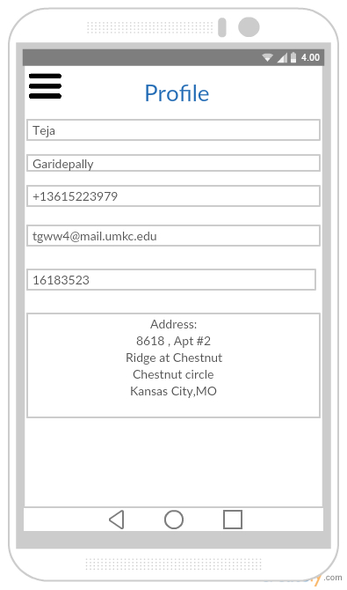

Fig. 20 Student profile page

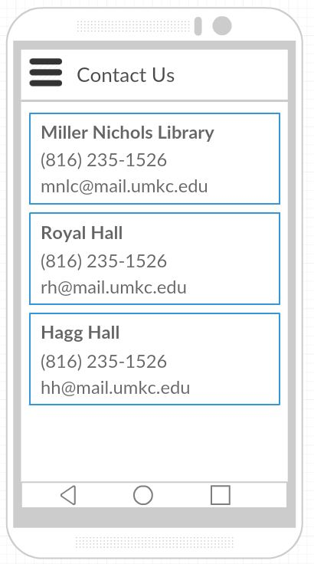

Fig. 21 Contact Us information page

**User Stories:**

* As a User, I can see the UI of StudentCompanion App.
* As a user, I can see the Login Screen.
* As a user, I can enter my Details and Login to the App.
* As a user, I can see the Side menu bar on Home Page with side menu options like Profile, Lab Information, Reserve Study Room, and SA Menu.
* As a User, I can see my Profile.
* As a User, I can see the Lab Information of specified lab.
* As a User, I can Reserve Study Room.
* As a User, I can choose the SA Menu option
* As a User, I can utilize the options in SA Menu.

As a user, I can Sign-out from the Application.

# Deployment

Deployment of application to Mobile phone.

Screen Shots:

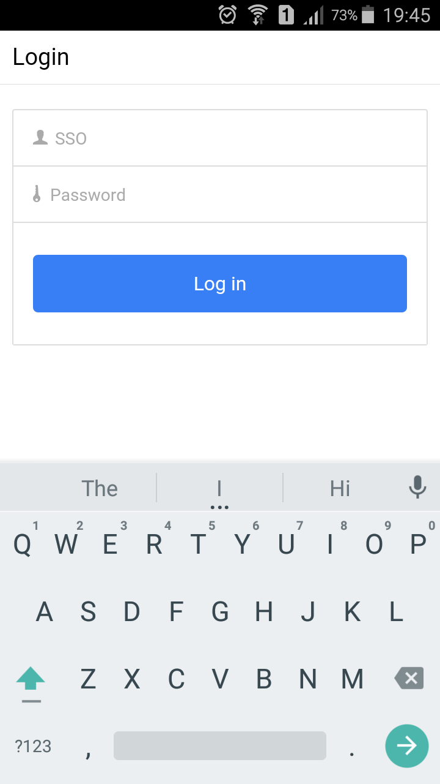

Fig: Login Screen

# C:\Users\RajKiranReddyM\Desktop\aseprojectincrement2appscreenshots\Testing.png

Fig : Login Fail message screen

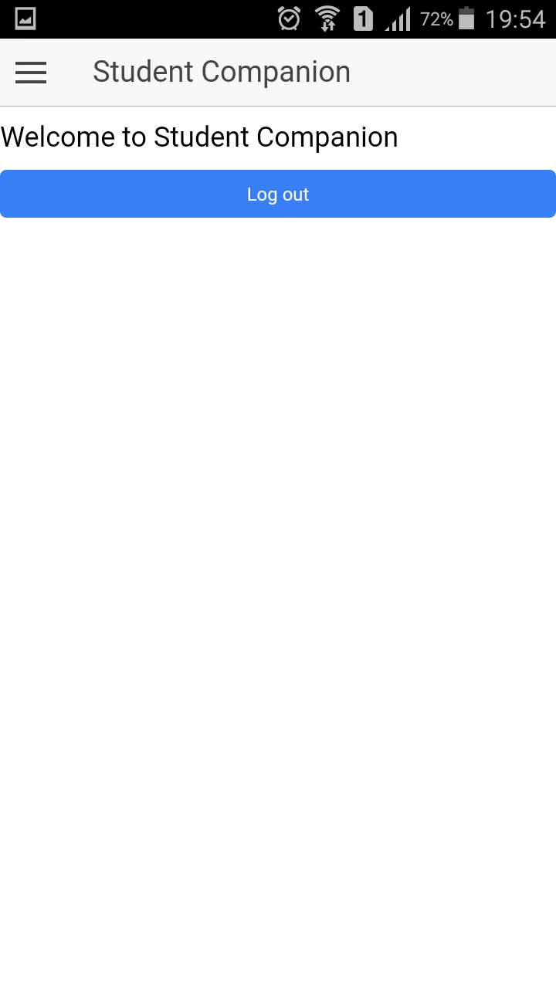

Fig: Home Screen

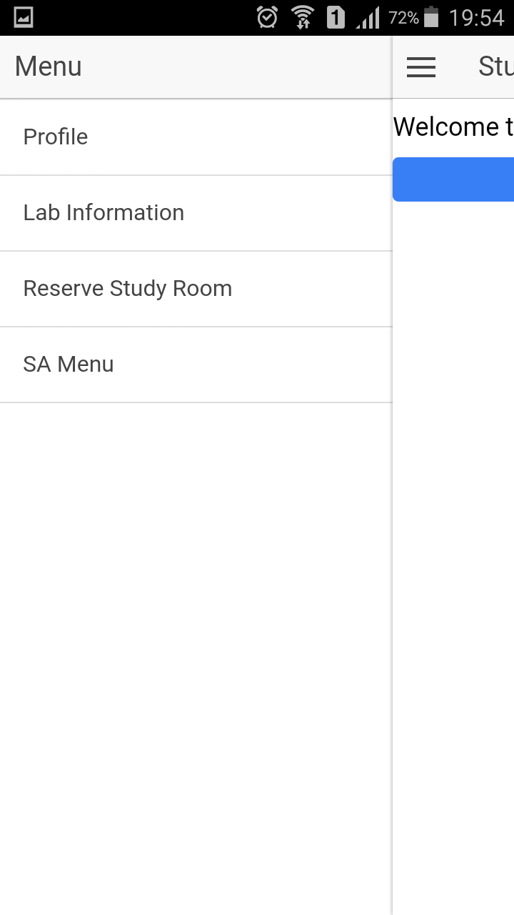

Fig: Side Menu

**Web Application:**

**Screenshots:**

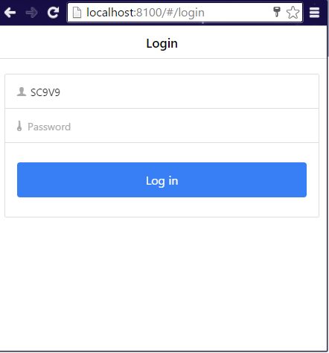

Fig: Login

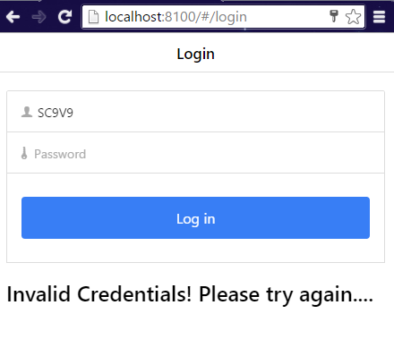

Fig: Login fail message screenshot

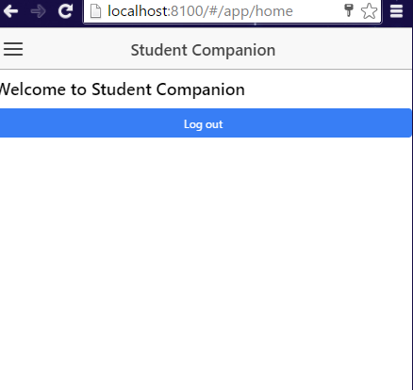

Fig : Home

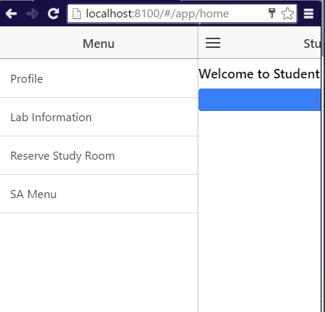

Fig: Side Menu

**Project URL:**

<https://github.com/meetsriharsha/ASE_S16_G7/tree/master/SourceCode/Increment2/StudentCompanion>

**Second Increment Document URL:**

<https://github.com/meetsriharsha/ASE_S16_G7/tree/master/Documentation>

# Project Management

## Work Completed

In detailed analysis of the system, environment and technical requirements for the application development. Project proposal documentation, Project tasks created in ZenHub and assigned the tasks to team members. Created the Project increment 1 document. All team members are involved in this task. Total time taken is 50 hours per person. Contributions: Harsha27.5%, Teja 27.5%, Raj 27.5%, Suhas 17.5%.

## Work To Be Completed

We need to work on remaining side-menu pages creation (both UI and logic) and we need to work on UI tweaking. We’re planning to concentrate on controller logic of the application. Raj Kiran and Harsha will work on Profile and Home page creation. Teja and Suhas will work on computer lab information and library information pages. We will also work on calendar inclusion for library room reservation. Projected person participation: Harsha 25%, Teja 25%, Raj 25%, Suhas 25%.

# Bibliography

* + University of Missouri Library -<http://library.umkc.edu/>
  + UMKC IS Labs - <http://www.umkc.edu/is/labs>
  + Top Library management android applications - [http://appcrawlr.com/androidapps/best-apps-library-manager](http://appcrawlr.com/android-apps/best-apps-library-manager)
  + SFU: Student Companion - <https://play.google.com/store/apps/details?id=com.teamzeta.sfu&hl=en>
  + ZenHub - Agile project management tool for GitHub - <https://www.zenhub.io>