DevOps Lab
Exercise 1

- Exploring Git Commands through Collaborative Coding – Basic Git commands.
Setting Up Git Repository named "Master"
- Open your terminal (Command Prompt, Git Bash, etc.).
- Navigate to the directory where you want to create the repository.
- Initialize a new Git repository by running the following command:
git init Master
- Change directory into the new repository:
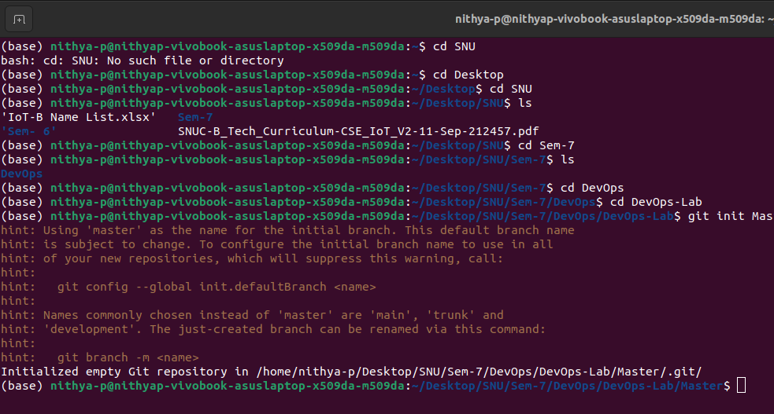
cd Master

Create a new text file named ReadMe.txt using any text editor
- Add the new file to the staging area:
git add ReadMe.odt
- Commit the change with a message:
git commit -m "Add ReadMe.odt"

c. Exploring history
Modify/add content to the text file
- Stage the changes:
git add ReadMe.odt
- Commit the changes:
git commit -m "Update ReadMe.odt with additional content"

d. Branching and merging
Create a new branch named "Updated_ReadMe" and commit the changes in the branch
- Create a new branch:
git checkout -b Updated_ReadMe
- Open ReadMe.odt and make further modifications.
- Save the file and close the editor.
- Stage and commit the changes:
git add ReadMe.odt
git commit -m "Update ReadMe.txt in Updated_ReadMe branch"
Merge the changes from the Updated_ReadMe branch into the Master branch
- Switch back to the master branch:
git checkout master
- Merge the changes from Updated_ReadMe:
git merge Updated_ReadMe

e. Collaborating with Remote Repositories
Link your local repository to the remote repository
- Create a repository on a hosting service like GitHub (if you haven't already).
- Copy the repository URL
- Link your local repository to the remote repository:

f. Push Changes
Push your local commits to the remote repository
- Push the changes to the remote repository:
git push -u origin master

Exercise 2: Implement GitHub Operations using Git

a. Cloning a Repository
Clone the repository of your project from GitHub
- Copy the URL of the repository you want to clone (e.g., https://github.com/yourusername/Master.git).
- Clone the repository:
sh
Copy code
git clone https://github.com/yourusername/Master.git
- Change directory into the cloned repository:
sh
Copy code
cd Master

b. Making Changes and Creating a Branch
Navigate into the cloned repository, do the necessary changes and check the status of the repository
- Open ReadMe.txt and make any necessary changes.
- Save the file and close the editor.
- Check the status of the repository:
sh
Copy code
git status
- Create a new branch:
sh
Copy code
git checkout -b feature-update

c. Pushing Changes to GitHub
Add Repository URL in a variable
- Add the remote repository URL in a variable:
sh
Copy code
REPO_URL="https://github.com/yourusername/Master.git"
- Stage and commit your changes:
sh
Copy code
git add ReadMe.txt
git commit -m "Update ReadMe.txt in feature-update branch"
Push the local branch to the repository
- Push the changes to the remote repository:
sh
Copy code
git push -u origin feature-update

d. Collaborating through Pull Requests
Create a pull request on GitHub
- Go to your repository on GitHub.
- Click on the "Pull requests" tab.
- Click on "New pull request".
- Choose the base branch (e.g., master) and compare it with the branch you want to merge (e.g., feature-update).
- Review the changes and click on "Create pull request".
- Add a title and description for the pull request.
- Assign reviewers if necessary.
Reviewers approve the pull request, merge it into the base branch
- Once reviewers approve the pull request, click on "Merge pull request".
- Confirm the merge.

e. Syncing Changes
After the pull request is merged, update your local repository
- Update your local repository with the latest changes from the remote repository:
git checkout master
git pull origin master

