

A Project Report On

**Tourism Guide System**

**BY**

**NITHYAPRIYA.V**

**BSC(CS)**

**Batch:** 2020 – 5351

#### Center: CHROMPET

Under the Guidance of,

**Jayant V.**

#### Technical Trainer

**EduBridge**

(School of coding)

**Introduction:**

Our project explains about the Online Mobile Recharge System name Mobile Recharge .This project mainly explains the various actions related to online Recharge. You can recharge your mobile through online . Our Project Include **Modules:-**

* Admin Module
* User Page
* New Registration
* Subscribe Login
* I have developed this Application in **Java, JSP and MySQL.** It’s a web-based projects so I have used **HTML, CSS, JavaScript and Bootstrap also**.

### The main feature of the project is to make Recharge Details easily . You canaccess this website from anywhere and everywhere.

* In Admin module, admin can add the Recharge ,Offer and Banking in the specific. He can also view the total number of users at present in the website. And Recharge ,Offer and Banking details also. Admincan only see the admin page.
* In User login and registration with field validation and session management .Able to add new recharge Offer with price and special offer details on existing operator.
* Recharge can be made with existing plan or customer price entered by user.

#### Software Requirements:

**Front end:** Java/J2EE technologies (Servlet, JSP), HTML, CSS, JavaScript, Bootstrap.

**Libraries**: jstl-1.2( JSP Taglib)

MySQL workbench 8.0.23CE.

**Middleware/Server:** Apache Tomcat v8.5. IDE: Eclipse IDE for Java EE Developers

**Browser:** Best result on Google Chrome

**Operating System:** Window 10.

## Data Dictionary:

### Create Database OMR

* DROP TABLE IF EXISTS `admin`;CREATE TABLE `admin` (

`username` varchar(50) NOT NULL DEFAULT '', `password` varchar(50) DEFAULT NULL, PRIMARY KEY (`username`)) ENGINE=MyISAM DEFAULT

CHARSET=latin1;LOCK TABLES `admin` WRITE;INSERT INTO `admin` VALUES ('admin','root') ; UNLOCK TABLES**;**

* DROP TABLE IF EXISTS `offer`;CREATE TABLE `offer` (`id` int NOT NULL AUTO_INCREMENT,`operator` varchar(50) DEFAULT NULL, `state` varchar(50) DEFAULT NULL, `amount` varchar(50) DEFAULT NULL,`offerdetail` varchar(1000) DEFAULT NULL,PRIMARY KEY (`id`)) ENGINE=MyISAM AUTO_INCREMENT=6 DEFAULT CHARSET=latin1;

LOCK TABLES `offer` WRITE;INSERT INTO `offer` VALUES (1,'airtel','karnataka','50','get talktime of Rs 100') , (5,'vodafone','tatadocomo','43','make your connection lifetime') ; UNLOCK TABLES;

* + DROP TABLE IF EXISTS `rechargedetail`;CREATE TABLE`rechargedetail` ( `amount` varchar(50) DEFAULT NULL,

`operator` varchar(50) DEFAULT NULL,`username` varchar(50) DEFAULT NULL, `transid` varchar(50) DEFAULT NULL) ENGINE=MyISAM DEFAULT CHARSET=latin1;LOCK TABLES `rechargedetail` WRITE;INSERT INTO

`rechargedetail`VALUES('null','null','sritolia','36908350'),('34','reliance','sritol ia','89904393'),('34','reliance','sritolia','37012051'),('23','reliance','sritolia','995

01537'),('35','reliance','sritolia','23719975'),('20','reliance','sritolia','87122237')

,('23','airtel','nayan','24345546'),('300','tatadocomo','ass','11950799'),('34','relia nce','sritolia','10972525'),('558','airtel','kishor','5603046');

UNLOCK TABLES;

* + DROP TABLE IF EXISTS `subscribe`;CREATE TABLE `subscribe` (`name` varchar(50) DEFAULT NULL, `emailid` varchar(50) DEFAULT NULL, `phoneno` varchar(50) DEFAULT NULL) ENGINE=MyISAM DEFAULT CHARSET=latin1;LOCK TABLES `subscribe` WRITE;INSERT INTO `subscribe VALUES ('srikant','srikant.ritolia@gmail.com','9886579971'),('xyz','xyz@mohan.com',' 1234567891'),('KishorKadam','kadamk33@gmail.com','7276763516');

UNLOCK TABLES;

* + DROP TABLE IF EXISTS `transaction detail`; CREATE TABLE`transaction detail` (`transid` varchar(50) DEFAULT NULL,`bank` varchar(50) DEFAULT NULL,`acctype` varchar(50) DEFAULT NULL, `accno` varchar(50) DEFAULT NULL, `pin` varchar(50) DEFAULT NULL,

`username` varchar(50) DEFAULT NULL) ENGINE=MyISAM DEFAULT CHARSET=latin1;LOCK TABLES `transactiondetail` WRITE;INSERT INTO `transactiondetail` VALUES('99501537','null','null','null','null','sritolia')

,('23719975','sboi','anp','3232','323','sritolia'),('87122237','sboi','anp','2121212'

,'22121','sritolia'),('24345546','sboi','anp','2323','2323','nayan'),('11950799','sb

oi','anp','576567','543','ass'),('10972525','sboi','anp','2323','23','sritolia'),('5603 046','sboi','anp','255869347','0014','kishor');

* + DROP TABLE IF EXISTS `user`; `fname` varchar(50) NOT NULL,`lname` varchar(50) DEFAULT NULL, `address` varchar(50) DEFAULT NULL,`email` varchar(50) DEFAULT NULL, `phoneno` decimal(10,0) NOT NULL,`username` varchar(50) NOT NULL,`password` varchar(50) NOT NULL, PRIMARY KEY (`username`)) ENGINE=MyISAM DEFAULT CHARSET=latin1;LOCK TABLES `user` WRITE;INSERT INTO `user` VALUES ('srikant','ritolia','1067, block','srikant.ritolia@gmail.com'

,9886579971,'sritolia','ritolia'),('Nayan','Mittal','dad','adasd',1234567891,'naya n','nayan'),('Kishor','Kadam','Pune','kadamk33@gmail.com',7276763516,'kish or','java@1991');UNLOCK TABLES;

## Screenshots:-

HOME Page

**Home Page:**

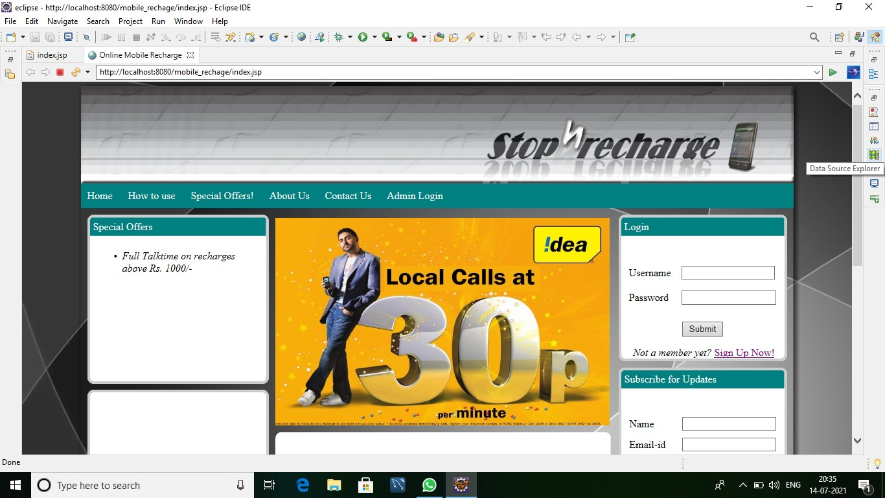

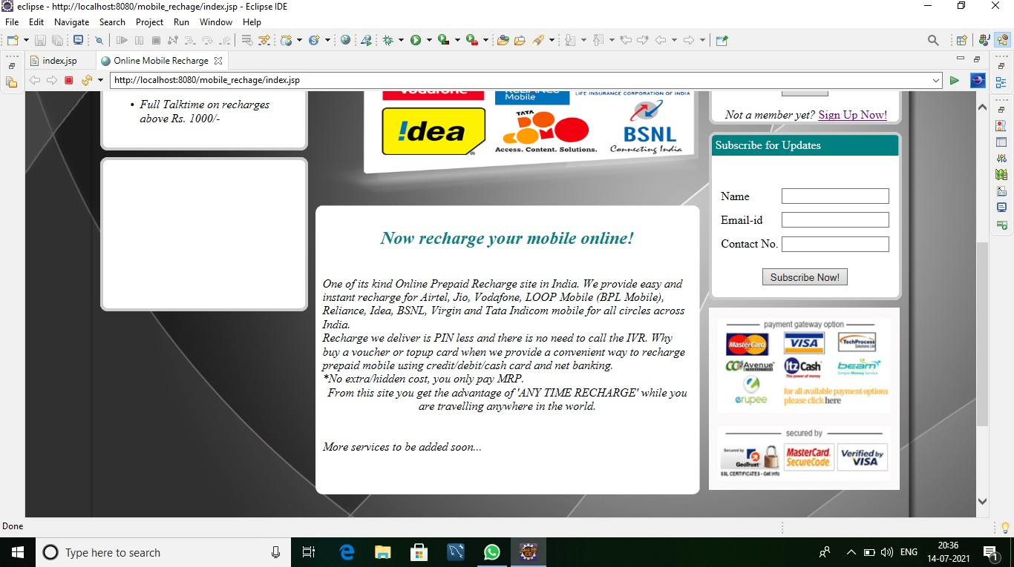

Login page

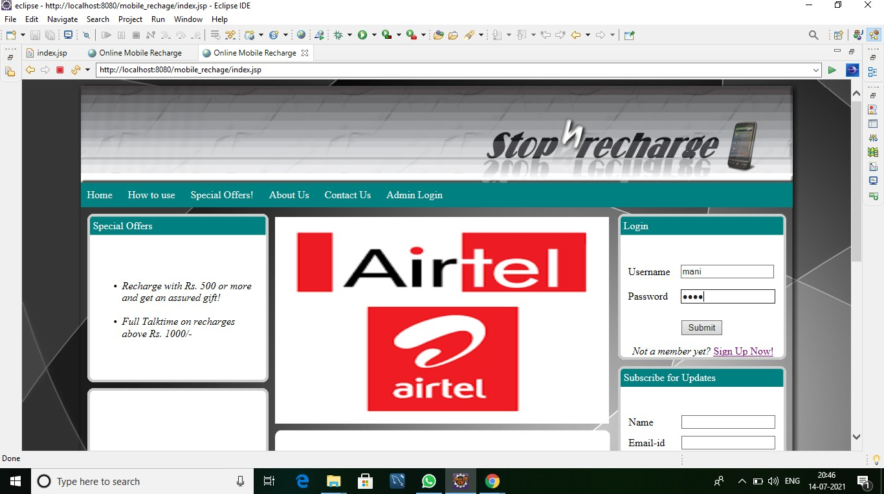

Register page

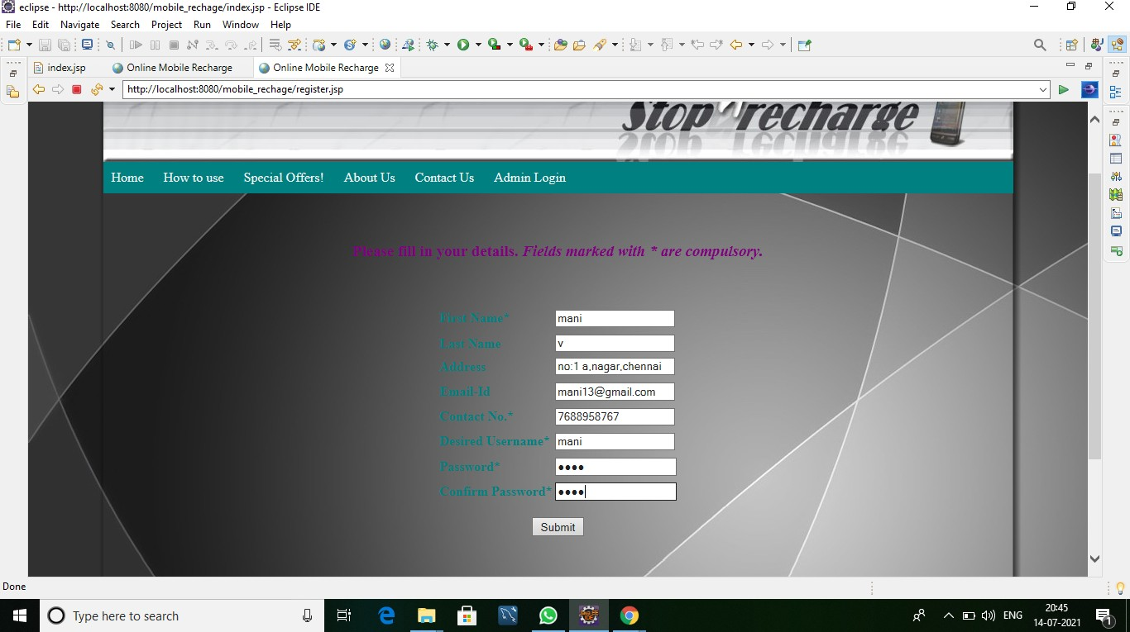

Registered Successful page:

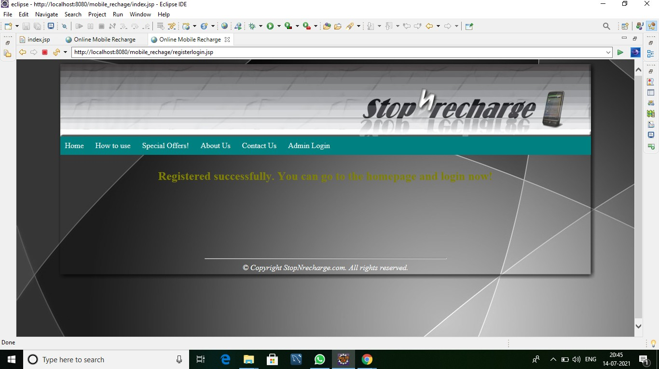

# Steps:

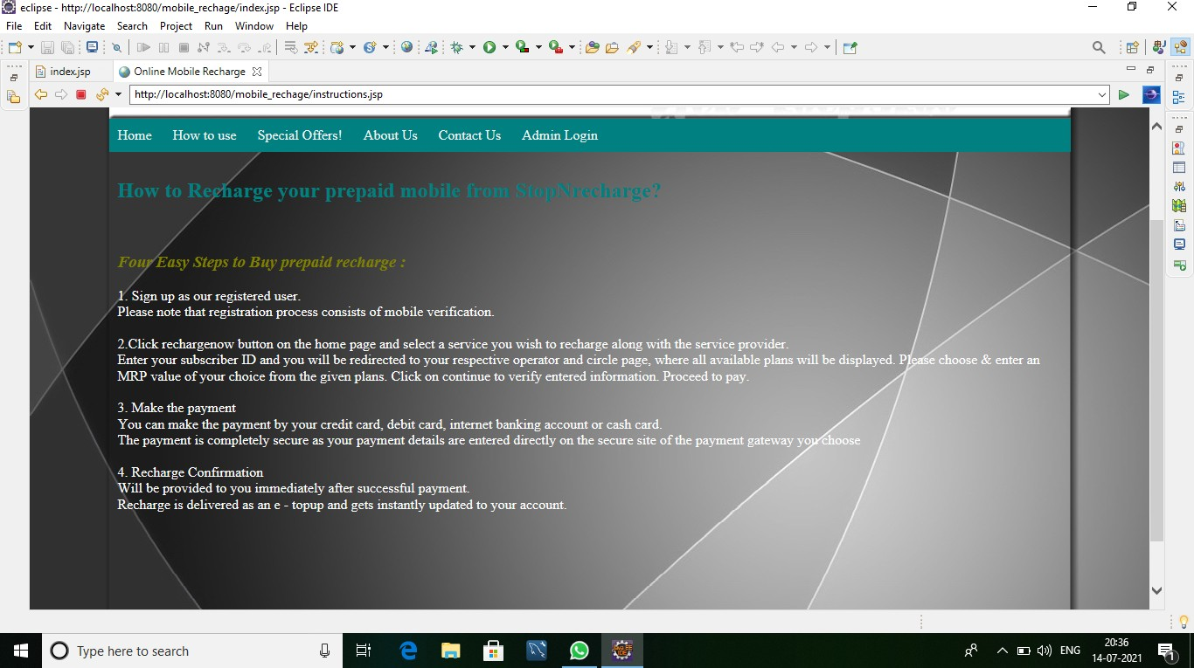

Special Offer

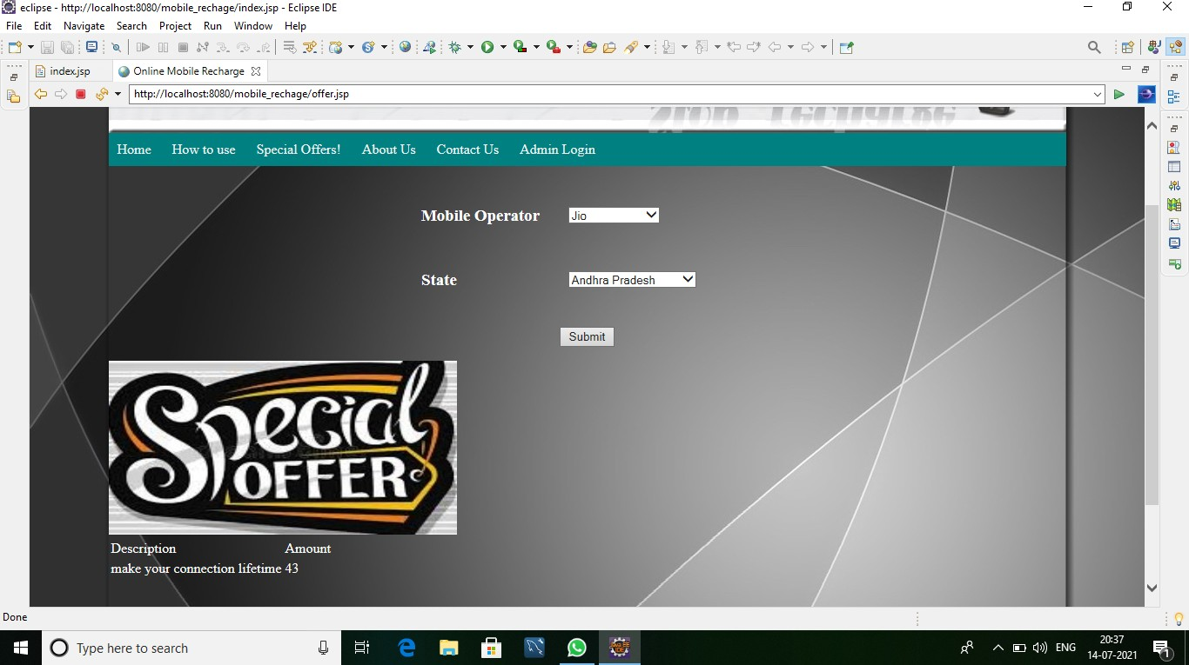

Recharge Page:

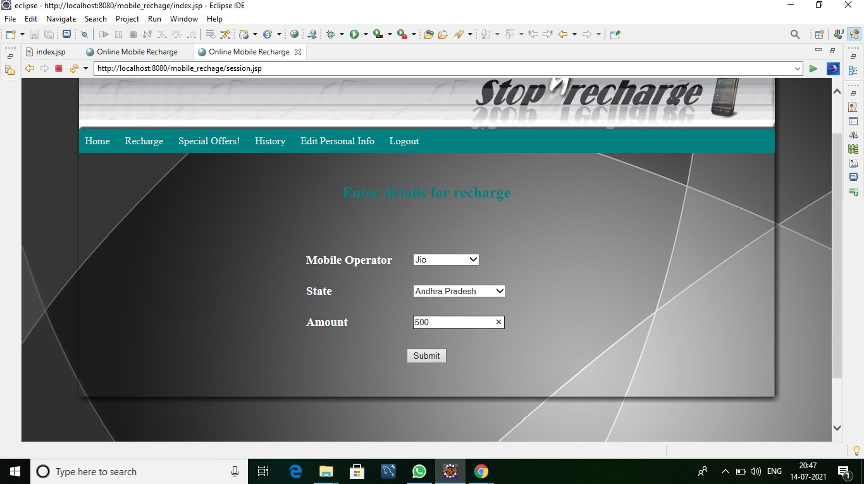

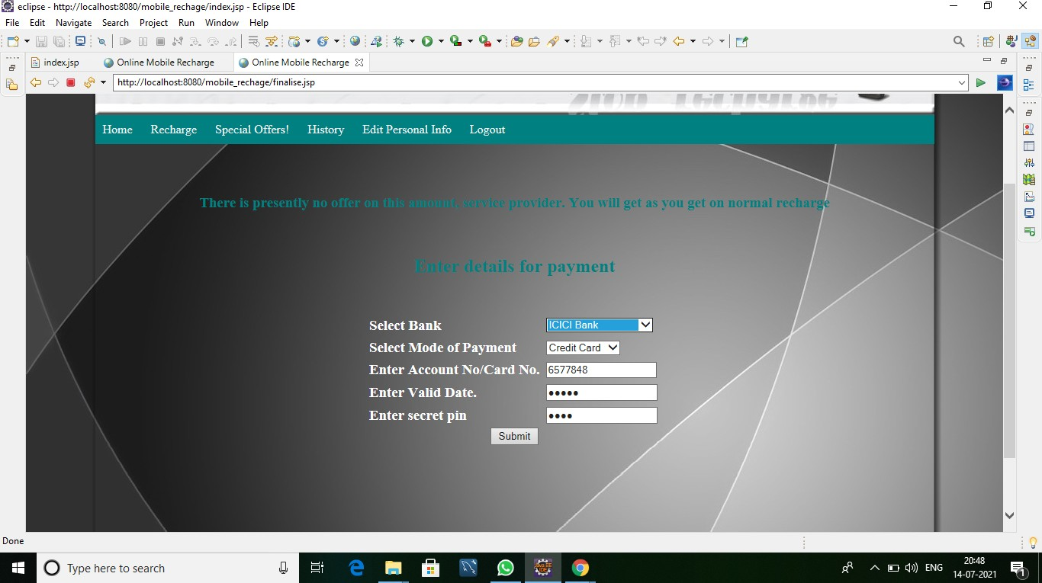

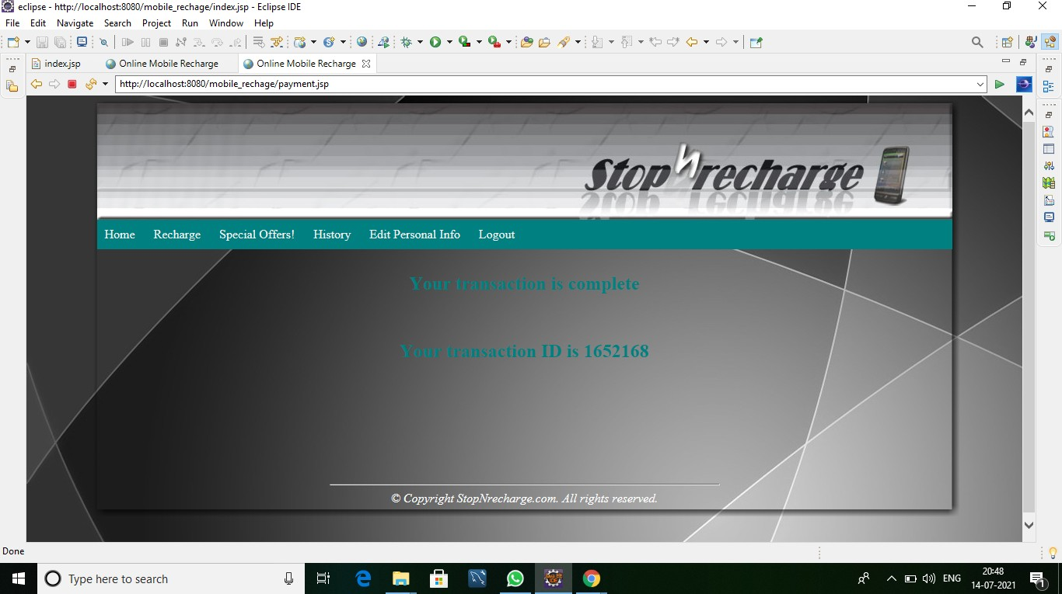

Admin Page:

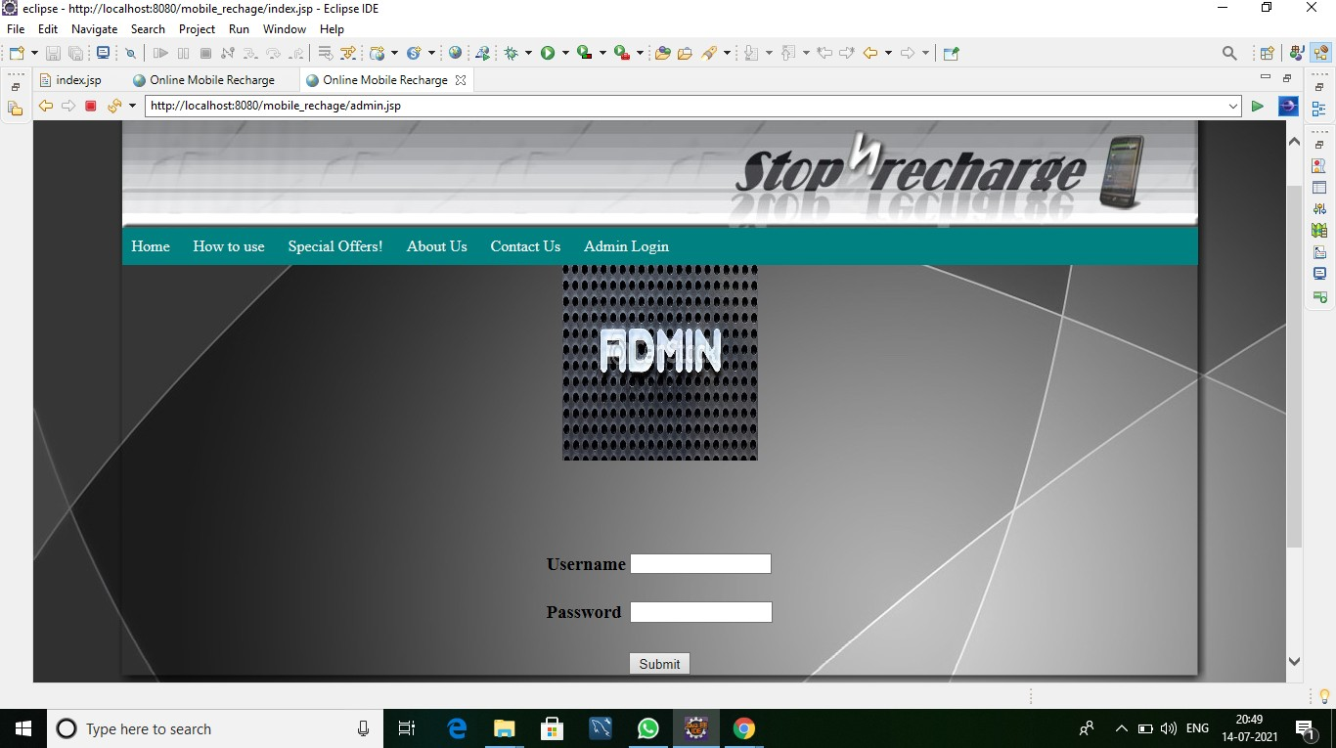

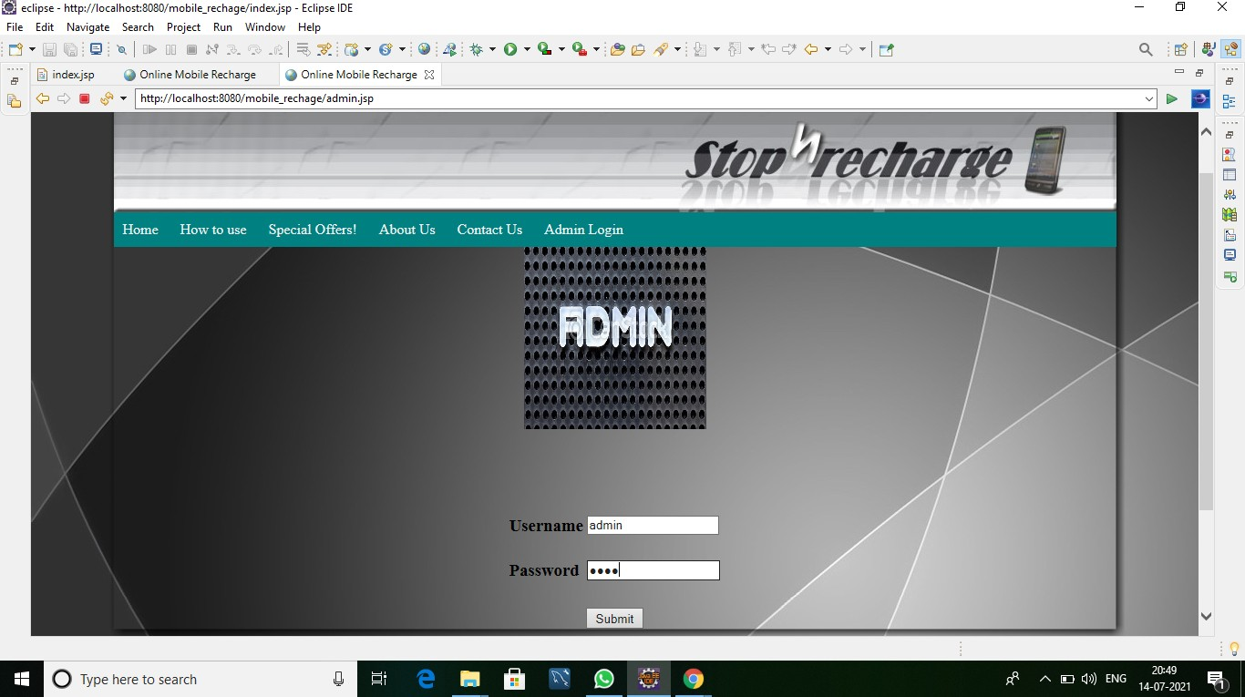

User List:

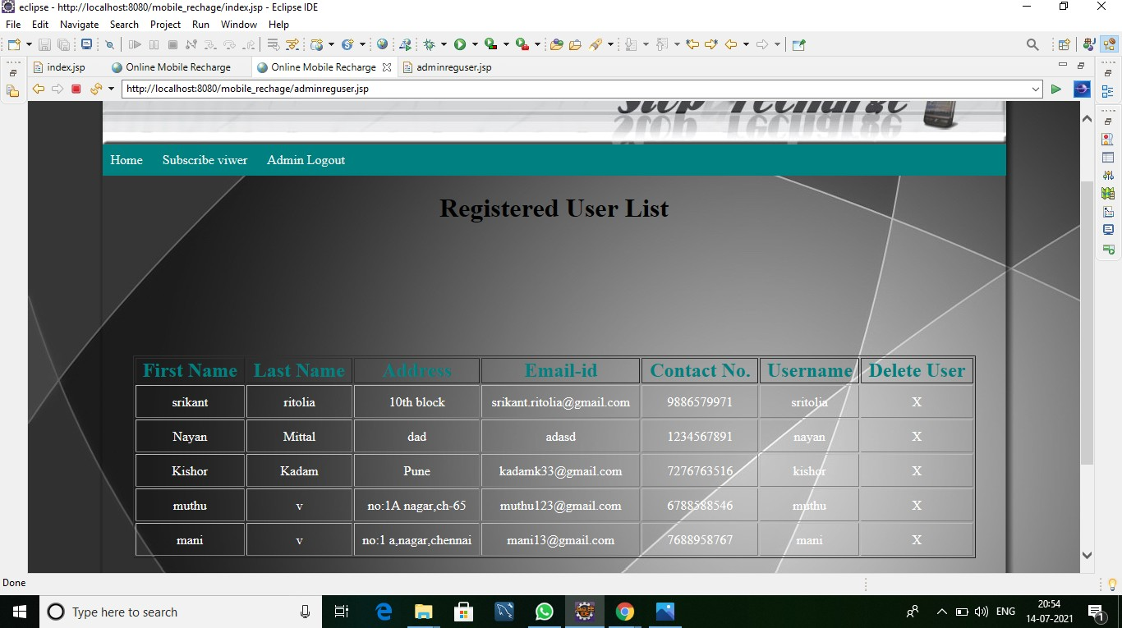

Add Offer Page:

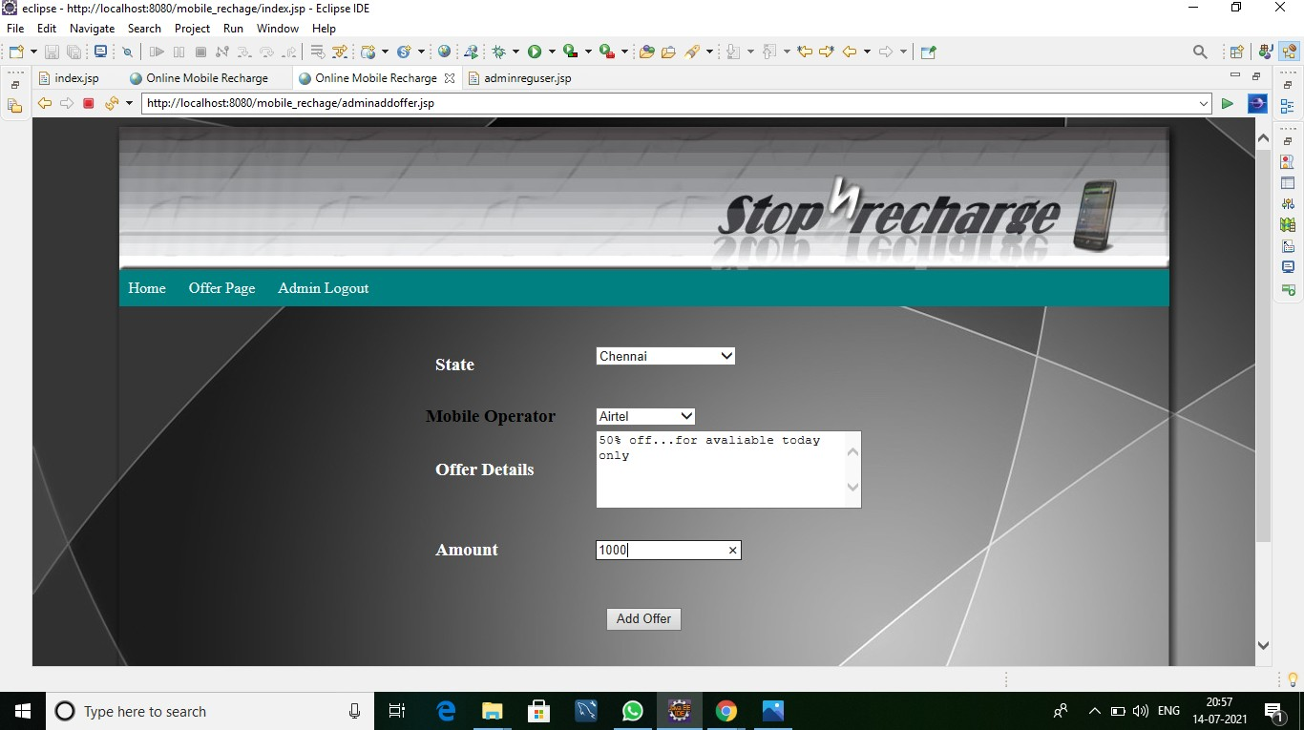

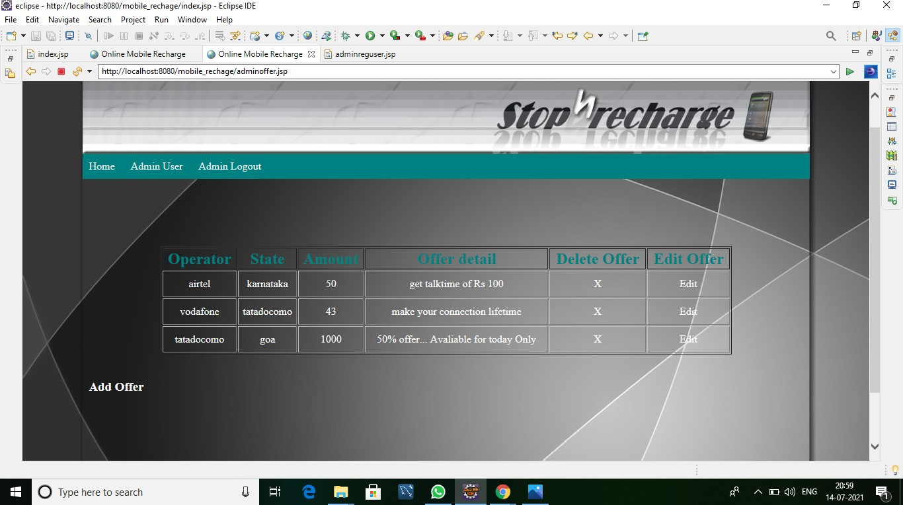

Subscribe Page:

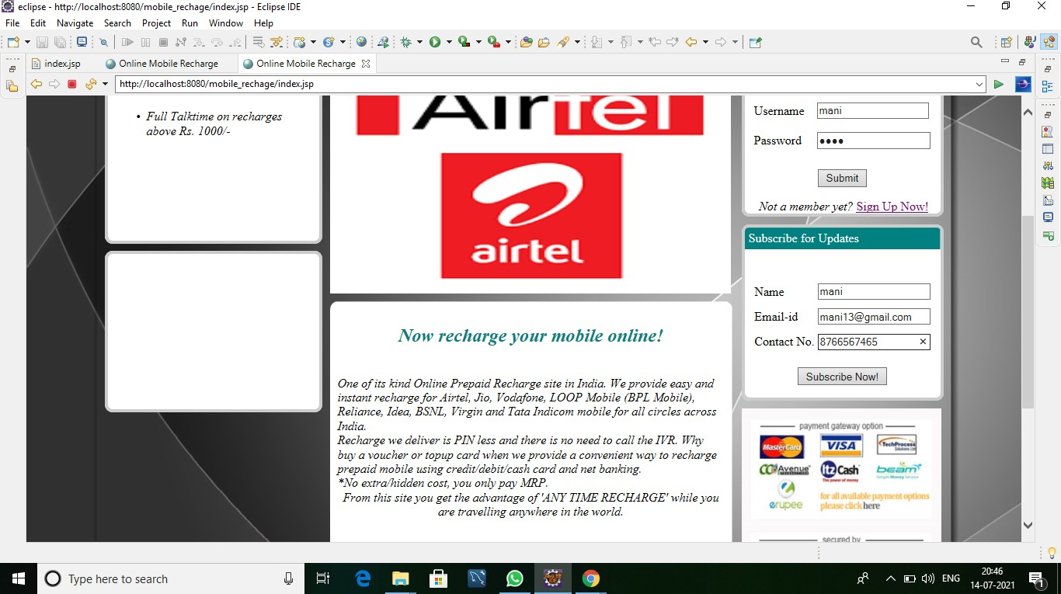

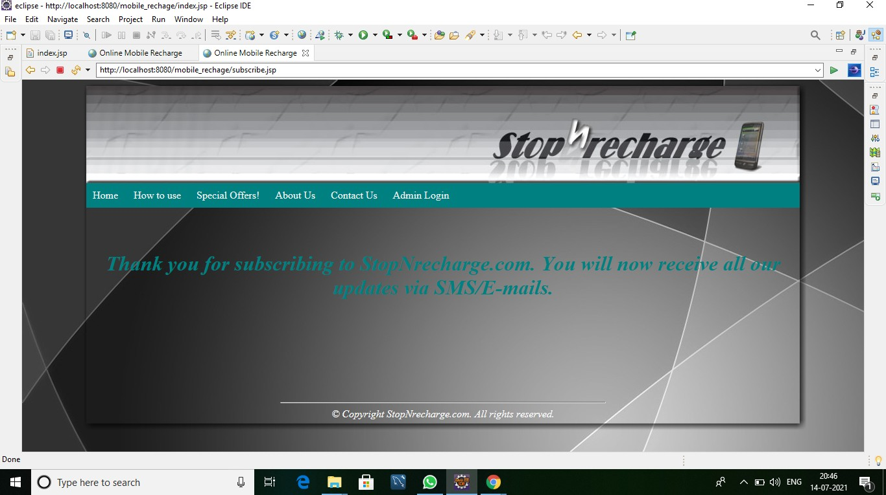

Subscribe User List:

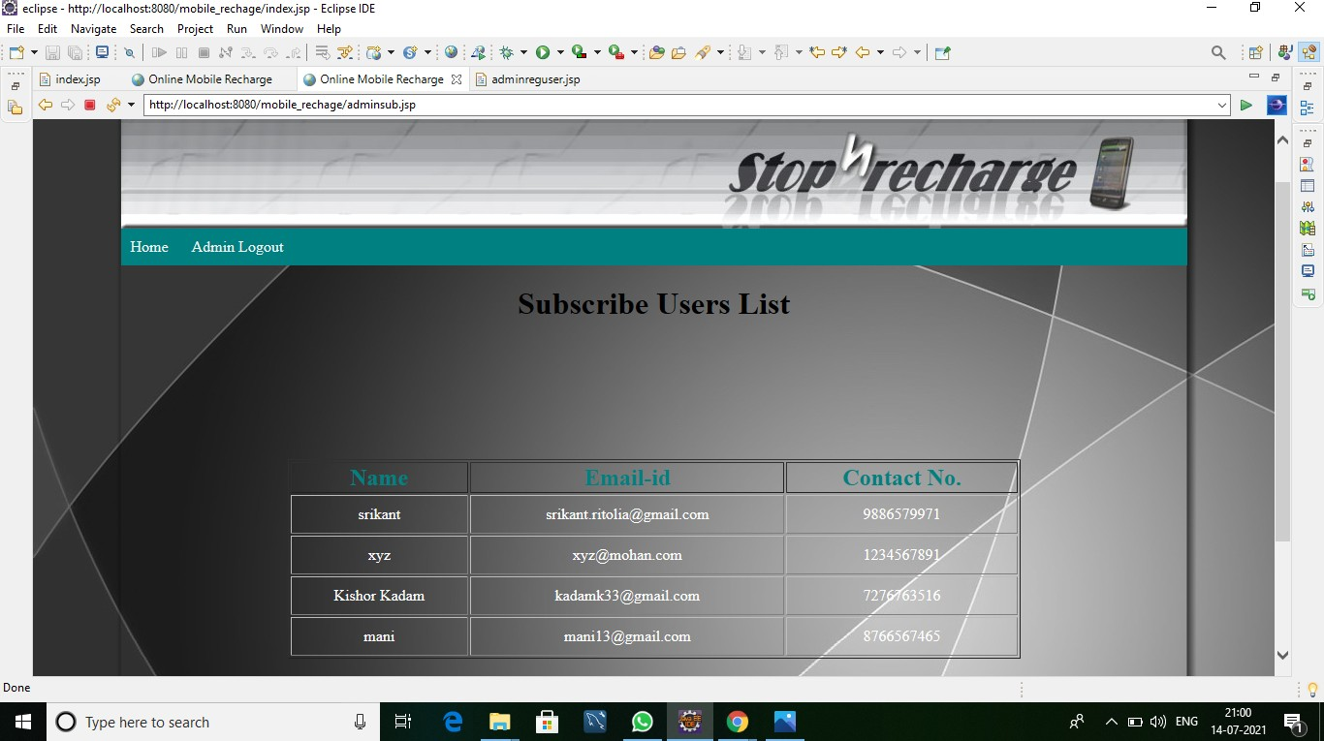

My SQL:

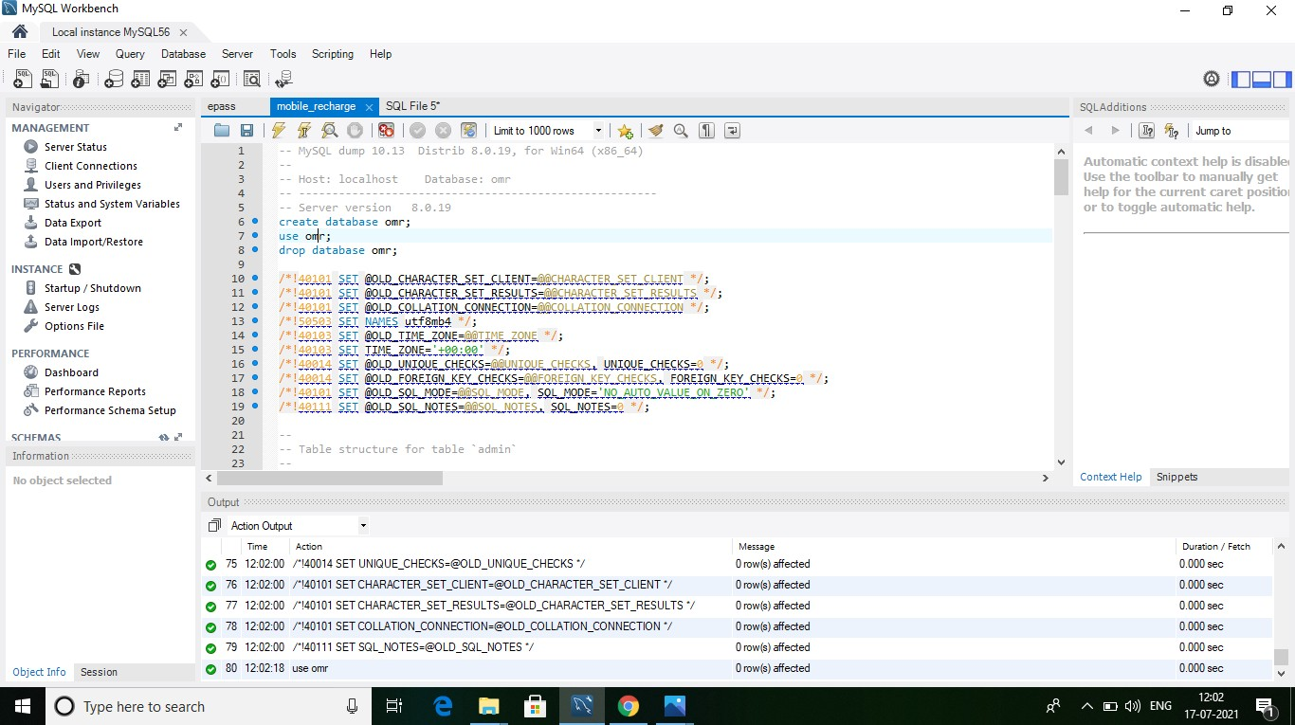

*THANK YOU*