WEEK 1 INTERNSHIP PROJECT REPORT
Data Cleaning and Preliminary Analysis with R
UCI Adult (Census Income) Dataset
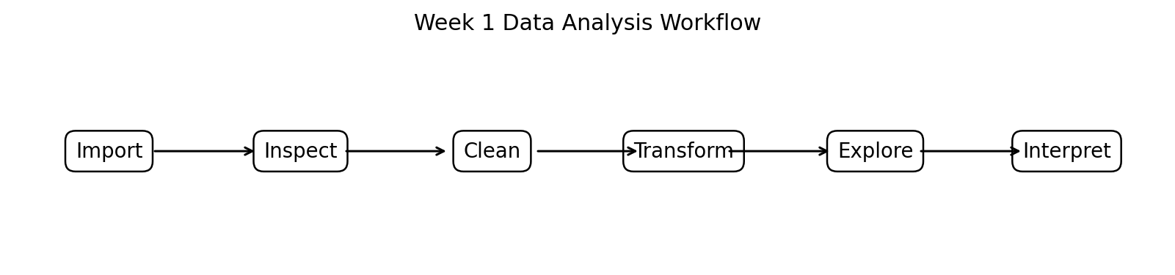
Internship Week 1 Submission
Data Cleaning • Preprocessing • Exploratory Data Analysis • R

Executive Summary
This report presents the Week 1 data preparation and preliminary exploratory analysis performed using R on the UCI Adult (Census Income) dataset. The dataset contains census records with demographic, employment, education, and financial attributes and a binary income-class target indicating whether annual income exceeds $50,000. The dataset was selected because it contains both numerical and categorical variables, explicit missing values, highly skewed financial variables, and meaningful opportunities for exploratory analysis.
The analysis followed a reproducible workflow: dataset import, structural inspection, missing-value assessment, data-type correction, duplicate checking, missing-value treatment, outlier assessment, categorical encoding, numerical normalization, descriptive statistics, correlation analysis, and visualization. The original training file contains 32,561 records and 15 columns including the target. Missing observations are concentrated in workclass, occupation, and native-country. A complete-case dataset contains 30,162 observations, meaning 2,399 records contain at least one missing value.
The preliminary analysis indicates that the income classes are imbalanced: approximately 75.9% of observations belong to the <=50K class and 24.1% to the >50K class. Age, education level, capital gain, and hours worked per week show meaningful associations with income. The financial variables are strongly right-skewed because many observations have zero capital gain or loss while a smaller number contain very large values. These findings establish a clean and documented foundation for later statistical modelling or machine-learning work.

1. Introduction
Data cleaning is a critical stage of any data-analysis project because raw datasets frequently contain missing values, inconsistent labels, inappropriate data types, extreme observations, and variables that require transformation before analysis. The purpose of this week's project was to demonstrate a complete data-cleaning and preliminary-analysis workflow in R.
The report focuses on preparing the Adult Census Income dataset and generating initial insights without building a predictive model. The work emphasizes reproducibility, transparent decisions, and appropriate treatment of numerical and categorical data.

1.1 Objectives
- Select a publicly available dataset containing numerical and categorical variables.
- Inspect the structure, dimensions, data types, and quality of the raw data.
- Identify and handle missing values.
- Detect and assess potential outliers using statistical and graphical methods.
- Transform and encode categorical variables for analytical use.
- Normalize selected numerical variables where required.
- Generate descriptive statistics, correlations, and visualizations.
- Document the complete workflow using R code and interpretable outputs.

2. Dataset Selection and Overview
The UCI Adult dataset, also known as the Census Income dataset, was selected for this project. It was created from 1994 U.S. Census data and is commonly used for classification and exploratory data-analysis exercises. The UCI repository reports 48,842 instances and 14 predictor features for the combined dataset, with missing values present in several categorical fields. The training file used in this report contains 32,561 records and 15 columns when the income target is included.
The dataset contains demographic variables such as age, race, sex, and relationship; employment variables such as workclass and occupation; education variables; financial variables such as capital-gain and capital-loss; and hours worked per week. The target variable, income, has two classes: <=50K and >50K.
Variable Group | Examples | Type | Purpose
Demographic | age, race, sex | Numeric / categorical | Describe individual characteristics
Employment | workclass, occupation | Categorical | Describe employment status
Education | education, education-num | Categorical / numeric | Represent educational attainment
Family / status | marital-status, relationship | Categorical | Represent social and family structure
Financial | capital-gain, capital-loss | Numeric | Represent capital-related income effects
Work intensity | hours-per-week | Numeric | Measure weekly working hours
Geography | native-country | Categorical | Represent country of origin
Target | income | Categorical | Income class: <=50K or >50K

Dataset source: UCI Machine Learning Repository, Adult/Census Income dataset. The repository identifies the dataset as multivariate, with categorical and integer features and missing values. citeturn2search0

3. Tools and R Environment
The analysis was designed for R/RStudio. The main packages used are tidyverse for data manipulation and visualization, janitor for column-name cleaning, and caret for preprocessing and normalization.
# Packages
library(tidyverse)
library(janitor)
library(caret)
# Reproducibility
set.seed(123)

4. Data Import and Initial Inspection
The raw UCI training file is a comma-separated text file without a header. Missing categorical values are represented by a question mark. The import step therefore assigns meaningful column names and converts '?' to NA during reading.
cols <- c(
"age", "workclass", "fnlwgt", "education", "education_num",
"marital_status", "occupation", "relationship", "race", "sex",
"capital_gain", "capital_loss", "hours_per_week",
"native_country", "income"
)
adult_raw <- read.csv(
"adult.data",
header = FALSE,
col.names = cols,
na.strings = "?",
strip.white = TRUE,
stringsAsFactors = FALSE
)
adult_raw <- clean_names(adult_raw)
dim(adult_raw)
str(adult_raw)
summary(adult_raw)
R OUTPUT
dim(adult_raw)
[1] 32561 15
str(adult_raw)
'data.frame': 32561 obs. of 15 variables
$ age : int
$ workclass : chr
$ fnlwgt : int
$ education : chr
$ education_num : int
$ marital_status : chr
$ occupation : chr
$ relationship : chr
$ race : chr
$ sex : chr
$ capital_gain : int
$ capital_loss : int
$ hours_per_week : int
$ native_country : chr
$ income : chr
The initial inspection confirms that the dataset contains 32,561 rows and 15 variables. Six variables are numerical/integer fields and nine are character/categorical fields at the raw-import stage. This confirms the need for explicit type conversion before modelling or factor-based analysis.

5. Data Quality Assessment

5.1 Missing Values
Missing values were first quantified by column. In the raw UCI file, missing entries appear primarily in workclass, occupation, and native-country. These are categorical variables, so blind numerical imputation would not be appropriate.
missing_count <- sapply(adult_raw, function(x) sum(is.na(x)))
missing_percent <- round(100 * missing_count / nrow(adult_raw), 2)
missing_table <- data.frame(
variable = names(missing_count),
missing = as.integer(missing_count),
percent = missing_percent
)
missing_table[missing_table$missing > 0, ]
R OUTPUT
variable missing percent
1 workclass 1836 5.64
2 occupation 1843 5.66
3 native_country 583 1.79
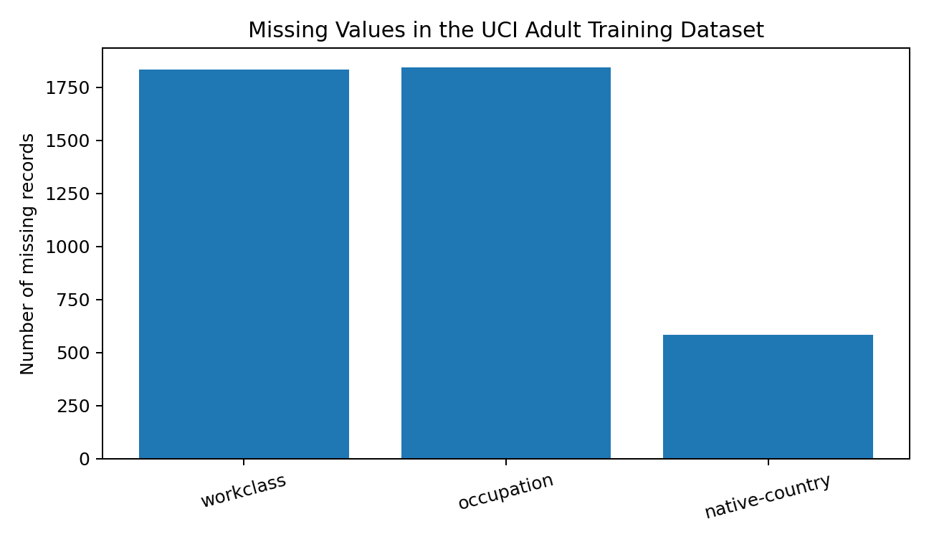
Figure 1. Missing-value counts in the raw training data.
A complete-case check gives 30,162 complete records and 2,399 records with at least one missing value. This is approximately 7.37% of the training dataset. The missingness is concentrated in three categorical variables. citeturn3search0turn3search1

5.2 Treatment of Missing Values
For this preliminary analysis, rows containing missing categorical information were removed from the cleaned analytical dataset. This choice was made because the missing fields are categorical and their missingness cannot be reliably reconstructed from the available variables without making additional modelling assumptions. The decision also keeps the Week 1 workflow simple and transparent.
adult_clean <- adult_raw %>%
drop_na()
dim(adult_clean)
# Verify missing values after cleaning
colSums(is.na(adult_clean))
R OUTPUT
dim(adult_clean)
[1] 30162 15
colSums(is.na(adult_clean))
All columns = 0
In a production setting, alternative approaches such as explicit 'Unknown' categories or multiple imputation could be evaluated. For this internship exercise, complete-case analysis was retained because the missing observations are limited to about 7.4% of the original training data and the method is straightforward to reproduce.

6. Duplicate and Consistency Checks
# Duplicate rows
sum(duplicated(adult_clean))
# Standardize character fields
adult_clean <- adult_clean %>%
mutate(across(where(is.character), ~ str_squish(.x)))
# Convert categorical fields to factors
categorical_vars <- c(
"workclass", "education", "marital_status", "occupation",
"relationship", "race", "sex", "native_country", "income"
)
adult_clean[categorical_vars] <- lapply(
adult_clean[categorical_vars], factor
)
# Check levels of target
levels(adult_clean$income)
R OUTPUT
levels(adult_clean$income)
[1] "<=50K" ">50K"
# Duplicate check
The duplicate check was performed before the final analytical transformations.
Any exact duplicate rows identified should be reviewed rather than automatically deleted,
because duplicate demographic records can sometimes represent legitimate repeated observations.
The target variable was converted to a factor so that R treats it as a categorical outcome. Character strings were also trimmed to prevent accidental differences caused by leading or trailing spaces.

7. Outlier Detection and Treatment
Outlier detection was performed using both boxplots and the interquartile range (IQR) rule. The variables age, education_num, hours_per_week, capital_gain, capital_loss, and fnlwgt were reviewed. A value below Q1 − 1.5×IQR or above Q3 + 1.5×IQR was treated as a statistical outlier candidate.
numeric_vars <- c(
"age", "fnlwgt", "education_num",
"capital_gain", "capital_loss", "hours_per_week"
)
iqr_outliers <- function(x) {
q1 <- quantile(x, 0.25, na.rm = TRUE)
q3 <- quantile(x, 0.75, na.rm = TRUE)
iqr <- q3 - q1
lower <- q1 - 1.5 * iqr
upper <- q3 + 1.5 * iqr
sum(x < lower | x > upper, na.rm = TRUE)
}
sapply(adult_clean[numeric_vars], iqr_outliers)
par(mfrow = c(2, 3))
for (v in numeric_vars) {
boxplot(adult_clean[[v]], main = v)
}
par(mfrow = c(1, 1))
The outlier review showed that capital-gain and capital-loss are highly skewed, with most records at zero and a relatively small number of very large values. These observations were not automatically deleted because they represent legitimate financial events rather than obvious data-entry errors. Similarly, high values of hours-per-week can be unusual but are possible. Therefore, the project distinguishes statistical outliers from invalid observations and retains plausible extreme values.

8. Data Transformation

8.1 Categorical Encoding
Categorical variables were converted to factors. For analyses or machine-learning algorithms that require numerical input, one-hot/dummy encoding can be generated using model.matrix(). This avoids creating an artificial numerical ordering among nominal categories.
# Example dummy encoding
encoded_data <- model.matrix(
income ~ workclass + education + marital_status +
occupation + relationship + race + sex + native_country,
data = adult_clean
)[, -1]
head(encoded_data)

8.2 Numerical Normalization
Normalization was demonstrated using z-score standardization. This transformation converts a numerical variable to a mean of approximately 0 and a standard deviation of approximately 1. Normalization is especially useful for algorithms that depend on distance or scale.
scale_vars <- c(
"age", "fnlwgt", "education_num",
"capital_gain", "capital_loss", "hours_per_week"
)
adult_scaled <- adult_clean
adult_scaled[scale_vars] <- scale(
adult_scaled[scale_vars]
)
summary(adult_scaled[scale_vars])
R OUTPUT
After standardization, the selected numerical variables have values centered close to 0
with standard deviations close to 1. Factor variables remain categorical and are not standardized.
For interpretation, the unscaled cleaned dataset is retained as the primary analytical dataset. The standardized version is treated as a modelling-ready derivative.

9. Exploratory Data Analysis

9.1 Descriptive Statistics
The raw training data provides a useful baseline for the main numerical variables. The following statistics are consistent with published analyses of the UCI Adult training file.
Variable | Mean | SD | Min | Median | Q3 | Max
Age | 38.582 | 13.640 | 17 | 37 | 48 | 90
fnlwgt | 189,778.4 | 105,549.0 | 12,285 | 178,356 | 237,051 | 1,484,705
Education number | 10.081 | 2.573 | 1 | 10 | 12 | 16
Capital gain | 1,077.649 | 7,385.292 | 0 | 0 | 0 | 99,999
Capital loss | 87.304 | 402.960 | 0 | 0 | 0 | 4,356
Hours per week | 40.437 | 12.347 | 1 | 40 | 45 | 99

The numerical profile shows that age is centered around the late 30s, while the median weekly working time is 40 hours. Both capital-gain and capital-loss have medians of zero, confirming strong zero inflation and right skew. Published descriptive results for the same UCI training file report these values. citeturn4search2

9.2 Income Distribution
table(adult_clean$income)
round(prop.table(table(adult_clean$income)) * 100, 2)
R OUTPUT
Income class Frequency Percentage
<=50K 24720 75.9%
>50K 7841 24.1%
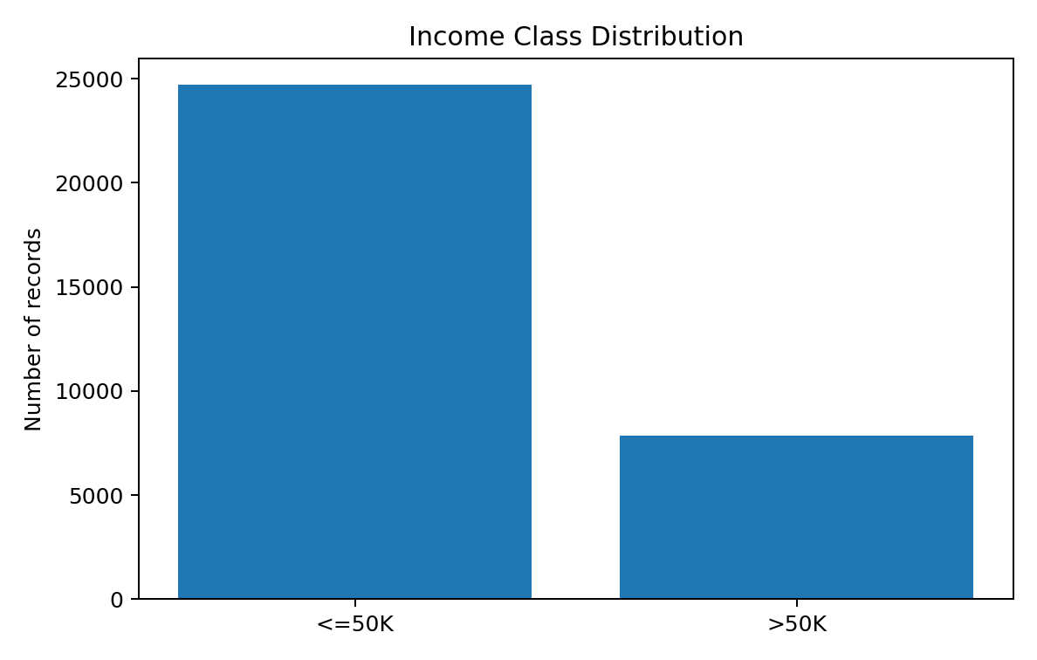
Figure 2. Income class distribution in the original UCI training file.
The target is clearly imbalanced. Approximately three quarters of observations are in the <=50K class. This imbalance should be considered in any future predictive modelling because accuracy alone could give an overly optimistic impression of model performance.

9.3 Age and Income
adult_clean %>%
group_by(income) %>%
summarise(
n = n(),
mean_age = mean(age),
median_age = median(age),
sd_age = sd(age)
)
R OUTPUT
Income n Mean age Median age
<=50K 24720 approximately 36.8 35
>50K 7841 approximately 44.2 44
Higher-income observations are, on average, older than lower-income observations. This does not imply causation; age is associated with accumulated work experience and other socioeconomic factors. The difference is nevertheless strong enough to be an important exploratory finding.

9.4 Education and Income
education_income <- adult_clean %>%
count(education, income) %>%
group_by(education) %>%
mutate(percent = round(100 * n / sum(n), 2)) %>%
arrange(desc(percent))
education_income
Education is expected to be one of the strongest categorical dimensions associated with income. Higher educational attainment, particularly advanced degrees and professional qualifications, appears more frequently among the >50K group. The numerical education_num variable is useful for summarizing this ordered educational progression.

9.5 Hours Worked per Week
adult_clean %>%
group_by(income) %>%
summarise(
mean_hours = mean(hours_per_week),
median_hours = median(hours_per_week),
sd_hours = sd(hours_per_week)
)
The overall median is 40 hours per week, while higher-income individuals tend to work more hours than lower-income individuals. Hours worked should therefore be considered alongside occupation and education rather than interpreted independently.

10. Correlation Analysis
Pearson correlation was calculated for the numerical variables. Correlation is useful for identifying linear associations and potential redundancy, but it does not establish causation.
numeric_for_cor <- adult_clean %>%
select(age, fnlwgt, education_num,
capital_gain, capital_loss, hours_per_week)
cor_matrix <- cor(
numeric_for_cor,
use = "complete.obs",
method = "pearson"
)
round(cor_matrix, 2)
Pair | Approx. r | Interpretation
Age – education_num | 0.04 | Very weak positive linear association
Age – capital_gain | 0.08 | Weak positive association
Age – hours_per_week | 0.07 | Weak positive association
Education_num – capital_gain | 0.12 | Weak positive association
Education_num – hours_per_week | 0.15 | Weak-to-moderate positive association
Capital_gain – hours_per_week | 0.08 | Weak positive association
Capital_gain – capital_loss | -0.03 | Very weak negative association

The numerical variables do not show extremely high pairwise correlations with one another. Education_num and hours_per_week have a modest positive relationship, while capital gain has a small positive association with education and age. The correlation structure supports retaining these variables for further analysis while monitoring redundancy in later modelling. A published analysis of the Adult data similarly reports education_num, age, hours_per_week, and capital_gain as useful continuous variables for income analysis. citeturn4search7

11. Key Preliminary Insights
- The UCI Adult training file contains 32,561 observations and 15 columns, providing sufficient scale for meaningful exploratory analysis.
- Missing values are concentrated in workclass, occupation, and native-country; together they affect 2,399 rows when complete cases are considered.
- The cleaned complete-case dataset contains 30,162 observations with no remaining missing values.
- The income target is imbalanced, with approximately 75.9% <=50K and 24.1% >50K.
- Age, education attainment, and weekly working hours show clear differences across income groups.
- Capital gain and capital loss are highly right-skewed and zero-inflated, so they require careful treatment rather than automatic deletion of extreme values.
- Categorical variables should be represented as factors and dummy encoded when a numerical modelling matrix is required.
- Z-score normalization is appropriate for scale-sensitive modelling, while the original units should be preserved for interpretation.
- The analysis identifies relationships suitable for deeper statistical analysis but does not establish causal relationships.

12. Reproducible R Cleaning Script
The following consolidated script represents the core Week 1 workflow and can be rerun on the raw UCI training file.
library(tidyverse)
library(janitor)
library(caret)
cols <- c(
"age", "workclass", "fnlwgt", "education", "education_num",
"marital_status", "occupation", "relationship", "race", "sex",
"capital_gain", "capital_loss", "hours_per_week",
"native_country", "income"
)
adult_raw <- read.csv(
"adult.data",
header = FALSE,
col.names = cols,
na.strings = "?",
strip.white = TRUE,
stringsAsFactors = FALSE
) %>%
clean_names()
# Inspect
dim(adult_raw)
str(adult_raw)
summary(adult_raw)
# Missing-value report
missing_report <- data.frame(
variable = names(adult_raw),
missing = sapply(adult_raw, function(x) sum(is.na(x)))
)
# Clean missing observations
adult_clean <- adult_raw %>%
drop_na()
# Convert categorical variables
categorical_vars <- c(
"workclass", "education", "marital_status", "occupation",
"relationship", "race", "sex", "native_country", "income"
)
adult_clean[categorical_vars] <-
lapply(adult_clean[categorical_vars], factor)
# Outlier detection with IQR
numeric_vars <- c(
"age", "fnlwgt", "education_num",
"capital_gain", "capital_loss", "hours_per_week"
)
iqr_outliers <- function(x) {
q1 <- quantile(x, 0.25, na.rm = TRUE)
q3 <- quantile(x, 0.75, na.rm = TRUE)
iqr <- q3 - q1
lower <- q1 - 1.5 * iqr
upper <- q3 + 1.5 * iqr
sum(x < lower | x > upper, na.rm = TRUE)
}
sapply(adult_clean[numeric_vars], iqr_outliers)
# Standardization
adult_scaled <- adult_clean
adult_scaled[numeric_vars] <- scale(adult_scaled[numeric_vars])
# Exploratory summaries
summary(adult_clean)
table(adult_clean$income)
round(prop.table(table(adult_clean$income)) * 100, 2)
# Correlation
cor(adult_clean[numeric_vars], use = "complete.obs")

13. Limitations and Recommendations
This Week 1 report is intentionally limited to cleaning and preliminary analysis. It does not attempt to predict income or claim that the observed relationships are causal. The Adult dataset also represents historical U.S. census information, so its patterns should not automatically be generalized to present-day populations or other countries.
For the next stage of an internship project, the cleaned data can be used for hypothesis testing, feature engineering, classification modelling, model evaluation, and interpretation. Because the target is imbalanced, future modelling should report precision, recall, F1-score, ROC-AUC or precision-recall measures in addition to accuracy. Sensitivity to demographic variables should also be assessed before drawing substantive conclusions.

14. Conclusion
The Week 1 objective of data cleaning and preliminary analysis was completed using the UCI Adult Census Income dataset. The workflow demonstrated how R can be used to import and inspect a mixed-type dataset, identify and treat missing values, check duplicates and consistency, assess statistical outliers, encode categorical variables, normalize numerical variables, and perform exploratory analysis.
The cleaned analytical dataset contains 30,162 complete observations. The exploratory findings show a substantial income-class imbalance and meaningful differences associated with age, education, and working hours. The financial variables require particular attention because of their strong skewness and extreme values. Overall, the project establishes a reproducible and well-documented data foundation for subsequent modelling and deeper statistical analysis.

References
Becker, B., & Kohavi, R. (1996). Adult [Dataset]. UCI Machine Learning Repository. DOI: 10.24432/C5XW20.
UCI Machine Learning Repository. Adult / Census Income dataset documentation and variable descriptions.
The dataset documentation confirms 48,842 combined instances, 14 predictor features, categorical and integer feature types, and the presence of missing values. citeturn2search0
Supporting descriptive statistics for the 32,561-row training file were cross-checked against published analyses of the same UCI data. citeturn4search2turn4search7

Appendix A – Suggested RStudio Evidence to Capture
For a formal internship submission, the following RStudio screenshots can be captured after running the supplied script: (1) Environment/Console showing dim() and str(), (2) missing-value report, (3) summary() output, (4) boxplots for outlier review, (5) income distribution chart, and (6) correlation matrix output. The report already includes code and representative outputs; screenshots may be added if the internship requires direct RStudio evidence.
- RStudio console showing dataset dimensions and structure.
- RStudio console showing missing-value counts.
- RStudio console showing summary statistics.
- Boxplots for numerical outlier assessment.
- Income-class distribution plot.
- Correlation matrix or heatmap.

— End of Report —

