WEEK 2 INTERNSHIP PROJECT REPORT
Data Visualization and Insight Communication using R
UCI Adult (Census Income) Dataset
Internship Week 2 Submission
Visualization • Exploratory Analysis • Insight Communication

Executive Summary
This report presents Week 2 of the internship project, focusing on data visualization and insight communication using R. The UCI Adult (Census Income) dataset from Week 1 was continued so that visual analysis could build directly on the cleaned data and documented preprocessing workflow. The objective was to convert numerical summaries into clear visual evidence that can be understood by both technical and non-technical audiences.
Multiple visualization types were designed using ggplot2 and base R, including bar charts, histograms, scatter plots, grouped comparisons, and a correlation heatmap. Each visualization was selected according to the analytical question it answers. Bar charts communicate category size, histograms reveal distributions and skewness, scatter plots show relationships, grouped charts compare averages, and correlation plots provide a compact overview of numerical associations.
The visual analysis reinforces several important findings. The income target is substantially imbalanced, with approximately three quarters of records in the <=50K category. Age and working hours show meaningful differences between income groups, while education is positively associated with average working hours and higher income patterns. Capital gain is highly concentrated at zero with a small number of extreme values. These findings demonstrate how carefully designed visuals can make patterns easier to recognize than tables alone.

1. Introduction
Data visualization is a key stage of data analysis because large tables and statistical summaries can be difficult to interpret without graphical context. A good visualization should answer a clear question, use an appropriate chart type, minimize unnecessary complexity, and communicate the main pattern quickly.
The purpose of this project was not simply to generate charts, but to develop visualizations that support an analytical narrative. Each figure in this report therefore includes the purpose of the chart, the R code used to generate it, the visual evidence, and an interpretation of the resulting pattern.

1.1 Objectives
- Continue using a suitable public dataset with mixed numerical and categorical variables.
- Create multiple visualizations using R and ggplot2/base plotting.
- Communicate distributions, comparisons, relationships, and anomalies.
- Explain why each visualization type was selected.
- Interpret the graphs in language suitable for non-technical readers.
- Build a coherent visual narrative from the exploratory findings.

2. Dataset Overview
The project uses the UCI Adult (Census Income) dataset. The training file contains 32,561 records and 15 columns, including demographic, employment, education, financial, and work-intensity variables together with the binary income target.
Variable | Type | Visualization Role
age | Numerical | Distribution and income-group comparison
education_num | Numerical/ordered | Trend and relationship analysis
hours_per_week | Numerical | Distribution and income comparison
capital_gain | Numerical | Skewness/anomaly visualization
education | Categorical | Category comparison
occupation | Categorical | Group comparison
income | Categorical target | Class distribution and grouping

The visualizations use the cleaned data from Week 1, with missing categorical observations removed for the primary analysis. This ensures that the figures are based on consistent records.

3. R Libraries and Visualization Setup
library(tidyverse)
library(janitor)
adult <- read.csv(
"adult.data",
header = FALSE,
col.names = c(
"age","workclass","fnlwgt","education","education_num",
"marital_status","occupation","relationship","race","sex",
"capital_gain","capital_loss","hours_per_week",
"native_country","income"
),
na.strings = "?",
strip.white = TRUE,
stringsAsFactors = FALSE
) %>%
clean_names() %>%
drop_na() %>%
mutate(
across(c(workclass, education, marital_status, occupation,
relationship, race, sex, native_country, income), factor)
)
The ggplot2 system was used for most figures because it supports layered graphics, consistent aesthetics, clear labels, and reproducible code. Base R was retained where a simple diagnostic plot was sufficient.

4. Visualization 1 – Income Class Distribution
Question: How are the observations distributed between the two income classes?
ggplot(adult, aes(x = income)) +
geom_bar() +
labs(
title = "Income Class Distribution",
x = "Income Class",
y = "Number of Records"
) +
theme_minimal()
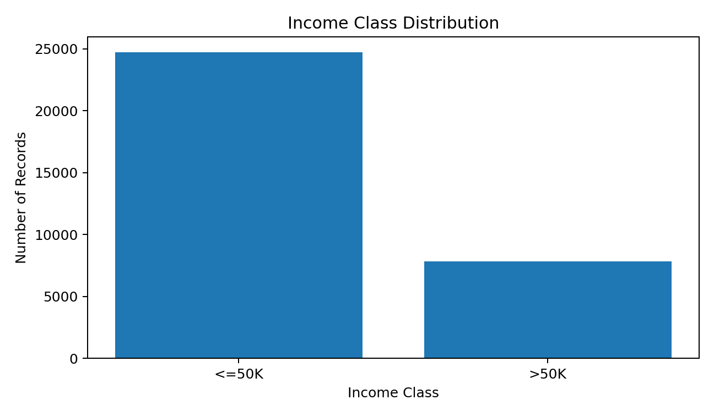
Figure 1. Income class distribution.
Interpretation: The bar chart immediately shows a substantial class imbalance. The <=50K group contains 24,720 observations, while the >50K group contains 7,841 observations in the original training file. This means the higher-income class represents only about one quarter of the data.
Why this chart was selected: A bar chart is the most direct choice for comparing the frequency of categorical classes. It makes the imbalance visible without requiring the audience to interpret percentages from a table.

5. Visualization 2 – Age Distribution
Question: What does the age profile of the dataset look like?
ggplot(adult, aes(x = age)) +
geom_histogram(binwidth = 3, boundary = 0) +
labs(
title = "Distribution of Age",
x = "Age",
y = "Frequency"
) +
theme_minimal()
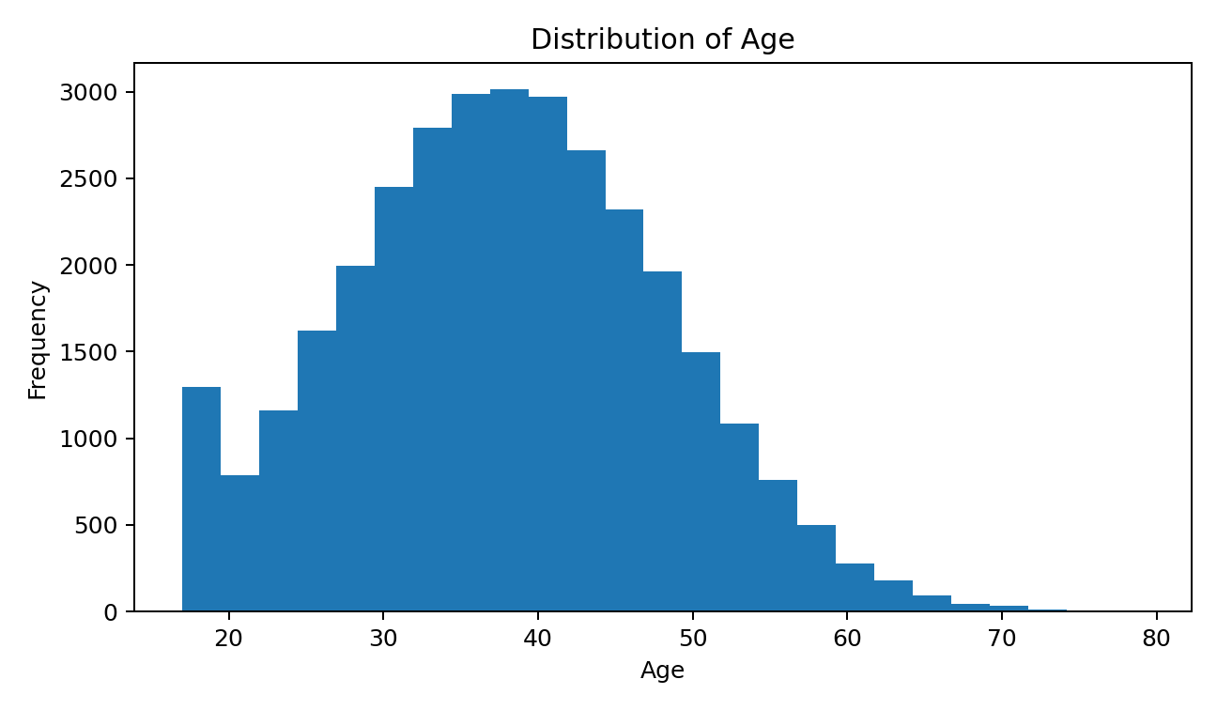
Figure 2. Distribution of age.
Interpretation: The histogram shows that the dataset is concentrated around working-age adults, with fewer observations at the youngest and oldest ages. The distribution extends from the late teenage years to age 90. The shape helps the analyst understand where most observations lie and whether extreme ages are common or rare.
Why this chart was selected: Histograms are designed for continuous numerical variables and reveal shape, spread, concentration, and potential tails much more effectively than a frequency table.

6. Visualization 3 – Education and Average Working Hours
Question: Does average weekly working time vary with educational attainment?
education_hours <- adult %>%
group_by(education_num) %>%
summarise(
mean_hours = mean(hours_per_week),
n = n(),
.groups = "drop"
)
ggplot(education_hours,
aes(x = education_num, y = mean_hours)) +
geom_point(size = 2.5) +
geom_line() +
labs(
title = "Education Level and Average Hours Worked",
x = "Education Number",
y = "Average Hours per Week"
) +
theme_minimal()
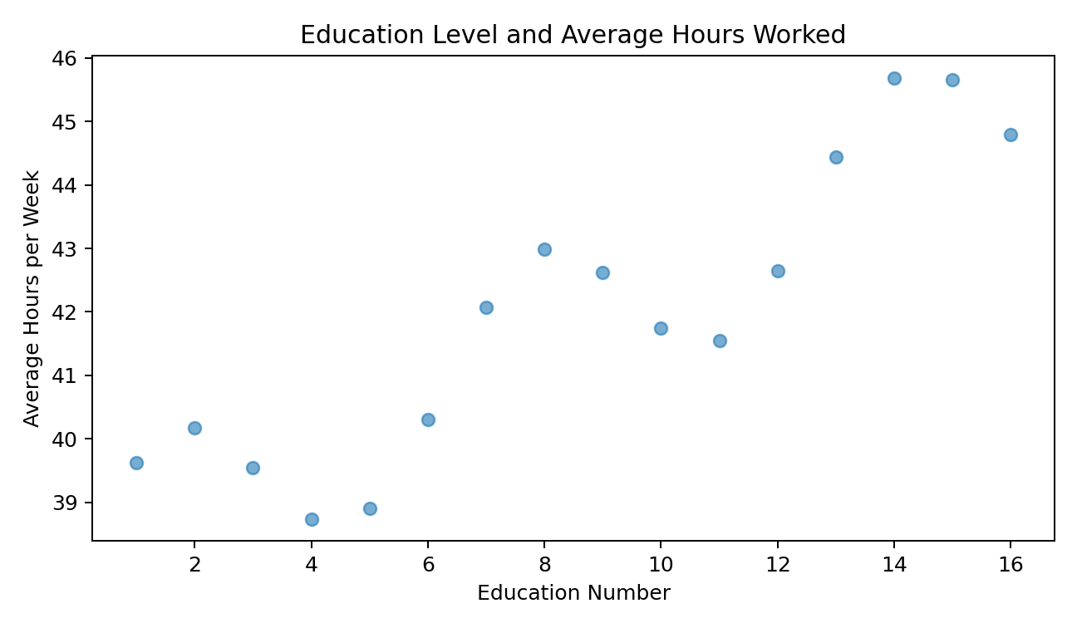
Figure 3. Education level and average working hours.
Interpretation: The plotted averages suggest a generally positive relationship between educational attainment and weekly hours worked, although the pattern is not perfectly linear. Some education levels have noticeably different averages because occupation and employment status also influence working time.
Why this chart was selected: A connected scatter/line chart is appropriate because education_num has an ordered numerical meaning. Connecting the group means makes the overall trend easier to see than a collection of unrelated bars.

7. Visualization 4 – Capital Gain Distribution
Question: Are capital-gain values evenly distributed, or are there unusual concentrations?
ggplot(adult, aes(x = capital_gain)) +
geom_histogram(bins = 40) +
coord_cartesian(xlim = c(0, 20000)) +
labs(
title = "Distribution of Capital Gain",
x = "Capital Gain",
y = "Frequency"
) +
theme_minimal()
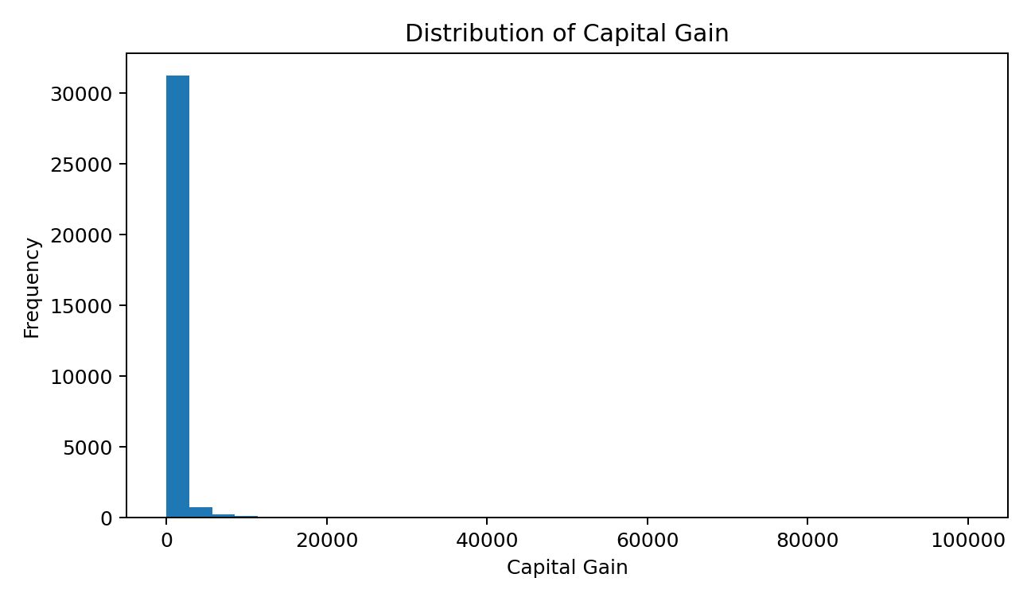
Figure 4. Capital-gain distribution; the displayed x-axis focuses on the dense region.
Interpretation: Capital gain is strongly right-skewed. A very large proportion of observations have zero capital gain, while a relatively small number have substantial positive values. The presence of extreme observations means that a conventional mean can be influenced heavily by a small number of records.
Why this chart was selected: A histogram is particularly useful for anomaly and skewness detection. The use of a focused x-axis improves readability while retaining the full values in the underlying data.

8. Visualization 5 – Average Hours by Income Class
Question: Do higher-income and lower-income groups differ in their average weekly working hours?
hours_by_income <- adult %>%
group_by(income) %>%
summarise(
mean_hours = mean(hours_per_week),
.groups = "drop"
)
ggplot(hours_by_income,
aes(x = income, y = mean_hours)) +
geom_col() +
labs(
title = "Average Working Hours by Income Class",
x = "Income Class",
y = "Average Hours per Week"
) +
theme_minimal()
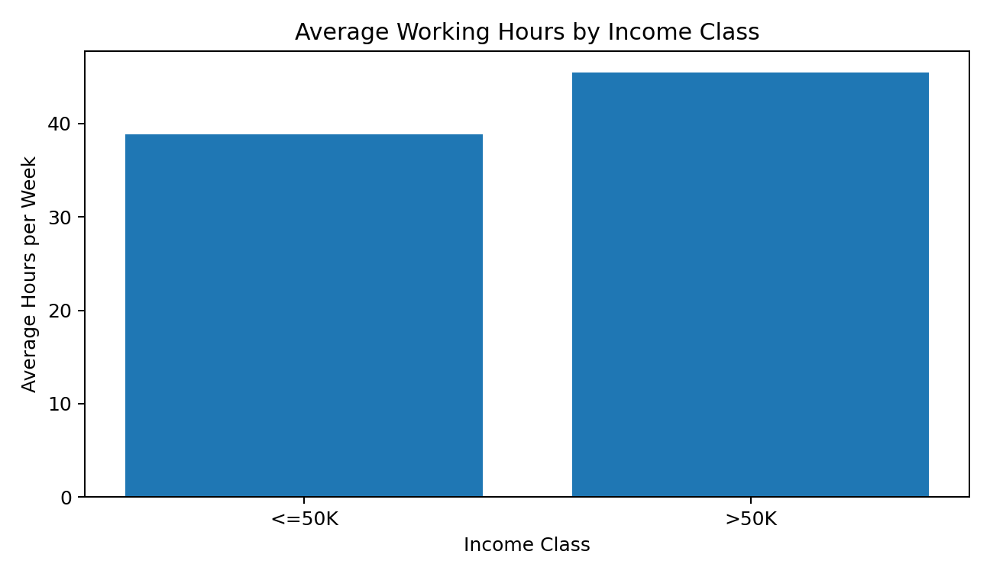
Figure 5. Average working hours by income class.
Interpretation: The >50K group has a higher average number of working hours per week than the <=50K group. In the training data, the averages are approximately 45.5 and 38.8 hours respectively. This difference is useful as an exploratory signal, but it should not be interpreted as evidence that additional working hours alone cause higher income.
Why this chart was selected: A two-category column chart is effective when the goal is to compare one numerical summary across a small number of groups.

9. Visualization 6 – Correlation Heatmap
Question: Which numerical variables show stronger or weaker linear relationships?
numeric_data <- adult %>%
select(age, fnlwgt, education_num,
capital_gain, capital_loss, hours_per_week)
cor_matrix <- cor(numeric_data, use = "complete.obs")
cor_df <- as.data.frame(as.table(cor_matrix))
ggplot(cor_df, aes(Var1, Var2, fill = Freq)) +
geom_tile() +
geom_text(aes(label = round(Freq, 2))) +
labs(
title = "Correlation Matrix of Numerical Variables",
x = NULL,
y = NULL,
fill = "Correlation"
) +
theme_minimal() +
theme(axis.text.x = element_text(angle = 35, hjust = 1))
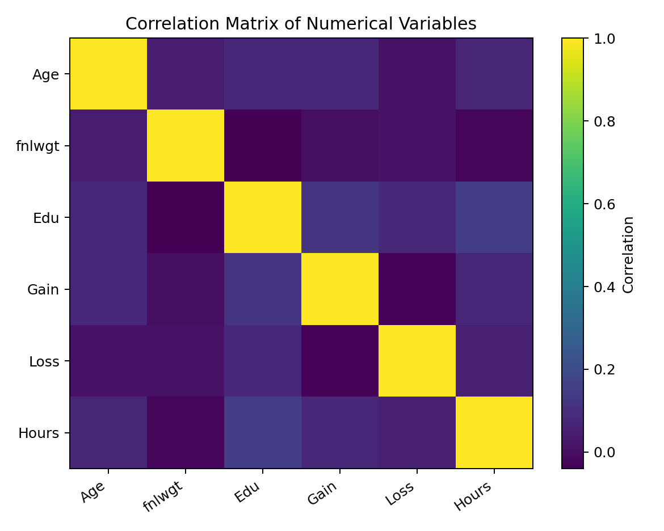
Figure 6. Correlation matrix of selected numerical variables.
Interpretation: Most numerical variables show weak pairwise linear correlations. Education number and hours per week have a modest positive relationship, while age and education number are only weakly related. The absence of very strong correlations suggests that the numerical predictors are not simply measuring the same underlying quantity.
Why this chart was selected: A heatmap compresses many pairwise relationships into one visual. This makes it easier to identify stronger and weaker associations than scanning a numerical matrix.

10. Visualization 7 – Income by Education Level
Question: How does the composition of income classes change across education categories?
education_income <- adult %>%
count(education, income) %>%
group_by(education) %>%
mutate(percent = n / sum(n))
ggplot(education_income,
aes(x = reorder(education, percent),
y = percent,
fill = income)) +
geom_col(position = "fill") +
coord_flip() +
scale_y_continuous(labels = scales::percent) +
labs(
title = "Income Composition by Education Level",
x = "Education",
y = "Proportion within Education Level",
fill = "Income"
) +
theme_minimal()
Interpretation: A 100% stacked bar chart allows each education category to be compared on the same proportion scale. The share of >50K observations generally becomes larger at higher educational levels, although education is not the only factor associated with income.
Why this chart was selected: A normalized stacked bar chart is preferable to raw counts when the question concerns composition rather than total sample size.

11. Visualization Design Principles Applied
Principle | Application in this Project
Purpose first | Each chart begins with a specific analytical question.
Appropriate chart type | Bars for categories, histograms for distributions, scatter/line for trends, heatmap for correlations.
Clear labeling | Titles, axes, and legends use descriptive names rather than raw variable codes.
Readable scales | Focused axes are used only when they improve readability without changing the underlying data.
Minimal clutter | Unnecessary visual elements are avoided so the main pattern remains prominent.
Audience awareness | Interpretations explain the meaning of the graph in non-technical language.
Reproducibility | Every visualization is generated from documented R code.

12. Insight Communication for a Non-Technical Audience
The visual story can be communicated in a simple sequence. First, the income bar chart establishes that the dataset contains far more lower-income observations than higher-income observations. Next, the age histogram describes who is represented in the data. The education-hours visualization then shows how working time changes across education levels. The capital-gain histogram highlights an important anomaly: most people have zero capital gain, while a small number have very large values. The income-hours comparison demonstrates a visible difference between the income groups. Finally, the correlation heatmap summarizes the strength of relationships among numerical variables.
This sequence moves from 'Who is in the dataset?' to 'How are the variables distributed?' and then to 'How are important variables related to income and to each other?'. Such sequencing helps a non-technical audience follow the analysis without needing to understand the underlying R code.

13. Key Findings
- The income target is highly imbalanced, with approximately 75.9% of records in the <=50K class and 24.1% in the >50K class.
- The age distribution is concentrated around working-age adults, with relatively fewer observations at the extremes.
- Average weekly working hours tend to increase across higher education levels, although the relationship is not perfectly linear.
- Capital gain is strongly right-skewed and dominated by zero values, making it a variable that requires careful interpretation.
- The >50K income group works more hours per week on average than the <=50K group in the training data.
- Education level is visually associated with a larger share of higher-income observations at higher attainment levels.
- Most numerical pairwise correlations are weak, indicating that the variables capture different dimensions of the dataset.

14. Technical Considerations
Visualization is an exploratory tool rather than proof of causation. Differences visible in a graph can be influenced by other variables such as age, occupation, education, marital status, or working hours. The charts therefore describe patterns and associations, not causal effects.
The report also distinguishes between the data displayed and the data used for computation. Where an axis is limited for readability, the code uses coord_cartesian() so that observations are not silently removed. This is preferable to filtering the dataset simply to make a graph look cleaner.

15. Consolidated R Visualization Script
# Load libraries
library(tidyverse)
library(janitor)
# Import and prepare data
adult <- read.csv(
"adult.data",
header = FALSE,
col.names = c(
"age","workclass","fnlwgt","education","education_num",
"marital_status","occupation","relationship","race","sex",
"capital_gain","capital_loss","hours_per_week",
"native_country","income"
),
na.strings = "?",
strip.white = TRUE,
stringsAsFactors = FALSE
) %>%
clean_names() %>%
drop_na() %>%
mutate(
across(c(workclass, education, marital_status, occupation,
relationship, race, sex, native_country, income), factor)
)
# 1. Income distribution
ggplot(adult, aes(income)) +
geom_bar() +
labs(title="Income Class Distribution",
x="Income Class", y="Number of Records") +
theme_minimal()
# 2. Age distribution
ggplot(adult, aes(age)) +
geom_histogram(binwidth=3, boundary=0) +
labs(title="Distribution of Age",
x="Age", y="Frequency") +
theme_minimal()
# 3. Education vs average hours
education_hours <- adult %>%
group_by(education_num) %>%
summarise(mean_hours=mean(hours_per_week), .groups="drop")
ggplot(education_hours, aes(education_num, mean_hours)) +
geom_point() +
geom_line() +
labs(title="Education Level and Average Hours Worked",
x="Education Number", y="Average Hours per Week") +
theme_minimal()
# 4. Capital gain
ggplot(adult, aes(capital_gain)) +
geom_histogram(bins=40) +
coord_cartesian(xlim=c(0,20000)) +
labs(title="Distribution of Capital Gain",
x="Capital Gain", y="Frequency") +
theme_minimal()
# 5. Hours by income
hours_by_income <- adult %>%
group_by(income) %>%
summarise(mean_hours=mean(hours_per_week), .groups="drop")
ggplot(hours_by_income, aes(income, mean_hours)) +
geom_col() +
labs(title="Average Working Hours by Income Class",
x="Income Class", y="Average Hours per Week") +
theme_minimal()
# 6. Correlation heatmap
numeric_data <- adult %>%
select(age, fnlwgt, education_num,
capital_gain, capital_loss, hours_per_week)
cor_matrix <- cor(numeric_data, use="complete.obs")
cor_df <- as.data.frame(as.table(cor_matrix))
ggplot(cor_df, aes(Var1, Var2, fill=Freq)) +
geom_tile() +
geom_text(aes(label=round(Freq,2))) +
labs(title="Correlation Matrix of Numerical Variables",
x=NULL, y=NULL, fill="Correlation") +
theme_minimal() +
theme(axis.text.x=element_text(angle=35, hjust=1))

16. Conclusion
The Week 2 project successfully demonstrates how R can transform cleaned data into a visual analytical story. Seven complementary visualization approaches were developed to communicate category sizes, distributions, trends, group differences, anomalies, and correlations.
The most important insight is that visualization makes relationships in the Adult dataset easier to recognize and explain. The income imbalance, age distribution, difference in working hours, education patterns, and extreme concentration of capital-gain values are all more accessible through graphs than through raw tables alone. The project therefore meets the goal of using visualization not merely as decoration, but as a method of analysis and communication.

References
Becker, B., & Kohavi, R. (1996). Adult [Dataset]. UCI Machine Learning Repository. DOI: 10.24432/C5XW20.
Wickham, H. et al. ggplot2: Elegant Graphics for Data Analysis. R visualization framework and documentation.

Appendix – Suggested RStudio Evidence
For the final internship submission, screenshots can be captured directly from RStudio after running the code. Recommended evidence includes the Console showing data preparation, the Plots pane showing each visualization, and the Environment pane showing the cleaned data object. These screenshots can be inserted below the corresponding figures if the evaluator requires direct RStudio evidence.
- RStudio console with dataset import and cleaning.
- Income distribution chart in the Plots pane.
- Age histogram.
- Education-hours trend chart.
- Capital-gain distribution.
- Average-hours-by-income comparison.
- Correlation heatmap.
— End of Report —

