IMPORTANT FACTORS OF STUDENT PERFORMANCE

Father Education and Mother Education are common important factors of all subjects. Educated parents ,reduce their wards to get low marks.

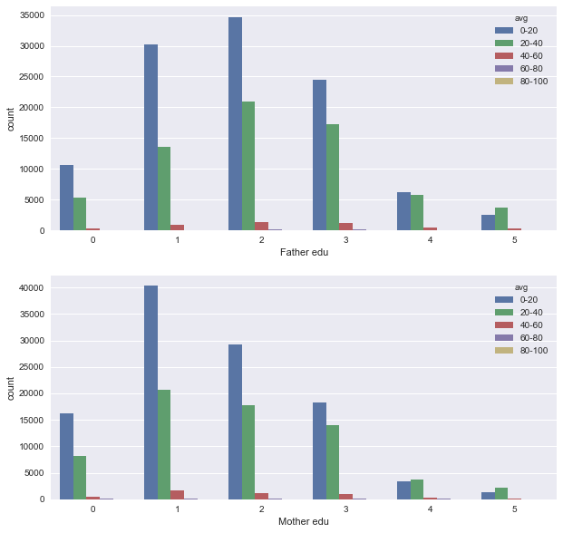

MATHS: Correct Maths HW regularly, gives good performance in students.

Private tuition also improve the students performance. Mainly ,it reduces to get low marks. 1-No, 2-Yes.

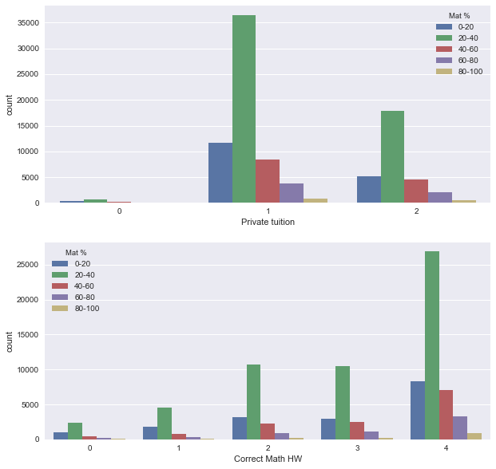

READING

Reading other books and using Dictionary to learn habit gives improvement in students.

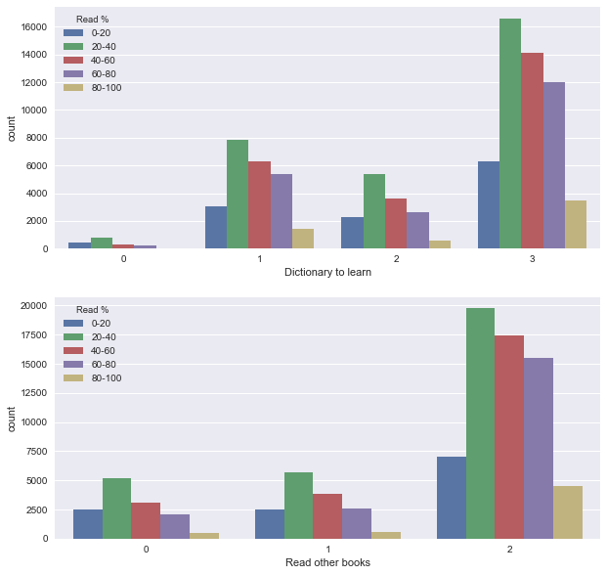

SCIENCE:

Solve Science problems and conducting experiments , improve student performance in Science.

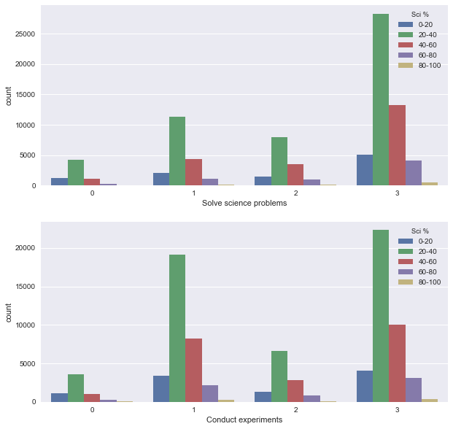

SOCIAL:

Historical excursion and Group study increase students performance in Social.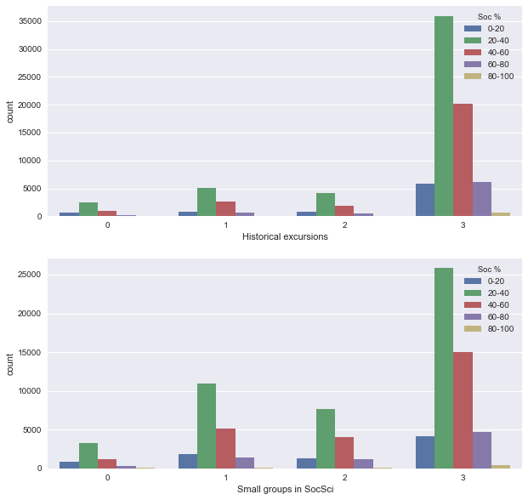

BOYS AND GIRLS PERFORMANCE ACCORDING STATES

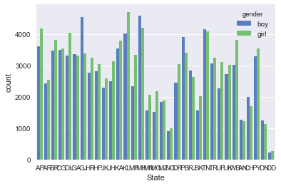

**NUMBER OF STUDENTS (BOYS & GIRLS) IN STATE WISE.**

**MORE STUDENTS FROM KERALA STATE.**

|  |  | **state** |  |  |  |
| --- | --- | --- | --- | --- | --- |
| **gender** | **Mat %** | **East** | **North** | **South** | **West** | **ALL** |
| **boy** | **0-20** | 2050 | 2244 | 2081 | 1118 | 7493 |
| **20-40** | 6616 | 7582 | 6658 | 4528 | 25384 |
| **40-60** | 1843 | 1861 | 896 | 1040 | 5640  **BOYS & GIRLS: MOST OF THE STUDENTS FROM EAST STATES PERFORM WELL IN MATHS.**  **COMPARING TO BOYS, GIRLS PERFORM WELL IN ALL STATES.** |
| **60-80** | 1028 | 833 | 306 | 338 | 2505 |
| **80-100** | 380 | 231 | 49 | 31 | 691 |
| **girl** | **0-20** | 2690 | 2698 | 2309 | 974 | 8671 |
| **20-40** | 7542 | 7723 | 7047 | 3944 | 26256 |
| **40-60** | 2172 | 1980 | 1159 | 1024 | 6335 |
| **60-80** | 1210 | 967 | 382 | 357 | 2916 |
| **80-100** | 351 | 271 | 65 | 30 | 717 |
| **All** |  | 25882 | 26390 | 20952 | 13384 | 86608 |

**MATHS oy**

GIRLS PERFORMANCE

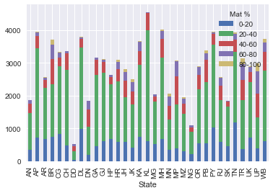

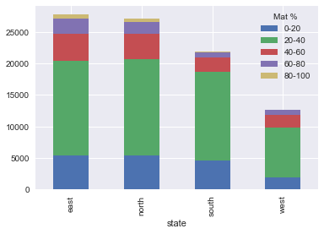

BOYS PERFORMANCE:

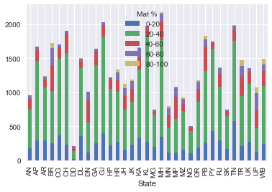

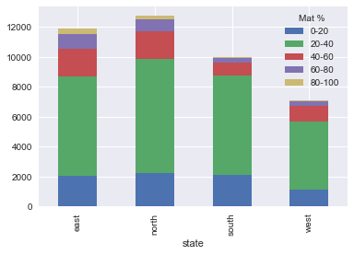

|  |  |  | **state** |  |  |
| --- | --- | --- | --- | --- | --- |
| **gender** | **Sci %** | **East** | **North** | **South** | **West** | **All** |
| **boy** | **0-20** | 1020 | 1485 | 1315 | 462 | 4282 |
| **20-40** | 6227 | 7480 | 5995 | 3775 | 23477 |
| **40-60** | 3030 | 2757 | 2091 | 2172 | 10050 |
| **60-80** | 1075 | 726 | 393 | 627 | 2821  **BOYS & GIRLS: MOST OF THE STUDENTS FROM EAST STATES PERFORM WELL IN SCIENCE.**  **COMPARING TO BOYS, GIRLS PERFORM WELL.** |
| **80-100** | 165 | 96 | 40 | 37 | 338 |
| **girl** | **0-20** | 1468 | 1659 | 1318 | 373 | 4818 |
| **20-40** | 7412 | 7733 | 6287 | 3325 | 24757 |
| **40-60** | 3277 | 2823 | 2674 | 2069 | 10843 |
| **60-80** | 1178 | 930 | 465 | 569 | 3142 |
| **80-100** | 171 | 127 | 39 | 40 | 377 |
| **All** |  | 25023 | 25816 | 20617 | 13449 | 84905 |

SCIENCE

**GIRLS PERFORMANCE**

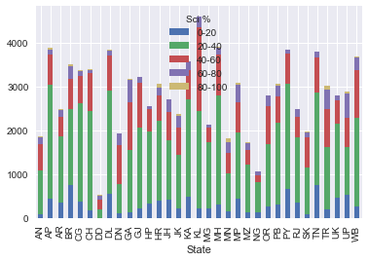



**BOYS PERFORMANCE**

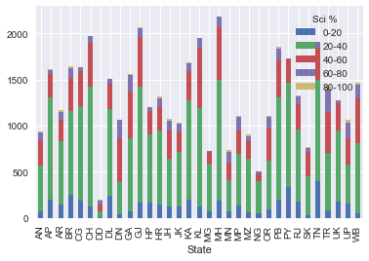

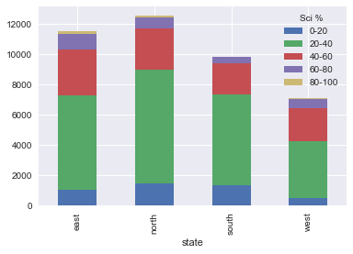

|  |  |  | **state** |  |  |
| --- | --- | --- | --- | --- | --- |
| **gender** | **Soc %** | **East** | **North** | **South** | **West** | **All**  **BOYS : MORE STUDENTS FROM SOUTH STATES GOT LOW MARKS 0-20(%) COMPARING TO NORTH AND EAST STATES.**  **MORE STUDENTS FROM NORTH STATES GOT 80-100 (%) (BOTH BOYS AND GIRLS)**  **COMPARE WITH GIRLS, MORE BOYS GOT 80-100(%)**  **COMPARING WITH BOYS , IN ALL STATES GIRLS ARE PERFORM WELL.**  **COMPARING TO BOYS, GIRLS PERFORM WELL.** |
| **boy** | **0-20** | 1041 | 1068 | 1240 | 371 | 3720 |
| **20-40** | 6056 | 6750 | 5576 | 3503 | 21885 |
| **40-60** | 3040 | 3483 | 2245 | 2287 | 11055 |
| **60-80** | 1124 | 976 | 481 | 697 | 3278 |
| **80-100** | 109 | 157 | 36 | 22 | 324 |
| **girl** | **0-20** | 1391 | 1121 | 1155 | 272 | 3939 |
| **20-40** | 7189 | 6991 | 5797 | 2820 | 22797 |
| **40-60** | 3535 | 3868 | 2731 | 2368 | 12502 |
| **60-80** | 1257 | 1125 | 703 | 644 | 3729 |
| **80-100** | 114 | 148 | 50 | 25 | 337 |
| **All** |  | 24856 | 25687 | 20014 | 13009 | 83566 |

SOCIAL

**GIRLS PERFORMANCE**

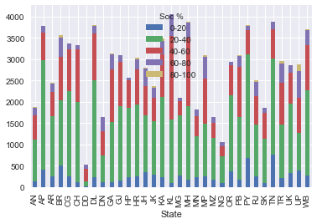

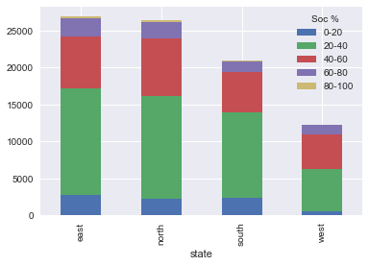

**BOYS PERFORMANCE:**

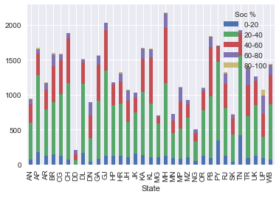

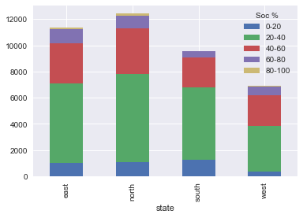

|  |  |  | **state** |  |  |
| --- | --- | --- | --- | --- | --- |
| **gender** | **Read %** | **East** | **North** | **South** | **West** | **All**  **BOYS: NORTH STATES, MORE STUDENTS GOT LOW MARKS IN READING.BOYS FROM EAST STATES PERFORM WELL.**  **GIRLS: EAST STATES, MORE STUDENTS GOT LOW MARKS.GIRLS FROM NORTH STATES PERFORM WELL.ESPECIALLY EAST STATES MORE GIRLS GOT 80-100(%).**  **COMPARING WITH BOYS, IN ALL STATES GIRLS ARE PERFORM WELL.** |
| **boy** | **0-20** | 1598 | 1709 | 1565 | 599 | 5471 |
| **20-40** | 4258 | 4420 | 3564 | 2288 | 14530 |
| **40-60** | 3045 | 3364 | 2374 | 2105 | 10888 |
| **60-80** | 2230 | 2592 | 1888 | 1725 | 8435 |
| **80-100** | 725 | 605 | 432 | 515 | 2277 |
| **girl** | **0-20** | 2124 | 1784 | 1387 | 407 | 5702 |
| **20-40** | 4909 | 4276 | 3179 | 1677 | 14041 |
| **40-60** | 3639 | 3632 | 2862 | 1817 | 11950 |
| **60-80** | 2635 | 3275 | 2748 | 1846 | 10504 |
| **80-100** | 786 | 740 | 737 | 711 | 2974 |
| **All** |  | 25949 | 26397 | 20736 | 13690 | 86772 |

READING

**GIRLS PERFORMANCE:**  
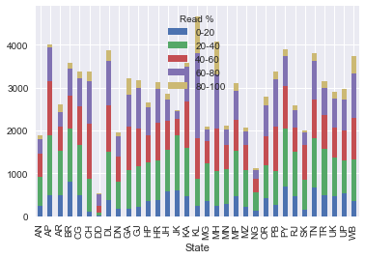

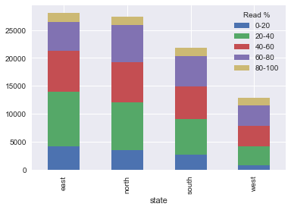

**BOYS PERFORM ANCE:**

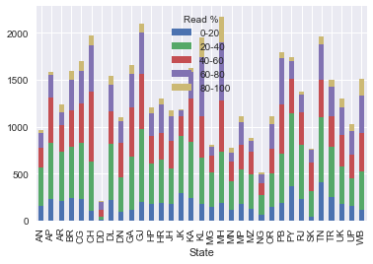

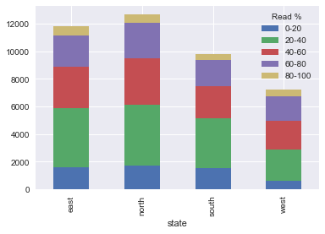

COMPARISION OF STUDENTS OF SOUTH STATES WITH OTHER STATES AT MATHS AND SCIENCE

**MATHS**

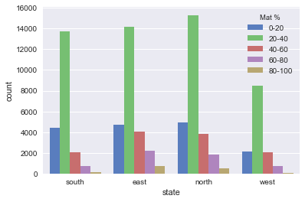

SCIENCE

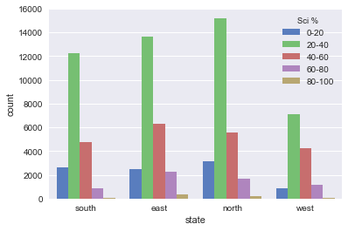

STATE WISE PERFORMANCE AT READING AND SOCIAL:

READINGS

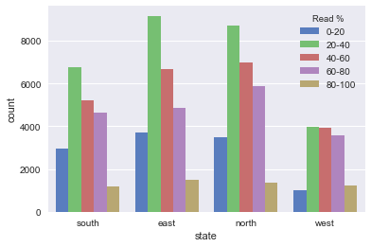

SOCIAL

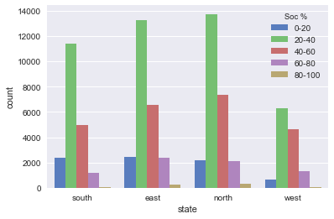

SUBJECT WISE PERFORMANCE

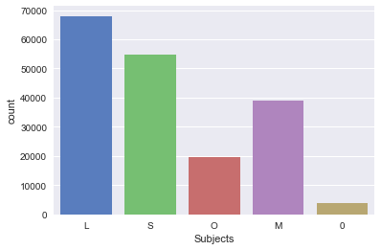

L-READING

S-SCIENCE

O-SOCIAL

M-MATHS

0-NONE

**STATE WISE PERFORMANCE WITH AVERAGE MARKS:**

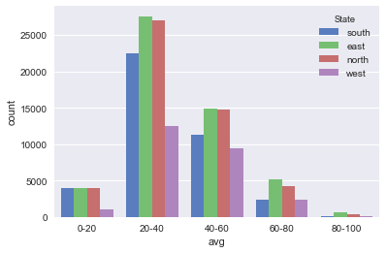

**GENDER WISE PERFORMANCE WITH AVERAGE MARKS:**



