EduGenie: Google Gemini Powered Learning Assistant
Functional Testing — Exploring the Updated EduGenie Interface

Overview
This document records a round of functional testing performed on the EduGenie web application, running locally at 127.0.0.1:8001. The updated interface introduces a redesigned landing page (“Welcome to EduGenie”) with a single “Choose a feature” dropdown that lets the user switch between four core capabilities: Ask a Question, Explain a Concept, Generate a Quiz, and Summarize Text. Each capability was tested end-to-end, from entering the prompt to reviewing the generated result, and the corresponding screenshots are included below.

Project Folder Structure
The EduGenie codebase is organized as a lightweight FastAPI project, separating the AI client, feature modules, and the web-facing templates and static assets, as shown below.
EduGenie/
1. main.py # FastAPI app entry point
2. ai_client.py # Wrapper for calls to the Gemini API
3. qna.py # Question answering module
4. explanation_module.py # Concept explanation logic
5. quiz_module.py # Quiz generation
6. summary_module.py # Summarization
7. learning_path.py # Learning recommendations
8. requirements.txt # Python dependencies
9. .env.example # Sample environment variables
10. .gitignore # Git ignore rules
11. README.md # Project documentation
12. templates/index.html # HTML frontend
13. static/style.css # Styling

Fig. Project folder structure

a. Asking a Question
With “Ask a Question” selected, the query “why is the sky is blue?” was entered into the input box and submitted using the Generate button.
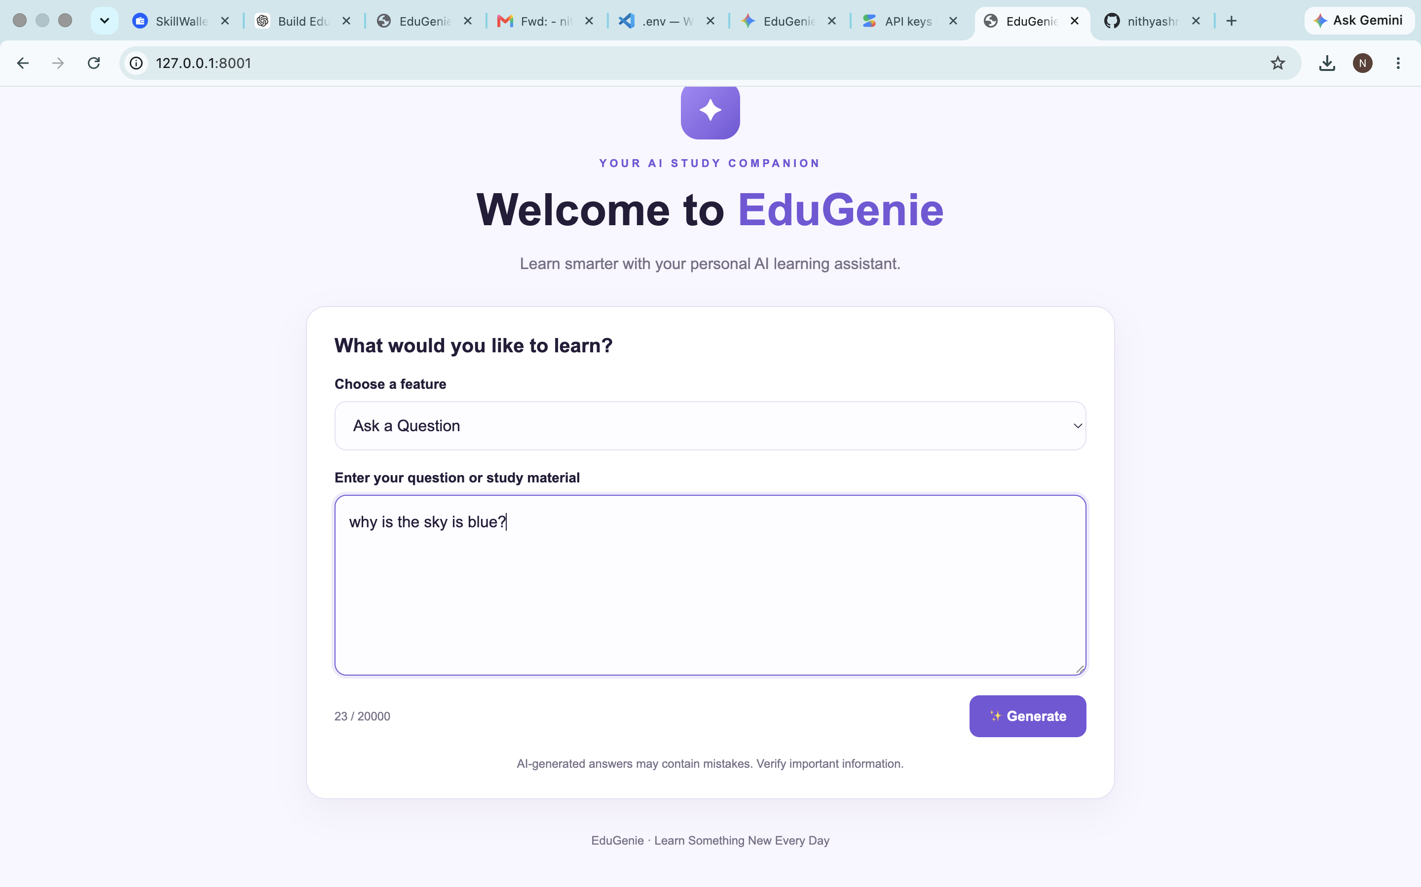
Fig. a1 — Ask a Question: entering the query
EduGenie returned a structured answer broken into a Direct Answer, a Short Explanation, and a relatable Example (rolling balls on an obstacle course), correctly explaining Rayleigh scattering in simple, student-friendly language.
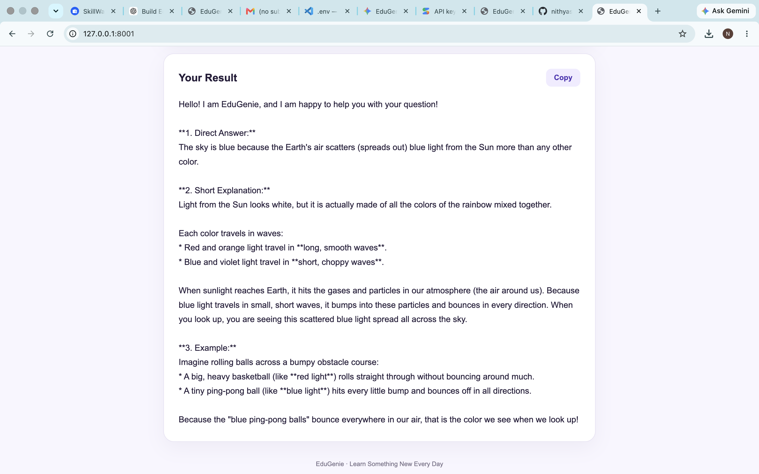
Fig. a2 — Ask a Question: generated result

b. Explaining a Concept
Switching the feature dropdown to “Explain a Concept,” the topic “photosynthesis” was submitted.
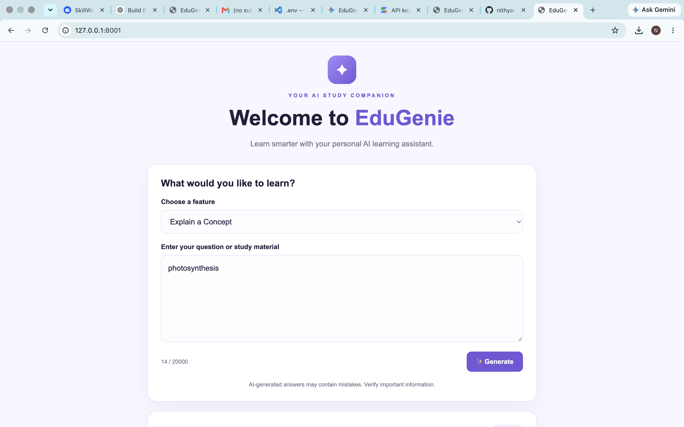
Fig. b1 — Explain a Concept: entering the topic
The assistant produced a well-organized, teacher-style explanation covering a Definition, a Simple Explanation (the “tiny green chef” analogy), Step-by-Step Points describing how a plant makes food, an Easy Example (baking a cake), and a Short Conclusion.
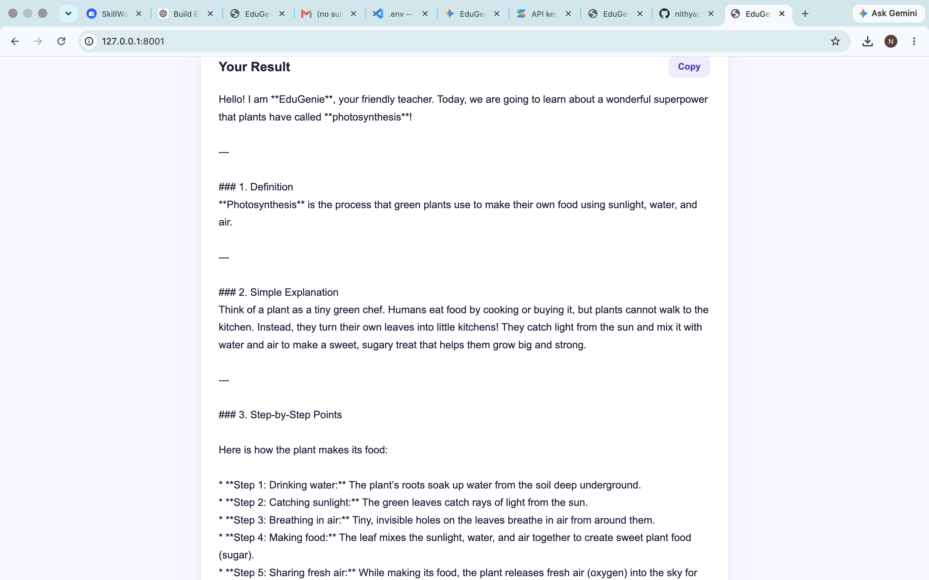
Fig. b2 — Explain a Concept: generated result (part 1)
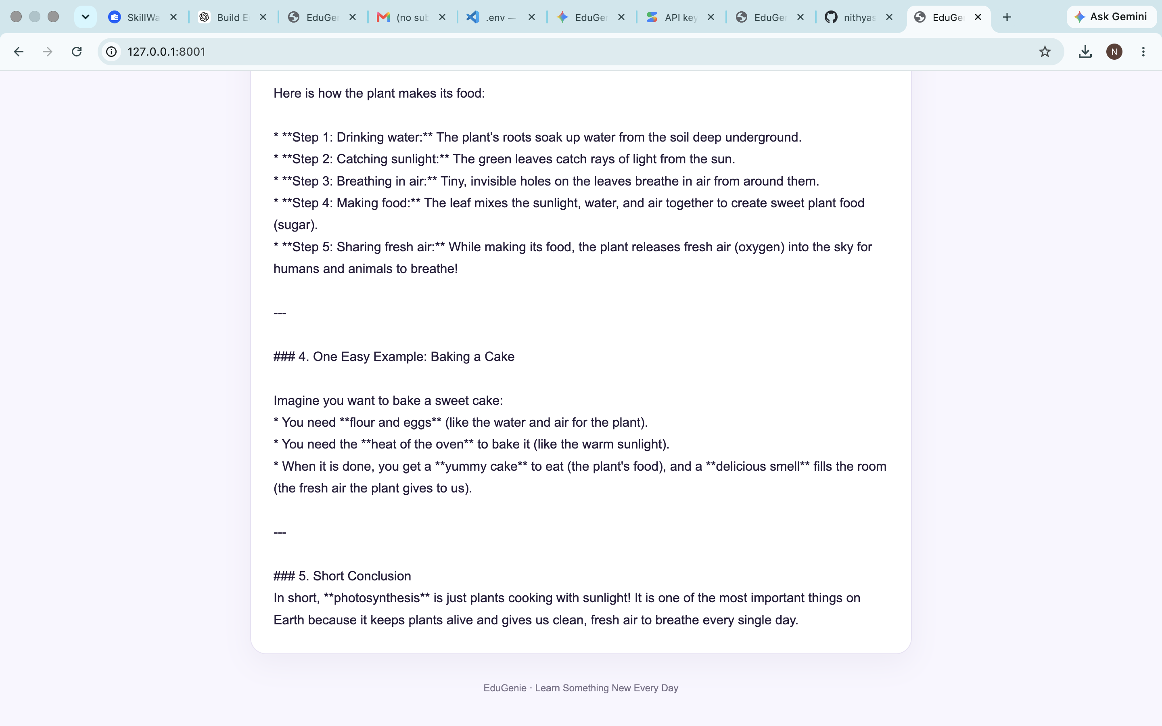
Fig. b3 — Explain a Concept: generated result (part 2)

c. Generating a Quiz
The feature dropdown was set to “Generate a Quiz” and the topic “solar system” was entered.
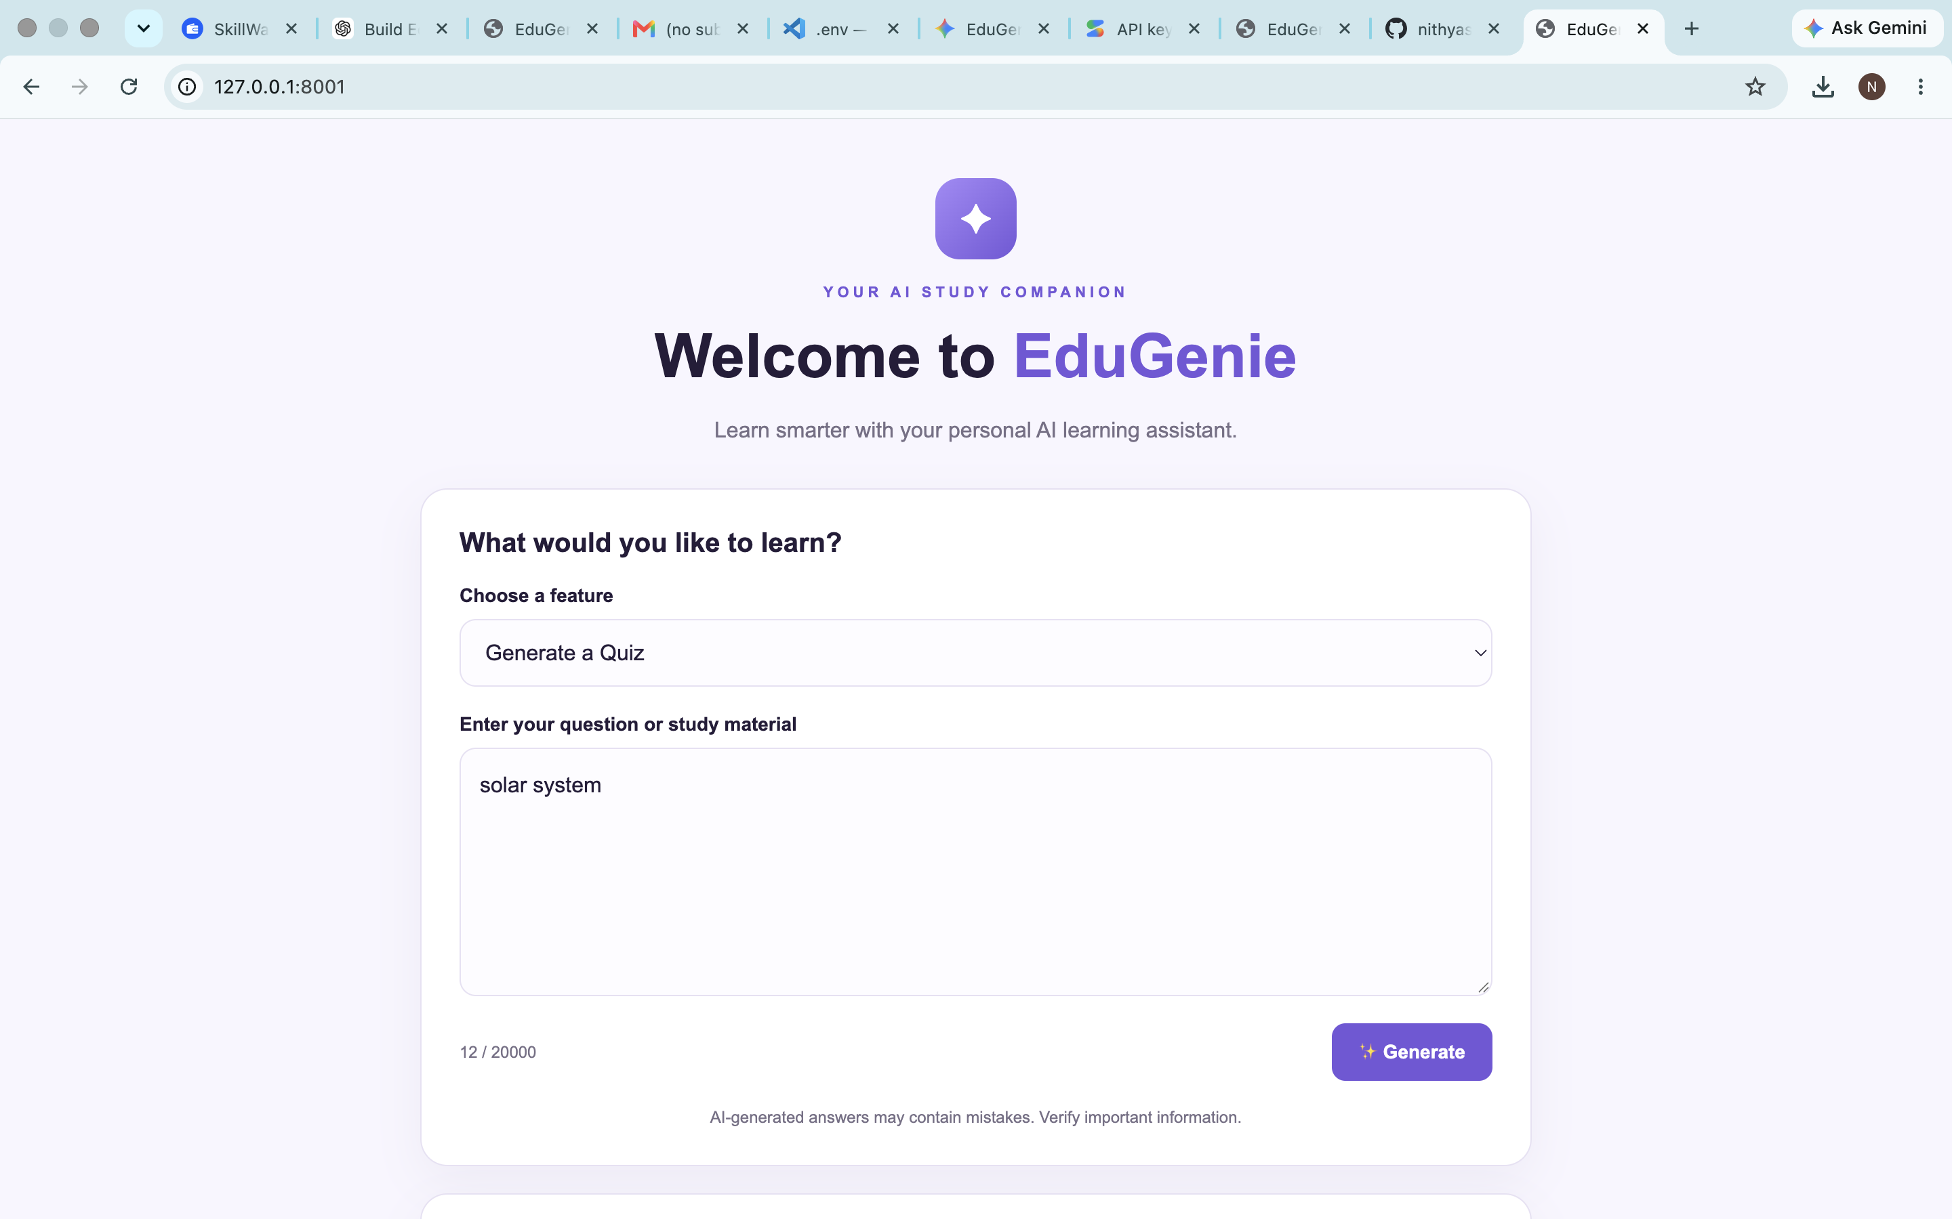
Fig. c1 — Generate a Quiz: entering the topic
EduGenie generated three multiple-choice questions, each with four options and a “Check Answer” button, covering the largest planet, the “Red Planet,” and the object at the center of the solar system.
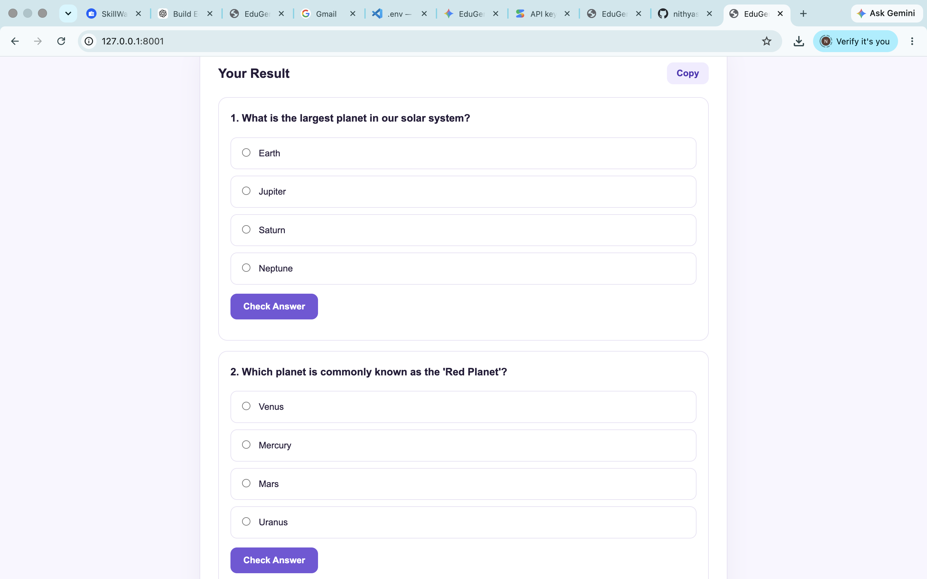
Fig. c2 — Generate a Quiz: Questions 1 and 2
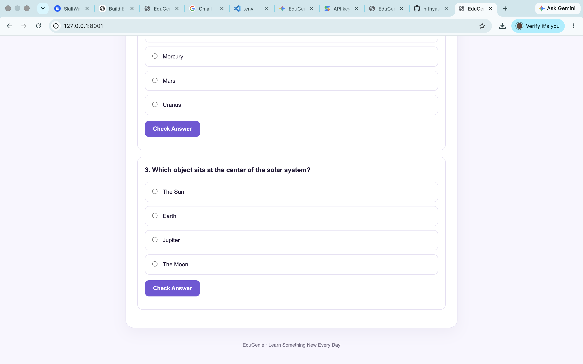
Fig. c3 — Generate a Quiz: Question 2 (continued) and Question 3

d. Summarizing Text
Finally, with “Summarize Text” selected, the phrase “Artificial Intelligence” was entered as the study material.
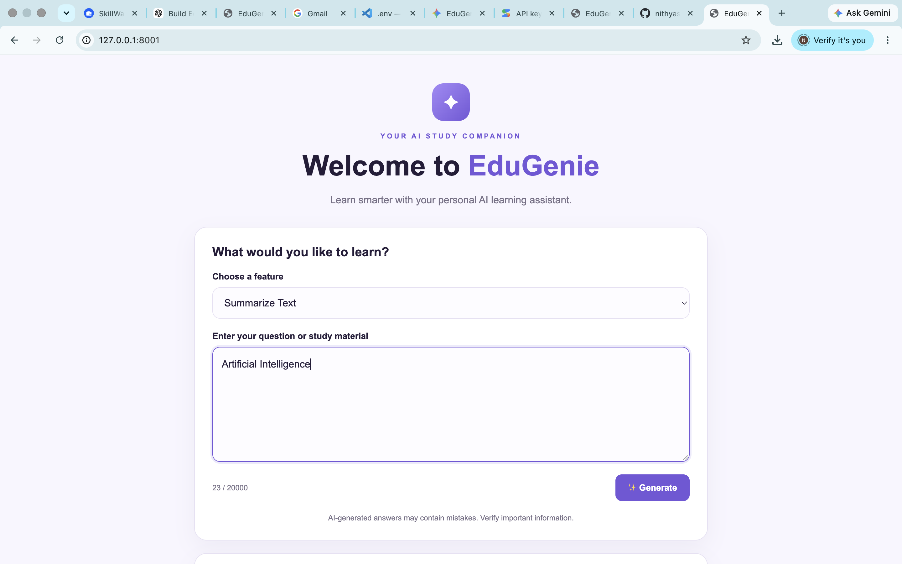
Fig. d1 — Summarize Text: entering the study material
Since the input contained only the phrase itself and no supporting passage, EduGenie correctly recognized that there was insufficient content to summarize and asked the user to share the full text or paragraph — demonstrating sensible handling of an edge case rather than fabricating a summary.
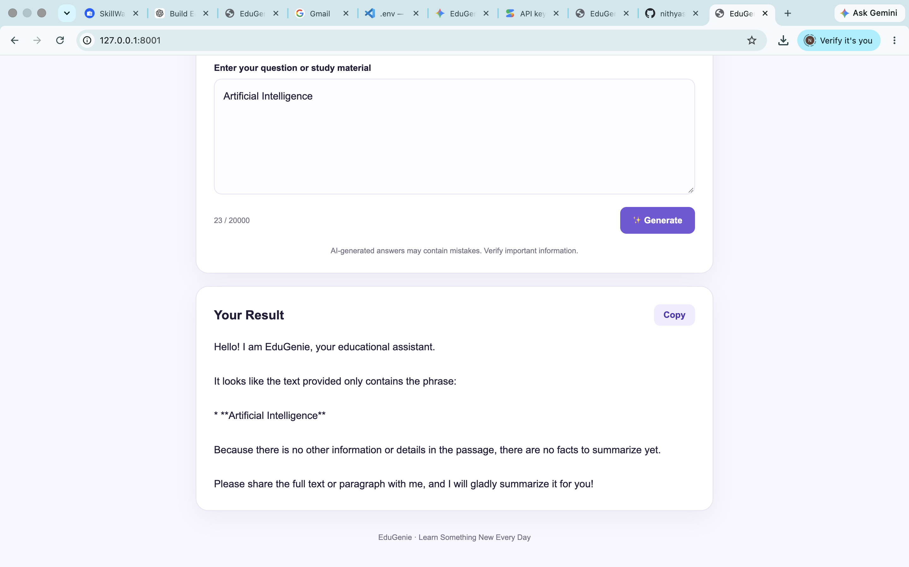
Fig. d2 — Summarize Text: generated result

Source Code
This section records the complete source code of the EduGenie application at the time of this round of testing, organized in the same order as the Project Folder Structure above.

main.py
FastAPI application entry point. Wires up the templates and static files, defines the /api/learn endpoint used by the frontend, and exposes individual per-feature endpoints (/qa, /explain, /quiz, /summarize, /learn/recommendations).
● ● ● main.py
from pathlib import Path
from typing import Literal

from fastapi import FastAPI, HTTPException, Request
from fastapi.responses import HTMLResponse
from fastapi.staticfiles import StaticFiles
from fastapi.templating import Jinja2Templates
from pydantic import BaseModel, Field

from qna import answer_question
from explanation_module import explain_topic
from quiz_module import generate_quiz
from summary_module import summarize_text
from learning_path import get_learning_recommendations

BASE_DIR = Path(__file__).resolve().parent

app = FastAPI(
title="EduGenie",
description="Gemini Powered Learning Assistant",
version="1.0.0"
)

app.mount(
"/static",
StaticFiles(directory=BASE_DIR / "static"),
name="static"
)

templates = Jinja2Templates(
directory=BASE_DIR / "templates"
)

class LearningRequest(BaseModel):
task: Literal[
"qa",
"explain",
"quiz",
"summarize",
"learn"
]

text: str = Field(
min_length=1,
max_length=20000
)

def process_request(task: str, text: str):
if task == "qa":
return answer_question(text)

if task == "explain":
return explain_topic(text)

if task == "quiz":
return generate_quiz(text)

if task == "summarize":
return summarize_text(text)

if task == "learn":
return get_learning_recommendations(text)

raise HTTPException(
status_code=400,
detail="Invalid task selected."
)

@app.get("/", response_class=HTMLResponse)
async def home(request: Request):
return templates.TemplateResponse(
request=request,
name="index.html",
context={}
)

@app.post("/api/learn")
async def learn(payload: LearningRequest):
text = payload.text.strip()

if not text:
raise HTTPException(
status_code=422,
detail="Please enter some text."
)

try:
result = process_request(
payload.task,
text
)

return {
"task": payload.task,
"result": result
}

except RuntimeError as error:
raise HTTPException(
status_code=503,
detail=str(error)
) from error

except Exception as error:
raise HTTPException(
status_code=502,
detail=f"AI request failed: {error}"
) from error

# Individual API endpoints

@app.post("/qa")
async def qa_endpoint(payload: dict):
return {
"result": answer_question(
get_text(payload)
)
}

@app.post("/explain")
async def explain_endpoint(payload: dict):
return {
"result": explain_topic(
get_text(payload)
)
}

@app.post("/quiz")
async def quiz_endpoint(payload: dict):
return {
"result": generate_quiz(
get_text(payload)
)
}

@app.post("/summarize")
async def summarize_endpoint(payload: dict):
return {
"result": summarize_text(
get_text(payload)
)
}

@app.post("/learn/recommendations")
async def recommendations_endpoint(payload: dict):
return {
"result": get_learning_recommendations(
get_text(payload)
)
}

def get_text(payload: dict) -> str:
text = str(
payload.get("text", "")
).strip()

if not text:
raise HTTPException(
status_code=422,
detail="The JSON body must contain a non-empty 'text' field."
)

if len(text) > 20000:
raise HTTPException(
status_code=422,
detail="Maximum input length is 20,000 characters."
)

return text

ai_client.py
Thin wrapper around the Gemini API. Loads the API key and model name from environment variables and exposes a single generate_text() helper used by every feature module.
● ● ● ai_client.py
import os
from functools import lru_cache

from dotenv import load_dotenv
from google import genai

load_dotenv()

@lru_cache(maxsize=1)
def get_client():
api_key = os.getenv("GEMINI_API_KEY", "").strip()

if not api_key or api_key == "your_actual_api_key":
raise RuntimeError(
"Gemini API key is missing. Add it to your .env file."
)

return genai.Client(api_key=api_key)

def generate_text(prompt: str) -> str:
client = get_client()

model = os.getenv(
"GEMINI_MODEL",
"gemini-2.5-flash"
)

response = client.models.generate_content(
model=model,
contents=prompt
)

answer = response.text

if not answer:
raise RuntimeError(
"Gemini returned an empty response."
)

return answer.strip()

qna.py
Builds the prompt for the “Ask a Question” feature, requesting a direct answer, a short explanation, and an example.
● ● ● qna.py
from ai_client import generate_text

def answer_question(question: str) -> str:
prompt = f"""
You are EduGenie, an educational AI assistant.

Answer the student's question accurately.
Use simple English that students can understand.

Give:
1. A direct answer
2. A short explanation
3. An example if necessary

Student's question:
{question}
"""

return generate_text(prompt)

explanation_module.py
Builds the prompt for the “Explain a Concept” feature, requesting a definition, a simple explanation, step-by-step points, an example, and a short conclusion.
● ● ● explanation_module.py
from ai_client import generate_text

def explain_topic(topic: str) -> str:
prompt = f"""
You are EduGenie, a friendly teacher.

Explain the following topic to a beginner.

Use:
1. Definition
2. Simple explanation
3. Step-by-step points
4. One easy example
5. Short conclusion

Use simple English.
Avoid difficult technical words.

Topic:
{topic}
"""

return generate_text(prompt)

quiz_module.py
Builds the prompt for the “Generate a Quiz” feature and parses the model's response into a validated JSON array of exactly three questions, each with four options, a correct answer, and an explanation.
● ● ● quiz_module.py
import json
import re

from ai_client import generate_text

def generate_quiz(text: str) -> list:
prompt = f"""
Create exactly 3 multiple-choice questions
based on the following study material.

Return ONLY a valid JSON array.

Each question must contain:
- question
- options: exactly 4 options
- answer: the exact correct option
- explanation: a short explanation

Example format:

[
{{
"question": "What is the largest ocean?",
"options": [
"Atlantic Ocean",
"Indian Ocean",
"Pacific Ocean",
"Arctic Ocean"
],
"answer": "Pacific Ocean",
"explanation": "The Pacific Ocean is the largest ocean."
}}
]

Create exactly 3 questions.

Study material:
{text}
"""

response = generate_text(prompt)

# Remove Markdown code fences if present.
cleaned = re.sub(
r"^\s*```(?:json)?\s*",
"",
response.strip(),
flags=re.IGNORECASE
)

cleaned = re.sub(
r"\s*```\s*$",
"",
cleaned
)

# Extract the JSON array.
start = cleaned.find("[")
end = cleaned.rfind("]")

if start == -1 or end == -1:
raise RuntimeError(
"Could not find a valid quiz JSON array."
)

try:
quiz = json.loads(cleaned[start:end + 1])
except json.JSONDecodeError as error:
raise RuntimeError(
f"Invalid quiz JSON: {error}"
) from error

if not isinstance(quiz, list) or len(quiz) != 3:
raise RuntimeError(
"The quiz must contain exactly 3 questions."
)

for question in quiz:
if not isinstance(question, dict):
raise RuntimeError("Invalid question format.")

if len(question.get("options", [])) != 4:
raise RuntimeError(
"Each question must have 4 options."
)

if question.get("answer") not in question["options"]:
raise RuntimeError(
"The correct answer must match an option."
)

for field in (
"question",
"answer",
"explanation"
):
if not question.get(field):
raise RuntimeError(
f"Missing quiz field: {field}"
)

return quiz

summary_module.py
Builds the prompt for the “Summarize Text” feature, instructing the model to keep key facts, remove repetition, and avoid adding unsupported information.
● ● ● summary_module.py
from ai_client import generate_text

def summarize_text(text: str) -> str:
prompt = f"""
You are EduGenie, an educational assistant.

Summarize the following passage for a student.

Requirements:
- Use simple English.
- Keep the important facts.
- Remove unnecessary repetition.
- Use bullet points where helpful.
- Do not add unsupported information.

Passage:
{text}
"""

return generate_text(prompt)

learning_path.py
Builds the prompt for the Learning Path feature, requesting a beginner-to-advanced roadmap with resources and a final project.
● ● ● learning_path.py
from ai_client import generate_text

def get_learning_recommendations(topic: str) -> str:
prompt = f"""
You are EduGenie, a personal learning guide.

Create a learning roadmap for:
{topic}

Organize the roadmap into:

1. Beginner Level
2. Intermediate Level
3. Advanced Level

For each level, include:
- Topics to study
- Suggested learning timeline
- Practice activities
- A small project

Also include:
- Recommended types of learning resources
- A final project
- Tips for consistent learning

Use simple English.
Make the roadmap practical for a student.
"""

return generate_text(prompt)

requirements.txt
Python dependencies required to run the project.
● ● ● requirements.txt
fastapi
uvicorn
jinja2
python-dotenv
google-genai

.env
Local environment configuration (not committed to version control). The API key value below has been redacted for this document — see the security note at the end of this section.
● ● ● .env
GEMINI_API_KEY=************************************ (redacted - see note below)
GEMINI_MODEL=gemini-3.8-flash

templates/index.html
HTML frontend: the feature dropdown, input form, and client-side JavaScript that calls /api/learn and renders either a text result or an interactive quiz.
● ● ● templates/index.html
<!DOCTYPE html>
<html lang="en">
<head>
<meta charset="UTF-8">
<meta name="viewport"
content="width=device-width, initial-scale=1.0">

<title>EduGenie - AI Learning Assistant</title>

<link rel="stylesheet"
href="{{ url_for('static', path='/style.css') }}">
</head>

<body>

<div class="container">

<header class="hero">
<div class="logo">✦</div>

<p class="tagline">YOUR AI STUDY COMPANION</p>

<h1>Welcome to <span>EduGenie</span></h1>

<p class="subtitle">
Learn smarter with your personal AI learning assistant.
</p>
</header>

<section class="card">

<h2>What would you like to learn?</h2>

<form id="learning-form">

<label for="task">Choose a feature</label>

<select id="task" name="task">
<option value="qa">Ask a Question</option>
<option value="explain">Explain a Concept</option>
<option value="quiz">Generate a Quiz</option>
<option value="summarize">Summarize Text</option>
<option value="learn">Learning Path</option>
</select>

<label for="user-input">
Enter your question or study material
</label>

<textarea
id="user-input"
name="text"
rows="6"
maxlength="20000"
placeholder="Type your question or paste your study material..."
required
></textarea>

<div class="form-footer">
<span id="counter">0 / 20000</span>

<button type="submit" id="submit-button">
✨ Generate
</button>
</div>

</form>

<p class="note">
AI-generated answers may contain mistakes.
Verify important information.
</p>

</section>

<section class="card result-card"
id="result-card"
hidden>

<div class="result-header">
<h2>Your Result</h2>

<button type="button"
class="copy-button"
id="copy-button">
Copy
</button>
</div>

<div id="result"></div>

</section>

<footer>
EduGenie · Learn Something New Every Day
</footer>

</div>

<script>
const form = document.getElementById("learning-form");
const task = document.getElementById("task");
const input = document.getElementById("user-input");
const button = document.getElementById("submit-button");
const resultCard = document.getElementById("result-card");
const result = document.getElementById("result");
const counter = document.getElementById("counter");
const copyButton = document.getElementById("copy-button");

const placeholders = {
qa: "Example: Which is the largest ocean?",
explain: "Example: Explain photosynthesis simply.",
quiz: "Enter a topic or paste your study material.",
summarize: "Paste the passage you want to summarize.",
learn: "Example: I want to learn Python from beginner to advanced."
};

task.addEventListener("change", () => {
input.placeholder = placeholders[task.value];
});

input.addEventListener("input", () => {
counter.textContent =
`${input.value.length} / 20000`;
});

function displayResult(data) {
result.replaceChildren();

if (Array.isArray(data)) {
data.forEach((question, index) => {
const card = document.createElement("div");
card.className = "quiz-question";

const heading = document.createElement("h3");
heading.textContent =
`${index + 1}. ${question.question}`;

card.appendChild(heading);

const options = document.createElement("div");
options.className = "options";

question.options.forEach((option, optionIndex) => {
const label = document.createElement("label");
label.className = "option";

const radio = document.createElement("input");
radio.type = "radio";
radio.name = `question-${index}`;
radio.value = option;

const span = document.createElement("span");
span.textContent = option;

label.append(radio, span);
options.appendChild(label);
});

const checkButton = document.createElement("button");
checkButton.type = "button";
checkButton.className = "check-button";
checkButton.textContent = "Check Answer";

const feedback = document.createElement("p");
feedback.className = "feedback";

checkButton.addEventListener("click", () => {
const selected =
options.querySelector("input:checked");

if (!selected) {
feedback.textContent =
"Please select an answer.";
return;
}

if (selected.value === question.answer) {
feedback.textContent =
"Correct! " + question.explanation;

feedback.className = "feedback correct";
} else {
feedback.textContent =
"Correct answer: " +
question.answer +
". " +
question.explanation;

feedback.className = "feedback incorrect";
}
});

card.append(
options,
checkButton,
feedback
);

result.appendChild(card);
});

} else {
const output = document.createElement("div");
output.className = "text-result";
output.textContent = String(data);

result.appendChild(output);
}
}

form.addEventListener("submit", async (event) => {
event.preventDefault();

const text = input.value.trim();

if (!text) {
input.focus();
return;
}

button.disabled = true;
button.textContent = "Generating...";

resultCard.hidden = false;
result.textContent = "EduGenie is preparing your answer...";

try {
const response = await fetch("/api/learn", {
method: "POST",

headers: {
"Content-Type": "application/json"
},

body: JSON.stringify({
task: task.value,
text: text
})
});

const data = await response.json();

if (!response.ok) {
throw new Error(
data.detail || "Something went wrong."
);
}

displayResult(data.result);

} catch (error) {
result.textContent =
"Error: " + error.message;

} finally {
button.disabled = false;
button.textContent = "✨ Generate";
}
});

copyButton.addEventListener("click", async () => {
try {
await navigator.clipboard.writeText(
result.innerText
);

copyButton.textContent = "Copied!";

} catch {
copyButton.textContent =
"Select text to copy";
}

setTimeout(() => {
copyButton.textContent = "Copy";
}, 1500);
});
</script>

</body>
</html>

static/style.css
Styling for the purple “EduGenie” theme, the input card, the result card, and the interactive quiz question layout, including a responsive breakpoint for small screens.
● ● ● static/style.css
:root {
--purple: #7357d9;
--dark-purple: #5035b5;
--light-purple: #f0ecff;
--background: #f8f6ff;
--text: #251d3a;
--muted: #777087;
--border: #e7e1f3;
--white: #ffffff;
}

* {
box-sizing: border-box;
}

body {
margin: 0;
min-height: 100vh;
font-family: Arial, Helvetica, sans-serif;
background: var(--background);
color: var(--text);
}

.container {
width: min(820px, 92%);
margin: 0 auto;
padding: 45px 0 25px;
}

.hero {
text-align: center;
margin-bottom: 30px;
}

.logo {
width: 60px;
height: 60px;
margin: 0 auto 18px;
display: grid;
place-items: center;
border-radius: 18px;
background: linear-gradient(
135deg,
#a58af9,
var(--purple)
);
color: white;
font-size: 30px;
}

.tagline {
color: var(--purple);
font-size: 11px;
font-weight: bold;
letter-spacing: 3px;
}

h1 {
font-size: clamp(30px, 5vw, 45px);
margin: 15px 0;
}

h1 span {
color: var(--purple);
}

.subtitle {
color: var(--muted);
line-height: 1.6;
}

.card {
background: var(--white);
border: 1px solid var(--border);
border-radius: 20px;
padding: 28px;
margin-bottom: 20px;
box-shadow: 0 12px 35px rgba(50, 30, 90, 0.05);
}

h2 {
font-size: 20px;
margin-top: 0;
}

label {
display: block;
font-size: 14px;
font-weight: bold;
margin: 20px 0 9px;
}

select,
textarea {
width: 100%;
padding: 14px;
border: 1px solid var(--border);
border-radius: 12px;
font: inherit;
color: var(--text);
background: #fdfcff;
outline: none;
}

select:focus,
textarea:focus {
border-color: var(--purple);
box-shadow: 0 0 0 3px rgba(115, 87, 217, 0.12);
}

textarea {
resize: vertical;
line-height: 1.6;
min-height: 140px;
}

.form-footer {
display: flex;
justify-content: space-between;
align-items: center;
gap: 12px;
margin-top: 16px;
}

#counter {
color: var(--muted);
font-size: 12px;
}

button {
padding: 12px 20px;
border: none;
border-radius: 10px;
background: var(--purple);
color: white;
font-size: 14px;
font-weight: bold;
cursor: pointer;
}

button:hover {
background: var(--dark-purple);
}

button:disabled {
opacity: 0.6;
cursor: wait;
}

.note {
text-align: center;
color: var(--muted);
font-size: 12px;
margin: 20px 0 0;
}

.result-card {
overflow-wrap: anywhere;
}

.result-header {
display: flex;
justify-content: space-between;
align-items: center;
gap: 10px;
}

.result-header h2 {
margin-bottom: 0;
}

.copy-button {
background: var(--light-purple);
color: var(--dark-purple);
padding: 9px 15px;
}

.copy-button:hover {
background: #e4dcff;
}

#result {
line-height: 1.7;
margin-top: 20px;
}

.text-result {
white-space: pre-wrap;
}

.quiz-question {
padding: 18px;
border: 1px solid var(--border);
border-radius: 14px;
margin-bottom: 16px;
}

.quiz-question h3 {
font-size: 16px;
margin-top: 0;
}

.options {
display: grid;
gap: 10px;
}

.option {
display: flex;
align-items: flex-start;
gap: 10px;
padding: 12px;
margin: 0;
border: 1px solid var(--border);
border-radius: 10px;
cursor: pointer;
font-weight: normal;
}

.option input {
margin-top: 4px;
accent-color: var(--purple);
}

.check-button {
margin-top: 14px;
}

.feedback {
font-size: 14px;
}

.correct {
color: #167647;
}

.incorrect {
color: #b42318;
}

footer {
text-align: center;
color: var(--muted);
font-size: 12px;
padding: 15px 0;
}

[hidden] {
display: none !important;
}

@media (max-width: 520px) {
.container {
padding-top: 25px;
}

.card {
padding: 20px;
}

.form-footer {
flex-direction: column;
align-items: stretch;
}

.form-footer button {
width: 100%;
}
}

Security note: the .env file pasted into this conversation contained a live-looking Gemini API key. That value has been redacted above and should be treated as compromised — rotate/regenerate it in Google AI Studio and update your local .env, since it was shared in plain text.

Conclusion
This round of testing confirms that all four core features of the updated EduGenie interface — Ask a Question, Explain a Concept, Generate a Quiz, and Summarize Text — work correctly through the single unified landing page. The application returns well-structured, easy-to-read responses and handles at least one edge case (insufficient input for summarization) gracefully, indicating the redesigned UI and underlying logic are functioning as intended.

