**OBJECTIVE:**

The **objective** of a customer churn project is typically to reduce the rate at which customers stop doing business with a company. Churn, or customer attrition, can have a significant impact on a business's revenue and profitability. The project aims to identify the factors contributing to customer churn, develop strategies to retain customers, and implement measures to minimize churn. This often involves analyzing customer data to identify patterns and predictors of churn, creating targeted retention campaigns, and continuously monitoring and adjusting strategies based on the evolving customer landscape. Ultimately, the goal is to enhance customer loyalty and maximize customer lifetime value.

**DESIGN THINKING:**

1. Empathize: Understand user and website owner needs and challenges.

2. Define: Clarify the problem - predicting churn and enhancing user experience.

3. Ideate: Brainstorm data sources, analytical techniques, and potential solutions.

4. Prototype: Develop data collection methods and predictive models.

5. Test: Validate the model and gather insights.

6. Implement: Communicate findings and strategies to the website owners.

**ANALYSIS OBJECTIVES:**

1.Build a predictive model to identify potential churners.

2.Analyse user behaviour, demographics, and website interactions.

3.Visualize key performance indicators (KPIs) using IBM Cognos and Python.

4.Identify factors influencing customer churn. - Build a predictive model to identify potential

**DEVELOPMENT PHASES:**

1. Data Collection: Gather historical user data, including behaviour, demographics, and churn labels.

2. Data Preprocessing: Clean and prepare data for analysis.

3. Exploratory Data Analysis (EDA): Explore data distributions and relationships.

4. Feature Engineering: Create predictive features.

5. Model Building: Develop a churn prediction model.

6. Data Visualization: Utilize IBM Cognos and Python for visualization.

7. Insights Generation: Derive actionable insights from the analysis.

**DATA VISUALIZATION:**

1.Employ IBM Cognos for interactive dashboard creation with KPIs.

2.Utilize Python libraries like Matplotlib and Seaborn for supplementary visualizations.

**DATA COLLECTION PROCESS:**

1.Collect historical user data from the website's database.

2.Include user behaviour data, demographic information, and churn status.

3.Ensure data quality and consistency.

**PYTHON CODE INTEGRATION:**

1.Integrate Python code for data preprocessing, feature engineering, and model development.

2. Generate actionable insights and predictions using Python scripts.

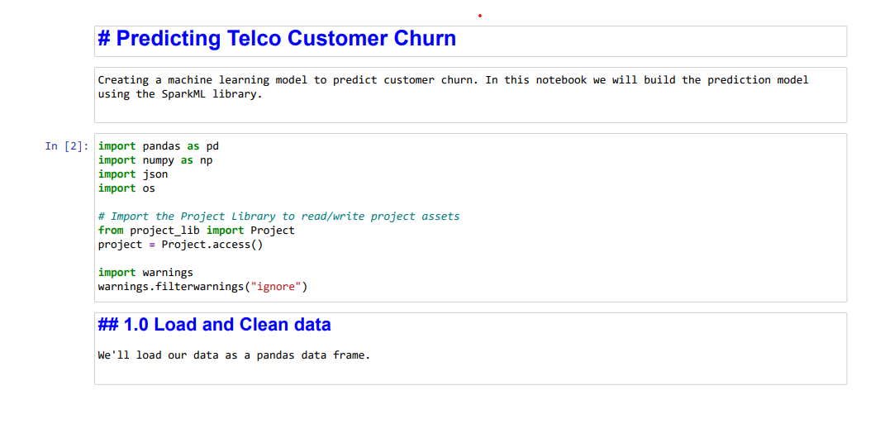

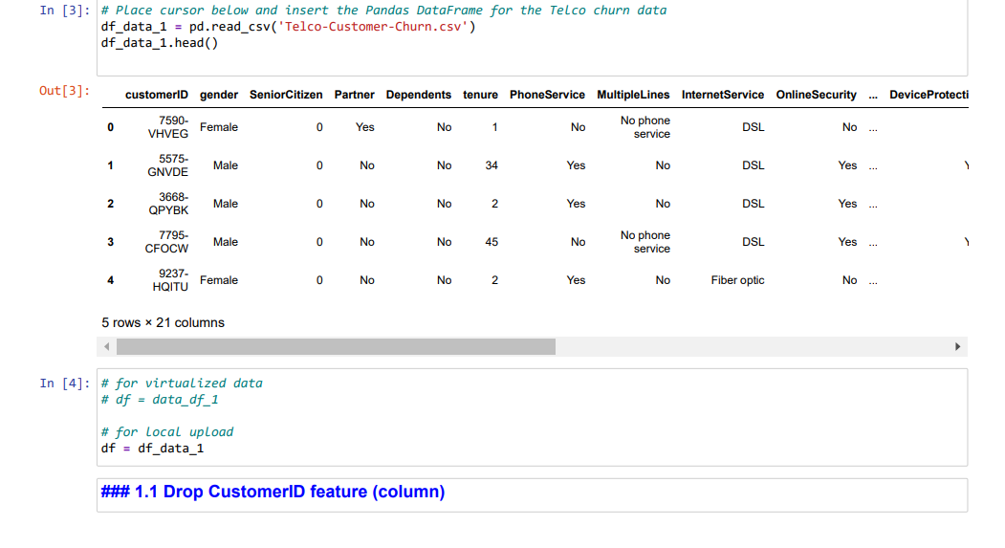

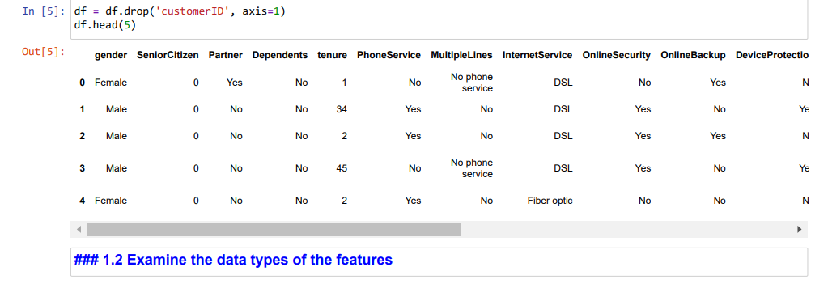

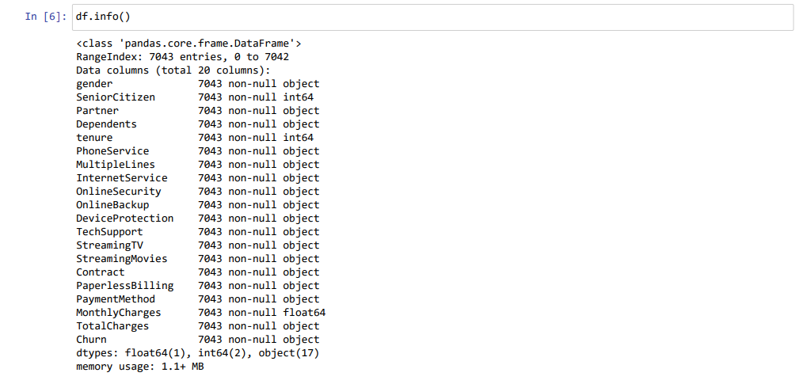

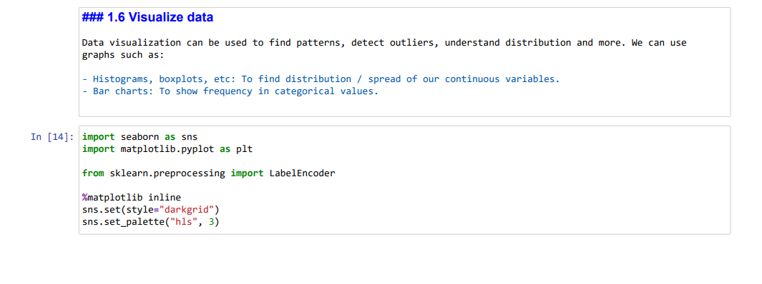

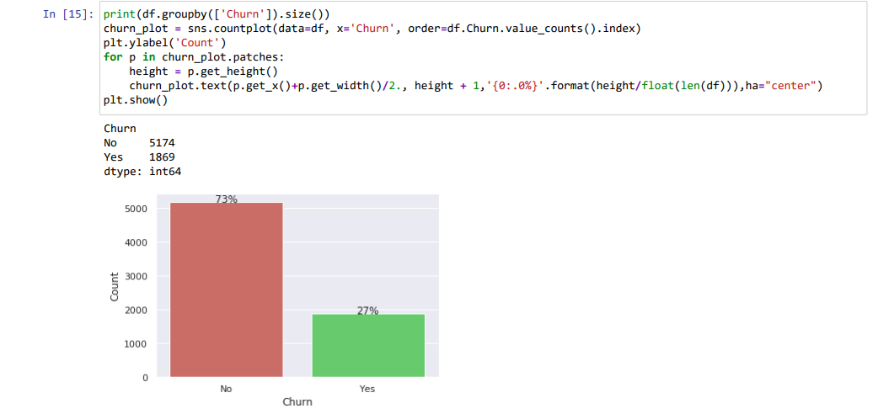

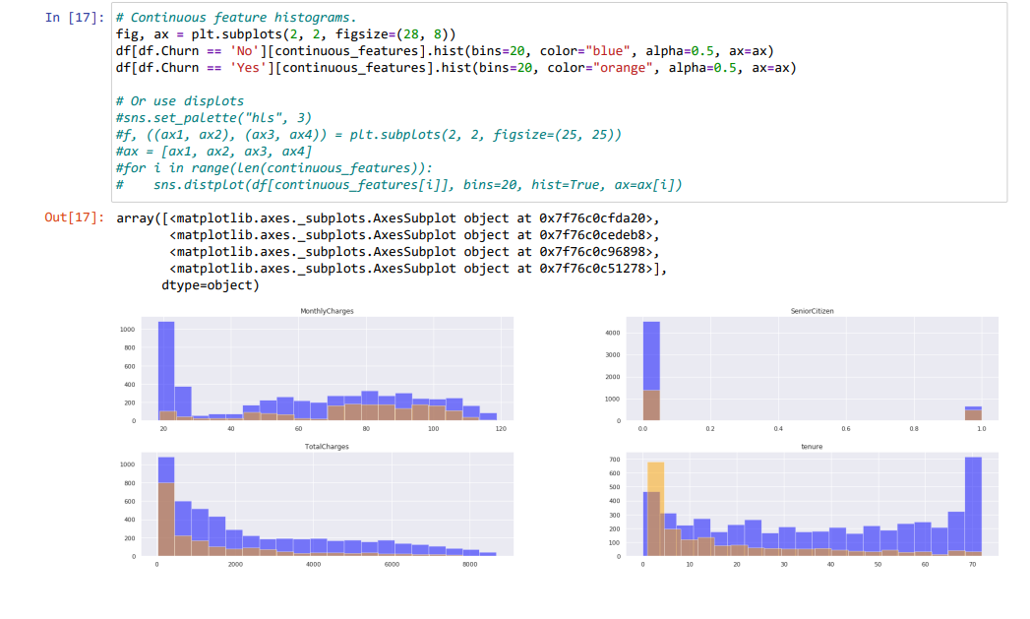

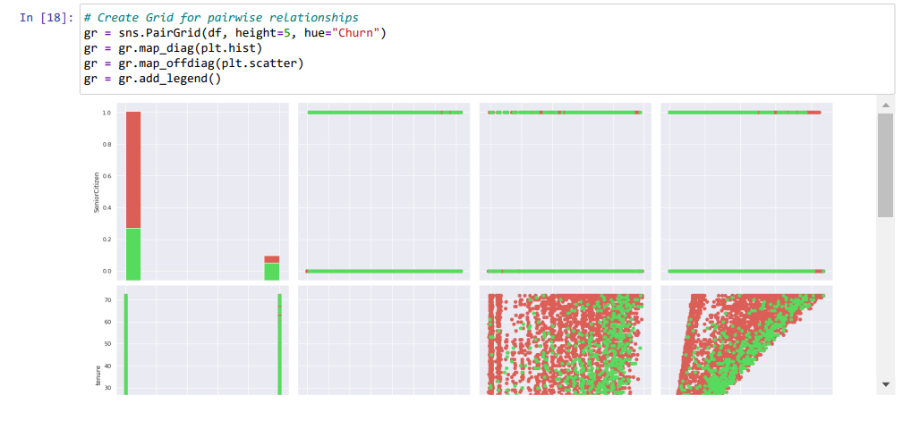

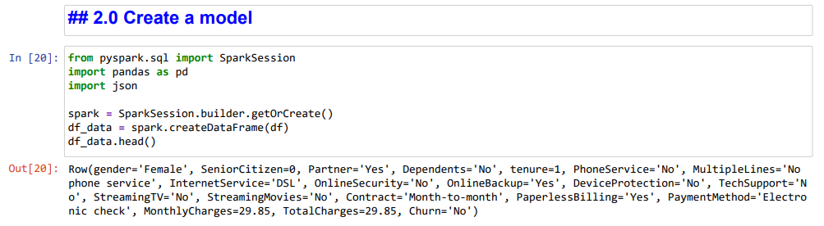



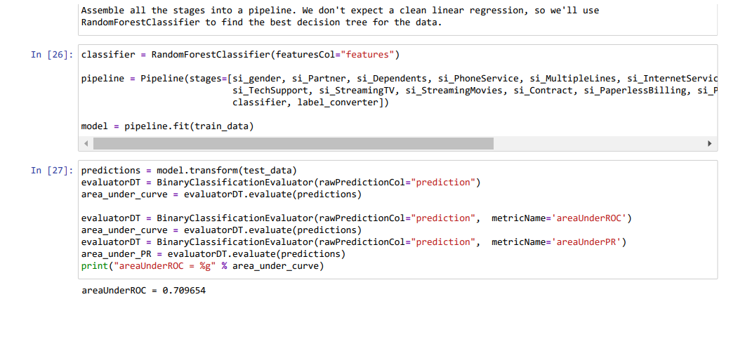

**INSIGHTS FOR WEBSITE OWNERS:**

The insights from the analysis can assist website owners in the following ways:

1. Identify users at risk of churning and take proactive retention measures.

2. Understand which website features or content are associated with higher retention.

3.Optimize marketing and user engagement strategies based on demographic data.

4.Monitor KPIs to assess the effectiveness of user experience improvements. - Integrate Python code for data preprocessing, feature engineering, and model development.

5.Generate actionable insights and predictions using Python scripts.