1 . Differentiate between supervised and unsupervised Machine Learning.
Feature | Supervised Learning | Unsupervised Learning
Data | Uses labeled data (input with correct output). | Uses unlabeled data (no correct output given).
Goal | To predict the output based on input data. | To find hidden patterns or groups in data.
Example Tasks | Classification and Regression. | Clustering and Association.
Example Algorithms | Decision Tree, Linear Regression, SVM. | K-Means, Hierarchical Clustering.

- Give the names of two clustering techniques used in unsupervised learning.
1. K-Means Clustering
2. Hierarchical Clustering
3 . Outline the concept of hierarchical clustering.

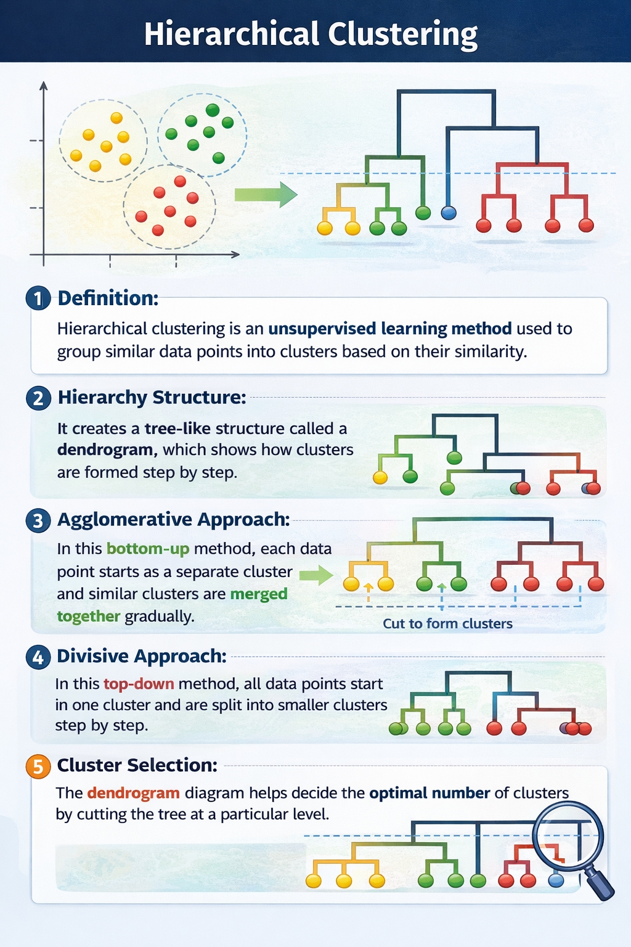
4 Write the difference between K-means and hierarchical clustering.
Feature | K-Means Clustering | Hierarchical Clustering
Method | Divides data into K number of clusters. | Creates a tree-like structure (dendrogram) of clusters.
Number of Clusters | K must be given before running the algorithm. | No need to specify clusters at the beginning.
Speed | Faster for large datasets. | Slower for large datasets.
Approach | Uses centroids to form clusters. | Uses merging or splitting of clusters step by step.

