. .Overview

Logistic Regression is used to predict a categorical target variable, usually binary (0/1).

Linear combination:

z = mx + c

Probability prediction:

p = 1 / (1 + e^-z) (Sigmoid function)

Threshold: p > 0.5 → class 1, else class 0

. Assumptions

Target variable should be binary.

No multicollinearity among predictors.

Log-odds should be linearly related to predictors.
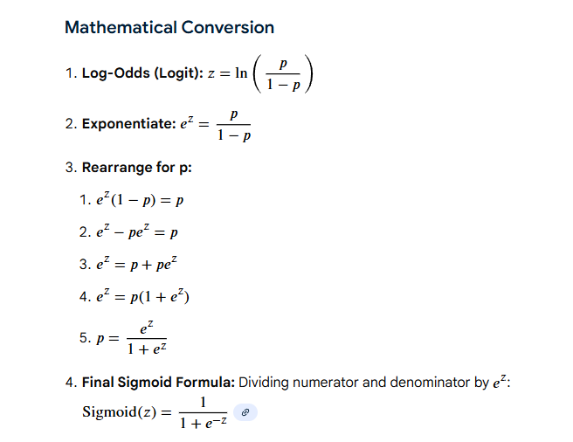

odds ratio= odds of success / odds of failure

p(A)/1-P(A)
log(odds)=log(p(A)/1-p(A))

