Introduction to Machine Learning (ML)

1. The Core Idea: Learning from Data
Imagine teaching a computer to tell a Cat from a Dog.
Traditional Programming (Not ML): You would write a thousand rules: "If the color is gray AND the sound is 'meow' AND the eyes are yellow... it's a cat." This is impossible to maintain!
Machine Learning (ML): You show the computer thousands of labeled pictures (this is a Cat, this is a Dog). The computer learns the complex visual patterns itself.

💡 Why ML is Required:
Problem | Traditional Code Solution | ML Solution
Spam/Ham Email | Impossible to write rules for every new spam trick. | ML learns the patterns of "spam words" and "ham words" from millions of past emails.
Dog/Cat Classification | Impossible to list the exact rules for every dog breed and lighting. | ML finds the common features (texture, ear shape, nose) that separate them.

🤖2. Types of ML: Supervised vs. Unsupervised

2.1. Supervised Learning (The Teacher is Present)
Concept: The data comes with labels (the correct answers).
Analogy: A student learning math where every problem has the answer key next to it.
Goal: To predict a known outcome (like 'Spam' or 'Price').
Classification (Predicting a Category) | Regression (Predicting a Number)
Predicting if a customer will click (YES/NO). | Predicting the price of a house.

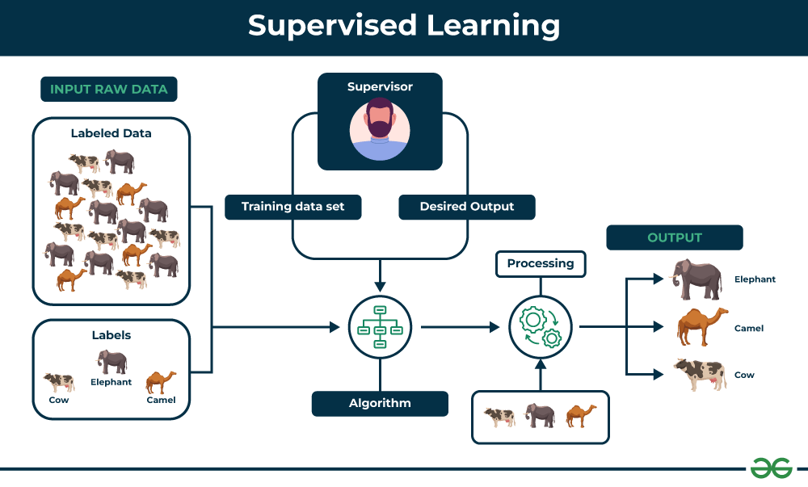

2.2 Unsupervised Learning (Finding Hidden Patterns)
Concept: The data has no labels. The computer must find structure on its own.
Analogy: Giving a child a box of random toys and asking them to sort them into groups (e.g., cars, dolls, blocks).
Goal: To group or simplify data.
Clustering: Grouping similar things together.
Example: Grouping your customers into segments (e.g., 'Young Families,' 'Retired Travelers') so you can send them targeted ads.
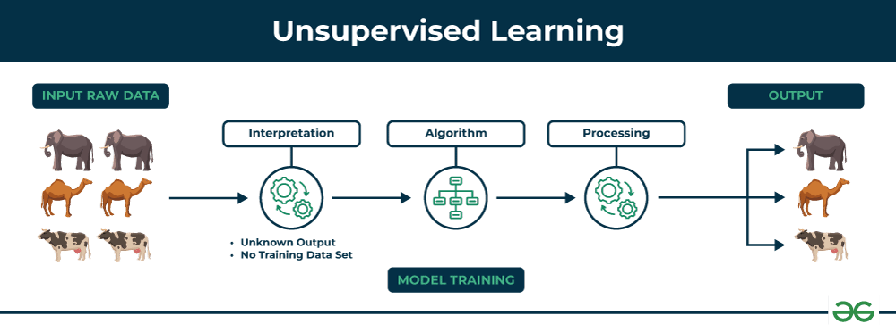

The Scope: Where ML Helps Managers
ML's scope in management means it touches almost every part of a business, from finding customers to fixing machines.

1. Predicting the Future (Forecasting)
Problem: A clothing store manager needs to know, "How many blue t-shirts of size Medium will we sell next week?" If they order too many, the shirts sit on the shelf and waste money. If they order too few, they lose a sale.
ML Solution: ML analyzes the past (sales data from last year, weather, holidays, and trends on social media). It then predicts the exact amount to order.
Management Benefit: Better decisions on inventory (stock) and resource allocation (where to spend money).

2. Knowing the Customer (Personalization)
Problem: An online video platform (like YouTube or Netflix) has millions of movies. How does it know what you want to watch next?
ML Solution: The ML model watches what you and other similar people have watched, skipped, or searched for. It then creates a personalized list of recommendations just for you.
Management Benefit: Increased Sales and Loyalty. Customers are happier and spend more time (or money) because they are shown exactly what they like.

3. Catching the Bad Guys (Fraud and Security)
Problem: A bank manager needs to spot a stolen credit card being used. A human cannot check millions of transactions every second.
ML Solution: The ML model learns the normal pattern of a person's spending (where they shop, how much they spend). If a transaction suddenly happens in a new country for a large amount, the ML flags it instantly as suspicious.
Management Benefit: Risk Reduction. The business saves money by stopping fraud and protecting customer information.

4. Making Work Easy (Automation)
Problem: A customer service manager gets thousands of emails a day asking common questions like, "What is your return policy?"
ML Solution: Chatbots and smart filters use ML (specifically, Natural Language Processing) to read the email, understand the question, and automatically send the right answer or quickly send the email to the correct department.
Management Benefit: Increased Efficiency. Employees are free to focus on difficult problems, and customers get instant replies.

🎯 The Relevance: Why Managers Need ML
ML is essential for modern management because it helps businesses gain a Competitive Edge.
ML Feature | Relevance to Management
Speed | ML analyzes large data sets in seconds, allowing managers to make real-time decisions instead of waiting days or weeks.
Accuracy | ML finds patterns that a human brain would miss, leading to more accurate forecasts and fewer expensive mistakes.
Growth | By understanding customers better and predicting trends, ML helps the company find new opportunities and grow revenue.
Cost Saving | Automating repetitive tasks and predicting when equipment might break down (Predictive Maintenance) saves the company money.
In short, ML is the brain of the modern business, turning huge amounts of data into simple, smart actions that help managers run the company better.
Data requirements for machine learning: data preprocessing; splitting datasets

Project :

Titanic Survival Prediction using Machine Learning

Dataset - > https://github.com/adas754/ML_Foundations/blob/main/titanic.zip

IPynb file -> https://github.com/adas754/ML_Foundations/blob/main/Titanic_Survival_Prediction_using_Machine_Learning.ipynb

3. Evaluation Metrics: How Good is the Model?
To test the model, we use a concept called the Confusion Matrix, which tracks all the correct and incorrect predictions.

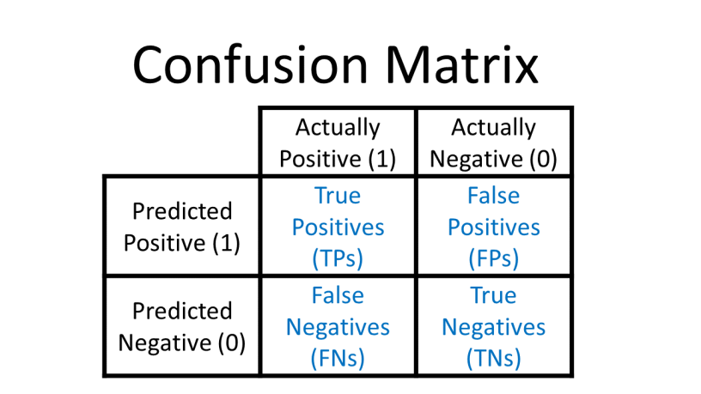

Accuracy (Overall Correctness)
Idea: What percentage of all predictions were correct?
Formula: 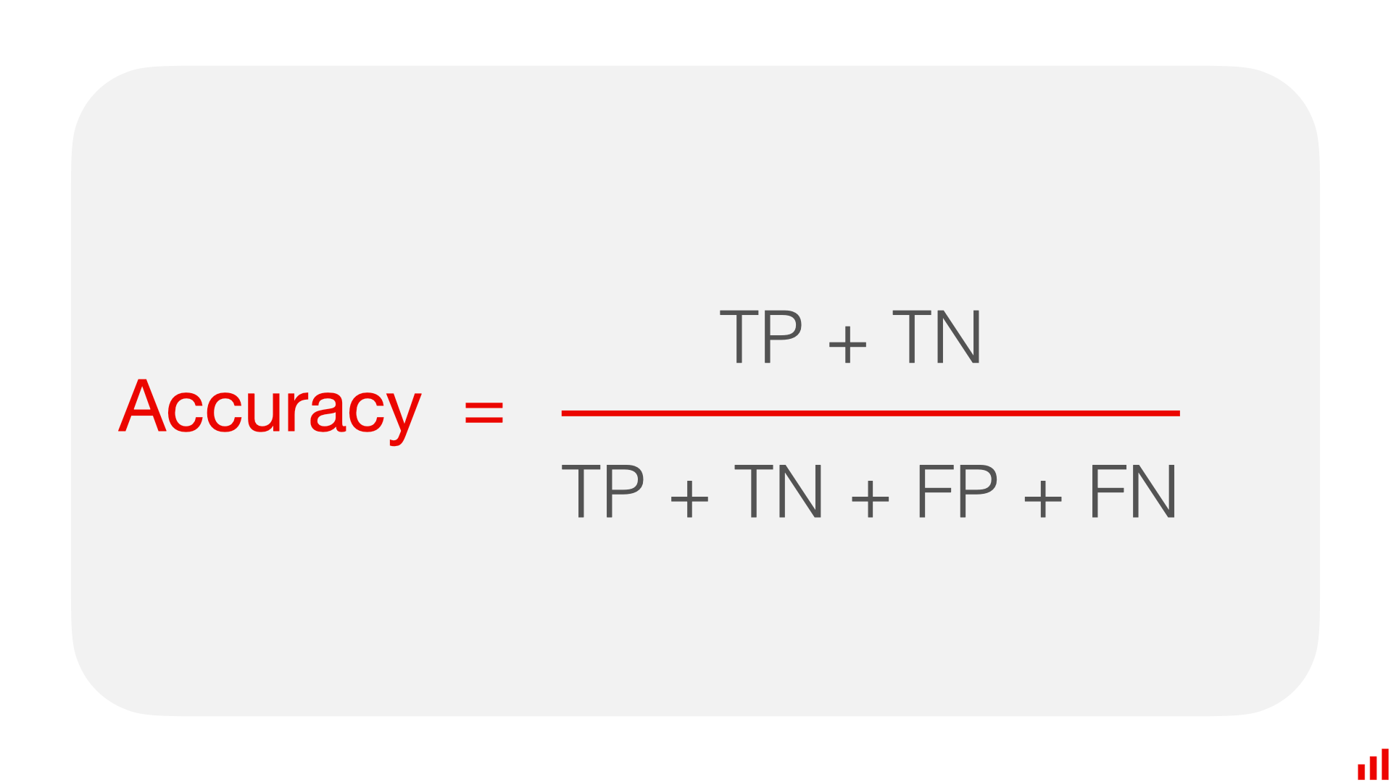
Limitation: It is misleading if one class is much bigger than the other (e.g., 95% of emails are 'Ham').

3.2. Precision (Trusting a 'YES' Prediction)
Idea: When the model says "YES," how reliable is that prediction? Focuses on minimizing False Positives (FP).
Formula: 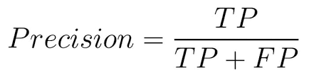

🛡️ Precision Example: Airport Security Alarm
Scenario: A scanner detects a 'Threat' (YES).
False Positive (FP): The scanner rings for a pair of keys (It says YES, but the Actual is NO). This is a wasted check and slows down the line.
Business Goal: In security, you need high Precision so that every time the alarm goes off, it's worth checking.

3.3. Recall (Catching All the 'YES' Cases)
Idea: Out of all the times the answer should have been "YES," how many did the model correctly identify? Focuses on minimizing False Negatives (FN).
Formula: 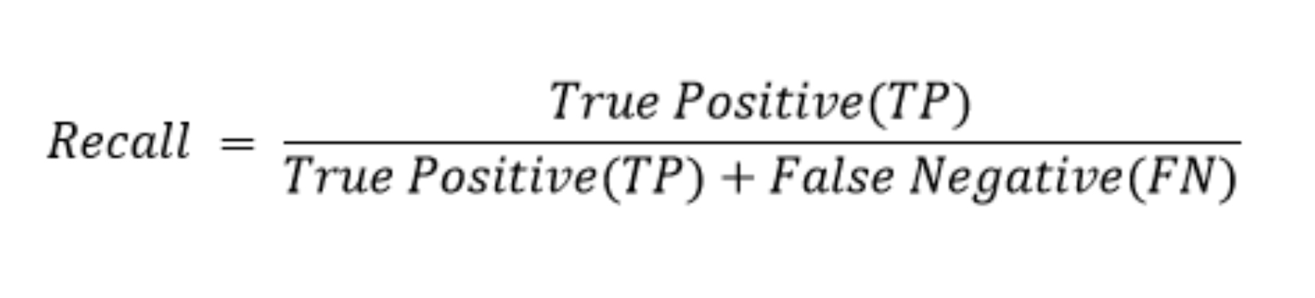

Recall Example: Cancer Screening
Scenario: A model scans for Cancer (YES).
False Negative (FN): A person actually has cancer, but the model says "NO." This is a missed diagnosis and can be dangerous.
Business Goal: In medical diagnosis, you need high Recall to ensure you catch every positive case, even if it means a few healthy people need a follow-up test.

3.4. F1 Score (The Balance)
Idea: A single score that balances the importance of both Precision and Recall. Use this when both False Positives and False Negatives are important to minimize.
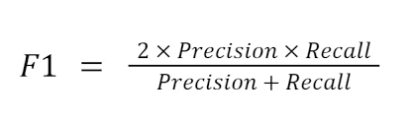

4. Business Use Cases (ML in Management)
ML is used everywhere a better decision is needed.
Industry | Use Case | ML Type | Business Value
Retail | Recommendation Systems: "Customers who bought this also bought..." | Unsupervised (Clustering) | Increases sales by showing relevant products.
Banking | Credit Risk Assessment: Will this person pay back a loan? | Supervised (Classification) | Reduces financial loss by avoiding risky loans.
Logistics | Predictive Maintenance: When will a delivery truck break down? | Supervised (Prediction) | Saves money and prevents delays by fixing problems before they happen.

