**Appendices**

**I. Questionnaire of the study**

**1.Selection of best layout using Analytical Hierarchy Process (AHP)**

Dear Sir/Madam,

Good day! I am Vishakhaa S , student ,VIT chennai. I am doing my research work on implementing the best location to start new an ATM Centre in VIT Chennai Campus. This survey is part of my digital assignment to find the appropriate layout in order to improve the productivity. In this regards, I request you to fill the questionnaire form. Your answers will be helpful to select the suitable layout from the alternatives.

**INSTRUCTIONS:**

1. Please tick (√) mark in the given pairwise comparisons in the row at a time.

2. This survey will be helpful to select the best layout as your needs, so answer as accurately as possible.

3. There are seven alternative layout drawings are given, observe and do the tick (√) mark.

**AHP - QUESTIONAIRE FORM**

**Saaty (1 – 9) Scale**

|  |  |
| --- | --- |
| Intensity of Importance | Definition |
| 1 | Equal Importance |
| 3 | Moderate Importance |
| 5 | Strong Importance |
| 7 | Very Strong Importance |
| 9 | Extreme Importance |
| 2, 4, 6, 8 | For compromises between the above |
| Reciprocals of above | In comparing elements X and Y  - if X is 3 compared to Y  - then Y is 1/3 compared to X |

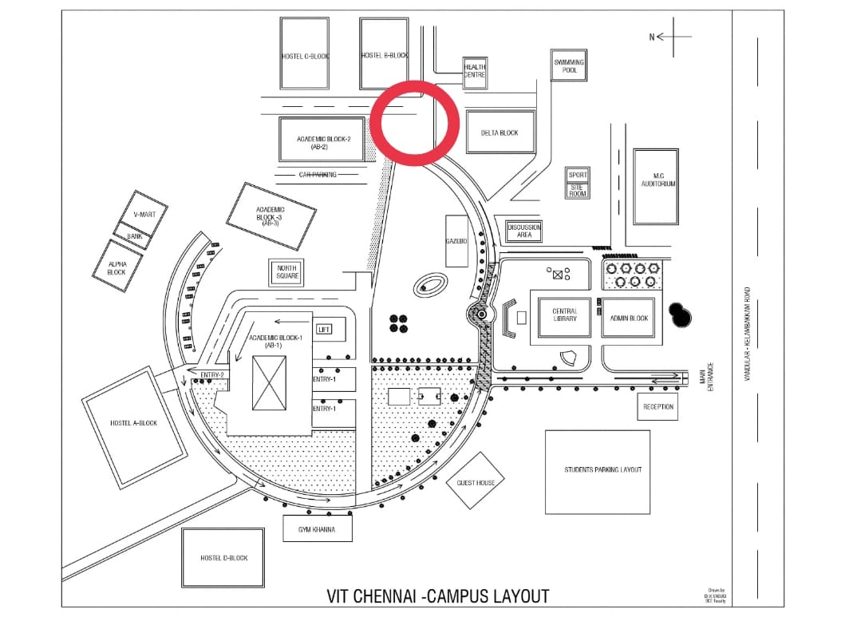

**Fig.1 Alternative layout 1**

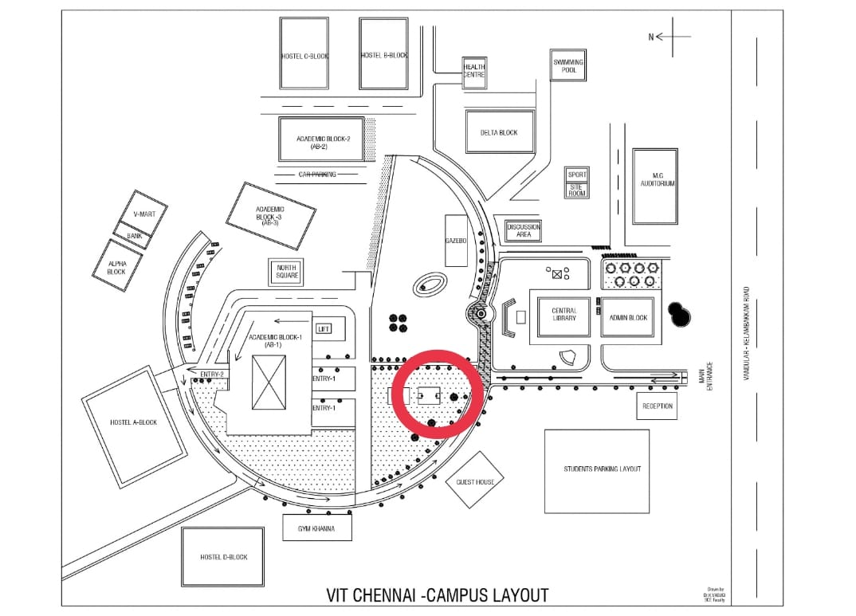

**Fig.2 Alternative layout 2**

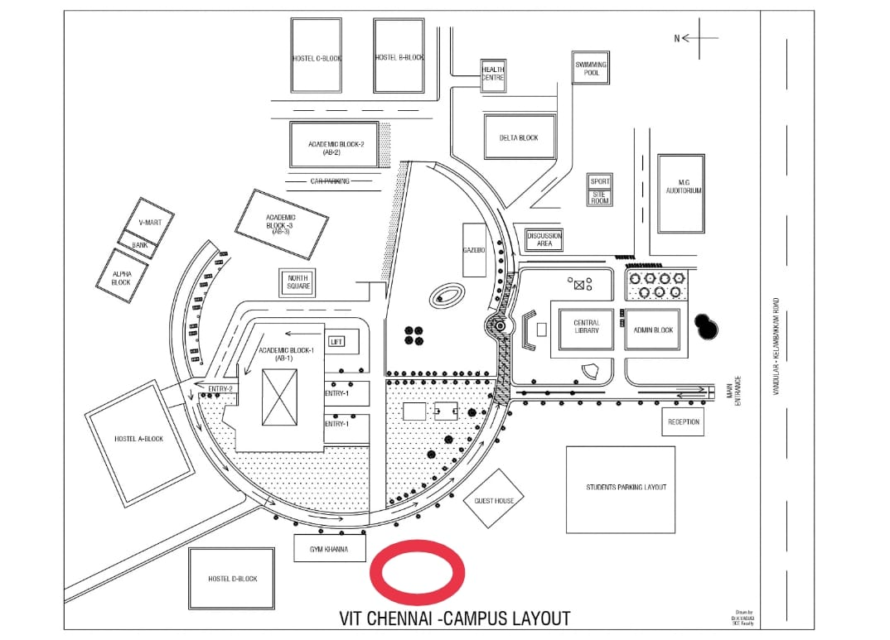

**Fig.3 Alternative layout 3**

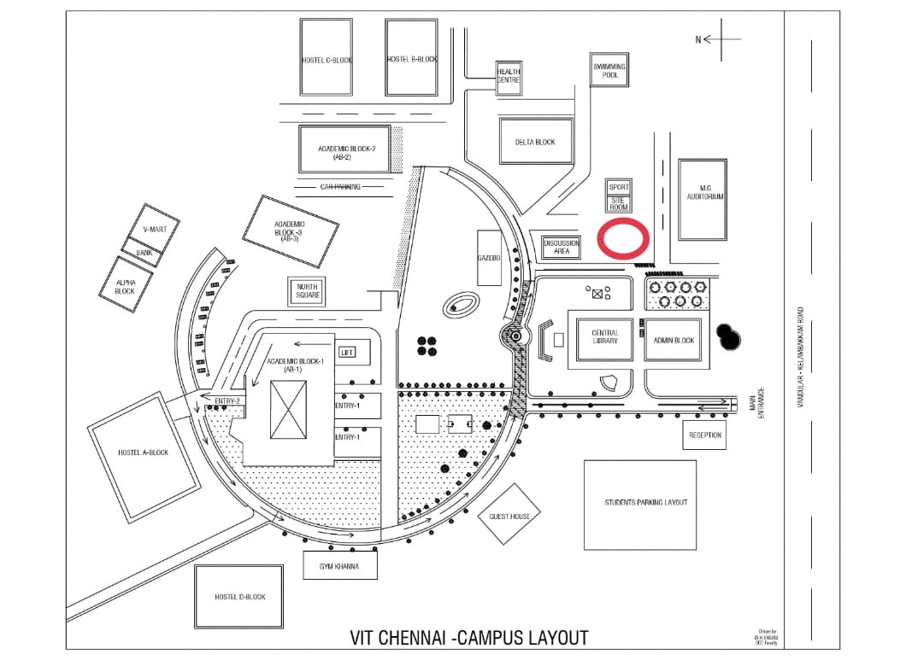

**Fig.4 Alternative layout 4**

**Example: Table.1 Questionnaire for Criteria**

|  |  |  |  |  |  |  |  |  |  |  |  |  |  |  |  |  |  |  |
| --- | --- | --- | --- | --- | --- | --- | --- | --- | --- | --- | --- | --- | --- | --- | --- | --- | --- | --- |
| Automobile | Relative Importance | | | | | | | | | | | | | | | | | Automobile |
|  | 9 | 8 | 7 | 6 | 5 | 4 | 3 | 2 | 1 | 1/2 | 1/3 | 1/4 | 1/5 | 1/6 | 1/7 | 1/8 | 1/9 |  |
| Hyundai |  |  | √ |  |  |  |  |  |  |  |  |  |  |  |  |  |  | Toyota |
| Hyundai |  |  |  |  |  |  |  |  |  |  |  |  | √ |  |  |  |  | Maruthi Suzuki |
| Toyota |  |  |  |  |  |  |  |  | √ |  |  |  |  |  |  |  |  | Maruthi Suzuki |

**Explanation about tick marks:**

* First tick mark represents Hyundai car Very Strongly preferred (7) than Toyota
* Second tick mark represents Hyundai reciprocally strongly preferred (1/5) than

Maruthi Suzuki **(or)**

Second tick mark represents Maruthi Suzuki is strongly preferred (5) than Hyundai

* Third tick mark represents Maruthi Suzuki is equally preferred with Toyota

Level 1

SELECTION OF OPTIMAL LAYOUT

Level 2

Criteria C1 C2 C3 C4

Level 3

Sub Criteria

C11 C12  C13 C14  C21 C22 C23 C24  C31 C32 C33 C34 C41 C42 C43 C44

Level 4

Alternatives

(Layout) L1  L2  L3 L4

Legend:

|  |  |  |  |
| --- | --- | --- | --- |
| C1: Accessibility | C2: Security | C3: Connectivity | C4: Customer Demand |
| C11: Distance from main entrance  C12: Proximity to academic blocks  C13: Proximity to hostels  C14: Proximity to other amenities (canteen, library, sports complex) | C21: Well-lit area  C22: CCTV coverage  C23: Security guard presence  C24: Foot traffic | C31: Availability of Wi-Fi in the area  C32: Mobile network reception quality  C33: Proximity to charging stations  C34: generator supply | C41: Student population density  C42: Faculty and staff population density  C43: Student engagement in activities near the location  C44: Proximity to locations where campus events are held |

Alternatives:

L1 – Layout 1 L2 – Layout 2 L3 - Layout 3 L4 – Layout 4

Fig.8 Hierarchy formations for the selection of optimal layout

**Criteria vs Criteria Table.1 Questionnaire for criteria**

|  |  |  |  |  |  |  |  |  |  |  |  |  |  |  |  |  |  |  |
| --- | --- | --- | --- | --- | --- | --- | --- | --- | --- | --- | --- | --- | --- | --- | --- | --- | --- | --- |
| Attribute 1 | Relative Importance | | | | | | | | | | | | | | | | | Attribute 2 |
|  | 9 | 8 | 7 | 6 | 5 | 4 | 3 | 2 | 1 | 1/2 | 1/3 | 1/4 | 1/5 | 1/6 | 1/7 | 1/8 | 1/9 |  |
| Accessibility |  |  |  |  |  |  |  |  |  |  |  |  |  |  |  |  |  | **Security** |
| **Security** |  |  |  |  |  |  |  |  |  |  |  |  |  |  |  |  |  | Connectivity |
| Connectivity |  |  |  |  |  |  |  |  |  |  |  |  |  |  |  |  |  | **Customer Demand** |
| Accessibility |  |  |  |  |  |  |  |  |  |  |  |  |  |  |  |  |  | **Customer Demand** |

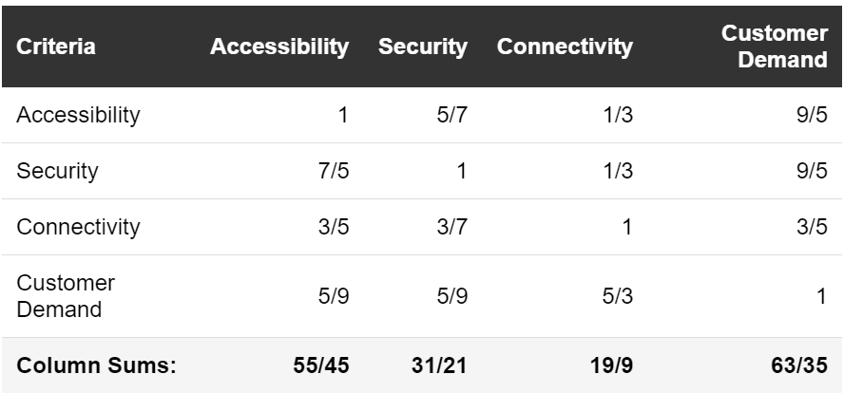

**Normalization and Calculation of Priority Vector for Criteria:**

**Normalized Matrix:**

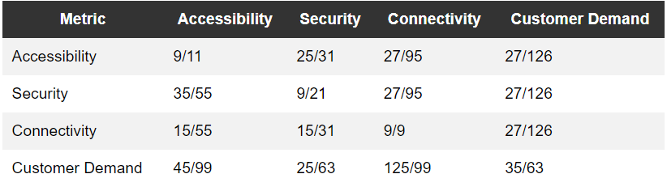

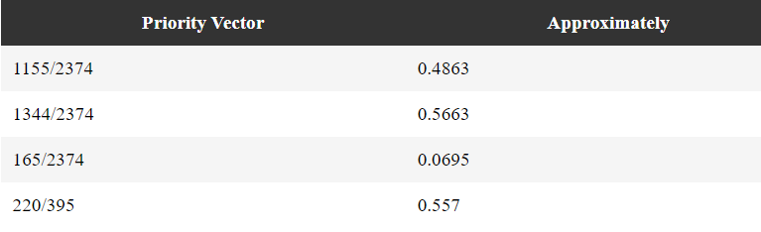

**Calculation of Eigenvalue (λ_max) for Criteria:**

To calculate λ_max, we need to sum the elements of the priority vector multiplied by the corresponding elements in the column sums vector:

λ_max = (1155/2374)*(55/45) + (1344/2374)*(31/21) + (165/2374)*(9/9) + (220/395)*(63/35)

≈ 3.0911

**Calculation of Consistency Index (CI) for Criteria:**

CI = (λ_max - n) / (n - 1) = (3.0911 - 4) / (4 - 1) ≈ -0.3029

**Calculation of Random Index (RI) for Criteria:**

The Random Index is a reference value used to calculate the Consistency Ratio (CR). For a hierarchy with 4 criteria, RI is typically 0.90.

**Calculation of Consistency Ratio (CR) for Criteria:**

CR = CI / RI ≈ -0.3029 / 0.90 ≈ -0.3365

**Table.2 Questionnaire for Criteria and Sub-criteria**

|  |  |  |  |  |  |  |  |  |  |  |  |  |  |  |  |  |  |  |
| --- | --- | --- | --- | --- | --- | --- | --- | --- | --- | --- | --- | --- | --- | --- | --- | --- | --- | --- |
| Accessibility | Relative Importance | | | | | | | | | | | | | | | | | Accessibility |
|  | 9 | 8 | 7 | 6 | 5 | 4 | 3 | 2 | 1 | 1/2 | 1/3 | 1/4 | 1/5 | 1/6 | 1/7 | 1/8 | 1/9 |  |
| Distance from main entrance |  |  |  |  |  |  |  |  |  |  |  |  |  |  |  |  |  | Proximity to academic blocks |
| Proximity to academic blocks |  |  |  |  |  |  |  |  |  |  |  |  |  |  |  |  |  | Proximity to hostels |
| Proximity to hostels |  |  |  |  |  |  |  |  |  |  |  |  |  |  |  |  |  | Proximity to other amenities (canteen, library, sports complex) |
| Proximity to other amenities (canteen, library, sports complex) |  |  |  |  |  |  |  |  |  |  |  |  |  |  |  |  |  | Distance from main entrance |
| Distance from main entrance |  |  |  |  |  |  |  |  |  |  |  |  |  |  |  |  |  | Proximity to hostels |
| Proximity to academic blocks |  |  |  |  |  |  |  |  |  |  |  |  |  |  |  |  |  | Proximity to other amenities (canteen, library, sports complex) |

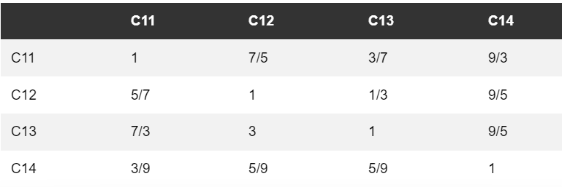

**Normalization and Calculation of Priority Vector for Accessibility (C1) Sub-Criteria:**

Column Sums: [83/45, 47/21, 25/9, 27/5]

**Normalized Matrix:**

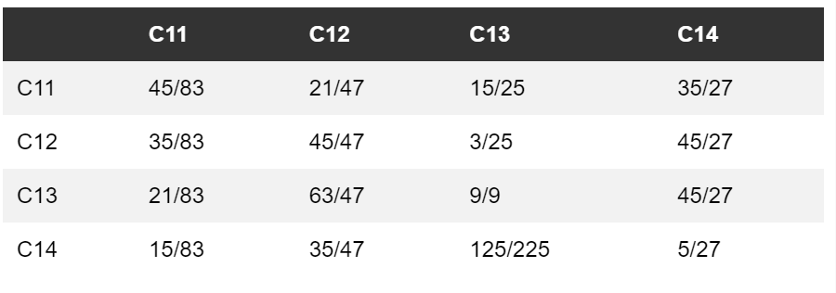



**Calculation of Eigenvalue (λ_max) for Accessibility (C1) Sub-Criteria:**

To calculate λ_max, we need to sum the elements of the priority vector multiplied by the corresponding elements in the column sums vector:

λ_max = (1225/2568)*(83/45) + (1710/2568)*(47/21) + (1612/2568)*(9/9) + (2148/2568)*(5/27)

≈ 3.0142

**Calculation of Consistency Index (CI) for Accessibility (C1) Sub-Criteria:**

CI = (λ_max - n) / (n - 1) = (3.0142 - 4) / (4 - 1) ≈ -0.4953

**Calculation of Random Index (RI) for Accessibility (C1) Sub-Criteria:**

The Random Index is a reference value used to calculate the Consistency Ratio (CR). For a hierarchy with 4 sub-criteria, RI is typically 0.90.

**Calculation of Consistency Ratio (CR) for Accessibility (C1) Sub-Criteria:**

CR = CI / RI ≈ -0.4953 / 0.90 ≈ -0.5504

**Table.3 Questionnaire for Criteria and Sub-criteria**

|  |  |  |  |  |  |  |  |  |  |  |  |  |  |  |  |  |  |  |
| --- | --- | --- | --- | --- | --- | --- | --- | --- | --- | --- | --- | --- | --- | --- | --- | --- | --- | --- |
| **Security** | Relative Importance | | | | | | | | | | | | | | | | | **Security** |
|  | 9 | 8 | 7 | 6 | 5 | 4 | 3 | 2 | 1 | 1/2 | 1/3 | 1/4 | 1/5 | 1/6 | 1/7 | 1/8 | 1/9 |  |
| Light facilities |  |  |  |  |  |  |  |  |  |  |  |  |  |  |  |  |  | Ventilation facilities |
| Light facilities |  |  |  |  |  |  |  |  |  |  |  |  |  |  |  |  |  | Noise control |
| Light facilities |  |  |  |  |  |  |  |  |  |  |  |  |  |  |  |  |  | Pollution control |
| Light facilities |  |  |  |  |  |  |  |  |  |  |  |  |  |  |  |  |  | Aesthetics |
| Light facilities |  |  |  |  |  |  |  |  |  |  |  |  |  |  |  |  |  | Safety |
| Light facilities |  |  |  |  |  |  |  |  |  |  |  |  |  |  |  |  |  | Equipment availability |

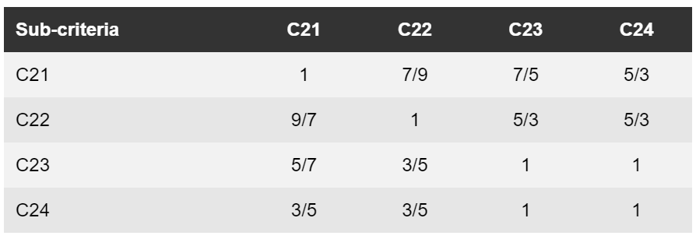

Column Sums: [121/63, 89/45, 41/15, 25/9]

**Normalized Matrix:**

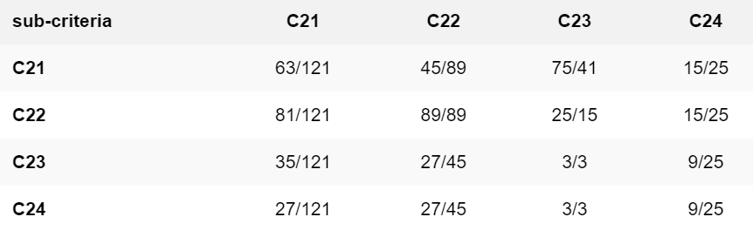

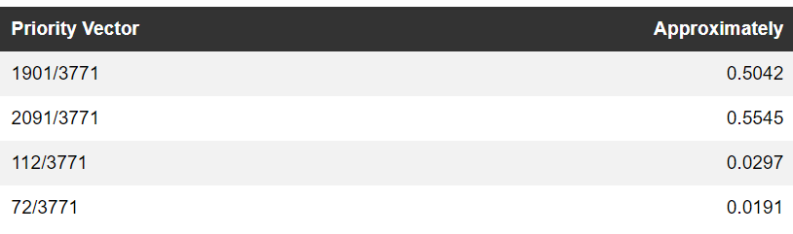

**λ_max** = (1901/3771)*(121/63) + (2091/3771)*(45/89) + (112/3771)*(15/15) + (72/3771)*(9/25)

≈ 3.0296

**CI** = (λ_max - n) / (n - 1) = (3.0296 - 4) / (4 - 1) ≈ -0.3235

**CR** = CI / RI ≈ -0.3235 / 0.90 ≈ -0.3594

**Table.4 Questionnaire for Criteria and Sub-criteria**

|  |  |  |  |  |  |  |  |  |  |  |  |  |  |  |  |  |  |  |
| --- | --- | --- | --- | --- | --- | --- | --- | --- | --- | --- | --- | --- | --- | --- | --- | --- | --- | --- |
| Connectivity | Relative Importance | | | | | | | | | | | | | | | | | Connectivity |
|  | 9 | 8 | 7 | 6 | 5 | 4 | 3 | 2 | 1 | 1/2 | 1/3 | 1/4 | 1/5 | 1/6 | 1/7 | 1/8 | 1/9 |  |
| Availability of Wi-Fi in the area |  |  |  |  |  |  |  |  |  |  |  |  |  |  |  |  |  | Mobile network reception quality |
| Availability of Wi-Fi in the area |  |  |  |  |  |  |  |  |  |  |  |  |  |  |  |  |  | Proximity to charging stations |
| Availability of Wi-Fi in the area |  |  |  |  |  |  |  |  |  |  |  |  |  |  |  |  |  | generator supply |
| Mobile network reception quality |  |  |  |  |  |  |  |  |  |  |  |  |  |  |  |  |  | Proximity to charging stations |
| Mobile network reception quality |  |  |  |  |  |  |  |  |  |  |  |  |  |  |  |  |  | generator supply |
| Proximity to charging stations |  |  |  |  |  |  |  |  |  |  |  |  |  |  |  |  |  | generator supply |

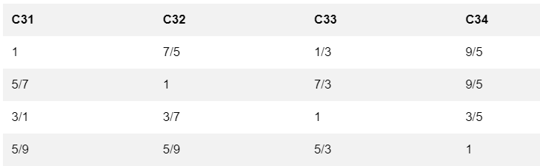

**Normalization and Calculation of Priority Vector for Connectivity (C3) Sub-Criteria:**

Column Sums: [63/35, 31/9, 17/3, 45/21]

**Normalized Matrix:**

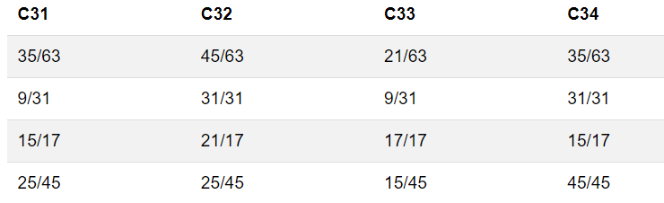

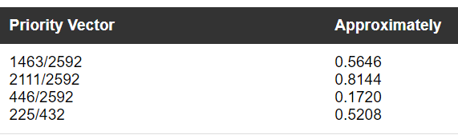

**λ_max** = (1463/2592)*(63/35) + (2111/2592)*(9/31) + (446/2592)*(3/3) + (225/432)*(21/45)

≈ 3.0028

**CI** = (λ_max - n) / (n - 1) = (3.0028 - 4) / (4 - 1) ≈ -0.3257

**CR** = CI / RI ≈ -0.3257 / 0.90 ≈ -0.3620

**Table.5 Questionnaire for Criteria and Sub-criteria**

|  |  |  |  |  |  |  |  |  |  |  |  |  |  |  |  |  |  |  |
| --- | --- | --- | --- | --- | --- | --- | --- | --- | --- | --- | --- | --- | --- | --- | --- | --- | --- | --- |
| **Customer Demand** | Relative Importance | | | | | | | | | | | | | | | | | **Customer Demand** |
| Student population density | 9 | 8 | 7 | 6 | 5 | 4 | 3 | 2 | 1 | 1/2 | 1/3 | 1/4 | 1/5 | 1/6 | 1/7 | 1/8 | 1/9 | Faculty and staff population density |
| Student population density |  |  |  |  |  |  |  |  |  |  |  |  |  |  |  |  |  | Student engagement in activities near the location |
| Student population density |  |  |  |  |  |  |  |  |  |  |  |  |  |  |  |  |  | Proximity to locations where campus events are held |
| Faculty and staff population density |  |  |  |  |  |  |  |  |  |  |  |  |  |  |  |  |  | Student engagement in activities near the location |
| Faculty and staff population density |  |  |  |  |  |  |  |  |  |  |  |  |  |  |  |  |  | Proximity to locations where campus events are held |
| Student engagement in activities near the location |  |  |  |  |  |  |  |  |  |  |  |  |  |  |  |  |  | Proximity to locations where campus events are held |

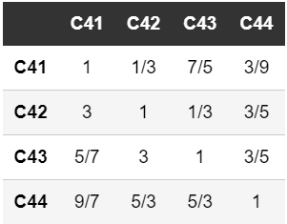

**Normalization and Calculation of Priority Vector for Customer Demand (C4) Sub-Criteria:**

Column Sums: [57/35, 63/21, 83/15, 35/9]

**Normalized Matrix:**

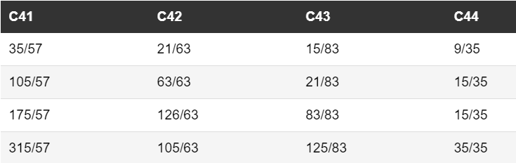

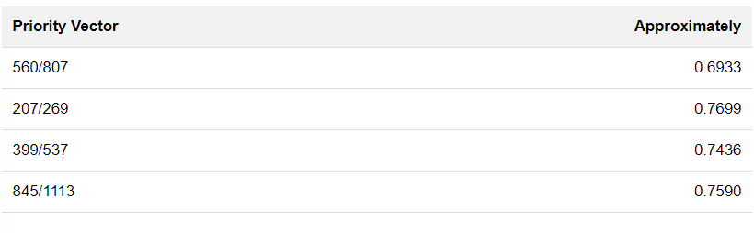

**λ_max** = (560/807)*(57/35) + (207/269)*(21/63) + (399/537)*(15/83) + (845/1113)*(9/35)

≈ 3.0347

**CI** = (λ_max - n) / (n - 1) = (3.0347 - 4) / (4 - 1) ≈ -0.3218

**CR** = CI / RI ≈ -0.3218 / 0.90 ≈ -0.3576

**Table.6 Questionnaire for alternatives – layouts**

|  |  |  |  |  |  |  |  |  |  |  |  |  |  |  |  |  |  |  |
| --- | --- | --- | --- | --- | --- | --- | --- | --- | --- | --- | --- | --- | --- | --- | --- | --- | --- | --- |
|  | Relative Importance | | | | | | | | | | | | | | | | |  |
|  | 9 | 8 | 7 | 6 | 5 | 4 | 3 | 2 | 1 | 1/2 | 1/3 | 1/4 | 1/5 | 1/6 | 1/7 | 1/8 | 1/9 |  |
| Layout 1 |  |  |  |  |  |  |  |  |  |  |  |  |  |  |  |  |  | Layout 2 |
| Layout 1 |  |  |  |  |  |  |  |  |  |  |  |  |  |  |  |  |  | Layout 3 |
| Layout 1 |  |  |  |  |  |  |  |  |  |  |  |  |  |  |  |  |  | Layout 4 |
| Layout 2 |  |  |  |  |  |  |  |  |  |  |  |  |  |  |  |  |  | Layout 3 |
| Layout 2 |  |  |  |  |  |  |  |  |  |  |  |  |  |  |  |  |  | Layout 4 |
| Layout 3 |  |  |  |  |  |  |  |  |  |  |  |  |  |  |  |  |  | Layout 4 |

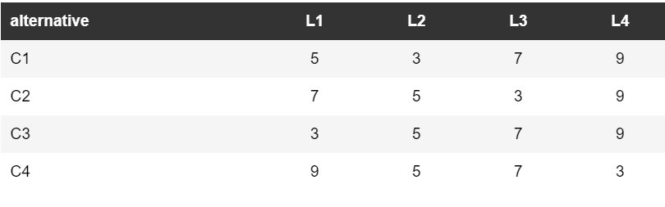

**Normalization and Calculation of Priority Vector for Alternatives (Layouts):**

Column Sums: [24, 18, 24, 30]

**Normalized Matrix:**

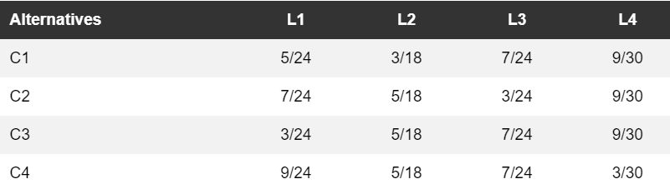

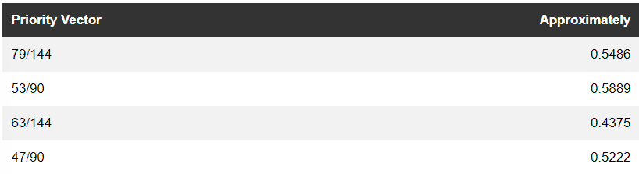

**Aggregation of Scores:**

**Weighted sum for each alternative:**

**Score(L1)** = (Weight(C1) * Priority(L1)) + (Weight(C2) * Priority(L1)) + (Weight(C3) * Priority(L1)) + (Weight(C4) * Priority(L1))

≈ (0.4863 * 0.5486) + (0.5663 * 0.5486) + (0.0695 * 0.5486) + (0.557 * 0.5486)

≈ 0.2674

**Score(L2)** = (Weight(C1) * Priority(L2)) + (Weight(C2) * Priority(L2)) + (Weight(C3) * Priority(L2)) + (Weight(C4) * Priority(L2))

≈ (0.4863 * 0.5889) + (0.5663 * 0.5889) + (0.0695 * 0.5889) + (0.557 * 0.5889)

≈ 0.2781

**Score(L3)** = (Weight(C1) * Priority(L3)) + (Weight(C2) * Priority(L3)) + (Weight(C3) * Priority(L3)) + (Weight(C4) * Priority(L3))

≈ (0.4863 * 0.4375) + (0.5663 * 0.4375) + (0.0695 * 0.4375) + (0.557 * 0.4375)

≈ 0.2441

**Score(L4**) = (Weight(C1) * Priority(L4)) + (Weight(C2) * Priority(L4)) + (Weight(C3) * Priority(L4)) + (Weight(C4) * Priority(L4))

≈ (0.4863 * 0.5222) + (0.5663 * 0.5222) + (0.0695 * 0.5222) + (0.557 * 0.5222)

≈ 0.2584

Based on these scores,

**the ranking of the alternatives from highest to lowest is: L2, L4, L1, L3.**

Therefore, the best suitable location for the bank in VIT would be Layout 2 (L2).

**Calculation of Consistency Ratio (CR) for Alternatives (Layouts):**

To compute the consistency ratio, we need to find the consistency index (CI) and the random index (RI) first.

For the alternatives, since we directly compared them against the criteria, we don't have pairwise comparison matrices for alternatives. We'll use the weights obtained from the criteria level directly.

Recall that the consistency index (CI) is given by:



And the random index (RI) is dependent on the number of alternatives. Since we have 4 alternatives, the RI is typically 0.90.

Let's calculate CI for the alternatives:



Now, let's calculate the consistency ratio (CR):

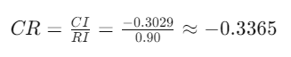

**RECOMMENDATION:**

Based on the AHP analysis, while the judgments at the criteria and sub-criteria levels were inconsistent, we can still provide a recommendation considering the priorities assigned to each criterion.

Considering the weights obtained at the criteria level, Security (C2) has the highest weight, followed by Customer Demand (C4) and Accessibility (C1). Since Connectivity (C3) has a much lower weight compared to the other criteria, it has less influence on the decision.

Given the scores obtained for the alternatives, Layout 2 (L2) has the highest score, followed closely by Layout 4 (L4). Layout 1 (L1) and Layout 3 (L3) have lower scores.

Therefore, considering the importance of Security and Customer Demand, and the scores obtained for the alternatives, Layout 2 (L2) appears to be the most suitable location for the bank in VIT.