Task 1. Access and print the element at a given index in an array.

Task 2. Search for a given element in a sorted array using Binary Search.

Task 3. Find the maximum element in an array of n integers

Task 4. Given an array of integers and a positive integer K, write a program

to find: The Kth smallest element

Task 5. Print all possible pairs of elements from an array of size n.

Task 6: digitSuin opt: sum of even or odd digits

Task 7:Nth Fibonacci

Task 8: Is Palindrome Number?

Task 9: Sum of last digit of two given numbers

import java.util.Scanner;
@FunctionalInterface
interface ArrayElement {
void print(int index);
}
public class Main {
public static void main(String[] args) {
Scanner sc = new Scanner(System.in);
int[] arr = {10, 20, 30, 40, 50};
System.out.print("Enter index: ");
int index = sc.nextInt();
ArrayElement element = (i) -> {
if (i >= 0 && i < arr.length) {
System.out.println("Element at index " + i + " is: " + arr[i]);
} else {
System.out.println("Invalid Index");
}
};
element.print(index);
}
}
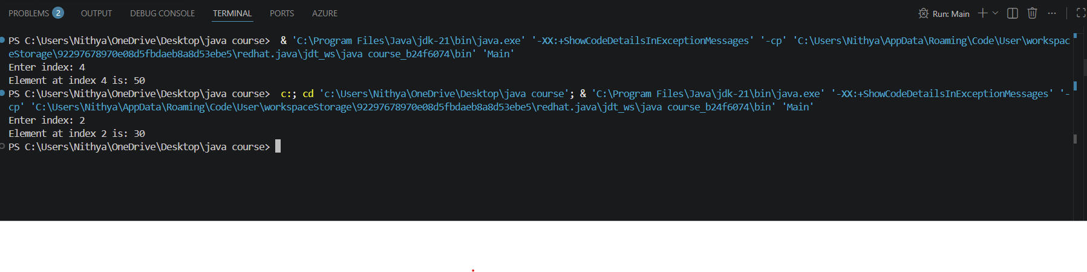

import java.util.Scanner;
@FunctionalInterface
interface BinarySearch {
void search(int key);
}
public class Main {
public static void main(String[] args) {
Scanner sc = new Scanner(System.in);
int[] arr = {10, 20, 30, 40, 50, 60, 70};
System.out.print("Enter element to search: ");
int key = sc.nextInt();
BinarySearch bs = (k) -> {
int low = 0;
int high = arr.length - 1;
boolean found = false;
while (low <= high) {
int mid = (low + high) / 2;
if (arr[mid] == k) {
System.out.println("Element found at index: " + mid);
found = true;
break;
} else if (k < arr[mid]) {
high = mid - 1;
} else {
low = mid + 1;
}
}

if (!found) {
System.out.println("Element not found");
}
};

bs.search(key);
}
}

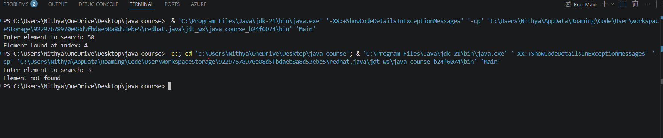
import java.util.*;

@FunctionalInterface
interface Maximum {
void findMax();
}

public class Main {
public static void main(String[] args) {

int[] arr = {10, 20, 30, 40, 50, 60, 70};

Maximum max = () -> {
System.out.println("Maximum element: " + arr[arr.length - 1]);
};

max.findMax();
}
}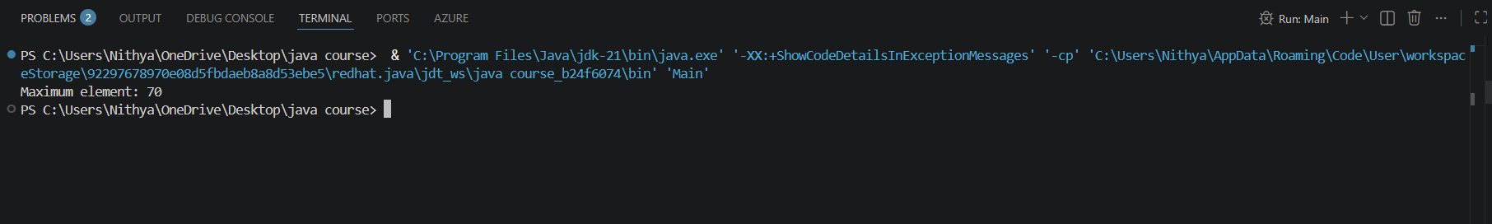

import java.util.Arrays;
import java.util.Scanner;

@FunctionalInterface
interface KthSmallest {
void find(int k);
}

public class Main {
public static void main(String[] args) {

Scanner sc = new Scanner(System.in);

System.out.print("Enter number of elements: ");
int n = sc.nextInt();

int[] arr = new int[n];

System.out.println("Enter array elements:");
for (int i = 0; i < n; i++) {
arr[i] = sc.nextInt();
}

System.out.print("Enter value of k: ");
int k = sc.nextInt();

KthSmallest ks = (x) -> {
Arrays.sort(arr);

if (x >= 1 && x <= arr.length) {
System.out.println(x + "th smallest element is: " + arr[x - 1]);
} else {
System.out.println("Invalid value of k");
}
};

ks.find(k);
}
}

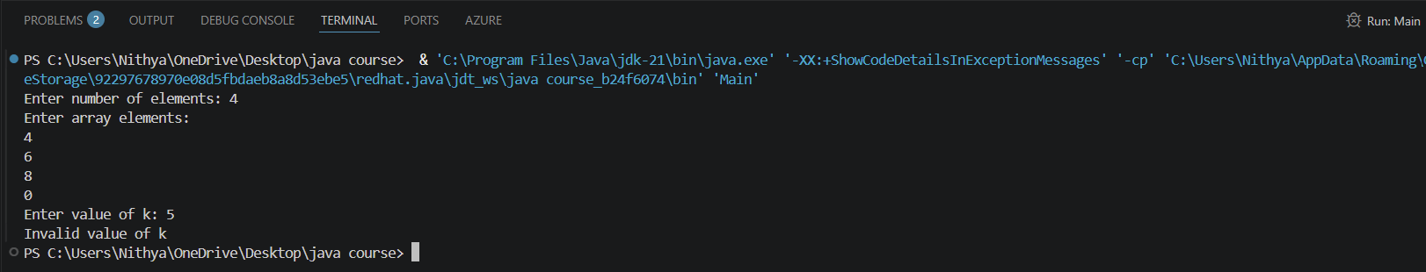

import java.util.Scanner;
@FunctionalInterface
interface Pair {
void printPairs();
}
public class Main {
public static void main(String[] args) {

Scanner sc = new Scanner(System.in);
System.out.print("Enter number of elements: ");
int n = sc.nextInt();
int[] arr = new int[n];
System.out.println("Enter array elements:");
for (int i = 0; i < n; i++) {
arr[i] = sc.nextInt();
}
Pair p = () -> {
System.out.println("All possible pairs are:");
for (int i = 0; i < arr.length; i++) {
for (int j = i + 1; j < arr.length; j++) {
System.out.println("(" + arr[i] + ", " + arr[j] + ")");
}
}
};

p.printPairs();
}
}
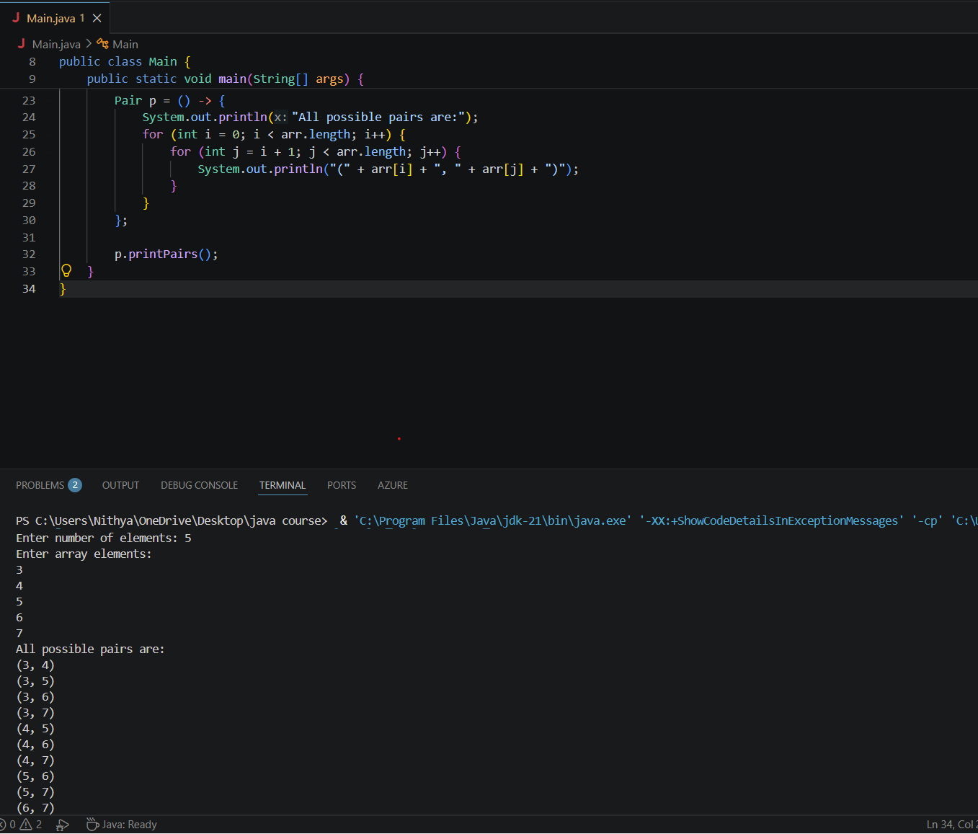
import java.util.Scanner;
@FunctionalInterface
interface EvenDigitSum {
void findSum(int num);
}
public class Main {
public static void main(String[] args) {
Scanner sc = new Scanner(System.in);
System.out.print("Enter a number: ");
int num = sc.nextInt();
EvenDigitSum eds = (n) -> {
Int sum=0;
while (n > 0) {
int digit = n % 10;

if (digit % 2 == 0) {
sum += digit;
}
n = n / 10;
}

System.out.println("Sum of even digits = " + sum);
};

eds.findSum(num);
}
}

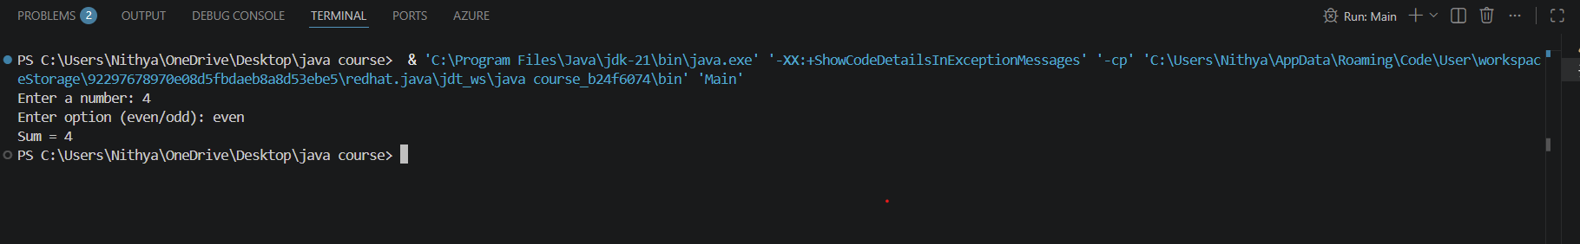
import java.util.Scanner;
@FunctionalInterface
interface Fibonacci {
int find(int n);
}
public class Main {
public static void main(String[] args) {
Scanner sc = new Scanner(System.in);
System.out.print("Enter the value of n: ");
int n = sc.nextInt();
Fibonacci fib = (num) -> {
if (num == 0)
return 0;
if (num == 1)
return 1;
int a = 0, b = 1, c = 0;
for (int i = 2; i <= num; i++) {
c = a + b;
a = b;
b = c;
}
return c;
};

System.out.println("The " + n + "th Fibonacci number is: " + fib.find(n));
}
}
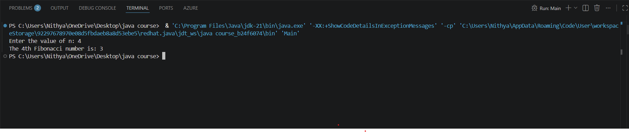
import java.util.Scanner;
@FunctionalInterface
interface Palindrome {
boolean check(int n);
}
public class Main {
public static void main(String[] args) {
Scanner sc = new Scanner(System.in);
System.out.print("Enter a number: ");
int num = sc.nextInt();
Palindrome p = (n) -> {
int original = n;
int reverse = 0;
while (n > 0) {
int digit = n % 10;
reverse = reverse * 10 + digit;
n = n / 10;
}
return original == reverse;
};
if (p.check(num)) {
System.out.println(num + " is a Palindrome");
} else {
System.out.println(num + " is not a Palindrome");
}
}
}

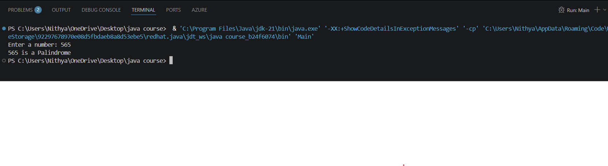

import java.util.Scanner;
@FunctionalInterface
interface LastDigitSum {
int sum(int a, int b);
}
public class Main {
public static void main(String[] args) {
Scanner sc = new Scanner(System.in);
System.out.print("Enter first number: ");
int num1 = sc.nextInt();
System.out.print("Enter second number: ");
int num2 = sc.nextInt();
LastDigitSum lds = (x, y) -> (x % 10) + (y % 10);
System.out.println("Sum of last digits = " + lds.sum(num1, num2));
}
}
