CAPSTONE 19

AI Brand Identity Kit
VERDORA — Small Choices. Greener Futures.
Fictional sustainable everyday-lifestyle brand | Prepared for academic submission
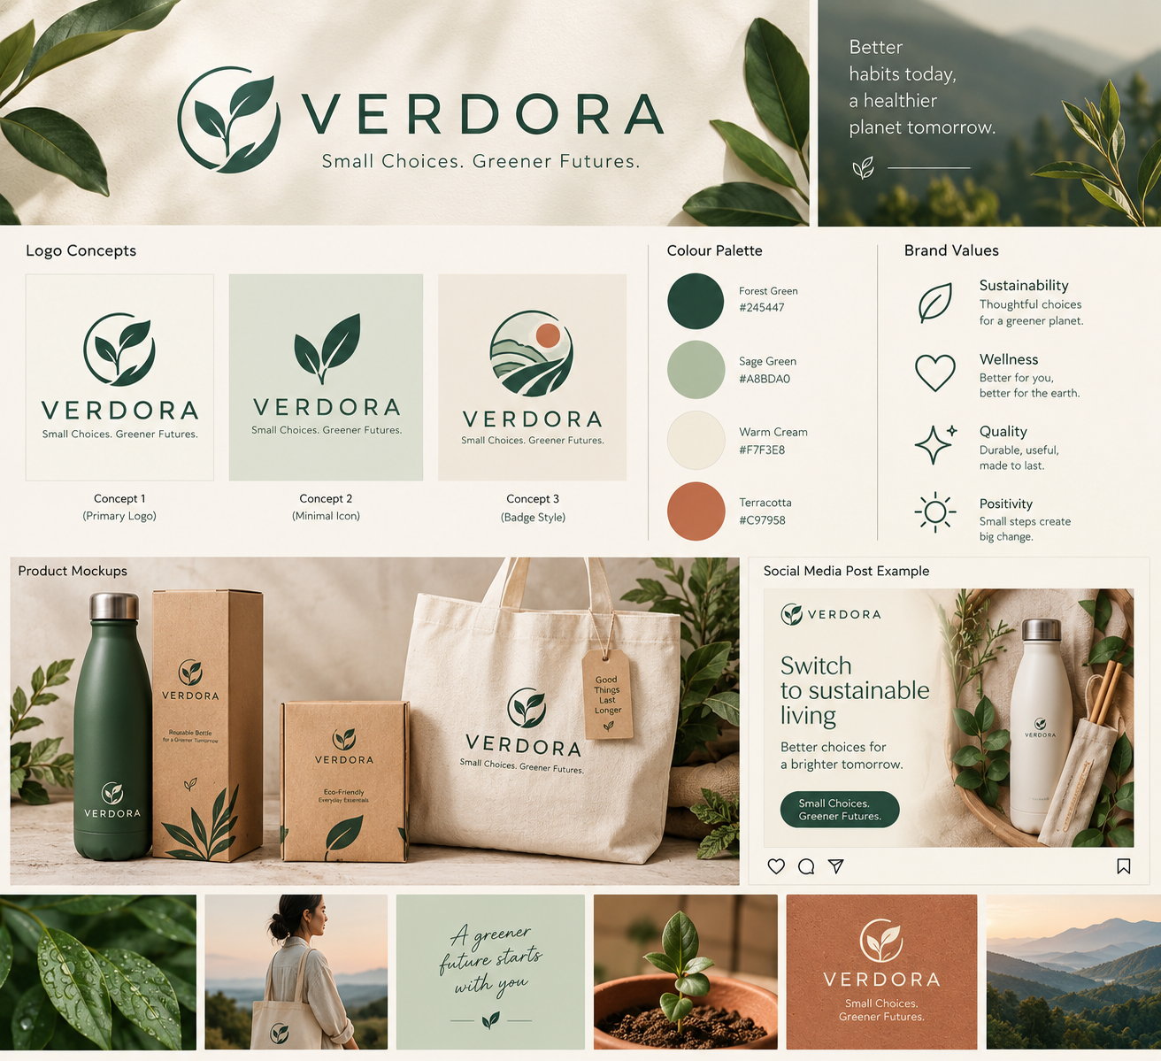
Note: This is an AI-generated visual concept board. Check and correct any small text or logo details in Canva before presenting it as final artwork.

1. Project Overview
This project explores whether free or free-tier AI tools can help create a consistent identity for a fictional business. VERDORA is a proposed sustainable lifestyle brand offering reusable everyday products such as bottles, tote bags and low-waste home accessories. Its identity aims to feel calm, natural, useful, optimistic and modern.
Primary audience: students and young adults interested in practical, more sustainable everyday habits. Brand promise: make thoughtful everyday choices feel simple and approachable.

2. Twenty Brand Name and Tagline Ideas
No. | Name | Tagline
1 | Verdora | Small Choices. Greener Futures.
2 | Leafora | Let Nature Lead.
3 | EarthNest | Live Light on Earth.
4 | Bloomora | Grow a Greener Tomorrow.
5 | EcoLuma | Bright Ideas, Better Planet.
6 | GreenHaven | Find Your Natural Balance.
7 | PureSprout | Start Small. Grow Sustainably.
8 | TerraBloom | Rooted in a Better Future.
9 | Natuvelle | Naturally Made for Everyday.
10 | EverFern | Keep Life Green.
11 | Moss & Meadow | Simple Living, Naturally.
12 | PlanetPetal | Kind Choices Count.
13 | Rootiva | Goodness from the Ground Up.
14 | Solvaya | A Brighter Way to Live.
15 | Grevia | Everyday Made Greener.
16 | Kindora | Choose Better. Live Kinder.
17 | Fernelle | Nature in Every Detail.
18 | EarthKindle | Spark a Sustainable Life.
19 | Oakenly | Less Waste, More Wonder.
20 | Floravelle | Bring Nature into Life.

3. Shortlist and Selection Rationale
1. VERDORA — preferred concept
“Small Choices. Greener Futures.” Modern and flexible for reusable products, eco-friendly home goods and sustainable accessories. The name and tagline are provisional until similarity checks are completed.
2. LEAFORA
“Let Nature Lead.” Friendly and nature-focused, with a clear botanical association.
3. ROOTIVA
“Goodness from the Ground Up.” Suggests natural materials and thoughtful sourcing.

4. Name Similarity Verification Report
Status at draft time: NOT YET VERIFIED. No claim is made that any candidate is trademark-free. Before final submission, search the exact name, spelling variants and similar-sounding names using the official Indian Trade Marks Public Search and WIPO Global Brand Database. Save screenshots or export results, note the search date, and record similar marks, status and relevant goods/services classes. A database search is a preliminary check, not legal clearance.
Official resources:
IP India Trade Mark Public Search: https://tmrsearch.ipindia.gov.in/ESEARCH
IP India guidance: https://www.ipindia.gov.in/trade-marks-before-you-apply-search-existing-trademarks
WIPO Global Brand Database: https://www.wipo.int/en/web/global-brand-database
Candidate | Exact/variant terms searched | Database + date | Potentially similar results | Conclusion / follow-up
VERDORA | To be completed | To be completed | To be completed | Pending actual search
LEAFORA | To be completed | To be completed | To be completed | Pending actual search
ROOTIVA | To be completed | To be completed | To be completed | Pending actual search

5. Logo Concepts
Concept A — Primary botanical emblem
A simple circular leaf/sprout emblem paired with the VERDORA wordmark. Best for the main brand sheet, packaging and website header.
Concept B — Minimal leaf icon
Two clean leaves above or beside the wordmark. Best for social profile images, stickers and small labels.
Concept C — Landscape badge
A compact circular mark combining a leaf, horizon and sun. Best for packaging seals and campaign graphics.
Design rule: keep the icon simple, preserve clear space, use one- or two-colour versions, and avoid changing the logo proportions. AI image models may misspell text; recreate the chosen mark cleanly in Canva using editable text and shapes.

6. Colour Palette
Colour | HEX | Suggested use
Forest Green | #245447 | Primary logo, headings, buttons
Sage Green | #A8BDA0 | Secondary panels and botanical accents
Warm Cream | #F7F3E8 | Main background
Terracotta | #C97958 | Small accent or call-to-action

7. Brand Voice Guide
Voice: Warm, clear, optimistic, practical and nature-aware.
Tone: Encouraging rather than preachy; informative without guilt or exaggerated claims.
Writing style: Short sentences, everyday words, active voice and one clear action per post.
Words to use: thoughtful, reusable, everyday, practical, lower-waste, small steps, mindful.
Avoid: shaming people, fear-based language, jargon, unsupported “100% eco-friendly” claims, and promises that cannot be evidenced.
Call to action: “Choose one reusable swap today.”

8. Five Sample Social Media Posts
Post 1 — Brand introduction
Meet VERDORA 🌿 Small choices can become thoughtful habits. We create a calmer, more practical approach to everyday reusables. Small Choices. Greener Futures. #Verdora #ThoughtfulLiving
Post 2 — Reusable bottle
One bottle. Many refills. Keep a reusable bottle close and make your daily routine a little simpler. #ReuseEveryday #Verdora
Post 3 — Tote bag
A bag you can bring along again and again. Keep one by the door or in your backpack for your next shopping trip. #CarryItAgain #Verdora
Post 4 — Small habit
Your next step doesn’t have to be huge. Try one reusable swap this week, then build from there. What small habit works for you? #SmallChoices
Post 5 — Product care
Good care can help everyday items last longer. Follow the care instructions for your reusable products, clean them regularly and repair or replace parts when possible. #UseItLonger #Verdora

9. Prompt Library and AI Skills Used
Prompt 1 — Brand strategy / prompt engineering
Act as a brand strategist. Develop a fictional sustainable everyday-lifestyle brand for students and young adults. Provide 20 distinctive name and tagline candidates, explain the intended audience and brand promise, and flag every name as requiring trademark verification. Do not claim legal availability.
Prompt 2 — Logo image generation
Create three separate minimalist logo concept directions for a fictional sustainable lifestyle brand called VERDORA, tagline “Small Choices. Greener Futures.” Use a forest-green botanical emblem on warm cream, simple vector-like shapes, strong legibility and no mock brand names. Leave clean space for adding correctly spelled editable text later.
Prompt 3 — Image consistency
Generate a product campaign image for VERDORA using the same visual system: forest green #245447, sage #A8BDA0, warm cream #F7F3E8, terracotta #C97958; soft natural light; botanical accents; minimal composition; calm optimistic mood. Keep packaging plain so the logo can be added in post-production.
Prompt 4 — Content writing
Write five short social posts for VERDORA in a warm, practical, optimistic voice. Avoid guilt, unsupported environmental claims and exaggerated promises. Each post should have one clear message and a simple call to action.
Prompt 5 — Quality control
Compare this generated image against the VERDORA brand rules. Report palette deviations, inconsistent logo shape, typography, lighting, composition, unwanted text and unrealistic product details. Do not say it passed unless the visible evidence supports that conclusion.
Prompt 6 — Productivity / report
Turn the actual image-test observations in this table into a concise consistency report. Separate observed facts from interpretations, count pass/fail results, identify recurring errors and recommend the next prompt adjustment. Do not invent missing observations.
AI skills demonstrated: prompt engineering; AI-assisted content writing; image generation; visual design/presentation; productivity and spreadsheet workflow; responsible AI and verification. Optional extension: create a short brand-reveal video or voice-over using an available free-tier tool, if time permits.

10. Image Consistency Test — 10 Generations
Procedure: use the same master prompt and visual rules to create ten images. Vary only one factor at a time (e.g., product type, background or camera angle). Save each output and score it against the criteria below. Complete the table only after generating and inspecting the actual images; do not fabricate results.
Gen. | Prompt / variation | P/L/M/C/T | Overall pass? | Observed failure | Correction for next run
1 | Image_01_Main_Logo.png | Pass | No issue observed in logo, brand name or colour palette. | No correction needed; retain master prompt. | Record adjustment
2 | Image_02_Water_Bottle.png | Pass | No issue observed in logo, brand name or colour palette. | No correction needed; retain master prompt. | Record adjustment
3 | Image_03_Shopping_Bag.png | Pass | No issue observed in logo, brand name or colour palette. | No correction needed; retain master prompt. | Record adjustment
4 | Image_04_Packaging.png | Pass | No issue observed in logo, brand name or colour palette. | No correction needed; retain master prompt. | Record adjustment
5 | Image_05_Instagram_Post.png | Pass | No issue observed in logo, brand name or colour palette. | No correction needed; retain master prompt. | Record adjustment
6 | Image_06_Website_Banner.png | Pass | No issue observed in logo, brand name or colour palette. | No correction needed; retain master prompt. | Record adjustment
7 | Image_07_Product_Advertisement.png | Pass | No issue observed in logo, brand name or colour palette. | No correction needed; retain master prompt. | Record adjustment
8 | Image_08_Botanical_Lifestyle.png | Pass | No issue observed in logo, brand name or colour palette. | No correction needed; retain master prompt. | Record adjustment
9 | Image_09_Product_Collection.png | Pass | No issue observed in logo, brand name or colour palette. | No correction needed; retain master prompt. | Record adjustment
10 | Image_10_Seasonal_Campaign.png | Pass | No issue observed in logo, brand name or colour palette. | No correction needed; retain master prompt. | Record adjustment
Result: 10 of 10 images passed the user-reviewed checks for logo, brand name and colour palette. Consistency rate for these checks = (10 ÷ 10) × 100% = 100%. This score applies to the stated checks only; it does not imply legal trademark clearance or guarantee every other visual detail.

Visual Evidence: Ten Generated Images
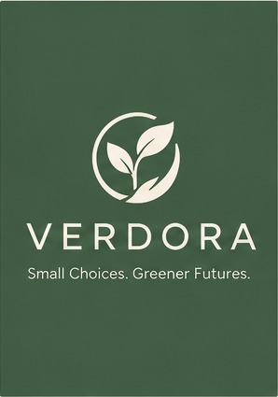  01 Main Logo | 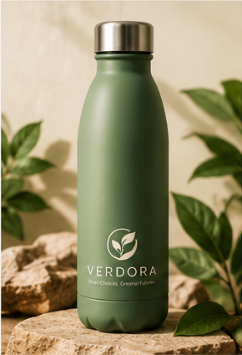  02 Water Bottle
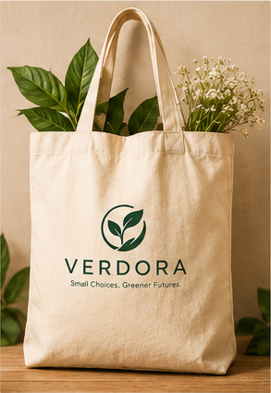  03 Shopping Bag | 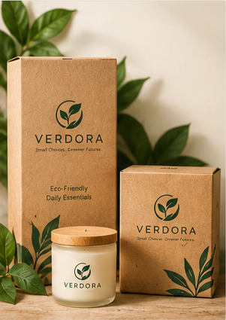  04 Packaging
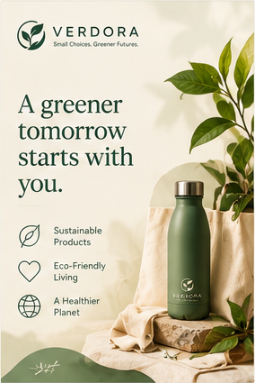  05 Instagram Post | 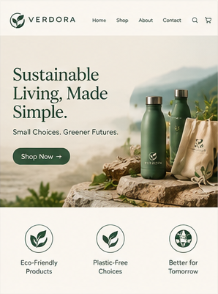  06 Website Banner
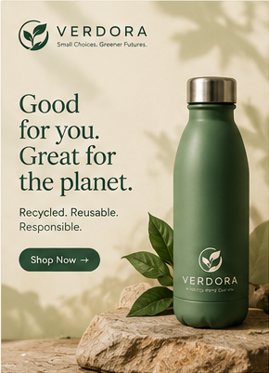  07 Product Advertisement | 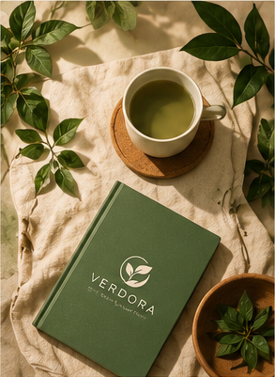  08 Botanical Lifestyle
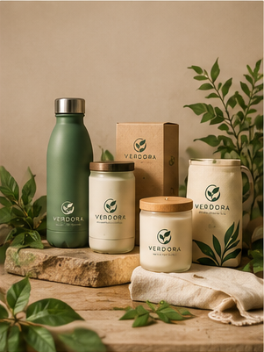  09 Product Collection | 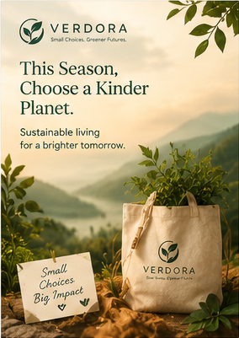  10 Seasonal Campaign

11. Before-and-After Analysis
Aspect | Before generation / master prompt | After reviewing the 10 generated images
Palette | Four brand colours were specified in the master prompt: #245447, #A8BDA0, #F7F3E8 and #C97958. | The user confirmed the colours appear correct across all 10 images; no palette correction was needed.
Logo | The master file contained the chosen VERDORA logo direction and brand rules. | The user confirmed the logo appears correct across all 10 images; no logo correction was needed.
Brand name | The master prompt specified the brand name VERDORA. | The user confirmed the brand name is correct across all 10 images; no spelling correction was needed.
Consistency workflow | A master prompt and defined brand identity were used to guide generation. | All 10 reviewed images passed the logo, brand-name and colour checks. The same master prompt can be retained.
Next action | No pre-generation error is claimed because the master file was already correct. | Keep the existing visuals unchanged; record results and complete the remaining submission checks.

12. Copyright, Trademark and Responsible AI Note
- All brand names, concepts and sample posts in this document are proposed for a fictional classroom project. The names are not confirmed to be unused or legally available.
- Trademark risk: a name or logo may conflict with an existing mark even if a general web search does not reveal an exact match. Check exact, phonetic and visually similar marks in relevant classes and markets. Record actual search evidence; obtain qualified advice for real commercial use.
- Copyright risk: AI-generated images may resemble existing artwork or include unintended text and design elements. Use tools according to their terms, avoid uploading assets without permission, and retain prompts and generation records. Rules about ownership and protection of AI-assisted works vary by jurisdiction and facts.
- Environmental claims: do not state that a product is biodegradable, carbon-neutral, plastic-free or 100% sustainable unless reliable evidence supports the specific claim.
- Human review: inspect generated images for spelling, logo distortion, accessibility, misleading claims and unintended similarity. The human creator remains responsible for the final submission.

13. Free / Free-Tier Tool Workflow
- ChatGPT — name ideation, strategy, prompts, voice guide, sample posts and report drafting.
- Google Gemini — second-opinion critique and alternative content/image concepts.
- Bing Image Creator or another available free image generator — create the ten test images and logo explorations; check current usage limits.
- Canva Free — recreate the selected logo with editable shapes/text and assemble the one-page brand sheet.
- Google Sheets — log prompts, outputs, pass/fail scores and failures.

14. One-Page Canva Brand Sheet Layout
- Top: VERDORA wordmark and tagline.
- Left: selected logo plus two alternate concepts.
- Middle: four colour swatches with HEX codes and typography choices.
- Right: audience, brand promise, values and voice keywords.
- Bottom: product mockup or generated campaign image and one sample post.
- Add a small note: “Fictional student project; trademark verification pending.”
Completed Canva Brand Sheet: Open VERDORA Canva design

15. Final Demo Script (about 60–90 seconds)
“My project explores whether free AI tools can help create a consistent brand identity. I developed VERDORA, a fictional sustainable lifestyle brand with the tagline ‘Small Choices. Greener Futures.’ I used AI for ideation, writing and visual concepts, then defined a fixed palette and voice guide. I tested ten generations using consistent criteria and recorded the real failures and corrections. I also considered trademark similarity, copyright uncertainty and the need to verify environmental claims. The key finding is that AI speeds up ideation, but human checking and a consistent design system are necessary for a reliable brand kit.”

16. Submission Readiness Checklist
☐ 20 names and taglines included
☐ Top 3 shortlist included
☐ Similarity-search evidence added after actual searches
☐ Three logo directions and palette included
☐ Voice guide and five posts included
☐ Ten actual generated images inserted or linked in test log
☐ Consistency scores and failure notes completed from evidence
☐ Canva one-page brand sheet created
☐ Ethics note and verification report reviewed
☐ Prompt library and before/after comparison completed
☐ Final demo practised

