Question: .NET MVC site slows on user profiles. Implement OutputCache in controllers, invalidate on SQL updates with triggers, and use distributed Redis.
Ans:
Implement OutputCaching in the Controller.
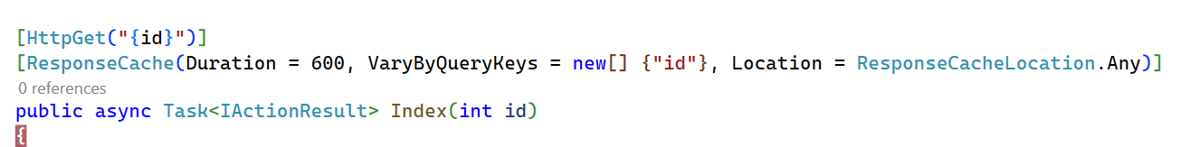
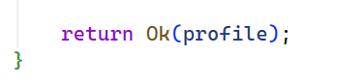
This will cache the profile data for 10 minutes on server and reduce the DB hit. In .NET , “VaryByQuerKeys” is “VaryByParam”.

Redis:
Distributed Caching across servers:
Generally [OutputCache] caches data in-memory. To share cached data across servers ,
- Configure Redis as the output cache provider in the appsettings.json /Web.Config
To integrate Redis in the application
- Install Nuget Packages:
  - Microsoft.Web.RedisOutputCacheProvider.
  - Microsoft.Extensions.Caching.StackExchangeRedis
  - Microsoft.Web.RedisOutputCacheProvider
  - StackExchange.Redis
- Use Azure Redis
Configuration (appsettings.json):
"ConnectionStrings": {
"Redis": "localhost:6379",
"AdventureWorks": "Server=localhost,1433;Database=AdventureWorks2022;User Id=sa;Password=******;TrustServerCertificate=true"
}
Program.cs:
Add the below services ,
Configure distributed Cache Service:
builder.Services.AddStackExchangeRedisCache(options =>
{
options.Configuration = builder.Configuration.GetConnectionString("Redis");
options.InstanceName = "SampleInstance";
}); [This is for caching data at Multiple server(Distributed)]

Manage Redis Connection

To get the address and port for the Redis server to which the app will connect.

var redisConnection = builder.Configuration.GetConnectionString("Redis");

ConnectionMultiplexer – manages connection at Redis. The scope for ConnectionMultiplexer should be singleton, the application where implement redis cache and backgrounservice (to receive publisher message for example when cache updates from client) have to shared the same instance of ConnectionMultiplexer.

builder.Services.AddSingleton<IConnectionMultiplexer>(sp => ConnectionMultiplexer.Connect(redisConnection!));

Register In-Process Cache (MemoryCache)

Register the built-in IMemoryCache service , it is an in-process cache that lives in the memory of the current server instance.

builder.Services.AddMemoryCache();

Register a BackGroundService , in this application CacheInvalidationSubscriber class inherits BackGroundService.

Background Subscriber Service
builder.Services.AddHostedService<CacheInvalidationSubscriber>();
Create a background service (CacheInvalidationSubscriber) that inherits from BackgroundService.
- It starts automatically when the application launches.
- It connects to Redis through IConnectionMultiplexer.
- It subscribes to the channel Cache-Invalidate.
- When a message is received, it removes the relevant entry from IMemoryCache.
Option 2: SQL Trigger + External Notification (For external DB changes)
Careate sql Trigger on the Person.Person table to insert new row into a ‘Change Log’ table.
Use a background service for example Scheluder like Quartz.NET or Azure Function to monitor ChangeLog and publish to Redis

