**Release V1**

**Date: (04/14/2017)**

1. Extract the zip file SoapCore_v1.zip
2. Open the solution and configure the data source path
   1. Open ZipCode.Data.ZipCodeRepository
   2. Configure the excel source path to the variable ZipSource. This is currently hard coded core test
3. Run the solution (already configured to run below projects)
   1. \Middleware\Services.SelfHost
   2. \Client\ZipLookupService.exe
4. ZipLookupService Client Program

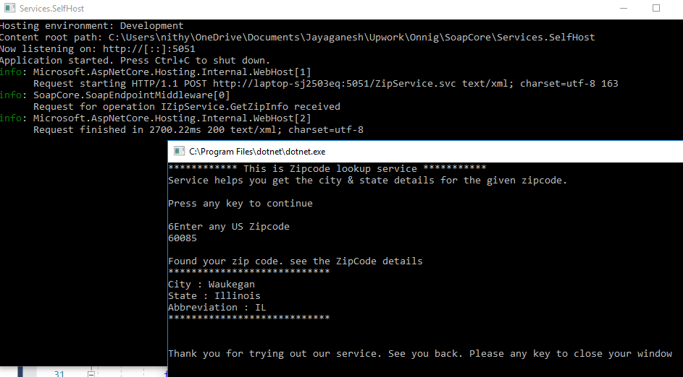

1. Solution Explorer

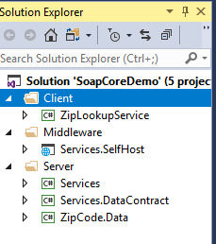

**Release V2**

**Date: 04/17/2018**

1.Extract the zip file SoapCore_v2.zip

2.Open the solution and configure the data source path

2.1 Open ZipCode.Data.ZipCodeRepository

2.2 Configure the excel source path to the variable ZipSource. This is currently hard coded core test

3. Hosting on Server

* 1. Build the application
  2. Right click on \Middleware\Services.SelfHost  
     3.2.1 Choose IIS,FTP and Click Publish  
     3.2.2 Publish Method: File System and Select Target Location (Copy all files from target location into wwwroot directory If the it is other than intpub\wwwroot )
  3. Open IIS Manager and right click on the published application and Convert To Application
  4. Browse the application and copy the WSDL URL.

4. Consume Service

4.1 Go To Tools Menu => Extensions and Updates=>Download Microsoft WCF Web Service Reference Provider.

4.2 Right click on client application and click connected service=>Microsoft WCF Web Service Reference Provider=>Url of WSDL file =>Next => Finish.

5. Client Applications

5.1 ClientApplication(Console Application-.Net Core).  
 Consume ZipService.asmx

5.2 ClientApplcation_2(Console Applcation-.Net Core)

Consume WCF Service ZipService.svc (Current system use XMLSerializer since DataContractSerializer returns null values) .

5.3 ClientApplication_3(Console Application- .Net 3.5)

Consume service ZipService.asmx

6.Solution Explorer

