MyPA
Your Personal & Business AI Assistant
Architecture Document
Version 1.4
20 July 2026
Status: Draft for Review

Document Control

Version History
Version | Date | Author | Description
1.0 | 20-Jul-2026 | Technical Consultant | Initial architecture baseline, derived from BRD v1.0
1.1 | 20-Jul-2026 | Technical Consultant | Updated AI gating to paid-tier-only; split multi-tenancy into separate consultant-client and business-team models
1.2 | 21-Jul-2026 | Technical Consultant | Replaced single-provider OpenAI integration with a multi-provider AI Model Marketplace (credit-based); added Ads Module architecture
1.3 | 21-Jul-2026 | Technical Consultant | Locked Phase 1 provider list (all 8); added real-pricing-based credit methodology; clarified Ads upload workflow and admin ownership
1.4 | 21-Jul-2026 | Technical Consultant | Moved to actual-usage-based billing (real tokens per call, not an estimate) and live rate sync via OpenRouter, replacing the flat per-model credit_cost approach

Reference Documents
- MyPA — Business Requirements Document (BRD) v1.0
- MyPA — Functional Design Document (FDD) — to follow
- MyPA — Technical Design Document (TDD) — to follow
- MyPA — Flow Diagrams (Functional, Technical, Data) — to follow

Table of Contents
1. Introduction & Architectural Goals
2. Architecture Principles
3. High-Level Architecture
4. Client Architecture (Flutter)
5. Backend Architecture (Supabase)
6. AI Model Marketplace Architecture (Multi-Provider)
7. Voice Architecture
8. Social Media Platform Integration Architecture
9. Ads Module Architecture
10. Multi-Tenancy & Data Isolation
11. Security Architecture
12. Repository Structure (Monorepo)
13. CI/CD & Deployment Architecture
14. Scalability & Performance
15. Technology Stack Summary
16. Third-Party Dependencies & Risk Notes
17. Open Architectural Decisions

1. Introduction & Architectural Goals
This document translates the MyPA Business Requirements Document (BRD v1.0) into a concrete system architecture. It defines how the Flutter client, Supabase backend, OpenAI integration, voice layer, and social media platform integrations fit together, and establishes the structural decisions (monorepo, state management, adapter patterns, multi-tenancy model) that the Technical Design Document will implement in detail.
Architectural goals, directly traceable to the BRD:
- One Flutter codebase running natively across Android, iOS, iPadOS, macOS, and Windows (BR-CP-01 to BR-CP-04).
- A backend that supports both individual users and multi-user businesses with strict data isolation (BR-CP-02, BR-CP-05).
- Secure, cost-controlled access to OpenAI's API with no client-exposed keys (BR-SM-01, NFR Security).
- A pluggable integration layer for 5 social platforms at launch that tolerates each platform's independent API changes (BR-SM-03, BR-SM-05, Risk: platform API policy changes).
- Voice input/output available consistently across all modules and platforms (BR-VC-01 to BR-VC-03).
- An admin layer for quota enforcement and role management that maps directly to the freemium/paid tier model (BR-AD-01, BR-AD-02, Monetization Model).

2. Architecture Principles
- Single codebase, platform-adaptive UI — one Flutter app; layout and interaction adapt per form factor rather than forking code.
- Backend-for-frontend via Supabase — no custom server to operate; business logic that must stay server-side (secrets, quota enforcement, cross-platform publishing) lives in Supabase Edge Functions.
- No secret ever reaches the client — OpenAI keys and social platform app secrets are stored only in Supabase Edge Function environment variables.
- Adapter pattern for external platforms — every social network is implemented against one internal interface, so adding/removing a platform does not touch core app logic.
- Security by default — Postgres Row Level Security (RLS) is mandatory on every multi-tenant table; nothing relies solely on client-side checks.
- Design for Phase 2 from day one — the schema and module boundaries anticipate the AI Personal/Business Assistant Core without requiring rework.

3. High-Level Architecture
The diagram below shows the full system: client devices, the Flutter application layer, the Supabase backend services, and the external AI/social APIs it depends on.
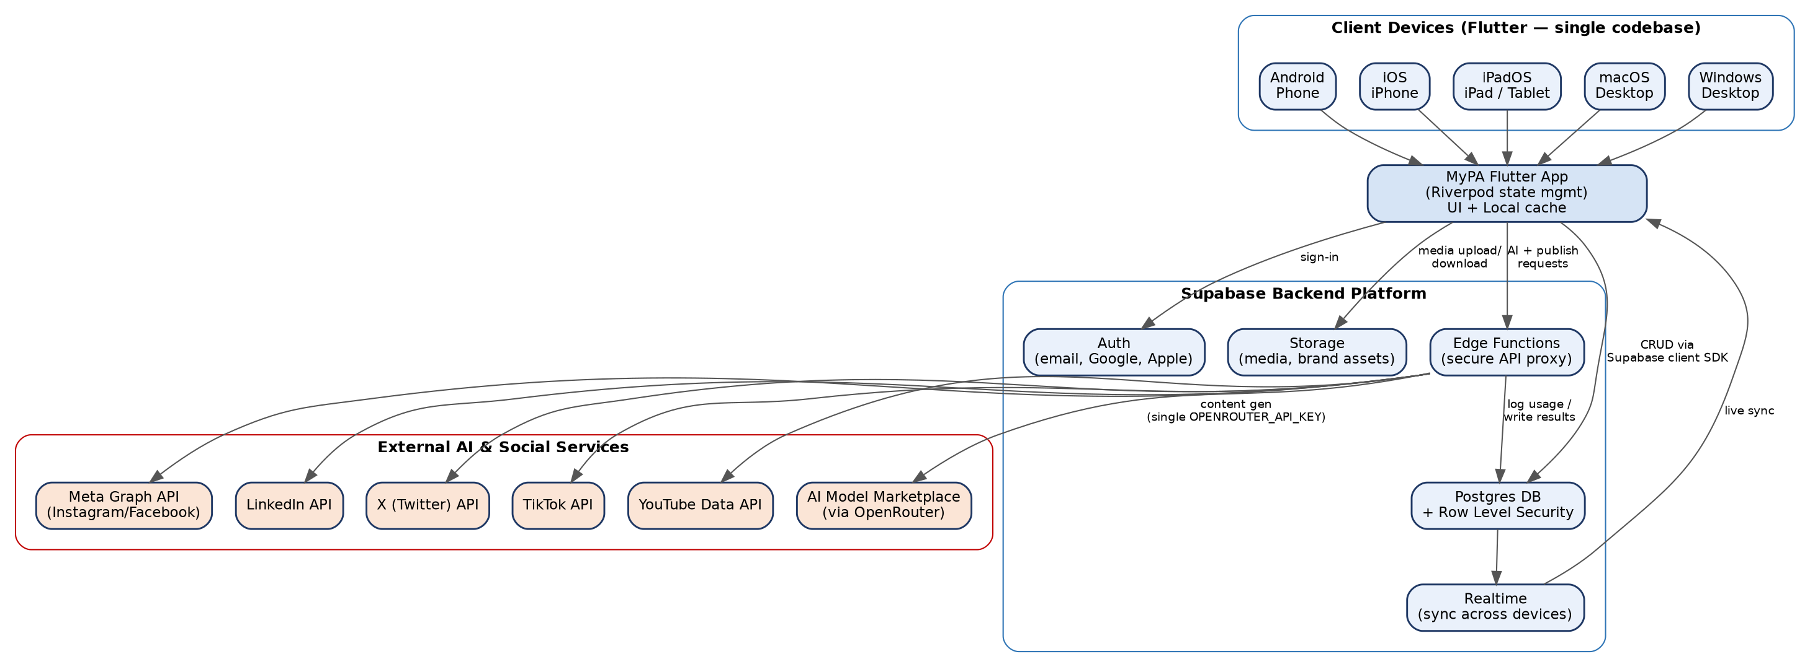
Figure 1 — MyPA High-Level System Architecture
Key flow: clients never call OpenAI or any social platform API directly. Every such call is routed through a Supabase Edge Function, which attaches the correct secret, enforces the caller's quota/entitlement, executes the call, and logs the result back to Postgres for auditability and analytics.

4. Client Architecture (Flutter)

4.1 State Management — Riverpod
Riverpod is selected as the state management approach for MyPA. Rationale:
- Compile-safe dependency injection works identically across mobile, desktop, and tablet targets.
- Testability: providers can be overridden in tests without a widget tree, important given the breadth of platforms to QA.
- Scales cleanly as modules grow (Social Media Marketing now, Assistant Core in Phase 2) without a central store becoming a bottleneck.

4.2 Layered Client Structure
presentation/ -> Widgets, screens, platform-adaptive layouts
application/ -> Riverpod providers, controllers, state notifiers
domain/ -> Entities, use-cases, business rules (pure Dart, no Flutter deps)
data/ -> Supabase client calls, local cache, repositories
This separation keeps business rules platform-independent and unit-testable, and keeps Supabase-specific code isolated behind repository interfaces so the backend can evolve without rewriting UI logic.

4.3 Platform Adaptivity
- A responsive layout system with breakpoints for phone, tablet/iPad, and desktop (macOS/Windows), rather than separate codebases per form factor.
- Desktop targets add keyboard shortcuts and multi-window affordances where natural (e.g. content calendar in a wider grid).
- Voice input uses platform-appropriate capture (native mic APIs on mobile, system audio input on desktop).

5. Backend Architecture (Supabase)
Service | Role in MyPA
Auth | Email/password + Google/Apple OAuth sign-in; issues JWTs consumed by Postgres RLS and Edge Functions.
Postgres Database | System of record: users, workspaces, content, prompt library, schedules, quotas, audit logs. RLS enforced on every tenant-scoped table.
Storage | Media assets (images/video for posts), brand asset libraries, per-workspace buckets with RLS-equivalent storage policies.
Edge Functions | Server-side logic: OpenAI proxy, social platform publishing adapters, quota enforcement, webhook receivers.
Realtime | Pushes content/schedule/status changes to all of a user's signed-in devices for cross-device sync (BR-CP-04).

Supabase is sufficient for Phase 1 without a separate custom backend server, per the BRD assumption. If Phase 2's Assistant Core later needs long-running background jobs beyond Edge Function limits, a dedicated worker service can be introduced without disturbing this core design.

6. AI Model Marketplace Architecture (Multi-Provider)
MyPA offers a marketplace of AI providers that a user selects per generation, paid for via a credit system. Free-tier accounts still have no AI access at all (BRD v1.1 decision unchanged); Pro/Business accounts choose a model each time they generate. As of v1.4, pricing is no longer a flat per-model estimate — credits are charged on the actual tokens used in that specific call, at rates kept current by an automated sync, rather than a fixed number set once and left to go stale.
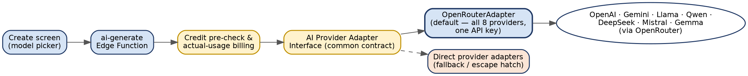
Figure 2 — AI Provider Adapter Pattern (OpenRouter default, direct adapters as fallback)

6.1 Routing via OpenRouter (Primary Path)
No AI provider exposes a live 'current price' API of its own — pricing pages are documentation, not queryable data. Rather than hand-maintain 8 separate rate cards, MyPA routes AI generation through OpenRouter, a unified multi-provider gateway that (a) exposes an OpenAI-compatible API covering all 8 launch providers behind one key, and (b) publishes a public, unauthenticated models endpoint with live per-token pricing for every model it serves.
- Single secret to manage: OPENROUTER_API_KEY, instead of 8 separate provider credentials — a meaningful simplification of Section 6.4's adapter surface and of the Environment Setup Guide's prerequisite accounts.
- Every generation response includes actual token usage (prompt_tokens, completion_tokens), which is what billing is computed from (Section 6.3) — never an estimate.
- Direct provider adapters (the original per-provider design) remain available as a documented fallback for any provider not well served by OpenRouter, but are not the default path — see Open Architectural Decisions.

6.2 Live Rate Sync
- A scheduled Edge Function (sync-model-pricing, TDD Section 6.1c) calls OpenRouter's public GET /api/v1/models endpoint on a nightly cadence.
- For each of the 8 launch providers' mapped models, it updates ai_models.input_rate_per_million, output_rate_per_million, and is_free directly from OpenRouter's response — no manual pricing edits in normal operation.
- Initial seed data (TDD Section 3.7b) uses the real July 2026 rates researched for this document, and is immediately superseded by the first sync run once deployed.

6.3 Actual-Usage Credit Billing
Replacing the flat per-generation estimate from v1.3, credits are now computed from the real token counts OpenRouter reports for that specific call:
- Pre-check (before calling): using the model's current rates and a capped max_output_tokens for the request, compute a conservative max_possible_cost; reject with 402 insufficient_credits if the account's balance can't cover it. This bounds worst-case exposure without a separate holds/authorization table.
- Actual charge (after the call succeeds): credits = ceil((prompt_tokens/1,000,000 × input_rate + completion_tokens/1,000,000 × output_rate) × margin_multiplier / 0.001), using the real usage figures returned by OpenRouter — always ≤ the pre-check cap by construction.
- The account is charged the actual amount, not the pre-check cap; ai_generation_logs records the real tokens_used and credits_used for audit and analytics.
- margin_multiplier (TDD Section 3.7, platform_settings) still applies on top of raw cost, defaulting to 1.0 (no markup) — a commercial decision, not an architectural one.

6.4 Provider Adapter Contract
The adapter interface from v1.2 is retained, but OpenRouterAdapter is now the single default implementation satisfying it for all 8 marketplace entries — model selection happens via an OpenRouter model slug (e.g. openai/gpt-4o, meta-llama/llama-3.3-70b) rather than 8 separate adapter classes:
- generate(openrouterSlug, prompt, params) -> { text, promptTokens, completionTokens }
- Direct per-provider adapters (OpenAIAdapter, GeminiAdapter, etc.) remain a documented escape hatch for a provider OpenRouter doesn't cover well, implementing the same interface, so ai-generate's core logic never needs to know which path is in use.
This keeps adding, removing, or re-pricing a provider a contained, largely data-driven change — a new ai_models row and (if not using OpenRouter) a new adapter — rather than a change to core generation or billing logic.

7. Voice Architecture
- Speech-to-text: on-device/platform APIs where available (fast, offline-capable, no extra cost) as the default; cloud STT (e.g. Whisper API via Edge Function) as a fallback for higher accuracy or unsupported platforms.
- Text-to-speech: platform-native TTS by default for zero marginal cost; upgradeable to a higher-quality cloud voice for Pro/Business tiers if desired later.
- Voice is a cross-cutting capability consumed by the Social Media Marketing module now, and designed to be reused by the Assistant Core in Phase 2 without a separate implementation.

8. Social Media Platform Integration Architecture
All 5 launch platforms (Meta/Instagram & Facebook, LinkedIn, X, TikTok, YouTube) are implemented behind one common adapter interface, so the publishing service and the app's UI never contain platform-specific branching logic.
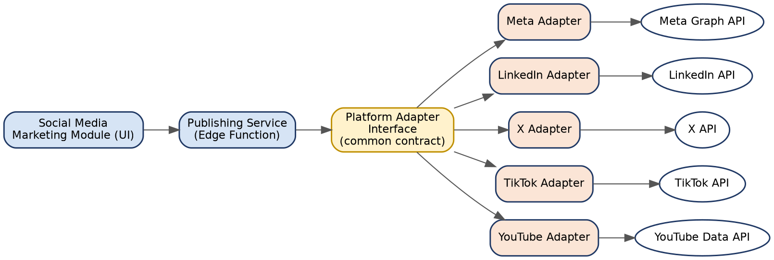
Figure 3 — Platform Adapter Pattern for Social Media Integrations

8.1 Common Adapter Contract
- connectAccount() — OAuth flow to link a user's/workspace's social account
- publishPost(content) — publish or schedule content in the platform's required format
- fetchInsights(postId) — retrieve available performance metrics (BR-SM-08)
- disconnectAccount()

8.2 Platform-Specific Notes
Platform | Integration Notes
Meta (Instagram/Facebook) | Graph API; requires Meta App Review for publishing permissions; supports scheduled publishing natively.
LinkedIn | LinkedIn Marketing/Share API; company page publishing requires partner-level access approval.
X (Twitter) | X API v2; tiered access levels affect rate limits — plan for the paid tier needed for reliable scheduled posting.
TikTok | TikTok API for Business/Content Posting API; approval process is typically the slowest — build manual-export fallback for launch if approval lags.
YouTube | YouTube Data API; primarily for video upload/metadata — most relevant to consultants managing video content.

Per the BRD's risk register, each adapter is isolated so that a policy change or outage on one platform (e.g. TikTok approval delay) never blocks the other four or requires a core app release to work around.

9. Ads Module Architecture
MyPA serves promotional ad content in two fixed slots on the Home screen — a top banner and a bottom banner — entirely sourced from a database table via an upload/entry workflow, so ads can be added, scheduled, and rotated without an app release.
- A single ads table (TDD Section 3.8) holds every ad. Whoever creates an ad uploads: an image, the ad content/text, the placement (top or bottom), a start date, and the number of days it should run — the system computes the active end date from start date + duration rather than requiring a raw end-date entry, matching how an admin naturally thinks about running an ad ('show this for 3 days').
- Additional fields captured at upload for completeness: a target URL (where tapping the ad leads), an advertiser/campaign name for internal tracking, and an active/paused flag for manual override independent of the date window.
- The client fetches currently-active ads per placement (server-side filtered by today's date and placement) rather than filtering client-side, so expired or paused ads never reach the device.
- Administration: ads are created and managed by a platform-level MyPA operations role, separate from any business workspace's own Admin role — this is not a per-workspace, self-serve feature in Phase 1. (If self-serve workspace advertising is wanted later, it can be added as a distinct capability without changing the core ads table.)
- No RLS-based user-scoping is needed for ads (they are not tenant data); write access is restricted to the platform-level admin claim (TDD Section 4.4), distinct from a business workspace's own Admin role.

10. Multi-Tenancy & Data Isolation
MyPA uses two distinct, separately-modeled workspace types rather than one shared workspace abstraction, reflecting the fact that a consultant's relationship to their clients and a business's relationship to its team are structurally different (single-owner-many-clients vs. multi-user-one-team):

10.1 Consultant-Client Model
- A Consultant/Influencer account owns one or more Client Workspaces (BR-SM-04).
- Each Client Workspace has exactly one owning consultant account, with content, brand assets, and schedules isolated per client.
- Optional collaborators can be added to a specific Client Workspace without granting access to the consultant's other clients.

10.2 Business-Team Model
- A Business account owns one or more Team Workspaces, each with multiple team members (BR-CP-02, BR-CP-05).
- Team members hold a role per workspace — Admin, Manager, Contributor, Viewer (BR-AD-01) — checked in both RLS policy and Edge Function logic for side-effecting actions (publishing, quota changes).
- An Individual account (non-consultant, non-business) has exactly one implicit personal workspace with no separate membership table.

10.3 Data Isolation
- Every tenant-scoped table carries either a client_workspace_id or a team_workspace_id (never both); RLS policies are written per workspace type against the owning/member relationship, not a single generic workspace table.
- This keeps the access rules for 'my clients' (consultant) and 'my team' (business) independently simple, rather than one policy trying to express both relationship shapes at once — the tradeoff is two sets of tables/policies to maintain instead of one.

11. Security Architecture
Layer | Control
Transport | TLS enforced end-to-end (Supabase default + Flutter HTTPS-only networking).
Authentication | Supabase Auth (JWT-based); social/OAuth login supported; session refresh handled by Supabase client SDK.
Authorization | Postgres RLS on every table plus role checks in Edge Functions; no client-side-only authorization.
Secrets | OpenAI key and each social platform's app secret stored only as Supabase Edge Function environment variables — never bundled in client builds.
Data at rest | Encrypted by Supabase's underlying managed Postgres/Storage infrastructure.
Auditability | All AI generations and publish actions logged with user, workspace, timestamp (NFR Auditability, BR-AD-02 quota tracking).
Third-party data handling | OpenAI API usage disclosed to users per BRD Privacy NFR; no training on business data beyond OpenAI's standard API policy.

12. Repository Structure (Monorepo)
Single GitHub repository named MyPA contains both the Flutter application and the Supabase backend definition, as decided for this project:
MyPA/
|-- app/ Flutter application
| |-- lib/
| | |-- presentation/
| | |-- application/
| | |-- domain/
| | `-- data/
| |-- android/ ios/ macos/ windows/
| `-- test/
|-- supabase/ Backend definition (Supabase CLI project)
| |-- migrations/ SQL schema + RLS policies, version controlled
| |-- functions/ Edge Functions (ai-generate, publish-*, quota-check)
| `-- config.toml
|-- docs/ BRD, Architecture, FDD, TDD, flow diagrams, user guides
|-- .github/workflows/ CI/CD pipelines
`-- README.md
Keeping app and backend in one repository (per project decision) simplifies coordinated changes — e.g. a new Edge Function and the client code that calls it ship in the same pull request and commit history.

13. CI/CD & Deployment Architecture
GitHub Actions drives build, test, and deployment across all six release targets from the single monorepo.
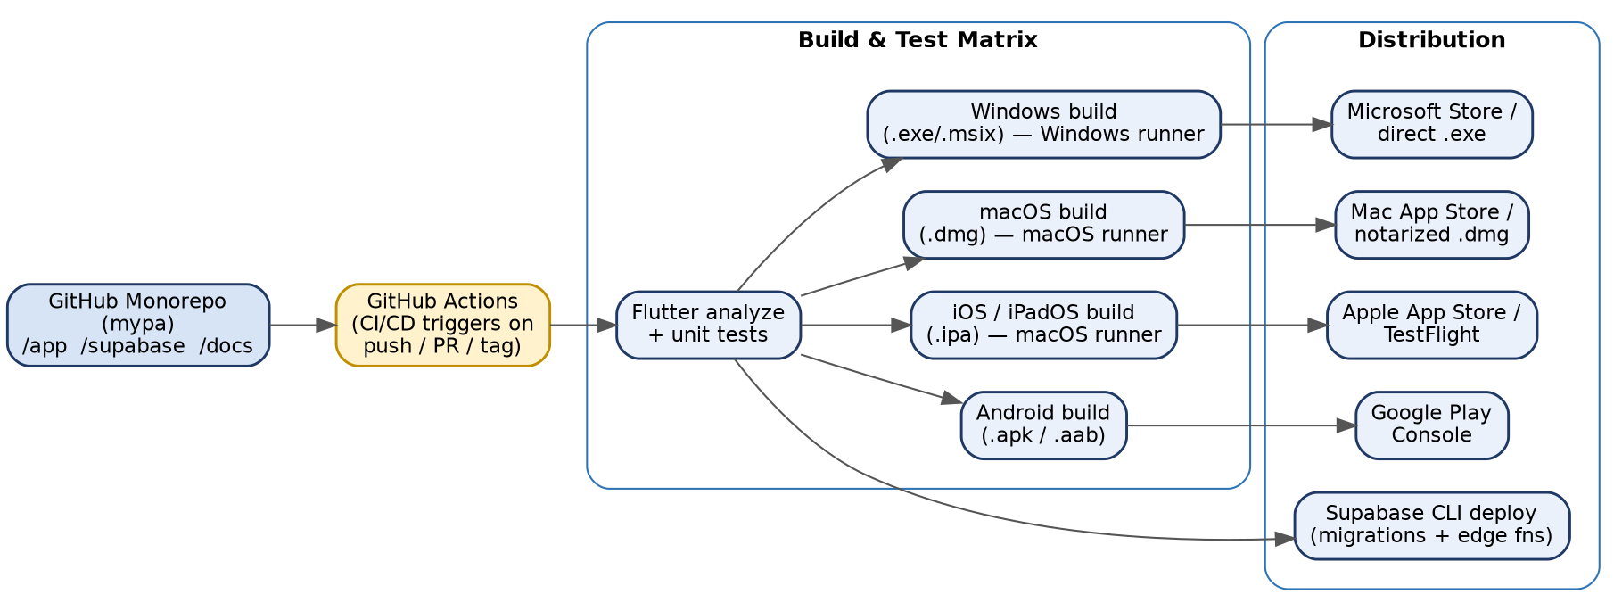
Figure 4 — CI/CD Pipeline Across Build Targets
- Every push/PR runs Flutter analyze + unit tests before any platform build proceeds.
- Android and Windows builds can run on standard GitHub-hosted Linux/Windows runners; iOS, iPadOS, and macOS builds require macOS runners (GitHub-hosted or self-hosted Mac).
- Supabase schema migrations and Edge Function deployments run via the Supabase CLI as part of the same pipeline, keeping backend and app releases in sync.
- Tagged releases trigger store submission steps (Play Console, App Store Connect/TestFlight, Mac App Store or notarized .dmg, Microsoft Store or signed .exe/.msix).

14. Scalability & Performance
- Supabase Postgres scales vertically/horizontally under Supabase's managed infrastructure; indexes planned per workspace_id and common query patterns in the TDD.
- Edge Functions scale automatically per-request; OpenAI streaming responses are used so perceived latency stays low even under load (NFR: response streaming within 2 seconds).
- Realtime channel subscriptions are scoped per-workspace to avoid unnecessary broadcast load as the user base grows.
- Adapter-based social integrations allow independent rate-limit handling per platform without one platform's throttling affecting others.

15. Technology Stack Summary
Layer | Technology
Client framework | Flutter (Dart) — Android, iOS, iPadOS, macOS, Windows
State management | Riverpod
Backend platform | Supabase (Auth, Postgres, Storage, Edge Functions, Realtime)
AI / LLM | Multi-provider marketplace: OpenAI, Google AI Studio (Gemini), Hugging Face, Llama, Qwen, DeepSeek, Mistral, Gemma — via provider adapters and a credit system; NotebookLM linked externally, not called as a generation API
Voice | Platform-native STT/TTS, with cloud fallback (e.g. Whisper) via Edge Function
Social integrations | Meta Graph API, LinkedIn API, X API, TikTok API, YouTube Data API
Source control / CI-CD | GitHub + GitHub Actions (single monorepo: MyPA)
Promotional content | Database-driven ads table (top/bottom placement, date-range scheduling)

16. Third-Party Dependencies & Risk Notes
Dependency | Architectural Mitigation
OpenAI API availability/cost | Edge Function quota gate isolates cost impact per tier; streaming reduces perceived latency risk.
Social platform API approval delays (esp. TikTok) | Adapter isolation lets other platforms ship on time; manual export/copy fallback available per BRD risk register.
Apple ecosystem builds require macOS runners | CI/CD pipeline explicitly plans macOS-hosted runners for iOS/iPadOS/macOS jobs.
Supabase platform limits (Edge Function execution time, etc.) | Long-running work is designed as short, quota-checked calls; a dedicated worker service is the identified escape hatch for Phase 2 if needed.
Each new AI provider's own API availability/cost/rate limits (Gemini, Hugging Face, Qwen, DeepSeek, Mistral, Gemma) | Provider adapter isolation (Section 6.3) means one provider's outage or policy change doesn't affect the others; credit costs can be tuned per provider independent of app releases.

17. Open Architectural Decisions
Resolved since the v1.3 draft: pricing is now live-synced from OpenRouter rather than hardcoded (Section 6.2), and credits are charged on actual per-call token usage rather than a flat estimate (Section 6.3). Remaining open items:
- Whether to apply a margin multiplier on top of raw-cost credit pricing (Section 6.3) — the schema supports this as a single configurable value; the multiplier itself is a commercial decision.
- Whether any of the 8 providers should also get a direct (non-OpenRouter) adapter for cost or latency reasons once real usage data exists — Section 6.1 documents this as a supported fallback, not a Phase 1 requirement.
- Whether a self-serve, per-workspace advertising capability is wanted in a later phase, distinct from the platform-level ads described in Section 9.
- Whether GitHub-hosted macOS runners are sufficient for build volume, or a self-hosted Mac build machine is needed for cost/speed reasons.

