MyPA
Your Personal & Business AI Assistant
Data Flow Diagrams (DFD)
Version 1.0
20 July 2026
Status: Draft for Review

Purpose
This document shows how data moves through MyPA using standard Data Flow Diagram (DFD) notation: external entities (squares), processes (ellipses), and data stores (open rectangles). Level 0 shows MyPA as a single process against its external entities; Level 1 decomposes it into its five major processes and the Postgres tables (data stores) each one reads or writes, per the Technical Design Document's schema.

Related Documents
- MyPA — Technical Design Document v1.0 (data store = table definitions)
- MyPA — Technical Flow Diagrams (call-sequence view of the same processes)

1. Level 0 — Context Diagram
MyPA as a single process, showing all data crossing its system boundary.
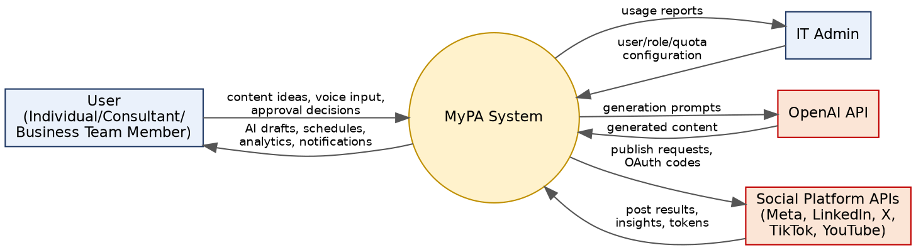
Figure 1 — DFD Level 0: System Context

2. Level 1 — Process Decomposition
MyPA decomposed into five processes, each reading/writing specific Postgres data stores (labeled D1-D6, matching TDD Section 3 tables).
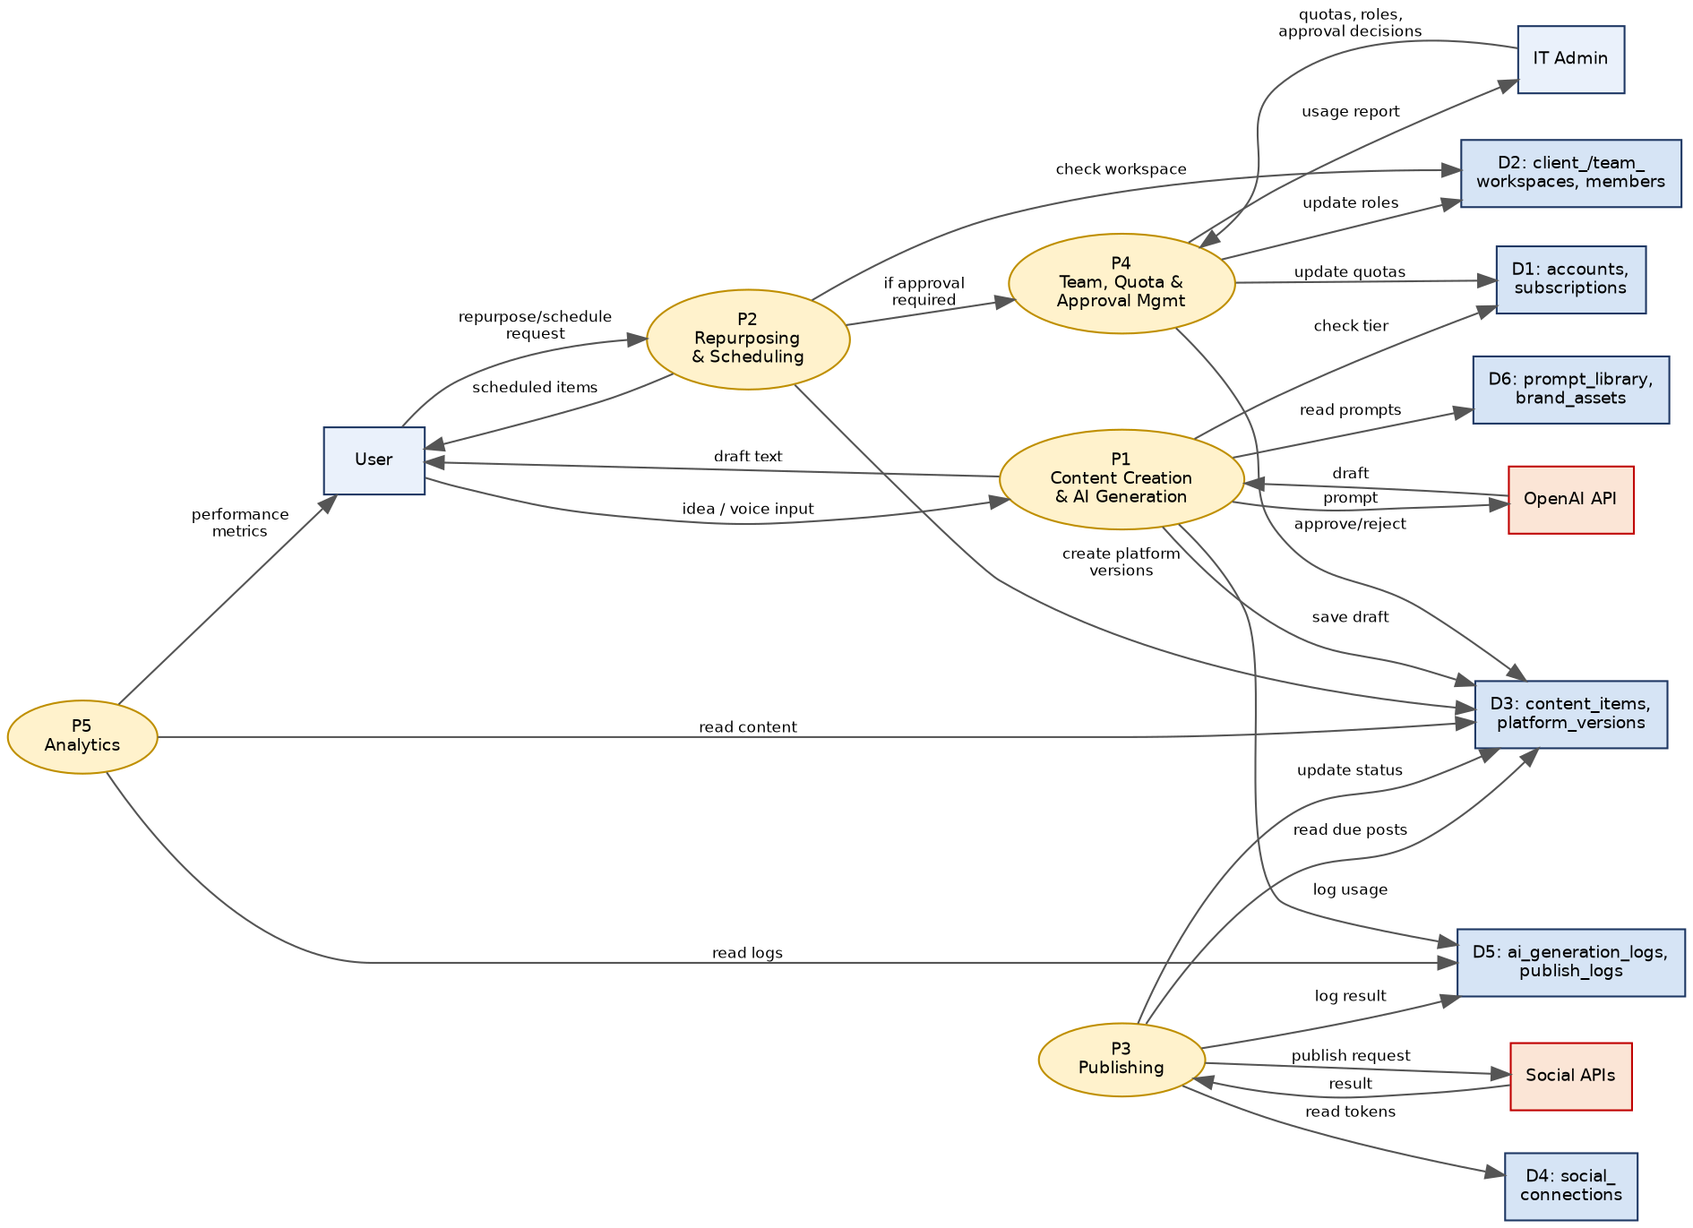
Figure 2 — DFD Level 1: Process & Data Store Detail

3. Data Store Reference
Store | Name | Corresponding TDD Tables
D1 | Accounts & Subscriptions | accounts, subscriptions
D2 | Workspaces & Membership | client_workspaces, client_workspace_collaborators, team_workspaces, team_members
D3 | Content | content_items, content_platform_versions, approval_requests
D4 | Social Connections | social_connections
D5 | Logs | ai_generation_logs, publish_logs
D6 | Prompts & Brand Assets | prompt_library, brand_assets

4. Process Reference
Process | Name | Primary Responsibility
P1 | Content Creation & AI Generation | Validates tier eligibility, calls OpenAI, persists AI drafts, logs usage — implements TDD Section 5 & 6.1
P2 | Repurposing & Scheduling | Creates per-platform content versions and schedule entries — TDD Section 6.2
P3 | Publishing | Reads due/requested posts, calls the relevant platform adapter, records results — TDD Section 6.3, 7
P4 | Team, Quota & Approval Management | Handles role/quota configuration and the approval decision path — TDD Section 4.2, 6.5, 6.6
P5 | Analytics | Aggregates content and log data into user-facing performance metrics — supports BR-SM-08

5. Data Lifecycle Notes
- Creation: content and log rows are created only via Edge Functions (P1-P4), never written directly by the client, so every write passes through tier/role/approval checks.
- Storage: all data stores are Postgres tables under Supabase, with Row Level Security scoping every read/write to the requesting user's workspace(s) (TDD Section 4).
- Transmission: data leaving the system boundary (to OpenAI or a social platform) contains only what that call requires — OpenAI receives prompt text, not account/billing data; social platforms receive only the specific post content being published.
- Retention: publish_logs and ai_generation_logs are retained for audit and analytics per the BRD's Auditability NFR; a retention/archival policy is a commercial/compliance decision to be set before launch, not fixed by this document.

