MyPA
Your Personal & Business AI Assistant
Functional Flow Diagrams
Version 1.0
20 July 2026
Status: Draft for Review

Purpose
This document shows MyPA's core user journeys as functional (user-facing) flowcharts — the decisions and steps a person experiences, independent of system internals. Corresponding system-level call sequences are in the Technical Flow Diagrams document; corresponding data movement is in the Data Flow Diagrams document.

Related Documents
- MyPA — BRD v1.1, Functional Design Document v1.0 (screen-level detail)
- MyPA — Technical Flow Diagrams (system sequence view of these same journeys)
- MyPA — Data Flow Diagrams (data movement view)

1. Individual/Consultant: Create & Publish a Post
Covers BR-SM-01, BR-SM-07 (guided creation), the Free-tier AI paywall decision (BRD v1.1), BR-SM-03 (repurposing), BR-SM-05 (scheduling), and BR-AD-03 (approval gate).
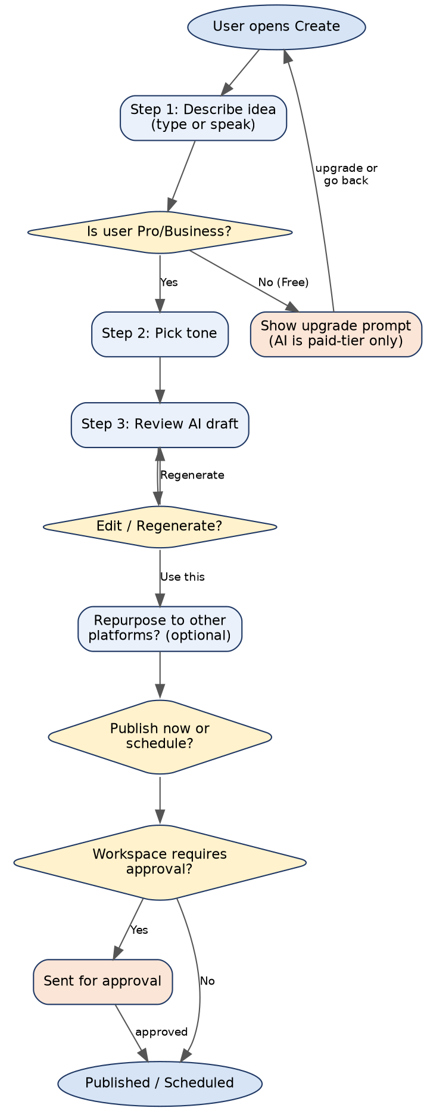
Figure 1 — Create & Publish Post: Functional Flow

2. Consultant: Multi-Client Repurposing Session
Covers BR-SM-04 (workspace isolation per client) combined with BR-SM-03 (one-click repurposing across all 5 launch platforms), reflecting how a consultant works through several clients in one sitting.
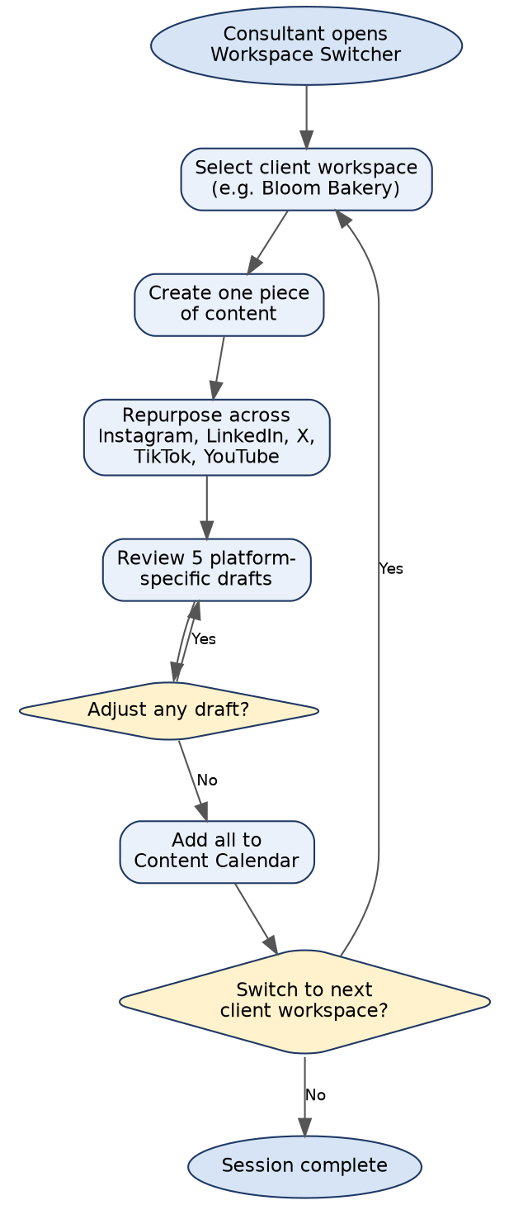
Figure 2 — Consultant Multi-Client Session: Functional Flow

3. Business: Content Approval Workflow
Covers BR-AD-03 (approval workflow) as experienced by a Contributor and an Admin/Manager approver within a Team Workspace.
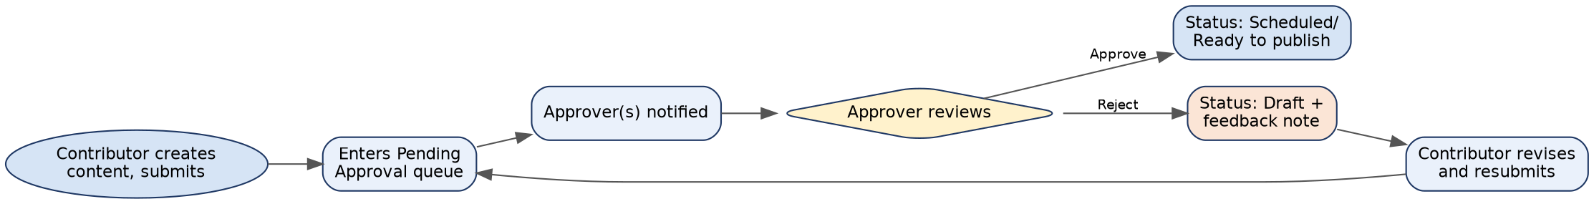
Figure 3 — Content Approval Workflow: Functional Flow

4. Journey-to-Requirement Traceability
Journey | BRD Requirements Covered
Create & Publish a Post | BR-SM-01, BR-SM-03, BR-SM-05, BR-SM-07, BR-AD-03, Free-tier gating (BRD v1.1)
Consultant Multi-Client Session | BR-SM-03, BR-SM-04
Content Approval Workflow | BR-AD-03

