MyPA
Your Personal & Business AI Assistant
Technical Flow Diagrams
Version 1.0
20 July 2026
Status: Draft for Review

Purpose
This document shows the system-level (component-to-component) call sequences underlying MyPA's core operations, complementing the user-facing journeys in the Functional Flow Diagrams document and the Edge Function contracts specified in the Technical Design Document. Each diagram reads left-to-right in call order; numbered labels indicate sequence.

Related Documents
- MyPA — Technical Design Document v1.0 (schema and Edge Function contracts referenced here)
- MyPA — Architecture Document v1.1 (component roles)
- MyPA — Functional Flow Diagrams (user-facing view of these same operations)

1. AI Content Generation Call Sequence
Underpins the Create step in the Functional Flow's 'Create & Publish a Post' journey. Implements the entitlement check from TDD Section 5 — Free-tier callers are rejected before any OpenAI call is made, so they incur zero cost.
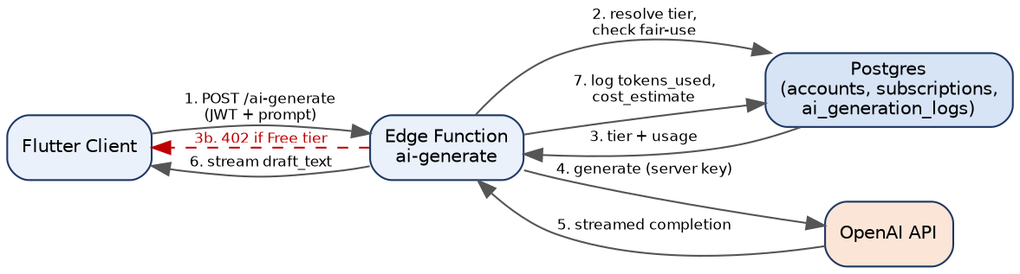
Figure 1 — ai-generate Edge Function Call Sequence

2. Publish / Schedule Call Sequence
Underpins the scheduling and publish steps of the Functional Flow. Uses the platform adapter pattern (TDD Section 7) so this sequence is identical regardless of which of the 5 launch platforms is the target — only the Adapter and Social Platform API box change.
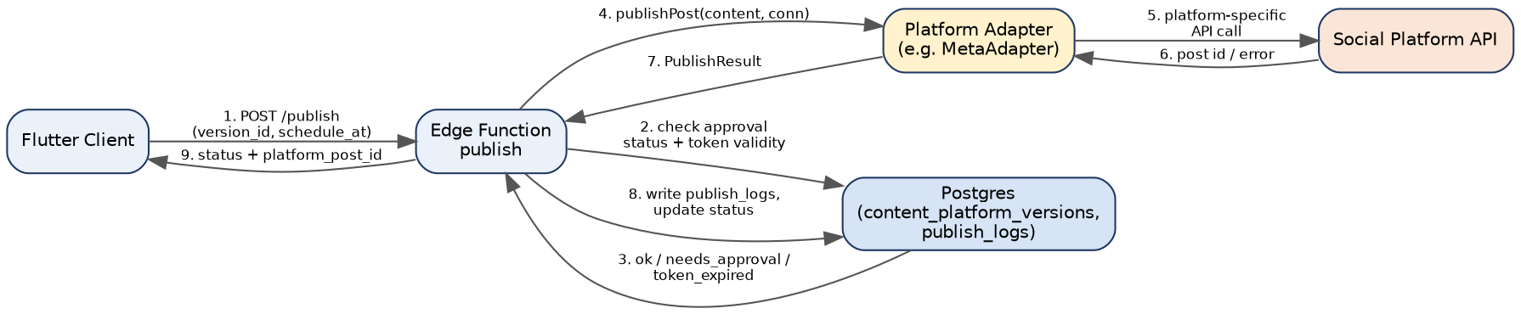
Figure 2 — publish Edge Function Call Sequence

3. Social Account OAuth Connection Sequence
Underpins the 'Connected accounts' action referenced in the Core Platform and Admin/IT Console FDD screens. Access and refresh tokens are only ever stored server-side (Postgres, encrypted) — never held by the client.
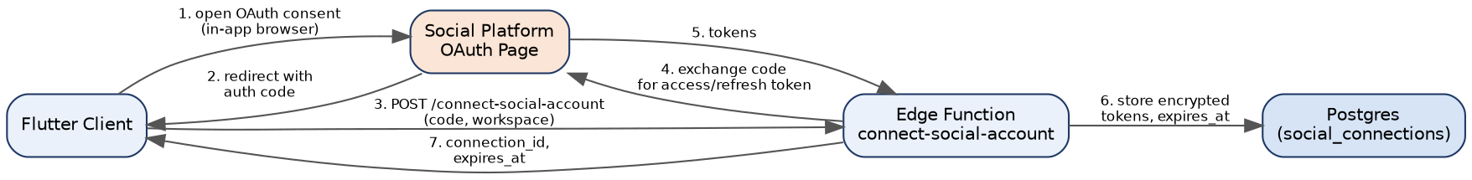
Figure 3 — connect-social-account Call Sequence

4. Cross-Device Realtime Sync Sequence
Underpins BR-CP-04 (near-real-time sync across devices). No custom WebSocket server is required — Supabase Realtime broadcasts are filtered by the same Row Level Security rules as direct table access, so a device only receives updates for workspaces its user belongs to.
Figure 4 — Cross-Device Realtime Sync Sequence

5. Sequence-to-Contract Traceability
Sequence | Edge Function / Mechanism | TDD Reference
AI Content Generation | POST /functions/v1/ai-generate | Section 5, 6.1
Publish / Schedule | POST /functions/v1/publish + adapter | Section 6.3, 7
OAuth Connection | POST /functions/v1/connect-social-account | Section 6.4
Realtime Sync | Supabase Realtime channel per workspace | Section 9

