OBJECTIVE: TO IMPLIMENT BUBBLE SORT

# include <stdio.h>

#include<conio.h>  
int main()

{

int array[100], n, i, j, swap;

printf("Enter number of elementsn");

scanf("%d", &n);

printf("Enter %d Numbers:n", n);

for(i = 0; i < n; i++)

scanf("%d", &array[i]);

for(i = 0 ; i < n - 1; i++)

{

for(j = 0 ; j < n-i-1; j++)

{

if(array[j] > array[j+1])

{

swap=array[j];

array[j]=array[j+1];

array[j+1]=swap;

}

}

}

printf("Sorted Array:n");

for(i = 0; i < n; i++)

printf("%dn", array[i]);

return 0;

}

TO IMPLIMENT SELECTION SORT

#include <stdio.h>

#include<conio.h>

void swap(int *a, int *b) {

int temp = *a;

*a = *b;

*b = temp;

}

void selectionSort(int array[], int size) {

for (int step = 0; step < size - 1; step++) {

int min = step;

for (int i = step + 1; i < size; i++) {

if (array[i] < array[min_idx])

min= i;

}

swap(&array[min], &array[step]);

}

}

void printArray(int array[], int size) {

for (int i = 0; i < size; ++i) {

printf("%d ", array[i]);

}

printf("\n");

}

int main() {

int data[] = {20, 12, 10, 15, 2};

int size = sizeof(data) / sizeof(data[0]);

selectionSort(data, size);

printf("Sorted array in Acsending Order:\n");

printArray(data, size);

}

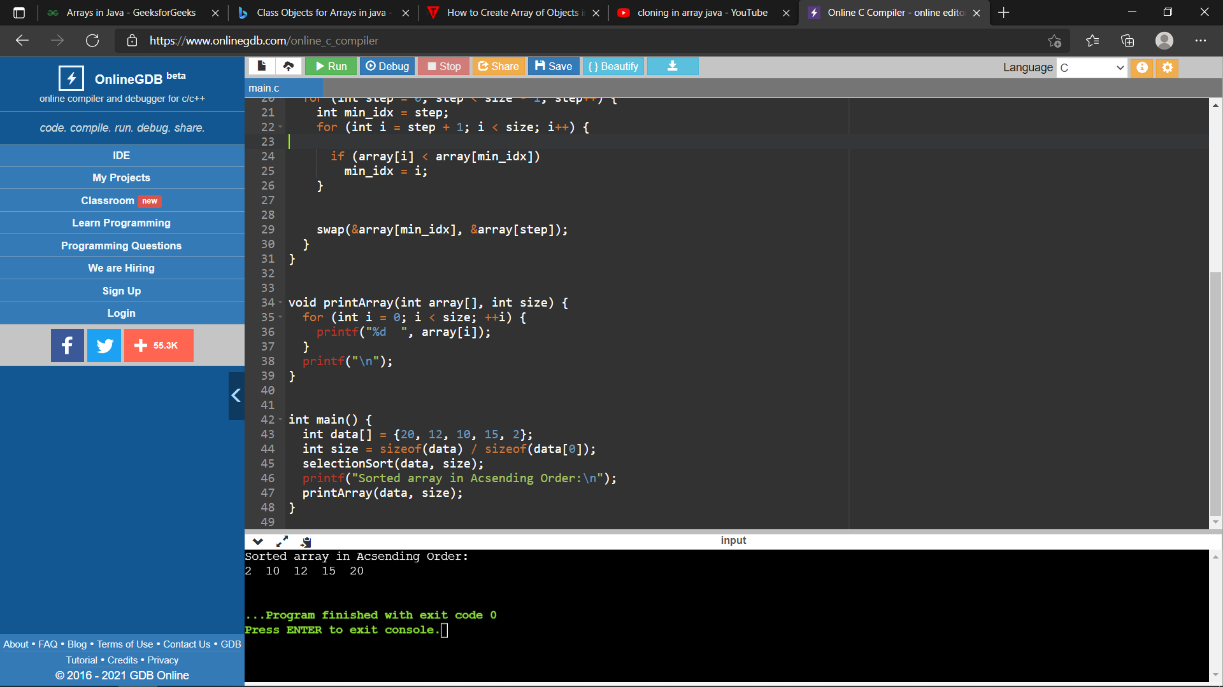

NITIKA PATEL