"Underwater Image Quality Assessment for Autonomous Vehicles"

A

Project Report
submitted in partial fulfillment of the
requirements for the award of the degree of

BACHELOR OF TECHNOLOGY
in
COMPUTER SCIENCE & ENGINEERING

by

Name | SAP ID
Jhilmil Bansal | 500122855
Divyansh Rajput | 500123839
Nitika Thakral | 500120622
Janvi Singh | 500118951

under the guidance of

Dr. Anish Kumar Vishwakarma
Assistant Professor



School of Computer Science
University of Petroleum & Energy Studies
Bidholi, Via Prem Nagar, Dehradun, Uttarakhand

May – 2026

CANDIDATE'S DECLARATION

We hereby certify that the project work entitled "Underwater Image Quality Assessment for Autonomous Vehicles" in partial fulfilment of the requirements for the award of the Degree of BACHELOR OF TECHNOLOGY in COMPUTER SCIENCE AND ENGINEERING with specialization in DATA SCIENCE and submitted to the Department of Systemics, School of Computer Science, University of Petroleum & Energy Studies, Dehradun, is an authentic record of our work carried out during the period from January, 2026 to May, 2026 under the supervision of Dr. Anish Kumar Vishwakarma, Assistant Professor, School of Computer Science, UPES, Dehradun.

The matter presented in this project has not been submitted by us for the award of any other degree of this or any other University.

(Jhilmil Bansal)
SAP ID: 500122855

(Divyansh Rajput)
SAP ID: 500123839

(Nitika Thakral)
SAP ID: 500120622

(Janvi Singh)
SAP ID: 500118951

This is to certify that the above statement made by the candidates is correct to the best of my knowledge.

Date: 5th May 2026
(Dr. Anish Kumar Vishwakarma)
Assistant Professor, SoCS, UPES

ACKNOWLEDGEMENT

We wish to express our deep gratitude to our guide, Dr. Anish Kumar Vishwakarma, for all advice, encouragement, and constant support he has given us throughout our project work. This work would not have been possible without his support and valuable suggestions.

We sincerely thanks to our respected Virender Kadyan, Head Department of Data Science, for his great support in doing our project in "Underwater Image Quality Assessment for Autonomous Vehicles".
We are also grateful to Dean SoCS UPES for giving us the necessary facilities to carry out our project work successfully. We also thanks to our Course Coordinator, (Sagar Deep Deb) and our Activity Coordinator (Gouranga Duari) for providing timely support and information during the completion of this project.
We would like to thank all our friends for their help and constructive criticism during our project work. Finally, we have no words to express our sincere gratitude to our parents who have shown us this world and for every support they have given us.

Name | Jhilmil Bansal | Divyansh Rajput | Nitika Thakral | Janvi Singh
SAP ID | 500122855 | 500123839 | 500120622 | 500118951

ABSTRACT

"Underwater Image Quality Assessment for Autonomous Vehicles" is a project that deals with the challenge of automatically evaluating the visual quality of underwater images using deep learning techniques, without requiring any reference image for comparison.

Underwater images suffer from severe degradations caused by light absorption, scattering, color distortion, and reduced contrast; all of which make it difficult for computer vision systems to accurately perceive the underwater environment. Manually assessing the quality of such images is time-consuming and impractical at scale.

The goal of this project is to design and implement a deep learning-based system that can automatically predict a perceptual quality score for any given underwater image, reflecting how a human observer would rate its visual quality.

The proposed system uses a Swin Transformer (Swin-Base) backbone pretrained on ImageNet as its core feature extractor. The model extracts visual features from multiple stages of the backbone simultaneously, capturing texture, structural detail, and high-level semantic information at different levels. These multi-scale features are combined into a single unified representation, which is then passed through a regression network to predict a Mean Opinion Score (MOS) on a scale of 0 to 100.

The system is trained and evaluated on the SAUD dataset comprising 1,000 human-annotated enhanced underwater images. The model achieves strong correlation with human perceptual judgments, outperforming existing state-of-the-art methods.

This system can be useful in applications such as:
- Autonomous Underwater Vehicle (AUV) navigation
- Underwater robotics and remote operations
- Marine research and environmental monitoring
- Offshore infrastructure inspection
- Defense and underwater surveillance
- Evaluation of underwater image enhancement algorithms

TABLE OF CONTENTS

Contents | Page No.
1. Introduction | 1
1.1 Background and Motivation | 1
1.2 Problem Statement | 2
1.3 Objectives | 2
1.4 Scope of the Project | 3
1.5 Project Timeline | 3
2. System Analysis | 4
2.1 Existing Systems | 4
2.2 Proposed System | 4
2.3 SWOT Analysis | 5
2.4 Modules | 5
3. Design | 6
3.1 System Architecture | 6
3.2 Use Case Diagram | 7
3.3 Activity Diagram | 7
3.4 Sequence Diagram | 8
3.5 Class Diagram | 8
3.6 State Diagram | 9
3.7 Data Flow Diagram | 9
4. Proposed Methodology | 10
4.1 Dataset Description | 10
4.2 Multi-Scale Feature Extraction using Swin Transformer | 11
4.3 Global Average Pooling | 11
4.4 Concatenation-Based Feature Fusion | 12
4.5 Quality Score Regression | 12
4.6 Loss Function Formulation | 12
5. Implementation | 13
5.1 Experimental Setup | 13
5.2 Software and Hardware Requirements | 13
5.3 Evaluation Metrics | 14
6. Results and Output | 15
6.1 Performance Comparison | 15
6.2 Training and Validation Loss Curves | 16
6.3 Scatter Plot | 16
6.4 Residuals Histogram | 16
7. Limitations and Future Enhancements | 17
8. Conclusion | 18
References | 19

LIST OF FIGURES

Figure | Page No.
Fig. 1.1 PERT Chart / Project Timeline | 3
Fig. 3.1 System Architecture Diagram | 6
Fig. 3.2 Use Case Diagram | 7
Fig. 3.3 Activity Diagram | 7
Fig. 3.4 Sequence Diagram | 8
Fig. 3.5 Class Diagram | 8
Fig. 3.6 State Diagram | 9
Fig. 3.7 Data Flow Diagram | 9
Fig. 4.1 Proposed UIQA Framework Architecture (Swin Transformer) | 10
Fig. 6.1 Training and Validation Loss Curves | 16
Fig. 6.2 Scatter Plot of Predicted vs. Ground-Truth MOS Scores | 16
Fig. 6.3 Histogram of Residuals | 16

LIST OF TABLES

Table | Page No.
Table 2.1 SWOT Analysis of the Proposed System | 5
Table 4.1 SAUD Dataset Properties | 10
Table 5.1 Software and Hardware Requirements | 13
Table 6.1 Performance Comparison with State-of-the-Art Methods | 15

1. Introduction

1.1 Background and Motivation
Underwater imaging plays a fundamental role in a wide range of ocean-based applications, including autonomous underwater vehicle (AUV) navigation, marine exploration, offshore infrastructure inspection, and environmental monitoring. The underwater optical environment, however, introduces severe visual degradations that are fundamentally different from those encountered in natural atmospheric imaging. Key distortion sources include wavelength-dependent light absorption, which causes color casts predominantly toward the blue-green spectrum, as well as scattering due to suspended particles that results in haze, reduced contrast, and loss of fine structural detail.

To counteract these degradations, a large number of underwater image enhancement (UIE) algorithms have been proposed. However, enhancement pipelines frequently introduce secondary artifacts such as over-saturation, structural distortion, and noise amplification. This creates a fundamental challenge: objectively determining whether a processed image is truly of higher quality than its original version. There is therefore a critical need for a reliable, objective, and perceptually aligned quality metric tailored specifically to underwater imagery.

Conventional Image Quality Assessment (IQA) methods, whether full-reference or no-reference, were originally designed for natural atmospheric images and fail to generalize to underwater-specific distortion patterns. Their quality predictions frequently misalign with human perceptual judgment in underwater contexts. Recent deep learning-based IQA models have shown strong performance on natural image benchmarks, but most existing approaches extract features at a single scale of abstraction, limiting their capacity to simultaneously capture low-level textural distortions and high-level semantic degradation — both of which are critical for accurate underwater quality estimation.

1.2 Problem Statement
The core problem addressed by this project is the absence of an effective, no-reference (blind) image quality assessment framework specifically designed for underwater imagery. Existing general-purpose IQA methods produce quality predictions that are poorly correlated with human perceptual judgments in underwater contexts, making them unsuitable for evaluating the effectiveness of UIE algorithms or guiding autonomous underwater perception systems.

Specifically, this project addresses the following challenges:
- The inability of natural-image IQA models to capture underwater-specific degradations such as color casts, haze, and contrast loss.
- The limitation of single-scale feature extraction in capturing the full spectrum of quality-relevant information spanning texture, structure, and semantics.
- The lack of a composite training objective that simultaneously optimizes for numerical accuracy, perceptual correlation, and rank-order consistency.

1.3 Objectives
The main objectives of this project are as follows:
- To develop a deep learning-based no-reference UIQA framework capable of predicting perceptual image quality scores without requiring reference images.
- To leverage a Swin Transformer (Swin-Base) backbone with a selective fine-tuning strategy for hierarchical multi-scale feature extraction.
- To design a multi-scale feature fusion mechanism that concatenates globally pooled feature maps from multiple backbone stages into a unified quality descriptor.
- To train the model using a composite loss function combining L1, MSE, PLCC, and pairwise ranking losses to jointly optimize prediction accuracy, perceptual correlation, and rank-order consistency.
- To evaluate the proposed framework on the SAUD benchmark dataset and demonstrate competitive performance over state-of-the-art methods.

1.4 Scope of the Project
The scope of this project encompasses the design, implementation, and evaluation of a deep learning-based blind UIQA system. The system operates on the SAUD (Subjectively-Annotated UIE Benchmark Dataset) comprising 1,000 human-annotated enhanced underwater images. The framework performs end-to-end quality score prediction from raw underwater images, using a pretrained Swin Transformer backbone fine-tuned for the underwater domain.

The developed system can be deployed as a quality monitoring component within underwater image processing pipelines, supporting applications in underwater robotics, marine research, and automated inspection. The current implementation is designed as a standalone Python-based system running in a Jupyter Notebook environment, leveraging GPU-accelerated computation via the PyTorch deep learning framework.

1.5 Project Timeline
The project was executed over one semester, from January 2026 to May 2026. The key milestones included literature review and problem formulation (January 2026), SRS preparation and design finalization (February–March 2025), model development with MaxViT prototype (March 2026), transition to Swin Transformer architecture and training (April 2026), evaluation and paper writing (April–May 2026), and final report preparation (May 2026).

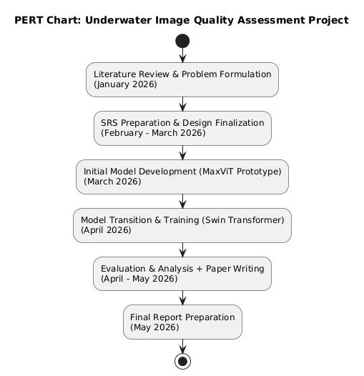
Fig 1.1: PERT Chart for the project timeline

2. System Analysis

2.1 Existing Systems
Several approaches have been proposed for underwater image quality assessment, ranging from handcrafted metrics to deep learning-based methods. Traditional UIQA methods such as UCIQE (Underwater Color Image Quality Evaluation) and UIQM (Underwater Image Quality Measure) rely on handcrafted features derived from color, sharpness, and contrast. While computationally efficient, these metrics often fail to align with human perceptual judgments, yielding low correlation scores (PLCC ≈ 0.39–0.49) on the SAUD benchmark.

The CCF (Color, Contrast, and Fog) metric represents another traditional no-reference approach that achieved even lower performance (PLCC = 0.387). The NUIQ method, specifically proposed for underwater image quality evaluation, improved correlation to 0.671 by incorporating dataset-specific training. Deep learning-based approaches, including ResNet-50, DenseNet-121, and B-FEN, achieved PLCC values in the range of 0.74–0.75, demonstrating the superiority of learned features over handcrafted ones. However, these methods rely on single-scale feature extraction, which limits their perceptual representational capacity.

2.2 Proposed System
The proposed system introduces a multi-scale feature fusion framework built upon a pretrained Swin-Base Transformer backbone. Unlike prior single-scale approaches, the proposed framework extracts feature maps from multiple backbone stages (Stages 2, 3, and 4), capturing quality cues at different levels of abstraction — from mid-level texture to high-level semantic representations. These features are globally average pooled and concatenated into a 1792-dimensional unified descriptor, which is subsequently mapped to a perceptual quality score via a regression MLP.

The system adopts a selective fine-tuning strategy, freezing the patch embedding layer and Stage 1 to preserve low-level ImageNet-pretrained representations, while keeping Stages 2, 3, and 4 fully trainable to adapt to underwater-specific distortions. Training employs a composite loss combining L1, MSE, PLCC, and pairwise ranking terms. At inference, Test-Time Augmentation (TTA) over five stochastic forward passes is applied to reduce prediction variance.

2.3 SWOT Analysis

Strengths | Weaknesses
Multi-scale feature fusion captures texture, structural, and semantic quality cues simultaneously | High computational resource requirement (GPU-dependent training)
Swin Transformer backbone provides hierarchical representations with shifted window attention | Limited to 1,000 annotated images in the SAUD dataset, constraining generalization
Composite loss function ensures accuracy, correlation, and ranking are jointly optimized | No baseline comparison against traditional methods (BRISQUE, NIQE) within this implementation
Opportunities | Threats
Growing demand in underwater robotics, marine monitoring, and defense applications | Domain shift due to environmental variation in real-world underwater conditions
Integration into real-time UIE pipelines for AUV and ROV navigation systems | Rapid emergence of competing UIQA approaches in deep learning literature
Table 2.1: SWOT Analysis of the Proposed System

2.4 Modules
The proposed system is organized into the following functional modules:

2.4.1 Data Loading and Preprocessing Module
This module is responsible for loading the SAUD dataset from disk, parsing the JSON annotation file (saud_dataset.json), and resolving image paths. A custom PyTorch Dataset class reads each image, applies appropriate transformations (resizing to 224×224, normalization), and returns image-MOS pairs for training, validation, and testing.

2.4.2 Feature Extraction Module
This module implements the Swin-Base Transformer backbone with forward hooks registered on Stages 2, 3, and 4. It extracts intermediate feature maps F2, F3, and F4, with channel dimensions of 256, 512, and 1024 respectively. The patch embedding layer and Stage 1 are frozen to preserve pretrained low-level features.

2.4.3 Feature Fusion and Regression Module
Global Average Pooling is applied to each stage output to produce compact fixed-size descriptors. These are concatenated into a 1792-dimensional unified vector, batch-normalized, and passed through a three-layer regression MLP (1792 → 512 → 128 → 1) with GELU activations, dropout, and a final Sigmoid activation scaled to the MOS range [0, 100].

2.4.4 Training and Evaluation Module
This module manages the end-to-end training loop using the composite loss function, AdamW optimizer with differential learning rates, cosine annealing scheduler with linear warmup, and early stopping. Model checkpoints are saved at the best validation loss. At inference, TTA is applied over five stochastic forward passes.

2.4.5 Visualization and Reporting Module
This module generates output visualizations including training/validation loss curves, scatter plots of predicted vs. ground-truth MOS scores, and a histogram of residuals. All evaluation metrics (PLCC, SROCC, KROCC, RMSE) are computed and reported.

3. Design

3.1 System Architecture
The overall system architecture of the proposed Deep Learning-Based Underwater Image Quality Assessment System follows a sequential pipeline from raw image input to perceptual quality score output. The architecture is organized into five primary layers: Input Layer, Data Pipeline, Model Layer, Training Engine, and Output Layer.

The Input Layer accepts the SAUD dataset, comprising 1,000 enhanced underwater images stored in a structured directory along with MOS annotations in a JSON file. The Data Pipeline performs dataset loading, train/validation/test splitting (70/15/15), and applies appropriate image transformations. The Model Layer implements the Swin-Base backbone with selective fine-tuning and the regression MLP. The Training Engine manages the optimization process, and the Output Layer produces evaluation metrics, scatter plots, and the best trained model checkpoint.

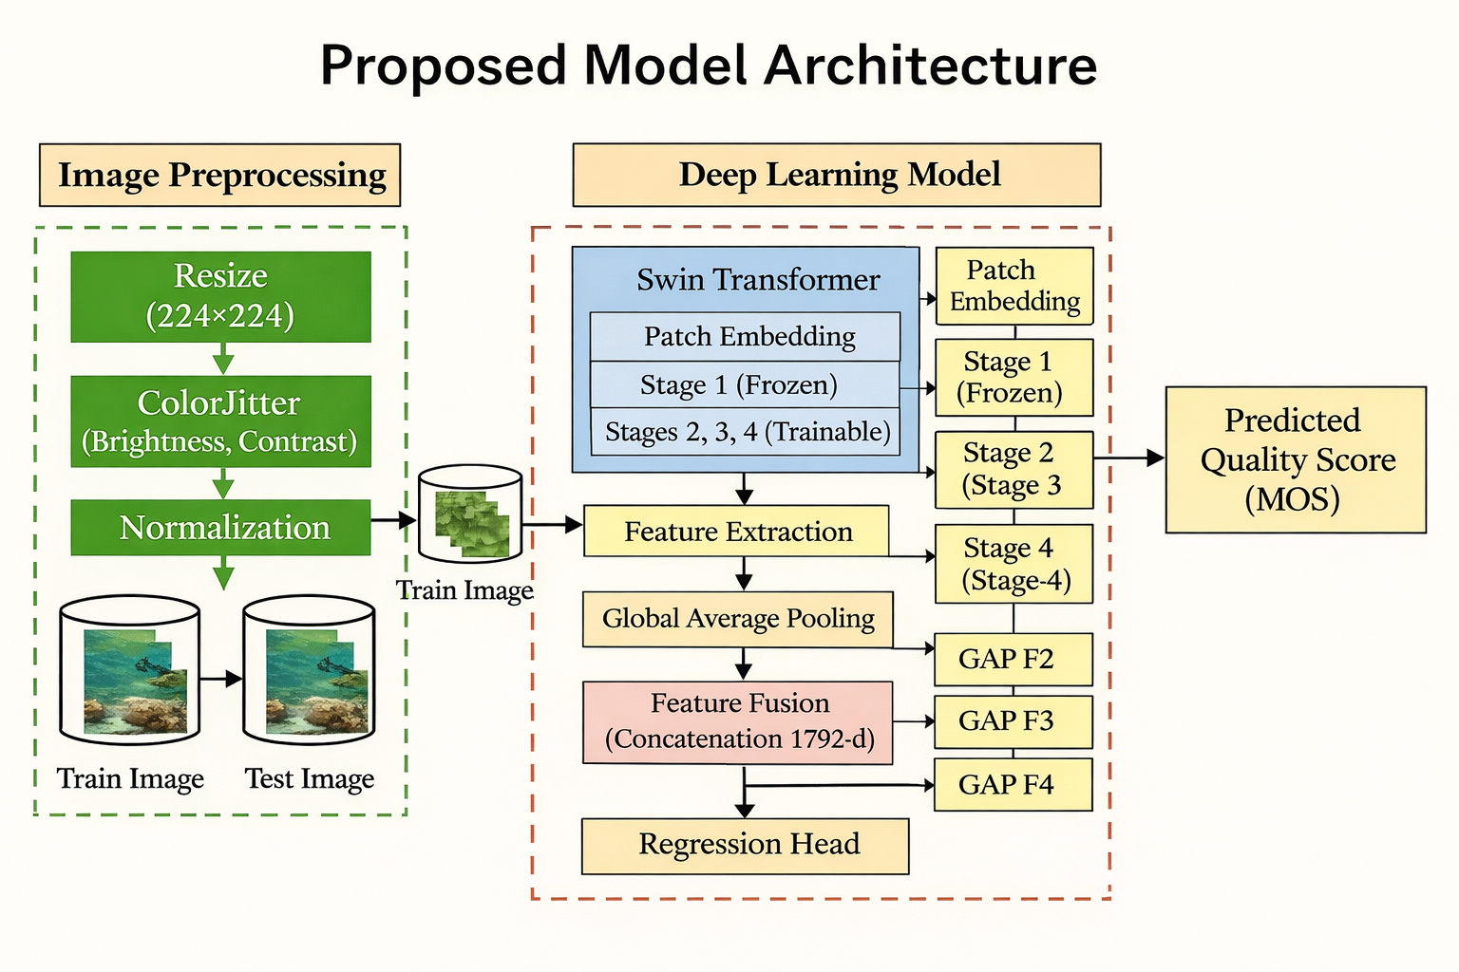[Fig. 3.1: System Architecture Diagram]

3.2 Use Case Diagram
The system involves two primary actors: the Admin and the Researcher. The Admin is responsible for managing dataset entries, monitoring model performance, and updating or retraining the ML model. The Researcher interacts with the system to upload underwater images, request quality assessments, view quality scores (MOS), view evaluation reports, compare image quality, and export results. The system internally triggers the ML model, validates image inputs, and maps raw scores to quality labels (Poor / Fair / Good / Excellent).

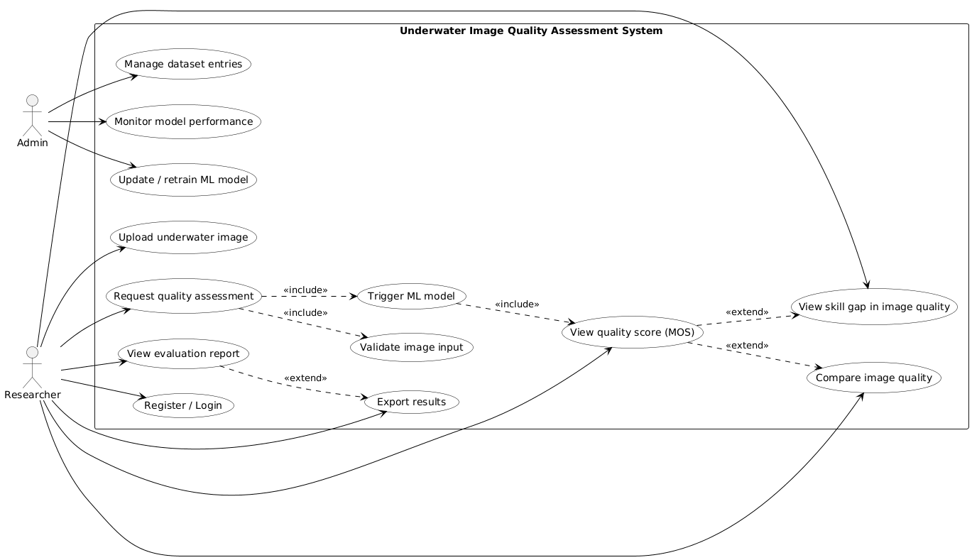
[Fig. 3.2: Use Case Diagram]

3.3 Activity Diagram
The activity diagram models the end-to-end workflow of the system from the researcher's perspective. The researcher begins by opening the application and logging in or registering. Upon uploading an underwater image dataset and providing metadata, the system fetches the image from storage, validates its format and completeness, and pushes the job to the assessment queue. An assessment worker preprocesses the image (resize, normalize) and runs the ML model to predict the MOS score. The score is mapped to a quality label, stored in the database, and the researcher is notified with the results. The researcher may then accept the result, export an evaluation report, or request a comparison with another image.

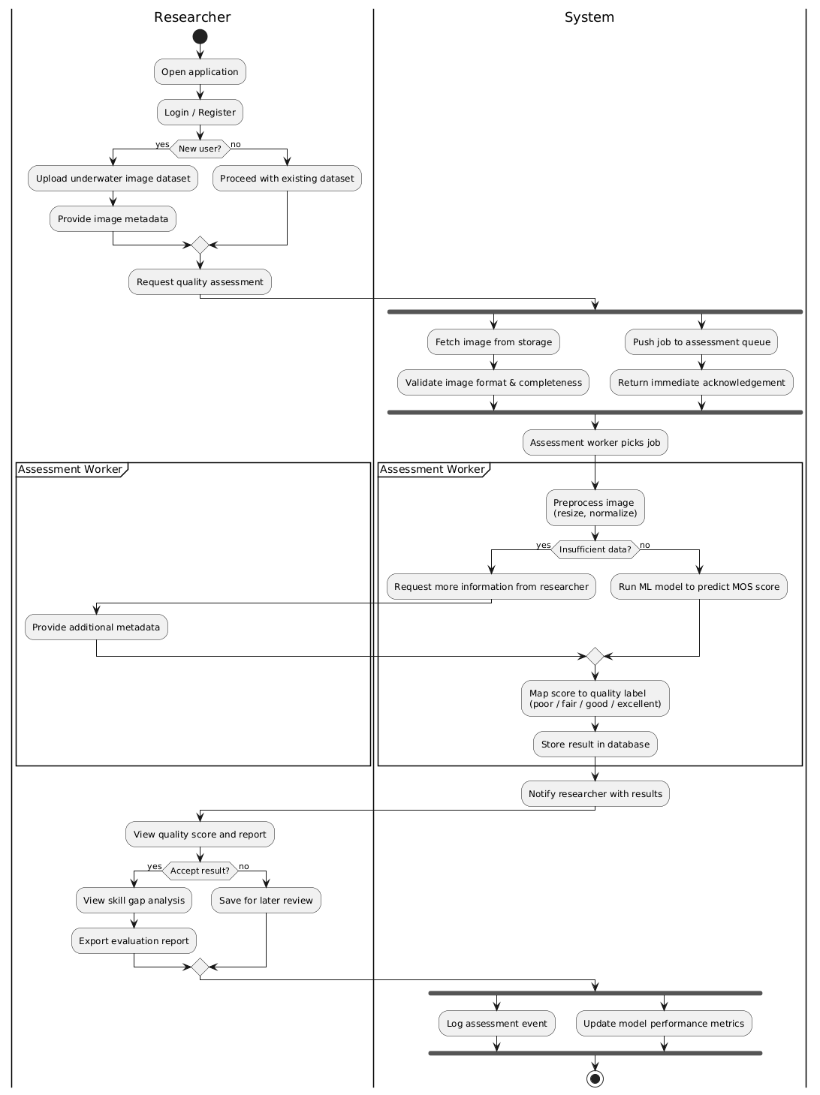
[Fig. 3.3: Activity Diagram]

3.4 Sequence Diagram
The sequence diagram captures the temporal interaction between system components during a quality assessment request. The Researcher initiates the flow by clicking 'Assess Image Quality' on the Frontend UI. The API Gateway validates the authentication token and retrieves the image from the Image Service. If the data is sufficient, the Assessment Engine preprocesses the image and runs the Swin Transformer model, producing a normalized score in [0, 1]. The Score Interpreter maps this to the MOS scale [0–100] and assigns a quality label. The Report Service inserts the assessment record into the Assessment DB and returns the report ID. The researcher receives the final quality score, label, and report.

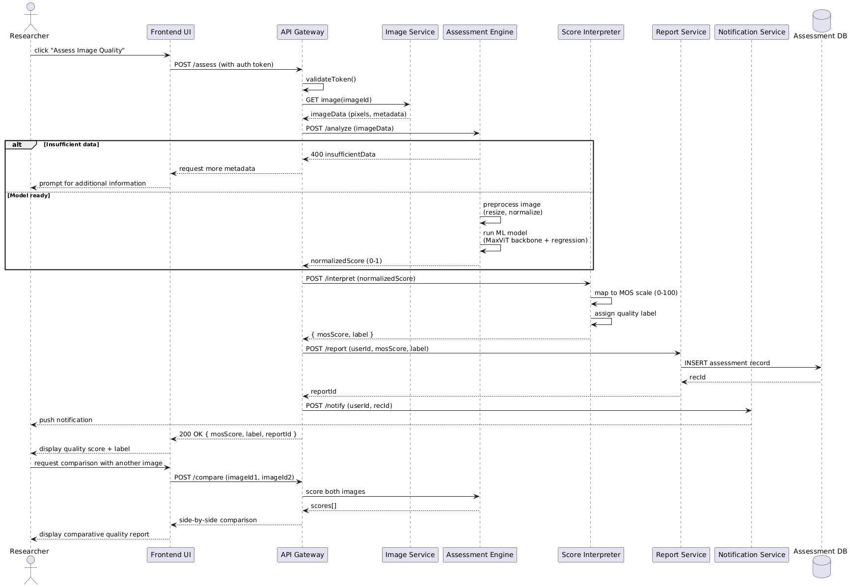
[Fig. 3.4: Sequence Diagram]

3.5 Class Diagram
The class diagram defines the object-oriented structure of the system. The primary classes are: MLModel, Dataset, UnderwaterImage, ProcessedImage, QualityAssessment, EvaluationReport, User, and QualityLabel. Relationships include trained-on, contains, preprocessed-into, assessed-by, generates, and assigned associations between these classes.

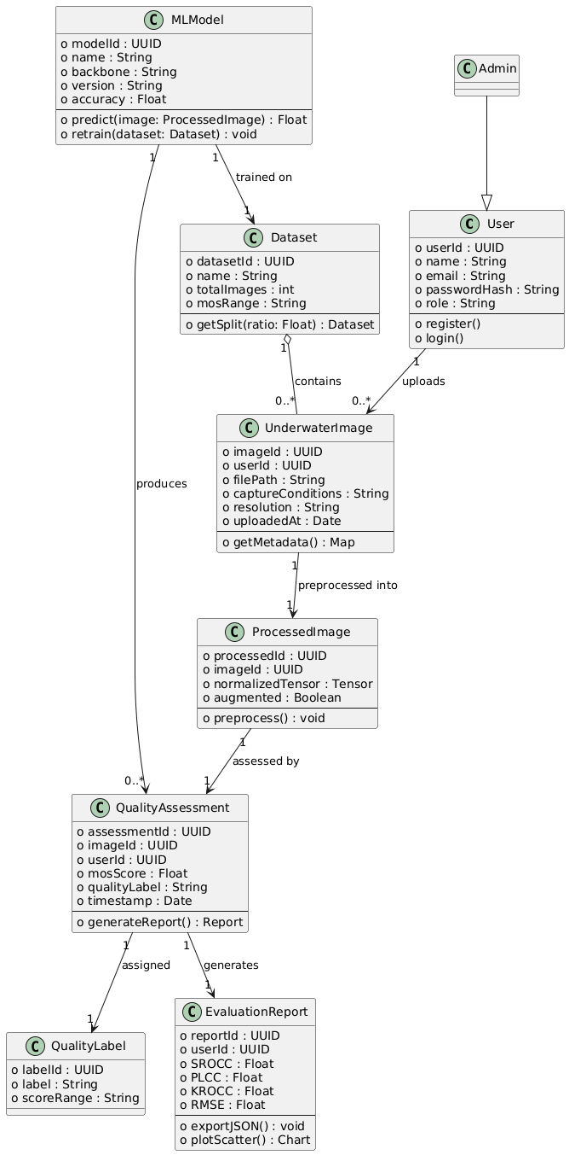
[Fig. 3.5: Class Diagram]

3.6 State Diagram
The state diagram models the lifecycle of an underwater image through the assessment system. The image begins in the Submitted state after upload, transitions to Preprocessing upon system acceptance, and then to Ready if the image is valid and complete, or Incomplete if metadata is missing. Upon triggering the ML model, the image moves through Assessing, FeatureExtraction, QualityRegression, ScoreGenerated. On successful prediction, the state transitions to Scored, then Reported, ScoreAssigned, and LabelAttached. The researcher may then Accept the result (leading to Compared or Exported states) or archive it. The final terminal state is Completed after all tasks are done.

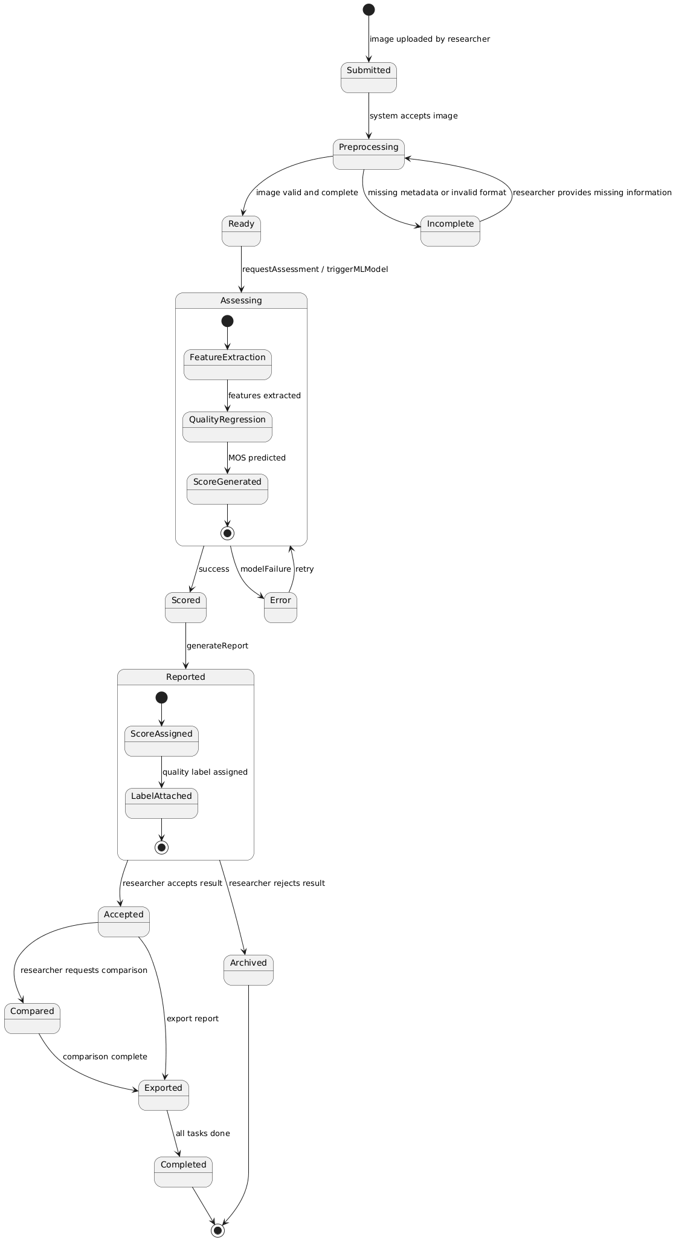
[Fig. 3.6: State Diagram]

3.7 Data Flow Diagram
The Data Flow Diagram (DFD) illustrates the movement of data through the system. External entities include the Report Storage, External Kaggle Dataset, Researcher/End User, and Human Annotators. Data flows from the external dataset through image loading and preprocessing into the Transform Pipeline, which feeds the Model Layer. The Model Layer processes feature through the Swin Transformer backbone, computes quality scores via the regression head, and outputs predictions. The Evaluation Engine computes correlation metrics (SROCC, PLCC, KROCC, RMSE) and generates scatter plots and loss curves for the Output Layer.

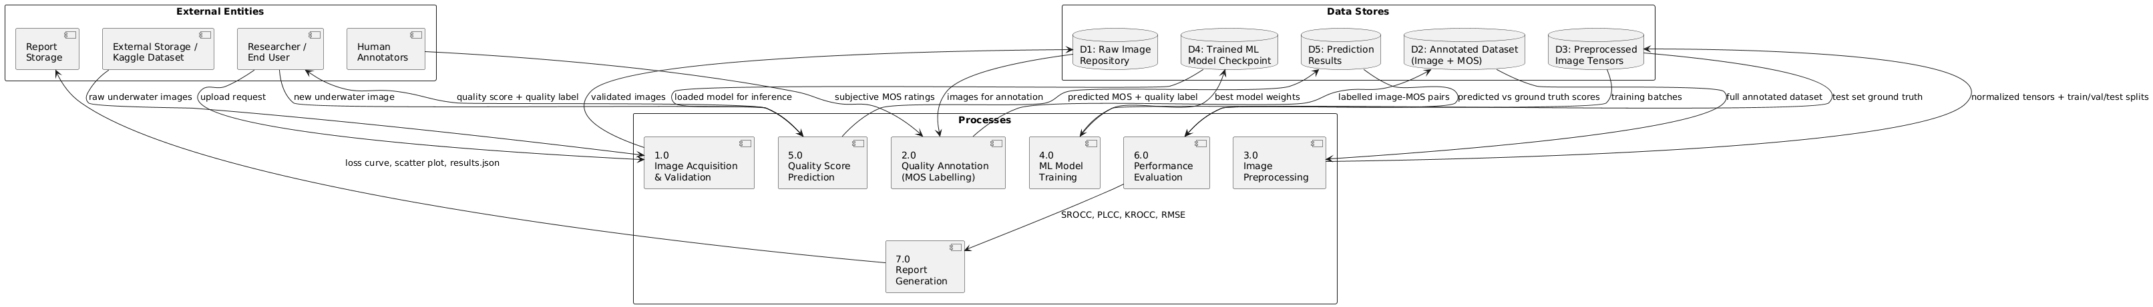
[Fig. 3.7: Data Flow Diagram]

4. Proposed Methodology
To address the challenge of blind UIQA, this project proposes a multi-scale feature fusion framework built upon a Swin Transformer backbone. The proposed model leverages the hierarchical representational capacity of the Swin-Base architecture to extract quality-relevant features at multiple levels of abstraction, which are subsequently fused and mapped to a perceptual quality score. The methodology comprises four primary stages: (1) multi-scale feature extraction through a pretrained Swin-Base backbone with selective fine-tuning; (2) global average pooling of intermediate stage outputs; (3) concatenation-based feature fusion; and (4) quality score regression via a multilayer perceptron.

4.1 Dataset Description
The proposed model was evaluated using the Subjectively-Annotated UIE Benchmark Dataset (SAUD), a benchmark specifically developed to assess underwater image enhancement algorithms. SAUD comprises 1,000 enhanced images generated by applying 10 representative enhancement techniques to 100 raw source images exhibiting typical underwater degradations, including color bias and reduced visibility. The ground-truth annotations are provided as reliable subjective ranking scores obtained through a large-scale double-stimuli pairwise comparison (DS-PC) user study.

Property | Value
Total Images | 1,000 enhanced underwater images
MOS Range | 0 to 88 (raw votes, 0–100 scale)
MOS Mean | 45.0 (well-balanced dataset)
Image Groups | group_1 to group_5
Input Resolution | 224 × 224 (resized)
Annotation File | saud_dataset.json
Train / Val / Test Split | 70% / 15% / 15%
Random Seed | 42 (fixed for reproducibility)
Table 4.1: SAUD Dataset Properties

4.2 Multi-Scale Feature Extraction using Swin Transformer
Given an input underwater image, the initial step transforms the image into a set of hierarchical feature representations using a Swin-Base Transformer pretrained on ImageNet as the feature extractor.
The Swin Transformer partitions the input into non-overlapping patches and processes them through four stages, each operating at a progressively reduced spatial resolution and increased channel dimensionality. To preserve low-level representations that transfer directly from the natural image domain, the patch embedding layer and Stage 1 are frozen during training. Stages 2, 3, and 4 are kept fully trainable, allowing the model to adapt to the unique distortion patterns characteristic of underwater imagery. Forward hooks are registered on each trainable stage to capture their intermediate output feature maps.

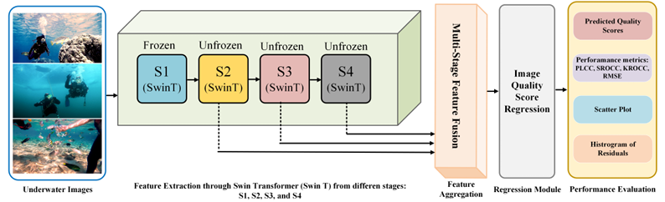
[Fig. 4.1: Proposed UIQA Framework Architecture based on multi-stage Swin Transformer]

4.3 Global Average Pooling of Stage Outputs
To obtain a fixed-size vector representation from each stage output, a Global Average Pooling (GAP) operation is applied independently to each feature map. This yields three compact descriptor vectors, capturing mid-level textural, structural, and high-level semantic quality cues respectively.

4.4 Concatenation-Based Feature Fusion
To construct a unified multi-scale quality descriptor, the three pooled vectors are concatenated along the feature dimension. The resulting descriptor simultaneously encodes representations from multiple levels of abstraction, providing a richer perceptual representation than any single-scale alternative. Batch normalization is applied to stabilize training with this high-dimensional fused input.

4.5 Quality Score Regression
The fused descriptor is passed through a three-layer regression MLP to predict the scalar quality score. The MLP comprises three fully connected layers with progressively reduced dimensionalit. Each of the first two layers is followed by Batch Normalization, GELU activation, and Dropout regularization. The final layer applies a Sigmoid activation, and the output is scaled to the MOS range [0, 100].

4.6 Loss Function Formulation
To effectively train the proposed model, a composite loss function is employed that jointly optimizes four complementary objectives: prediction accuracy, numerical error penalization, perceptual correlation, and rank-order consistency.

- L1 Loss: Provides a robust absolute error baseline, penalizing prediction deviations uniformly.
- MSE Loss: Penalizes large prediction errors more heavily, contributing to a lower RMSE.
- PLCC Loss: Directly maximizes the linear correlation between predicted and true scores, assigned the highest weight to drive alignment with human perceptual judgment.
- Pairwise Ranking Loss: Penalizes violations of the correct quality ordering between image pairs, directly improving SROCC.

5. Implementation

5.1 Experimental Setup
All experiments were conducted using the PyTorch deep learning framework. The proposed UIQA model employs a Swin-Base backbone pretrained on ImageNet, with patch embedding and Stage 1 frozen and Stages 2, 3, and 4 kept trainable. The model was trained for a maximum of 50 epochs with an early stopping patience of 10, using the AdamW optimizer with differential learning rates: 5×10⁻⁶ for the backbone and 1×10⁻⁴ for the regression head.

A cosine annealing scheduler with a linear warmup of 5 epochs was applied to stabilize early training. A weight decay of 1×10⁻⁴ and a batch size of 8 were used. All input images were resized to 224×224 pixels. At inference, Test-Time Augmentation (TTA) was applied over 5 stochastic forward passes, with predictions averaged to reduce variance. Training converged at epoch 47, with no observable signs of overfitting.

5.2 Software and Hardware Requirements

Component | Details
Programming Language | Python 3.9+
Deep Learning Framework | PyTorch (with torchvision)
Model Backbone | Swin Transformer Base (pretrained on ImageNet)
Numerical Computing | NumPy
Statistical Evaluation | SciPy
Visualization | Matplotlib
Development Environment | Jupyter Notebook
Hardware | GPU-enabled system (NVIDIA GPU recommended)
Dataset | SAUD Dataset (1,000 underwater images + saud_dataset.json)
Table 5.1: Software and Hardware Requirements

5.3 Evaluation Metrics
To ensure a rigorous and comprehensive evaluation, model performance is assessed using four widely adopted IQA evaluation metrics:

- Pearson Linear Correlation Coefficient (PLCC): Quantifies the linear correlation between predicted and ground-truth MOS scores. Higher values indicate better performance.
- Spearman Rank-Order Correlation Coefficient (SROCC): Measures monotonic agreement between predicted and ground-truth quality rankings. Higher values indicate better rank-order consistency.
- Kendall's Rank-Order Correlation Coefficient (KROCC): Assesses pairwise ordinal concordance between predicted and true rankings. Higher values are preferred.
- Root Mean Squared Error (RMSE): Captures the average prediction error on the MOS scale [0–100]. Lower values indicate higher predictive precision.

6. Results and Output

6.1 Performance Comparison with State-of-the-Art Methods
To assess the efficacy of the proposed UIQA framework, a rigorous quantitative comparison was conducted against a range of state-of-the-art (SOTA) methods on the SAUD dataset. Competing methods include both traditional UIQA metrics (UCIQE, UIQM, CCF, NUIQ) and prominent deep learning-based IQA models (ResNet-50, DenseNet-121, B-FEN). The comparative results are summarized in Table 6.1.

Methods | PLCC ↑ | SROCC ↑ | KROCC ↑ | RMSE ↓
UCIQE | 0.3939 | 0.2074 | 0.1456 | 18.36
UIQM | 0.4939 | 0.5050 | 0.3536 | 17.97
CCF | 0.3872 | 0.3614 | 0.1508 | 21.16
NUIQ | 0.6710 | 0.6735 | 0.4211 | 18.12
ResNet-50 | 0.7500 | 0.7477 | 0.5690 | 14.63
DenseNet-121 | 0.7389 | 0.7377 | 0.5486 | 13.57
B-FEN | 0.7402 | 0.7333 | 0.5534 | 14.11
Proposed (Ours) | 0.8317 | 0.8239 | 0.6398 | 12.38
Table 6.1: Performance Comparison with State-of-the-Art Methods on the SAUD Dataset (↑ higher is better, ↓ lower is better)

The results demonstrate that the proposed method achieves the best performance across all four-evaluation metrics, obtaining PLCC = 0.8317, SROCC = 0.8239, KROCC = 0.6398, and RMSE = 12.38. These results indicate strong linear and monotonic correlation with human perceptual judgments, validating the effectiveness of the proposed multi-scale fusion strategy. The proposed method outperforms the best competing deep learning baseline (ResNet-50) by approximately 8.2 percentage points in PLCC and 7.6 percentage points in SROCC.

6.2 Training and Validation Loss Curves
Both the training and validation loss curves exhibit a consistent and steady decrease over epochs, eventually converging to a stable state at epoch 47 with no observable signs of overfitting. The early stopping mechanism with a patience of 10 epochs effectively prevented unnecessary computation beyond convergence. The loss curves confirm that the composite training objective successfully guides the model toward perceptually meaningful predictions.

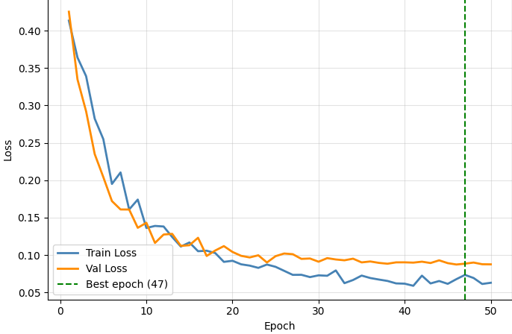
[Fig. 6.1: Training and Validation Loss Curves]

6.3 Scatter Plot of Predicted vs. Ground-Truth MOS Scores
The scatter plot illustrates the relationship between the predicted quality scores and the ground-truth MOS values on the held-out test set of 150 images. Although predictions follow the general trend of the diagonal reference line, confirming a positive correlation with human perceptual judgments, a degree of spread is observable across the score range. This spread is characteristic of the inherent subjectivity in the annotation of underwater image quality, rather than a fundamental failure of the model.

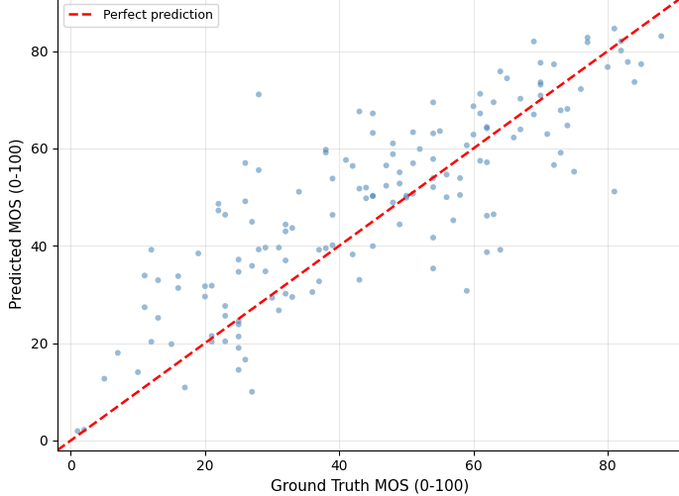
[Fig. 6.2: Scatter Plot of Predicted vs. Ground-Truth MOS Scores]

6.4 Residuals Histogram
The histogram of residuals (Predicted Score − True Score) illustrates the distribution of prediction errors across the test set. The distribution exhibits a slight positive mean of +3.45, indicating a marginal tendency toward over-prediction, with a standard deviation of 11.54. Although errors are widely distributed across the score range, the majority of residuals are concentrated near zero, suggesting that the model maintains reasonable calibration despite the inherent difficulty of the underwater quality assessment task.

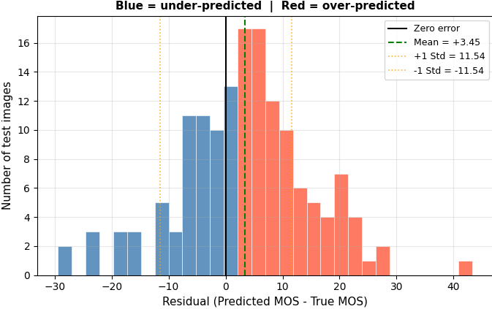
[Fig. 6.3: Histogram of Residuals]

7. Limitations and Future Enhancements

7.1 Current Limitations
- Dataset Scale: The SAUD dataset contains only 1,000 annotated images, which constrains the generalization ability of the trained model. Cross-validation has not yet been implemented to mitigate this risk.
- MOS Range: The MOS values in the SAUD dataset are capped at 88/100, leaving the upper portion of the output space unused. The normalization strategy may need review to better handle this truncated range.
- Computational Requirements: The Swin-Base backbone requires GPU-enabled hardware for efficient training. The model's computational complexity makes real-time deployment on resource-constrained embedded systems currently infeasible.
- No Traditional Baseline Comparison: The current implementation does not include a baseline comparison against traditional UIQA metrics (e.g., BRISQUE, NIQE) evaluated on the same test set.
- Residual Bias: The model exhibits a slight positive prediction bias (mean residual = +3.45), indicating a marginal tendency toward over-prediction that may affect applications requiring high precision.

7.2 Future Enhancements
- Larger and more diverse labeled underwater datasets should be incorporated to improve model generalization across varying underwater conditions and enhancement algorithms.
- Cross-validation across multiple dataset splits should be implemented to obtain more robust performance estimates and reduce evaluation variance.
- Attention visualization techniques such as Grad-CAM should be applied to the Swin Transformer stages to provide interpretable insights into the quality-relevant regions identified by the model.
- The model should be extended to support video quality assessment for continuous underwater monitoring applications, particularly for AUV navigation pipelines.
- Integration of the UIQA system as a real-time quality monitoring module within UIE pipelines should be explored, leveraging model optimization techniques (quantization, pruning) for deployment on edge devices.
- Future work should include a systematic ablation study to quantify the individual contribution of each backbone stage (S2, S3, S4) and each loss component to the overall performance.

8. Conclusion

This project introduced a multi-scale feature fusion framework for blind underwater image quality assessment, leveraging a Swin Transformer (Swin-Base) backbone with a selective fine-tuning strategy. The proposed approach goes beyond single-scale feature extraction by fusing intermediate representations from multiple backbone stages, enabling the model to simultaneously capture texture, structural, and semantic quality cues critical for accurate perceptual assessment.

By concatenating globally pooled feature maps from Stages 2, 3, and 4 into a unified 1792-dimensional descriptor, the framework constructs a rich and comprehensive representation of underwater image quality. The model was optimized end-to-end with a composite loss function combining L1, MSE, PLCC, and pairwise ranking terms, ensuring both high prediction accuracy and strong alignment with human perceptual judgment. Inference-time performance was further enhanced through Test-Time Augmentation, which consistently improved rank-order consistency across evaluation runs.

Experimental results on the benchmark SAUD dataset validated the effectiveness of the proposed framework, achieving an SROCC of 0.8239, PLCC of 0.8317, KROCC of 0.6398, and RMSE of 12.38 — outperforming all competing methods including traditional UIQA metrics and deep learning-based baselines such as ResNet-50, DenseNet-121, and B-FEN. The multi-scale fusion strategy therefore offers a principled and effective approach to the underwater image quality assessment task, with strong potential for deployment in real-world autonomous underwater perception pipelines.

The work also resulted in a research paper titled 'Hierarchical Feature Fusion with Swin Transformer for Blind Underwater Image Quality Assessment', which has been submitted for publication, further demonstrating the academic significance and novelty of the contributions made through this minor project.

References

[1] F. Sun, J. Yu, and D. Xu, "Visual measurement and control for underwater robots: A survey," in 2013 25th Chinese Control and Decision Conference (CCDC). IEEE, 2013, pp. 333–338.

[2] W. Zhang, Y. Wang, and C. Li, "Underwater image enhancement by attenuated color channel correction and detail preserved contrast enhancement," IEEE Journal of Oceanic Engineering, vol. 47, no. 3, pp. 718–735, 2022.

[3] C. Li, C. Guo, W. Ren, R. Cong, J. Hou, S. Kwong, and D. Tao, "An underwater image enhancement benchmark dataset and beyond," IEEE Transactions on Image Processing, vol. 29, pp. 4376–4389, 2019.

[4] C. Liu, X. Shu, L. Pan, J. Shi, and B. Han, "Multiscale underwater image enhancement in rgb and hsv color spaces," IEEE Transactions on Instrumentation and Measurement, vol. 72, pp. 1–14, 2023.

[5] Y. Liu, B. Zhang, R. Hu, K. Gu, G. Zhai, and J. Dong, "Underwater image quality assessment: Benchmark database and objective method," IEEE Transactions on Multimedia, vol. 26, pp. 7734–7747, 2024.

[6] M. U. Rehman, I. F. Nizami, F. Ullah, and I. Hussain, "IQA vision transformed: A survey of transformer architectures in perceptual image quality assessment," IEEE Access, vol. 12, pp. 183 369–183 393, 2024.

[7] Z. Liu, Y. Lin, Y. Cao, H. Hu, Y. Wei, Z. Zhang, S. Lin, and B. Guo, "Swin transformer: Hierarchical vision transformer using shifted windows," in Proceedings of the IEEE/CVF International Conference on Computer Vision (ICCV). IEEE, 2021, pp. 10 012–10 022.

[8] Q. Jiang, Y. Gu, C. Li, R. Cong, and F. Shao, "Underwater image enhancement quality evaluation: Benchmark dataset and objective metric," IEEE Transactions on Circuits and Systems for Video Technology, vol. 32, no. 9, pp. 5959–5974, 2022.

[9] M. Yang and A. Sowmya, "An underwater color image quality evaluation metric," IEEE Transactions on Image Processing, vol. 24, no. 12, pp. 6062–6071, 2015.

[10] K. Panetta, C. Gao, and S. Agaian, "Human-visual-system-inspired underwater image quality measures," IEEE Journal of Oceanic Engineering, vol. 41, no. 3, pp. 541–551, 2015.

[11] Y. Wang, N. Li, Z. Li, Z. Gu, H. Zheng, B. Zheng, and M. Sun, "An imaging-inspired no-reference underwater color image quality assessment metric," Computers & Electrical Engineering, vol. 70, pp. 904–913, 2018.

[12] K. He, X. Zhang, S. Ren, and J. Sun, "Deep residual learning for image recognition," in Proceedings of the IEEE Conference on Computer Vision and Pattern Recognition, 2016, pp. 770–778.

[13] G. Huang, Z. Liu, L. Van Der Maaten, and K. Q. Weinberger, "Densely connected convolutional networks," in Proceedings of the IEEE Conference on Computer Vision and Pattern Recognition, 2017, pp. 4700–4708.

[14] Q. Wu, L. Wang, K. N. Ngan, H. Li, F. Meng, and L. Xu, "Subjective and objective de-raining quality assessment towards authentic rain image," IEEE Transactions on Circuits and Systems for Video Technology, vol. 30, no. 11, pp. 3883–3897, 2020.

