**LOAD**

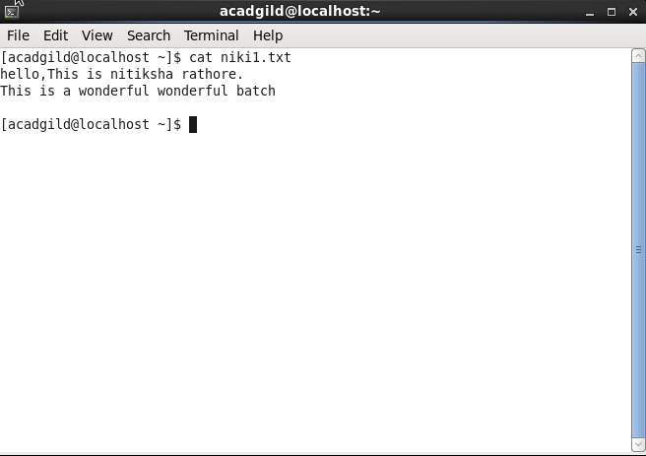

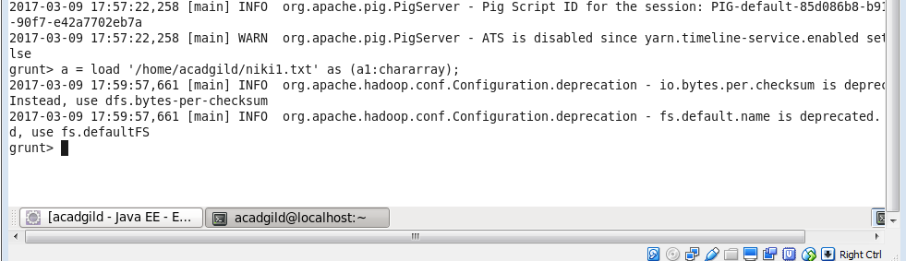

**CONVERT THE SENTENCE INTO WORD** 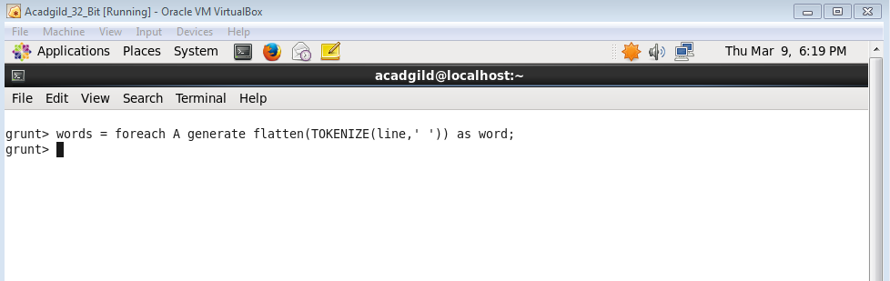

**GROUP BY WORD**

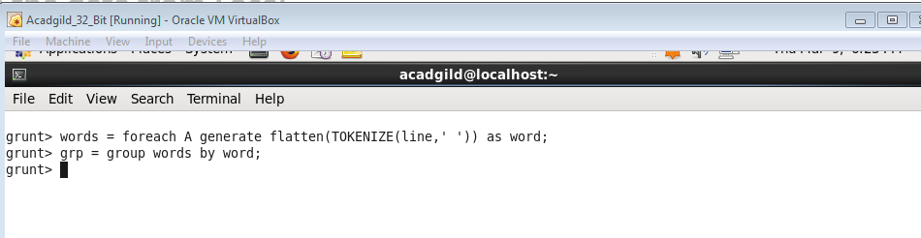

**GENERATE WORD COUNT**

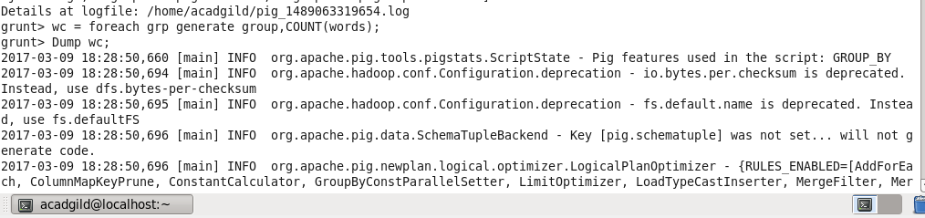

**OUTPUT**

