**Write the Pig codes to analyze the Student data set. https://github.com/prateekATacadgild/mAPrEDuce/blob/master/studentDS Data Dictionary**

**1. Name : chararray**

**2. Col.Undertaken : chararray**

**3. Dob : chararray**

**4. Stream : chararray**

**5. Grade : float**

**6. State : chararray**

**7. City : chararray**

**1. Find the number of students who scored less than 5(50%).**

**2. List the name of students who are from Alaska.**

**3. How many government colleges are there in Alabama?**

**4. List the name of students who are from Oregon and persuing BE.**

**Ans)**

1. Load data from input file.
2. Filter data to find students who scored less than 5.
3. Group them and count the students.
4. Display count of students.

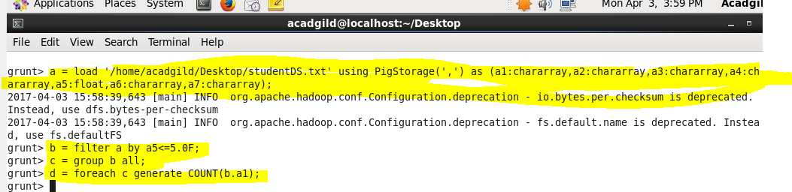

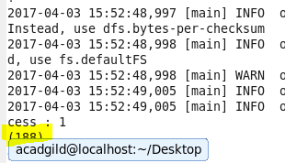

**A2)**

1. Load data from input file.
2. Filter data to find students from Alaska.
3. Display the names of those students.

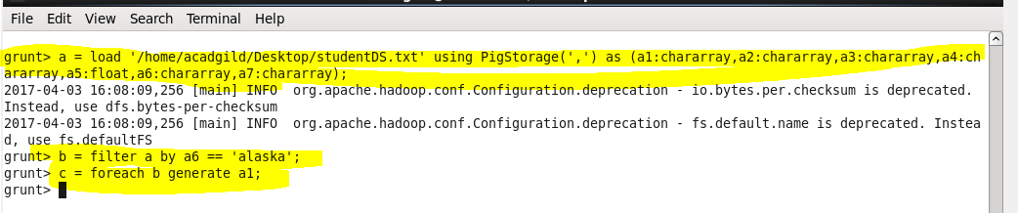

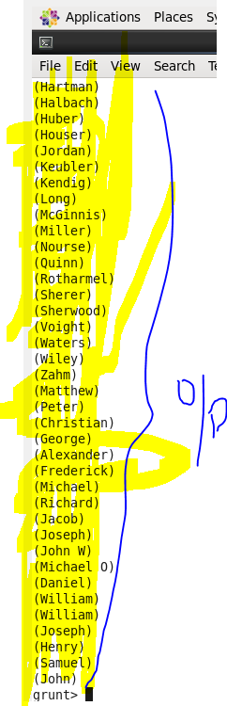

**A3)**

1. Load data from input file.
2. Filter data to find students from Alabama and the college is government.
3. Group them and count the number.
4. Display the data.

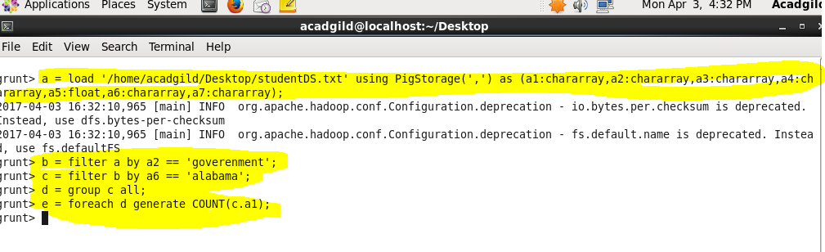

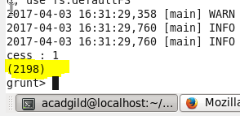

**A4)**

1. Load data from input file.
2. Filter data to find the students from Oregon and pursuing BE.
3. Display the names of such students.

