**PROBLEM STATEMENT:**

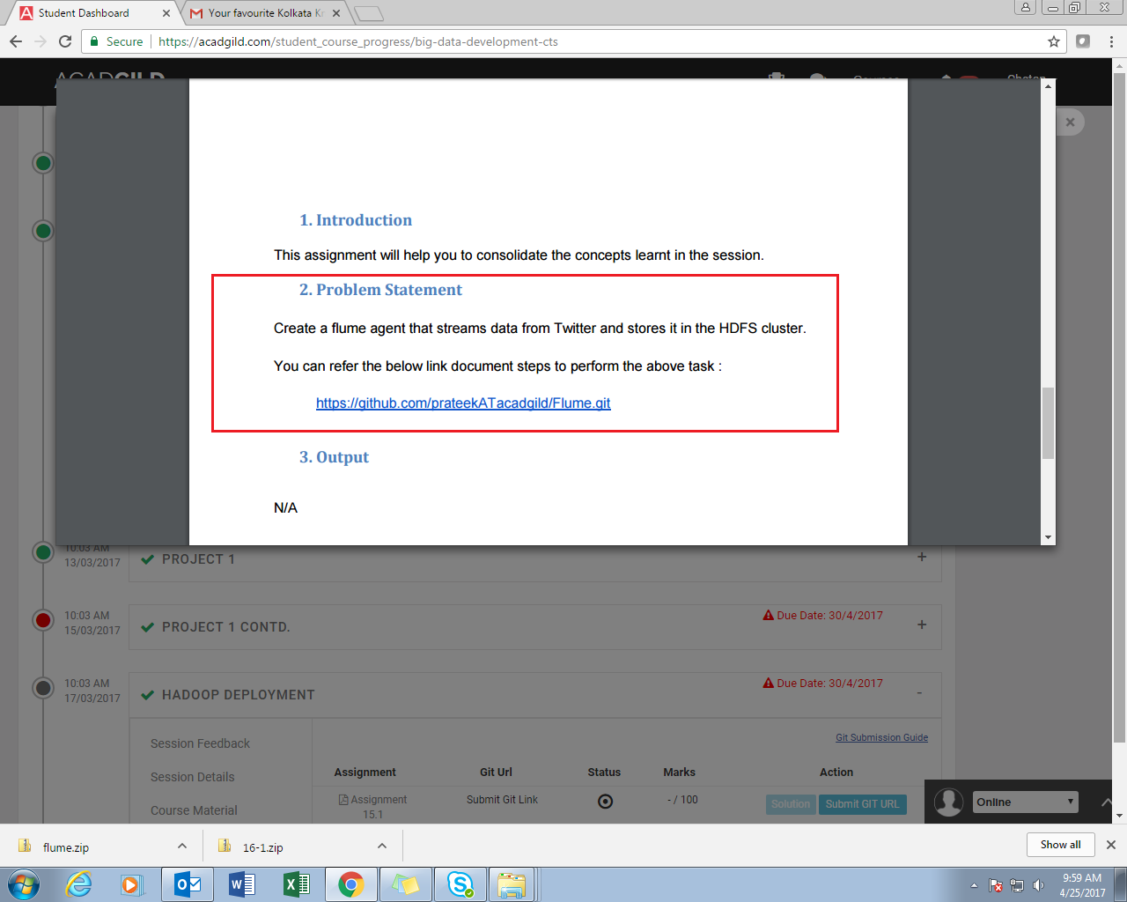

**SOLUTION:**

// Consumer key and Consumer secret key

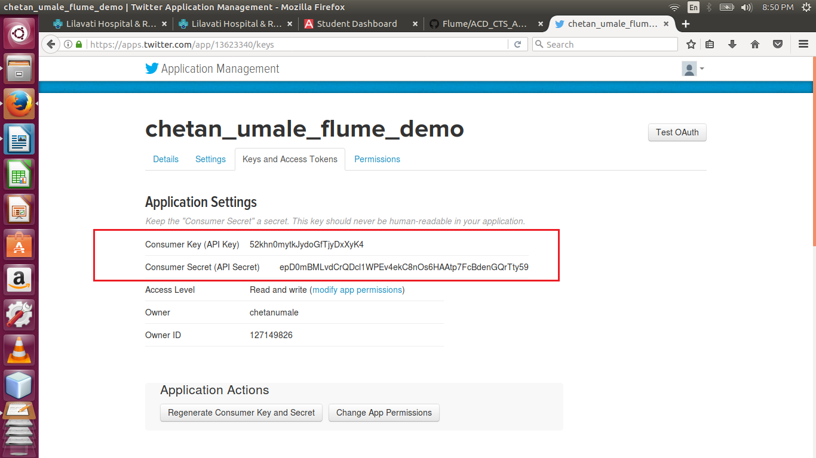// Access Token

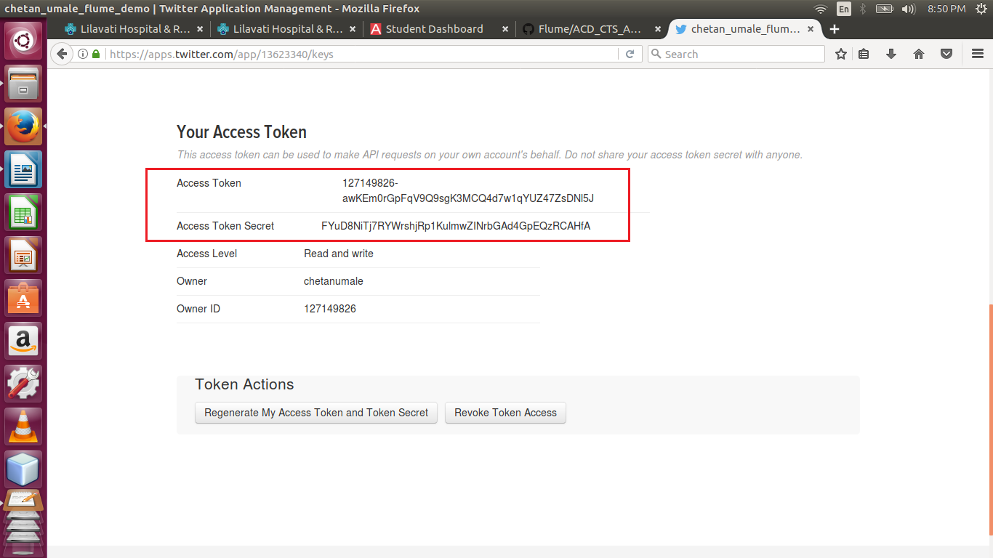

// flume.conf (configuration file)

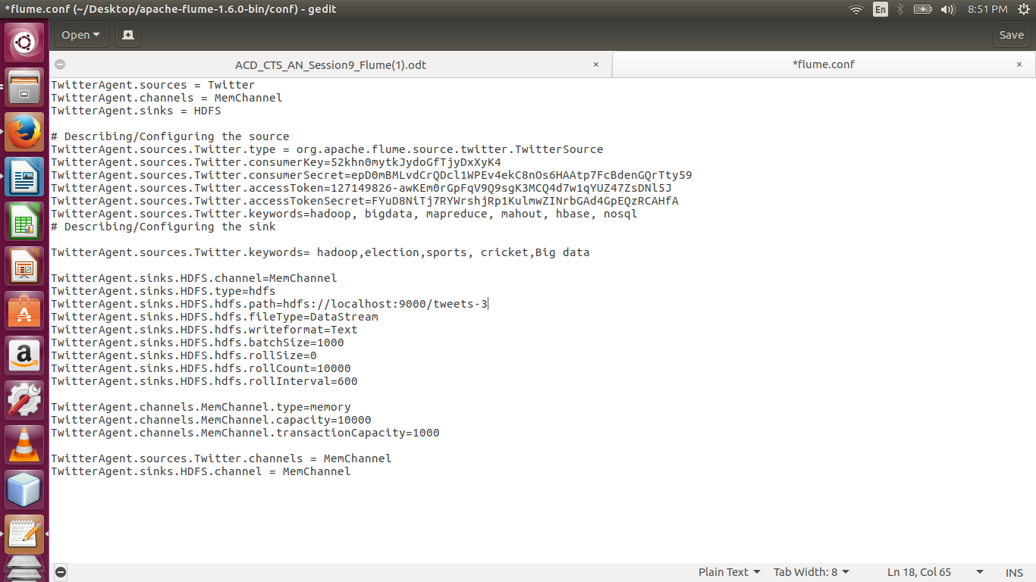

//Streaming Twitter data using flume –ng command

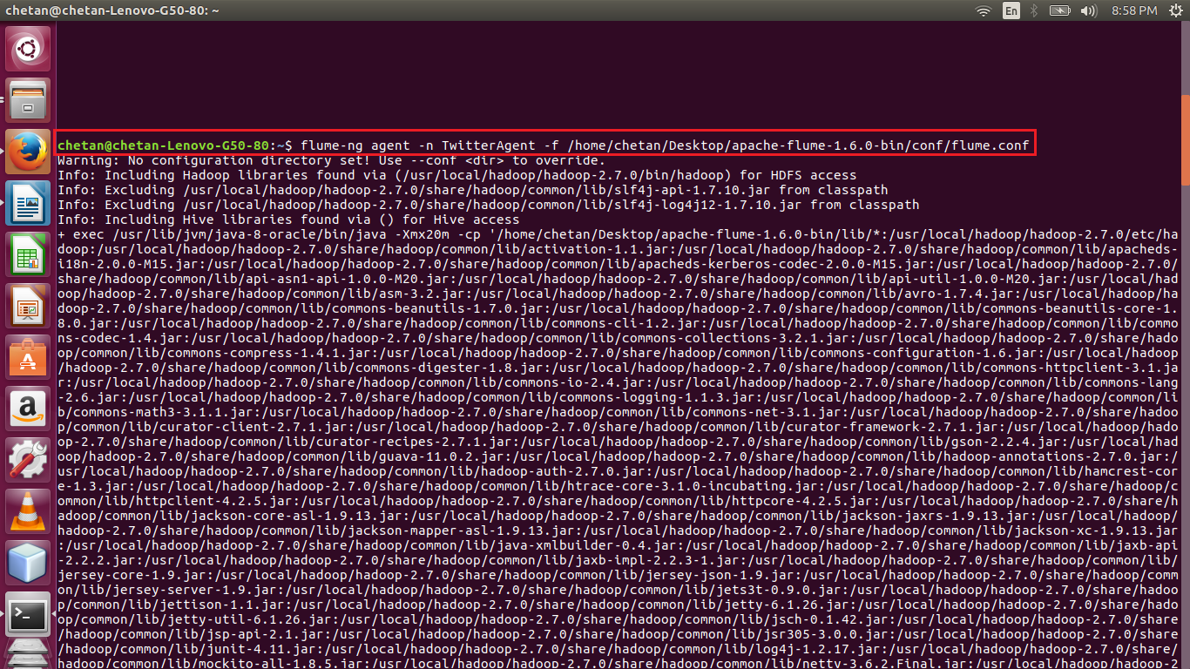

//displaying the contents of directory tweets-3

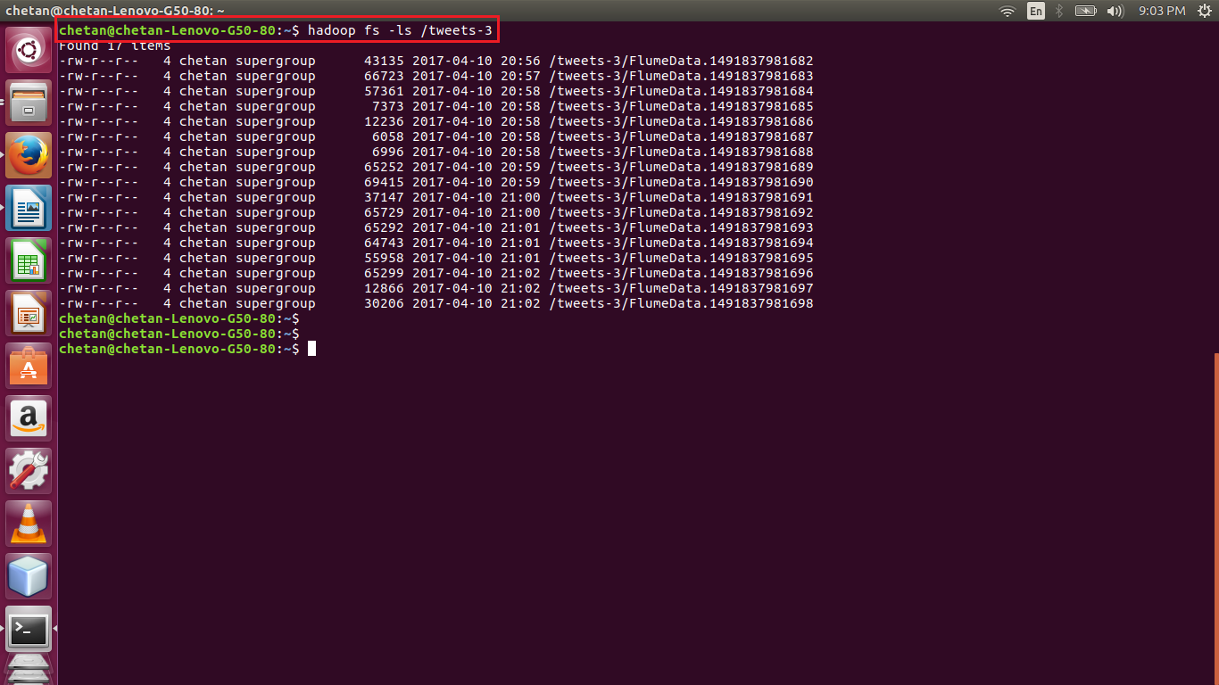

//displaying the contents of file

