**ASSIGNMENT 12.2**

flume.conf.

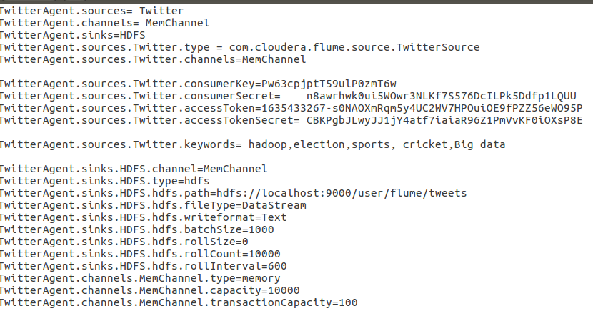

Twitter.app.

USING SHREY CHANDRA’S ACCOUNT I AM DOING THIS ASSIGNMENT

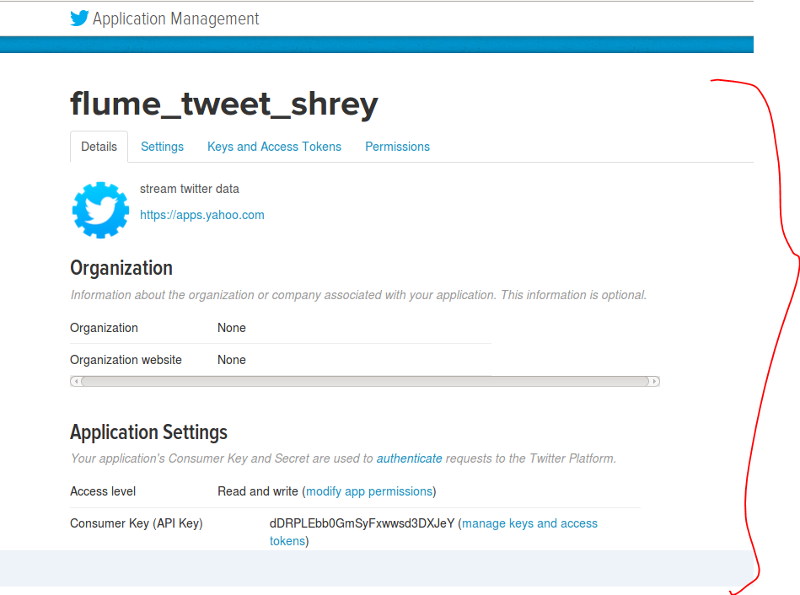

Running the flume agent

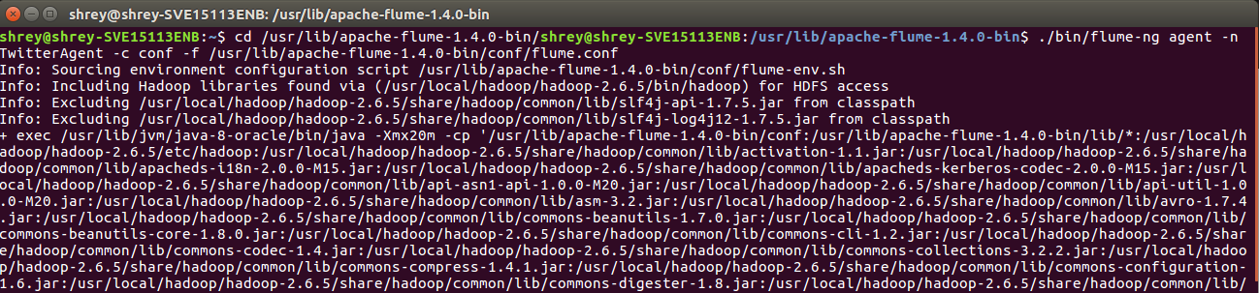

Check on HDFS

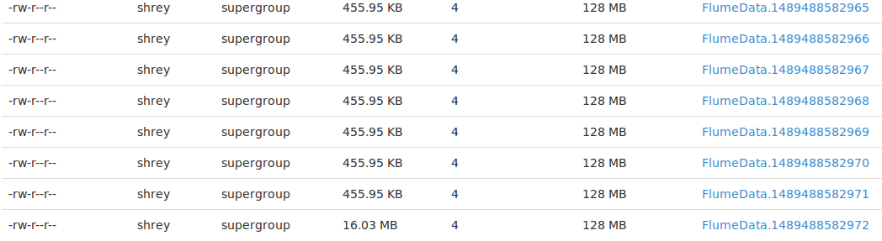

Data file on HDFS:

