Problem Statement:-

Using Distributed cache join the two datasets and find out the number of temperature variations in each country using mapreduce.

Driver Class:

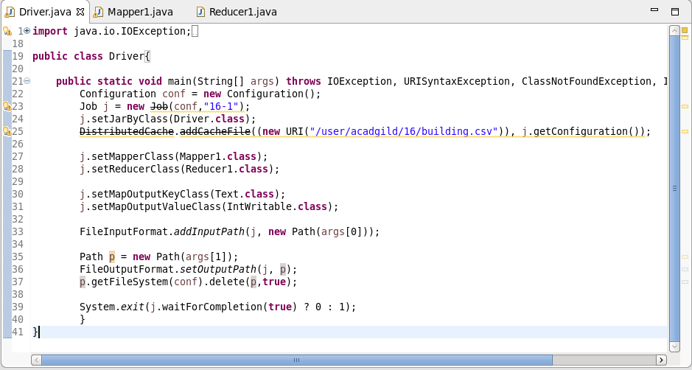

Mapper Class:-

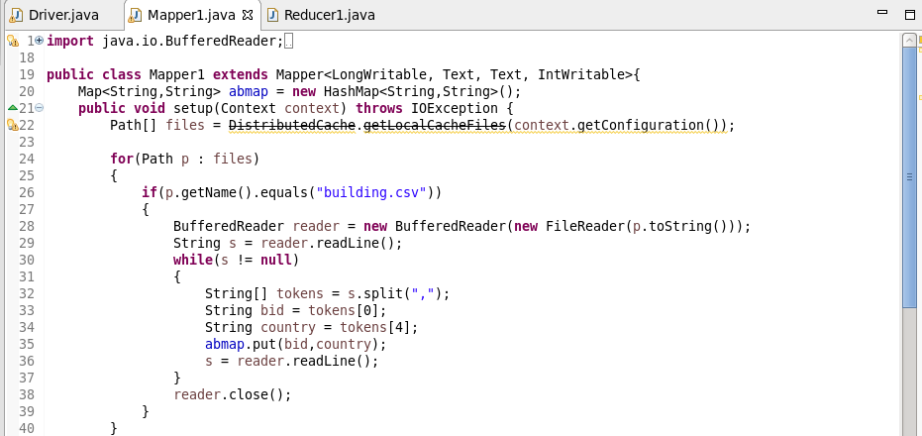

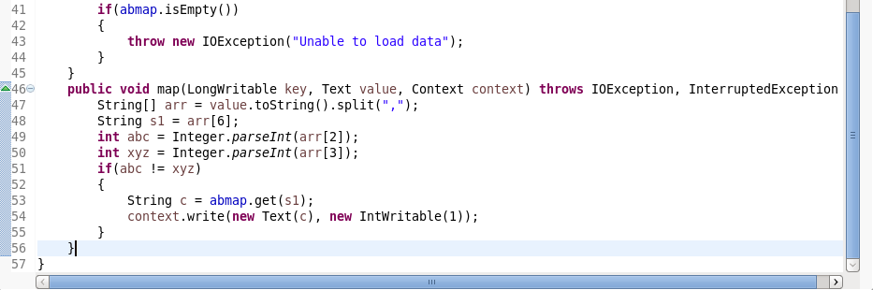

Reducer Class:-

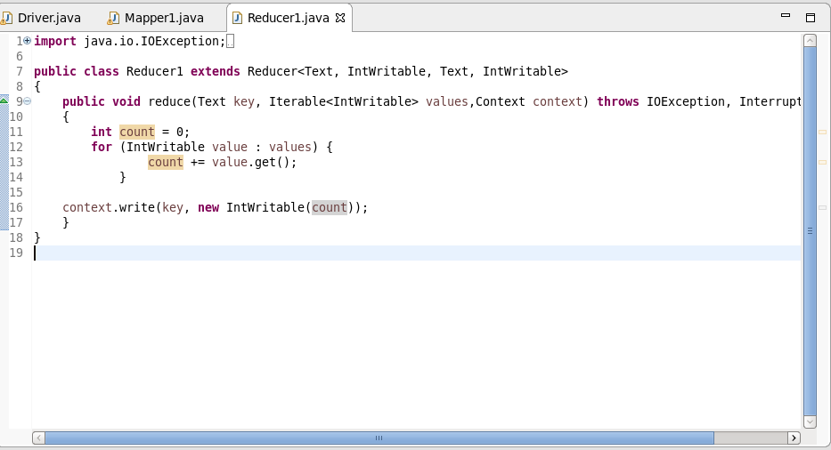

Execution Command:-

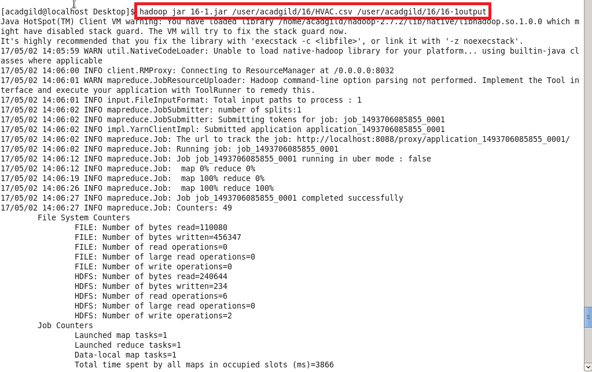

Output:-

