**ASSIGNMENT 17.3**

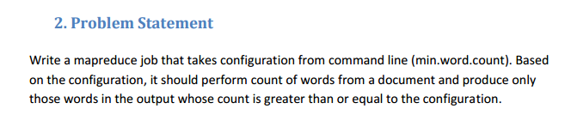

**Input file**

Hadoop is good subject

Hadoop is good subject

Hadoop is good subject

Hadoop is good subject for me

**Solution**

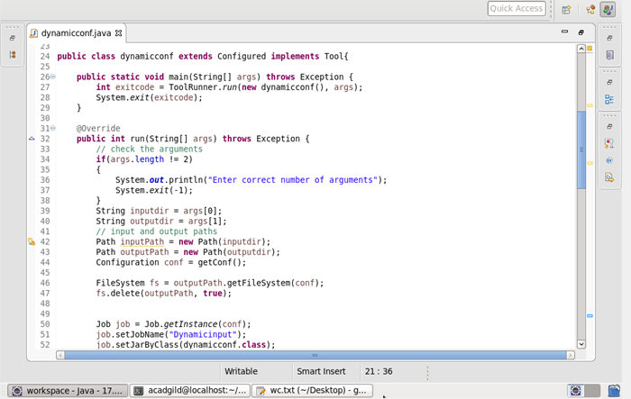

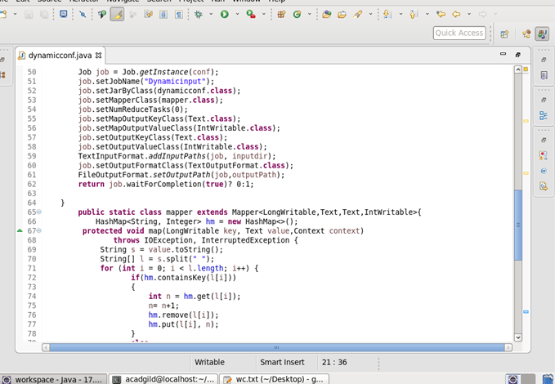

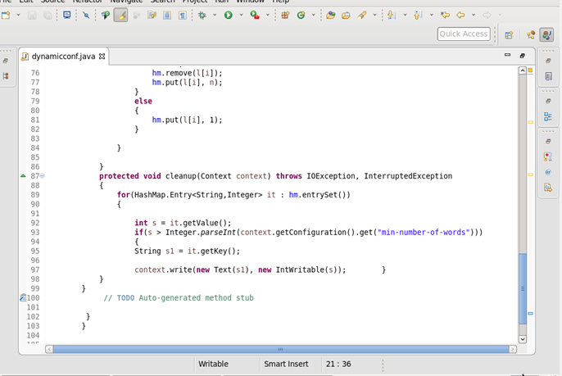

**Output**

