**Problem Statement:**

Write a mapreduce program to use CombineFileInputFormat. Pass a directory containing multiple small files. The program should be able to pick multiple files in a single mapper.

**Solution:**

**Task Class with mapper and reducer class:**

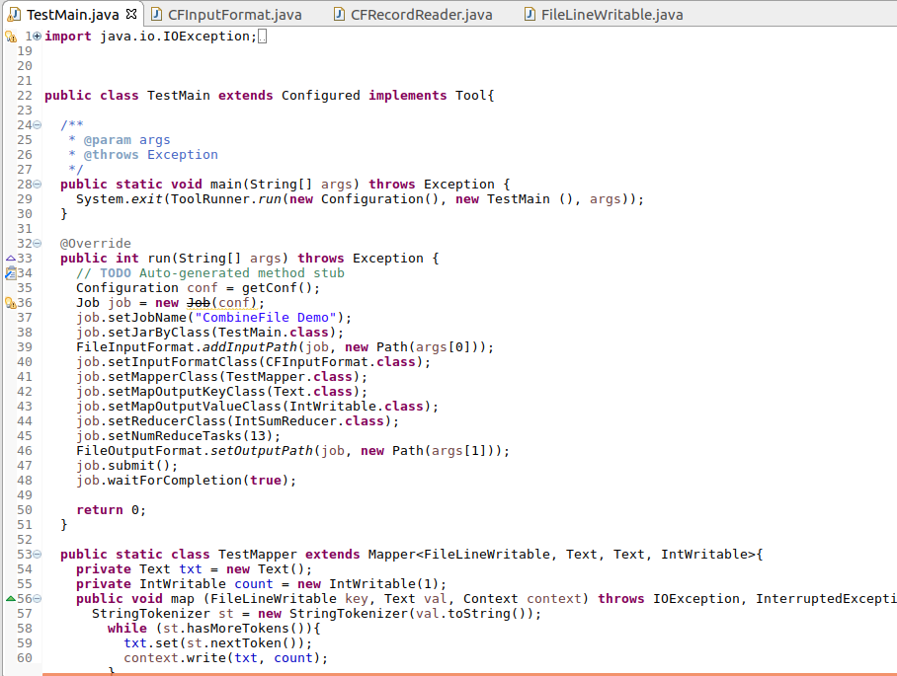

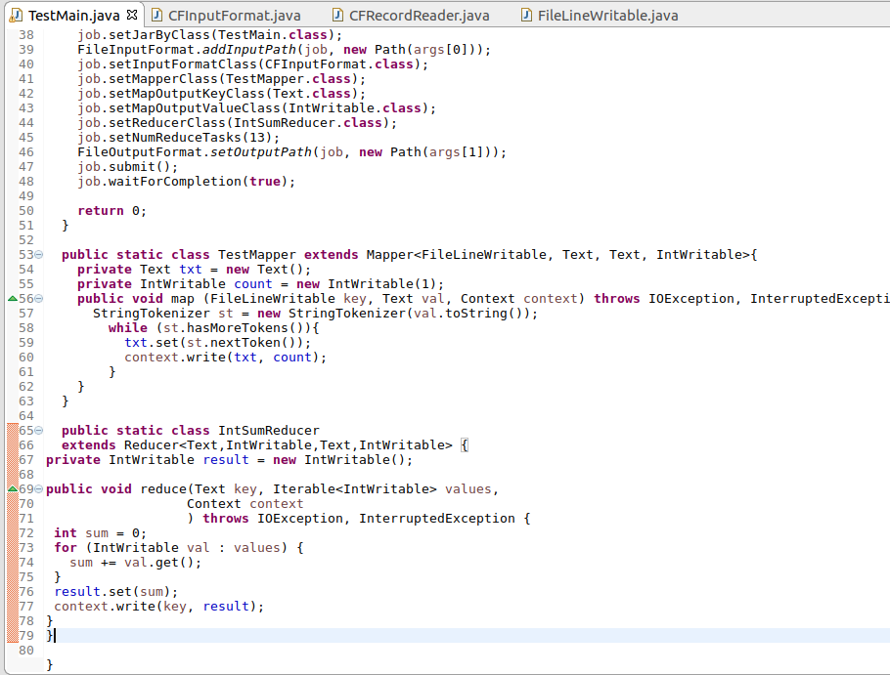

**Writable Comparable Class:**

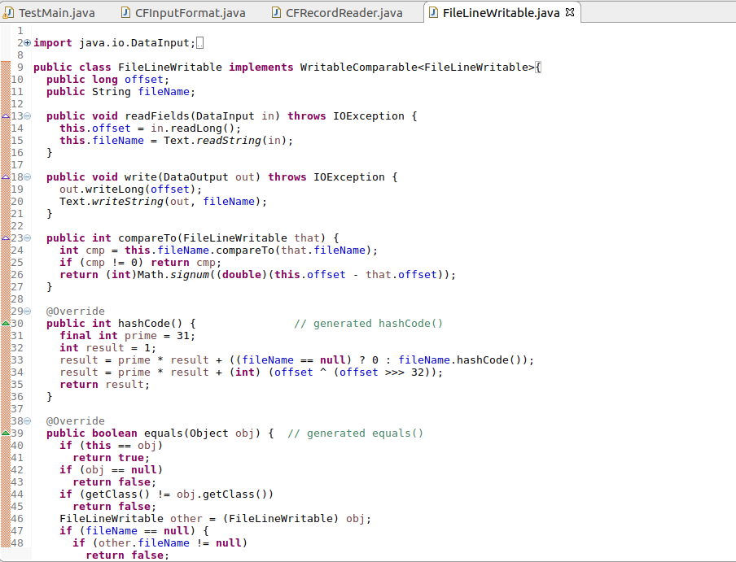**:**

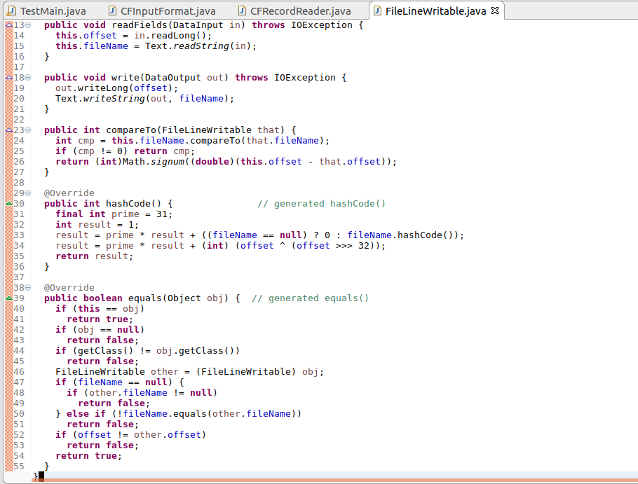

**Record reader class:**

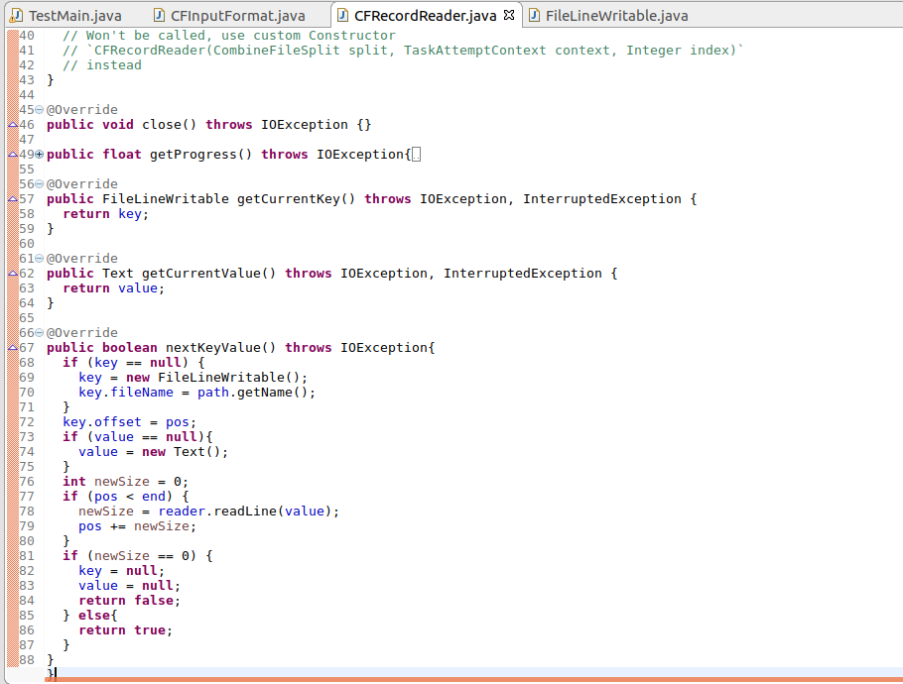

**Combined file input format class:**

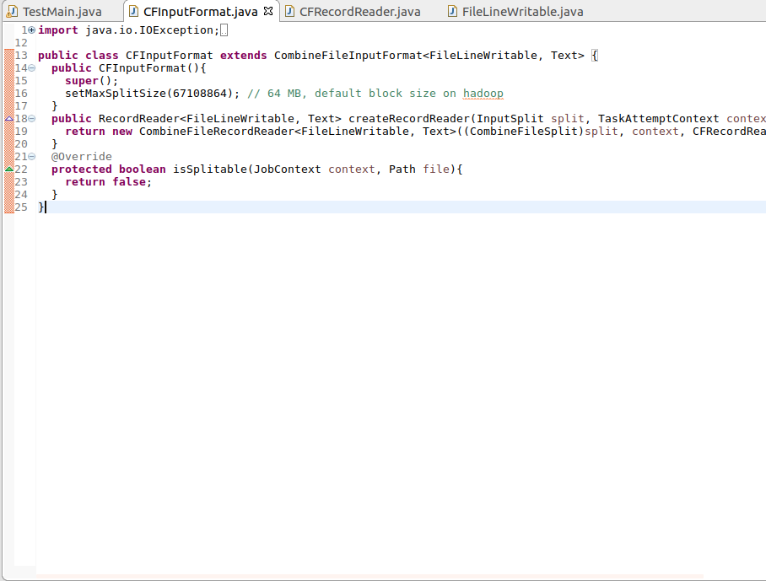

**Input files:**

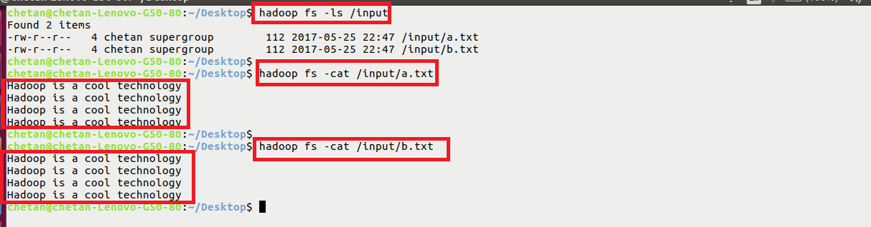

**Executing jar:**

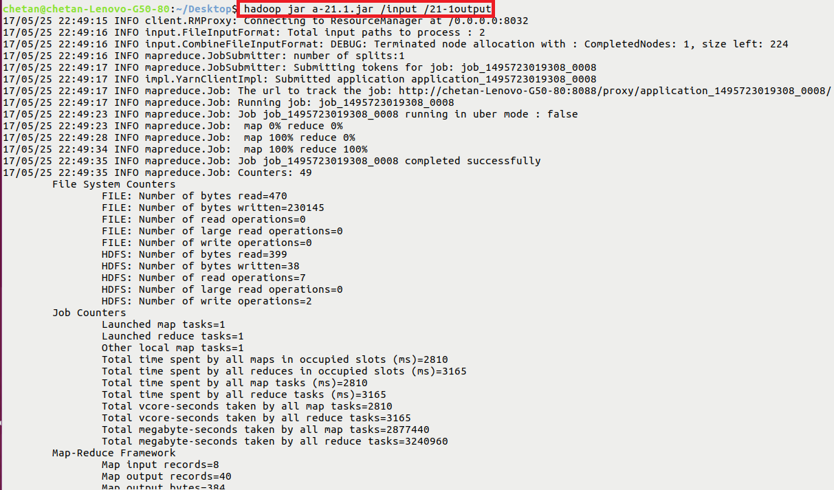

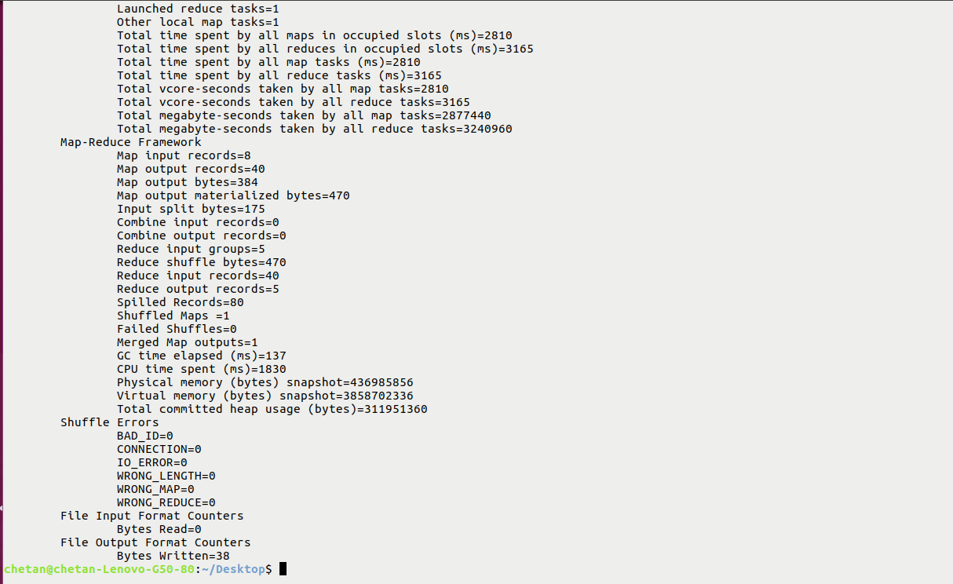

**Output:**

